Programme in South Africa Insolvency Law and Practice 2023 83

Summative Assessment (Examination): Paper 2

NB: no separate schedule for liq remuneration; marks awarded in Accounts.

Encumbered Asset Account 1 11 plus 2.5
Proceeds of Portion 8 of the farm “ValleyGrove”, Stellenbosch, Western Cape subject to a Mortgage Bond in favour of Capital Bank Ltd – Creditor No 1 (½)(½)
Narration | Vat | Debit | Credit
Receipts:  Sale of Portion 8 of the farm “ValleyGrove”, Stellenbosch, Western Cape sold by public auction by Hastings Auctions.  Sale of a quantity of Stella Valley Cabernet grapes harvested shortly after liquidation and sold privately. | R 1 186 956.52  (½)  R 15 766.53  (½) |  | R 9 100 000.00  R 120 876.76
Payments:  Pro rata Master’s fees as per schedule A  Pro rata bond of security to GuardianSure Bonds Ltd as per schedule A  Liquidator’s fee  Sale of Ptn 8: 9 100 000 x 3% = 273 000 (½)  1 186 956.52 x 3% = 35 608.70  35 608.70 x 15% = 5 341.30 (½)  Sale of grapes: 120 876.76 x 10% = 12 087.68 (½)  15 766.53 x 10% = 1 576.65  1 576.65 x 15% = 236.50 (½) (½)  Pro rata auctioneer’s commission and expenses on sale to Hastings Auctions as per schedule B  Wages paid to general labourers who assisted with harvesting the grapes  Western Province Municipality for rates and taxes payable  Vat payable to SARS  Total Payments | (½)  (½)  R 4 393.86  (½)  R 41 926.48  (½)  R 55 434.78  (½)  (½) | (½)  R 178 148.32  (½)  R 33 686.23  (½)  R 321 436.35  (½)  R 425 000.00  (½)  R 15 000.00  (½)  R 124 897.50  (½)(½)  R1 100 967.93  (½)  R 2 199 136.93
Balance awarded:  Capital Bank Ltd, Creditor Number 1, for mortgage bond over ValleyGrove as follows:  Capital: R 8 946 765.32(½)(½)  Interest thereon @ 14% from 05/09/2022 to 17/03/2023: R 662 305.75 (creditor has relied on security) |  | (½)(½)  R 7 021 739.83
Total |  | R 9 220 876.76 | R 9220 876.76

Encumbered Asset Account 2 11.5 plus 2
Proceeds of bottling and equipment ex situ subject to a special notarial bond in favour of Harvest Finance – Creditor No 2 (½)(½)
Narration | Vat | Debit | Credit
Receipts:  Sale of bottling and equipment which were clearly marked. | (½)  R 456 521.79 |  | R 3 500 000.00
Payments:  Pro rata Master’s fee as per Schedule A  Liquidator’s fee  Sale of bottling and equip: 3 500 000 x 10% = 350 000 (½)  456 521.74 x 10% = 15 652.17  15 652.17 x 15% = 6 847.83 (½) (½) (½)  Pro rata auctioneer’s commission and expenses on sale to Hastings Auctions as per Schedule B  Pro rata bond of security to GuardianSure Bonds Ltd as per schedule A  Repairs made to bottling plant prior to sale by GrapeFlow Bottling Solutions  Vat Payable to SARS  Total payments | (½)  (½)  R 51 472.83  R 4 247.40  (½)  (½)  R 1 667.79  (½)  R 3 732.10 | (½)  R 67 620.37  (½)  R 394 625.00  R 32 563.41  (½)  (½)  R 12 786.40  (½)  R 28 612.77  (½)  R 395 401.62  R 931 609.57
Balance awarded:  Harvest Finance, Creditor Number 2, for special notarial bond as follows:(½)  Capital: R 3 203 046.89(½)(½)  Interest thereon @ 16.5% from 05/09/2022 to 17/03/2023: R 279 454.87(½)(½)  Balance of the claim will be a concurrent claim (½)(½) |  | (½)(½)  R 2 568 390.43
Total |  | R 3 500 000.00 | R 3 500 000.00

Encumbered Asset Account 3 9.5 plus 2
Proceeds of the 2019 self-propelled Grape Harvester with registration number CA9090 which is subject to an installment sale agreement in favour of AgriTech Finance – Creditor No 3 (½)(½)
Narration | Vat | Debit | Credit
Receipts:  Sale of the 2019 self-propelled Grape Harvester by private treaty | R 150 000.00 (½) |  | R 1 150 000.00
Payments:  Pro rata Master’s fee as per Schedule A  Liquidator’s fee  Sale of bottling and equip: 1 150 000 x 10% = 115 000 (½)  150 000 x 10% = 15 000.00  15 000 x 15% = 2 250.00 (½) (½) (½)  Pro rata bond of security to GuardianSure Bonds Ltd as per schedule A  Vat payable to SARS  Total payments | (½)  R 16 912.50  (½)  (½)  R 547.99 | (½)  R 22 218.12  R 129 662.50  (½)  (½)  R 4 201.24  (½)  R 132 539.51  R 288 621.37
Balance awarded:  AgriTech Finance, Creditor Number 3, for installment sale transaction as follows:(½)  Capital: R 1 261 052.55(½)(½)  Interest thereon @ 18.75% from 05/09/2022 to 17/03/2023: R 125 025.59(½)(½)  Balance of claim will be concurrent (½)(½) |  | (½)(½)  R 861 378.63
Total |  | R 1 150 000.00 | R 1 150 000.00

Free Residue Account(½) 20 plus 3.5
Narration | Vat | Debit | Credit
Receipts:  Sale of substantial inventory of bottled wine manufactured by the farm  Sale of miscellaneous movable assets and office equipment at the farm  Proceeds of book debts collected by Sithole & Partners | R 30 116.62(½)  R 5 700.00(½)  (½) |  | R 230 894.10  R 43 700.00  R 88 405.08
Payments:  Pro rata Master’s fee as per Schedule A  Liquidator’s fee  Sale of inv bottled wine: 230 894.10 x 10% = 23 089.41 (½)  30 116.62 x 10% = 3 011.66  3 011.66 x 15% = 451.75 (½)  Sale of miscell. Movable: 43 700 x 10% = 4 370 (½)  5 700 x 10% = 570  570 x 15% = 85.50 (½) (½) (½)  Debt collected: 88 405.08 x 10% = 8 840.51  Pro rata bond of security to GuardianSure Bonds Ltd as per schedule A  Horizon Attorneys for application  Pro rata auctioneer’s commission and expenses on sale to Hastings Auctions as per schedule B  Advertising general (second) meeting of creditors  Advertising inspection of account  Advertising confirmation of account  Advertising destruction of books and records  Bank changes and provisional charges to Trust Bank Ltd  Postage and Petties  Sithole & Partners – professional collection fees  Vat payable to SARS  Total payments | (½)  (½)  R 5 364.40  (½)  R 172.97  (½)  R 2 430. 25  (½)  R 333.23  (½)  R 120.00  (½)  R 4.93  (½)  R 4.93  (½)  R 4.93  (½)  R 52.17  (½)  R 134.35  (½)  R 901.84 | (½)  R 7 013.18  (½)  R 41 127.07  (½)  R 1 326.13  (½)  R 18 631.93  (½)  R 2 554.78  (½)  R 920.00  (½)  R 37.82  (½)  R 37.82  (½)  R 37.82  (½)  R 400.00  (½)  R 1 030.00  (½)  R 6 914.10  (½)  R 26 292.60  R 106 323.25
Balance awarded:  Statutory preferent creditors:  Thabo Moeng (½)  Arrear Salary  Leave pay  Sindiwe Methembu(½)  Arrear salary(½)  SARS  Arrear VAT prior to liquidation(½)  Arrear Income Tax prior to liquidation (½)  Concurrent creditors @ 0.04 cents in the Rand |  | R 40 000.00  (½)(½)  R 9 000.00  R 119 345.02 (½)(½)  R 17 841.62 (½)(½)  R 70 489.29

Schedule A 6
Apportionment of Master’s Fees and Bond of Security Premiums
Account | Gross Proceeds | Master’s Fees | Bond Premium
Encumbered account 1 | R 9 220 876.76 | R 178 148.32(½) | R 33 686.23(½)
Encumbered account 2 | R 3 500 000.00 | R 67 620.37(½) | R 12 786.40(½)
Encumbered account 3 | R 1 150 000.00 | R 22 218.12(½) | R 4 201.24(½)
Free residue | R 362 999.18 | R 7 013.18(½) | R 1 326.13(½)
Total | R 14 233 875.94 (½)(½) | R 275 000.00 (max)(½) | R 52 000.00(½)

Master’s fees calculation: 2
Total gross value of estate = R 14 233 875.94(½) less R 150 000.00
Balance of R 14 083 875.94 divided by R 5 000.00 = 2 816(½) (x 275)(½)
Therefore = R 774 400 which is over the threshold of maximum R 275 000(½)

Schedule B
Apportionment of auctioneers commission and expenses 2.5
Account | Gross Proceeds | Commission
Encumbered asset account 2 | R 3 500 000.00 (½) | R 32 563.41 (½)
Free residue | R 274 594.10 (½) | R 2 554.78 (½)
Total |  | R 35 118.19 (½)

Schedule C
Vat Schedule 4
Account | Output Vat | Input Vat | Vat payable
Encumbered asset account 1 | R 1 202 723.05 | R 101 755.12 | R 1 100 967.93 (½)
Encumbered asset account 2 | R 456 521.74 | R 61 120.12 | R 395 401.62 (½)
Encumbered asset account 3 | R 150 000.00 | R 17 460.49 | R 132 539.51 (½)
Free residue | R 35 816.62 | R 9 524.02 | R 26 292.60 (½)
Total | R 1 845 061.41 (½) | R 189 859.75 (½) | R 1 655 201.67 (½) (½)

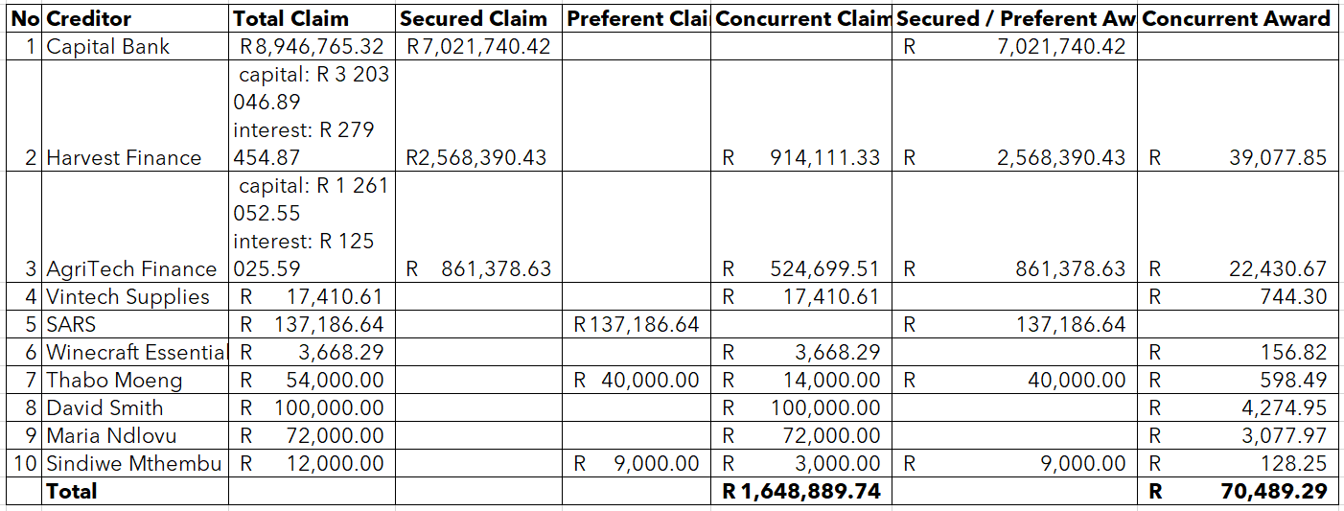
Distribution Account 5 [due to format of the below table, I could not indicate where marks were awarded.

Bank reconciliation statement 4
Narration | Debit | Credit
Balance as per bank statement as at date of drafting of account  Payments still to be made:  Bond of Security Premium  Master’s fee  Liquidator’s fee  Advertising Costs  Postage and Petties  Bank Charges  Vat payable to SARS  Awards to Creditors still to be made  Capital Bank  Harvest Finance  AgriTech Finance  Free residue  SARS  Thabo Moeng  Sindiwe Mthembu  Concurrent dividend | R 26 000.00  R 275 000.00  R 886 850.92  R 37.82  R 1 030.00  (½) (½)  R 150.00  R 1 655 201.67  R 7 021 740.42  R 2 568 390.43  R 861 378.63  (½) (½)  R 137 186.64  R 40 000.00  R 9 000.00  R 70 489.29 | R 13 552 455.81 (½) (½)
Total | R 13 552 455.82 | R 13 552 455.82 (½) (½)

