PERSONAL INFORMATION | JELENKO LEHKI
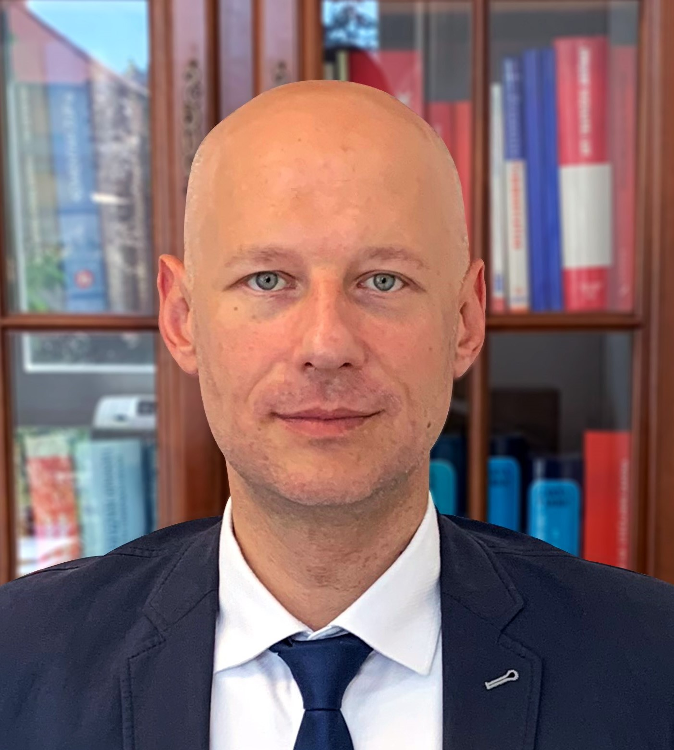 | Pavla Hatza 10, 10000 Zagreb, Croatia
 | +385 1 88 953 68 +385 98 16 394 16
 | jelenko.lehki@lehki.com
 | www.lehki.com
 | Sex Male | Date of birth 24/07/1979 | Nationality Croatian

ROLE IN THE TEAM | To be completed by the pursuit team
SHORT BIO | Experienced Attorney at Law and Insolvency Practitioner certified to work at all Commercial Courts in Croatia, with strong interest in international insolvency. Current President of Croatian Association of Trustees in Bankruptcy. Workshop leader and lecturer at Judiciary Academy and Ministry of Justice’s mandatory education for Insolvency Practitioners, Member of the Ministry of Justice workgroup for reform of Insolvency Act, Insol Europe Country coordinator, member of Insol International and International Bar Association. Owner of Lehki Law Office, currently team of 3, two lawyers and one intern/trainee.

WORK EXPERIENCE

2020 - | Country Coordinator
 | INSOL Europe
 | - Coordinating activities of members in Croatia, contributing to INSOL Europe projects
 | Business or sector Non Profit – professional association of Insolvency Pracitioners

2018 - | President of Association
 | Croatian Association of Trustees in Bankruptcy
 | - Responsible for organization and development of Association, Croatia’s only association of Insolvency Practitioners
 | Business or sector Financial Advisory Services

July 2015 - | Licensed Insolvency Practitioner
 | On List A of all (9) Commercial Courts in Croatia
- Appointed as Insolvency Office Holder in over 880 corporate insolvency proceedings
- Appointed as Trustee in pre-insolvency proceedings
- Appointed as Trustee in consumer insolvency proceedings

 | Business or sector Financial Advisory Services
October 2008 - | Attorney at Law
 | Lehki Law Office
- Owner of law office, providing representation and legal advice primarily in insolvency, real estate and corporate/M&A
- Representation of domestic and international clients
- Before focusing (on insolvency, represented companies mostly in Healthcare sector, wholesale and retail providing advice and assistance in expanding of business and acquiring cerificates for operation
- Extensive experience in real estate and land registry/cadastre matters

 | Business or sector Legal services

October 2005 – October 2008 | Lawyer Trainee
 | Attorney at law Krešimir Preprotić
- Lawyer Trainee
- Civil proceedings, court collection of debt proceedings, real estate and land registry proceedings

 | Business or sector Legal services

EDUCATION AND TRAINING

2020 - (2021 expected date of completion) | Foundation course in international insolvency
 | Insol International
2015 | Exam for Insolvency Practitioners
 | Ministry of Justice
2008 | Bar Exam  Ministry of Justice
1997 – 2005 | Mag.Iur.
 | University of Zagreb, Faculty of Law in Zagreb

PERSONAL SKILLS

Mother tongue(s) | Croatian
Other language(s) | UNDERSTANDING |  | SPEAKING |  | WRITING
 | Listening | Reading | Spoken interaction | Spoken production
English | C1 | C1 | C1 | C1 | C1
German | A1 | A1 | A1 | A1 | A1
Levels: A1/2: Basic user - B1/2: Independent user - C1/2 Proficient user
Common European Framework of Reference for Languages

Communication skills | - Strong communication, presentation and lecturing skills

Organisational / managerial skills | - leadership skills - currently responsible for a team of 4 people at Law Office  - currently president of professional association – 175 members

Job-related skills | - Healthcare/medicinal products and medical devices quality assurance systems design and development, successfully certified by Ministry of Health and Agency for Medicinal Products and Medical Devices of Croatia - HALMED – projects of certification of wholesale of medicinal products and medical devices

Computer skills | - Full computer literacy, Microsoft Office™ tools

Other skills

Driving licence | - B, C - 23 years

ADDITIONAL INFORMATION

Projects | ▪ Ministry of Justice – Workgruop for reform of Insolvency Act – workgroup member – Jan 2021  ▪ Insol International - Cost Assessment for Debt Collection Abroad – Croatia chapter – 2021  ▪ Croatian Associaton for Mediation and Croatian Association of Trustees in Bankruptcy – webinar on possibilities of mediation in insolvency – moderator/host  ▪ Insol Europe – “Covid coffebreaks” – video series on impact and challenges to the insolvency profession in Europe countries due to coronavirus (COVID-19) pandemic - 2020  ▪ Judicial Academy - Education of insolvency practitioners - Workshop leader – lecturer - Aug 2019 – Nov 2019  ▪ Ministry of Justice - Education of insolvency practitioners - Workshop leader – lecturer - Jul 2017 – Jul 2019

Publications | Eurofenix no. 80 (published by INSOL Europe) - Croatia: Emergency measures in response to the COVID-19 crisis – July, 2020  ▪ INSOL International – World Bank Group - Global Guide of Measures adopted to support distressed businesses through the COVID-19 crisis - Croatia chapter - publication date Jun 15, 2020  ▪ Lexis Nexis in partnership with INSOL Europe - (COVID-19) Tracker of Insolvency - Restructuring & Insolvency analysis: Reforms to the insolvency law in Croatia prompted by the coronavirus (COVID-19) pandemic - publication date May 5, 2020

