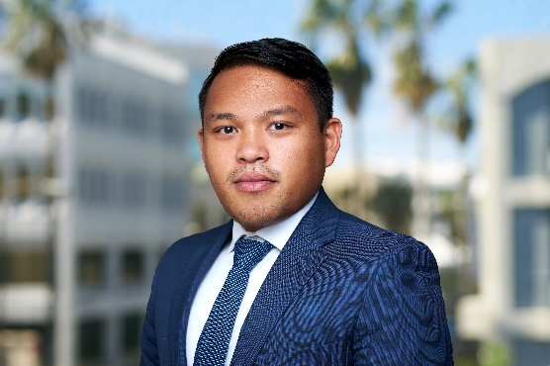 | Franco Kwan  Assitant Manager Financial Advisory  Deloitte Ltd, Hamilton, Bermuda  T +1 (441) (299) (1386)  M +1 (441) (505) (2290)  franco.kwan@deloitte.com

With deloitte since / Professional experience | - Deloitte LLP (Ireland): October 19, 2015 – October 19, 2018  - Deloitte Ltd (Bermuda): January 2, 2019 - present
Functional service | - Restructuring Services / Financial Statements Compilations
Qualification / Education | - ACA (2018), Association of Chartered Accountants Ireland  - MSc in Accounting (2015), Dublin City University  - BA in Accounting & Finance (2014), Dublin City University
Functional specialization /  Industry know-how* | - Assistant Manager – Restructuring & Insolvency Services  July 1, 2020 – present  I am currently working as an Assitant Manager in the Financial Advisory department. My main work involves review of companies’ solvency, restructuring and court appointed liquidations.  - Audit Senior – Investments  January 2, 2019 – June 30, 2020  I worked as an Audit Senior primarily in US GAAP Funds with Feeder-Master structure and Fund of Funds. I also deal with audit clients reporting under IFRS and ISA standards as well as local clients.  I am responsible for the management of the file, liaising with client administration to obtain supporting documents to various tests, planning and performing procedures on file and helping the manager complete various audit files and ensure that files are archived on a timely manner.  - Audit Senior - Financial Services  October 19, 2015 – October 19, 2018  I worked on a broad range of clients, with extensive experience in the Investment Management, Funds, and Aircraft Leasing industry. I have a lot of experience in critically assessing financial statements under IFRS and Irish GAAP and providing guidance to clients on complex accounting issues. I also worked in PCAOB audit engagements.  As a senior, I developed project management skills to ensure that deadlines for deliverables are met, liaise with Managers and Partners to deliver quality audit service and coached junior members of the engagement team. I also developed strong professional working relationship with the clientPrevious experience in the Dublin office include senior experience in Investment Management, Funds and Aircraft Leasing under IFRS and ISA (Ireland). I also have experience on Component/Group audit on a PCAOB engagement.  - Independent Oversight - Senior (Risk Advisory)  May 7, 2018 – October 5, 2018  I was seconded to London on a Risk Advisory engagement on a large commercial bank. Our role include reviewing the assessing the client’s response to rules issued by the Central Bank of Ireland and testing their logic, test approach, their inputs and deliverables. We reperformed their test and inquire any discrepancies found by the team.  I was assigned as task leader in one of the Phases. My job was to review the testing approach and design the testing paper to be used by the team. I was responsible to collate all queries, discuss the tests performed with Managers and feedback to the client in order to obtain responses. As team leader, I was also responsible to draw-up our testing approach and document findings in our test which would form part of the final report that will be issued to the Central Bank.  As added task, I was responsible for budgeting and expense analysis of the Project, review the invoices for any descrepancies with expectations and to ensure that expenses are on track with the budget.  - Project Management Officer - Analyst (Consulting)  May 9, 2016 – October 7 2016  I was seconded to the Consulting department (Project Management) working in a large commercial bank who primarily operates in Ireland and Scotland.  My work as a PMO Analyst involved keeping deliverables tracker updated from any discussions in team meetings, ensuring all tasks and reports are completed on a timely basis, sitting in team meetings to document discussions and action points to be circulated to the team, and ensuring collating board packs (internal meetings) and reports (communication to regulators). I assisted various project teams in the design of business process, creating business flow diagrams and creating excel templates to be used by their teams.  As added duties, I was tasked to create a resource tracker that includes staff work days and leave days ensuring that there is enough staff working on various projects at any given day. This tracker includes joiners and leavers date. I created a simple tool in the tracker to extract a list of joiners / leavers to ensure various steps are performed i.e. requesting / removing access to systems.
Language | - Cebuano (first language)  - English (professional)  - Filipino (conversational)

