GLOBAL INSOLVENCY PRACTICE COURSE 2023/2024

Prof. dr. Omar Salah – Norton Rose Fulbright / Tilburg University

Case Study II – Part I

- Introduction
  - This memorandum (the Memo) sets out our advice in relation to your request for guidance on the restructuring possibilities for the Efwon group of companies (the Efwon Group). I have prepared this Memo based on the facts and circumstances as provided by the General Counsel of the Efwon Group in his briefing document titled “Briefing and Preparation for Written Assessment Prior to Module B” (the Briefing).
  - I have made an initial assessment of the restructuring possibilities for the Efwon Group under Dutch, New York and Singaporean law. I note that the laws of other jurisdictions, including (without limitation) Romanian and Malaysian law, may also be relevant for the assessment and advice that you are seeking. Whilst I would be delighted to make a further analysis under the laws of other relevant jurisdictions as well, we have limited our review to Dutch, New York and Singaporean law only at this stage.
  - In paragraph 2, I set out the facts and circumstances that are deemed relevant for the advice in this Memo. In paragraph 3, a high-level overview of the restructuring possibilities for the Efwon Group is provided. I provide guidance on the strategy as well as next steps in paragraph 4, followed by a conclusion in paragraph 5.
- Relevant facts
  - The Efwon Group is a group of companies active in the Formula 1 (F1) competition, a series of races held at circuits across the world. The ultimate beneficial owner of the Efwon Group is Mr Maximov (the Shareholder). The Efwon Group has companies in various jurisdictions in the world. We understand from the Briefing that the group structure of the Efwon Group is as follows. Efwon Investments Inc. is the top holding of the group and incorporated in Texas, USA. It holds 100% of the shares in Efwon Trading B.V., a legal entity incorporated in the Netherlands. Efwon Trading B.V., in turn, holds 100% of the shares in each of Efwon Romania and Efwon Singapore.
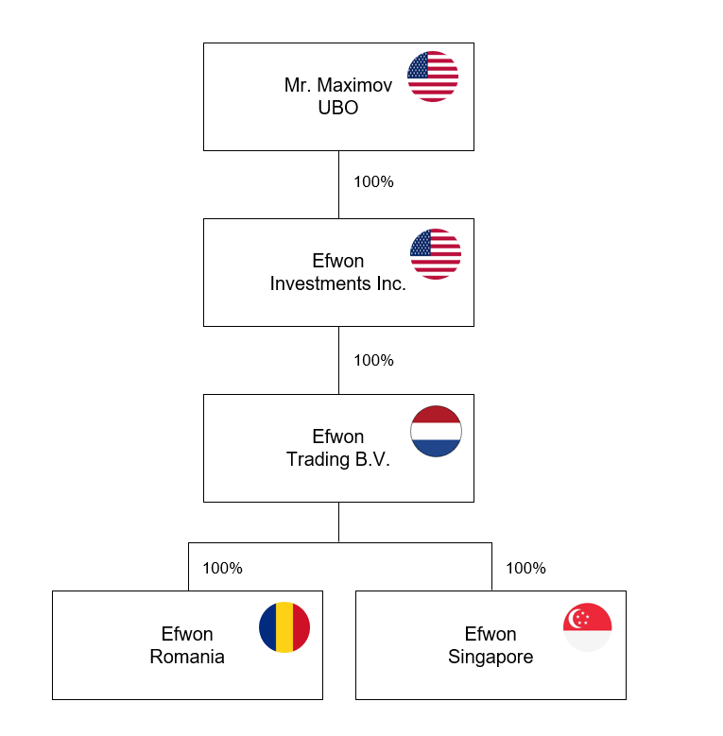
  - The Efwon Group has financed itself through equity financing from the Shareholder as well as debt financing from various lenders. Efwon Investments Inc. is financed with equity funding of USD 100 million from the Shareholder and debt funding of USD 250 million from a syndicate of banks (the Lenders). The Lenders have entered into a facilities agreement with Efwon Investments Inc., as the borrower, for a period of 10 years with an interest rate of LIBOR plus a margin of 4% (the Facilities Agreement). Currently, an interest of LIBOR plus a margin of 6% applies. The Facilities Agreement contains customary terms and conditions (including (without limitation) a negative pledge and a positive pledge) and the Lenders have security package consisting of a pledge over the shares in Efwon Investments Inc., a pledge over the shares in Efwon Trading B.V., a pledge over all revenues flowing back from the investment in the F1 sport, a pledge over the loans and mortgages over several real estate property of the Shareholder. Efwon Investments Inc. has, in turn, financed Efwon Trading B.V. with a USD 350 million shareholder loan which was secured with a pledge over the future revenue of the company’s trading activities. In addition, Efwon Trading B.V. has entered into a USD 100 million loan agreement with a lender in Monaco (the Alternative Lender) with a high interest rate and secured with pledges over revenues of itself, of Efwon Romania and of Efwon Singapore. Finally, Efwon Trading B.V. has granted two loans of USD 150 million in aggregate to Efwon Romania, secured with a pledge over the broadcasting revenues from participation by the team in F1.
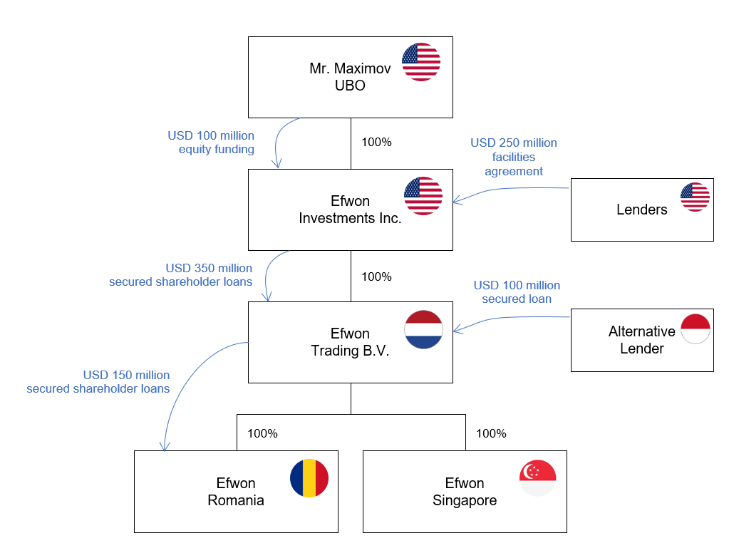
  - Finally, the sponsorship contracts are very important to the Efwon Group. Currently, Efwon Singapore has a sponsorship contract with Kretek. However, the expectation is that this will no longer be extended. KuasaNas has expressed that it is considering entering into a sponsorship contract with Efwon Singapore for funding in excess of USD 100 million, if it could acquire a 51% majority stake in the F1 team.
  - I understand that the financial position of the Efwon Group is dire currently. The drivers have brought claims against it before the Romanian courts for a substantial compensation. The drivers have filed inter alia for the insolvency of Efwon Romania. This affects the ability of the entire group to generate and upstream revenues. Consequently, the Lenders and the Alternative Lender are considering enforcement actions.
- Restructuring possibilities for the Efwon Group
  - This memorandum (the Memo) sets out our advice in relation to your request for restructuring options. I have reviewed the Independent Business Review (IBR), a copy of which was provided to me by the General Counsel of the Efwon Group, and note that any restructuring would need to factor in the following three elements: (a) Efwon will need to improve operations to be more cost-efficient; (b) a sponsorship deal such as KuasaNas is necessary for the company to (service its debt and) be cash-positive; and (c) there is no time to explore alternative options.
  - I believe the Efwon Group should initially focus on creating a stable platform. That needs to be its first priority in the initial stage. Subsequently, it can work out further restructuring possibilities and map it the content of a restructuring plan to be offered to its creditors and/or shareholders.
- Phase 1: Creating a stable platform
  - In phase 1, the Efwon will need to focus on creating a stable platform. With lenders’ enforcement actions having been announced and certain drivers already having initiated proceedings and filed for bankruptcy proceedings, getting some form of protection against these enforcement actions and bankruptcy filing is key in this phase. The key jurisdictions to focus on here are: the US, the Netherlands and Romania.
  - Generally, I would advise the debtor group to enter into lock-up agreements with the key stakeholders (i.e. creditors and shareholders) before opening any formal restructuring proceedings so that there is some certainty about the level of support for the restructuring plan. This provides deal certainty and gives the debtor more control over the amount of deal support from creditors and shareholders, especially in light of the requisite majority in the relevant jurisdiction to sanction the restructuring plan. However, given that the drivers in Romania have already filed for bankruptcy and the Lenders in the US as well as the Alternative Lender from Monaco are considering enforcement actions, seeking protection against these legal proceedings warrants the opening of restructuring proceedings to have the protection of a stay. Briefly put, the Efwon Group needs to petition for a Chapter 11 in the US and a Dutch WHOA in the Netherlands. I will discuss these options in more detail below.
US
  - The Efwon Group may consider filing for a US Chapter 11 proceeding in New York. One of the main benefits of the Chapter 11 proceeding is that it grants the debtor a global stay with universal effect. All the entities of the Efwon Group have access to the US Chapter 11 proceeding. Based on case law, a foreign (non-US) entity does not need to do business in the US to find itself within the jurisdiction of the US Bankruptcy court, but a transaction involving a US currency with a US bank account is sufficient to allow the US bankruptcy court to exercise jurisdiction over a foreign entity. One of the main benefits of the Chapter 11 proceeding is that it provides an automatic stay.
  - The stay under the US Chapter 11 proceeding has global effect. This means that, from a US perspective, the stay has global effect in all jurisdictions where the Efwon Group is active. Given that the Lenders are considering enforcement actions and they are lenders at the level of the US entity Efwon Investments Inc., having a stay in the US would facilitate the Efwon Group in creating a stable platform. Further, from a US perspective, the stay under the Chapter 11 proceeding would also halt enforcement action from the Alternative Lender vis-à-vis Efwon Trading B.V. in the Netherlands as well as Efwon Romania in Romania. However, the question is whether this would also be recognised in these jurisdictions.
The Netherlands
  - The Alternative Lender has granted a USD 100 million secured loan to Efwon Trading B.V. in the Netherlands and has security rights at that level of the Efwon Group. The Alternative Lender is also considering enforcement action. Whilst the stay under the Chapter 11 proceeding has a global effect from a US perspective, it may not be recognised in the Netherlands. The Dutch Bankruptcy Act (DBA) does not provide any rules for the recognition of non-EU foreign restructuring and insolvency proceedings. This raises the question whether the stay under a Chapter 11 proceeding is effective with respect to assets of the Efwon Group that are located in the Netherlands. From a Dutch law perspective, a foreign (non-Dutch) insolvency proceeding will not be recognised in the Netherlands, unless (i) the jurisdiction of the foreign judgment is based on a ground of jurisdiction generally acceptable by international standards; (ii) the foreign judgment was given in proceedings that meet the requirements of due and proper administration of justice with adequate safeguards; (iii) the recognition of the foreign judgment is not contrary to Dutch public policy; and (iv) the foreign judgment is not incompatible with a (foreign or Dutch) judgment rendered between the same parties in a dispute concerning the same subject matter and based on the same cause of action, provided that such earlier judgment is capable of recognition in the Netherlands. However, even if these four grounds are met and the US Chapter 11 judgment is recognised in the Netherlands, it does not have effect in the Netherlands insofar as it would prevent creditors from seeking recourse for their claims against assets which form part of the debtor’s estate and are located in the Netherlands. This means that there is a risk that the Alternative Lender would still be able to rake recourse for its claims against Efwon Trading B.V.’s assets that are located in the Netherlands, despite the Chapter 11 proceeding and its automatic stay in the US. Therefore, the Efwon Group may seek additional protection in the Netherlands.
  - Efwon Trading B.V. may file for a Dutch WHOA restructuring proceeding. Efwon Trading B.V. is presumed to have its centre of main interests in the Netherlands, given that its corporate seat as a Dutch B.V. is located in the Netherlanss. Consequently, the Dutch court will accept jurisdiction over it in a Dutch WHOA proceeding. Furthermore, the Dutch court may also accept jurisdiction over the other entities of the Efwon Group, provided that they have sufficient connection with the Netherlands which is the case given that there is a Dutch entity in the group with substantial activities in the Netherlands.
  - Efwon Trading B.V. may petition for a stay (afkoelingsperiode) under the Dutch WHOA. The Dutch court may also grant a stay in relation to the other (foreign) entities in the Efwon Group. Consequently, the entire Efwon Group will have the benefit of the stay under the WHOA. From a Dutch law perspective, such stay has global effect. This means that the Dutch WHOA provides the Efwon Group a group-wide stay for its Dutch and foreign (non-Dutch) debtors with universal effect.
  - To the extent required, the Efwon Group may also file for recognition of the Dutch WHOA proceeding under a Chapter 15 proceeding in the US. Based on case law, the US bankruptcy court will recognise a stay under the WHOA in the US in a Chapter 15 proceeding. As a result, the Efwon Group may benefit from protection in the US. One could argue that – with the recognition of the Dutch WHOA in a Chapter 15 proceeding in the US – there is no need for separate a Chapter 11 proceeding in the US. However, given that the Lenders are considering enforcement action in the US, I would still advise the Efwon Group to file for a Chapter 11 proceeding. The main reason for this is that the stay under a Chapter 11 proceeding has two advantages compared to a stay under the Dutch WHOA. First, the stay under a Chapter 11 is an automatic stay which enters into force upon opening of the Chapter 11 proceeding, whilst a stay under the Dutch WHOA requires a separate petition which the court needs to grant. This means that (at least in theory) there is a risk that the stay under the Dutch WHOA will not be granted. Second, the global effect of the Chapter 11 stay is de facto stronger than the global effect of the Dutch WHOA (although de jure there may be no difference, as each of them is dependant on recognition in the relevant foreign jurisdiction). This is due to the fact that acting in breach of a court order of a US bankruptcy court will lead to contempt of court. Whilst the same may be true for a court order of a Dutch, the power of the US is stronger than that of the Netherlands and in practice creditors may be more cautious acting in contempt of the court order of a US bankruptcy court compared to that of a Dutch court.
Romania
  - The Efwon Group will need to file for a public WHOA proceeding (openbare akkoordprocedure buiten faillissement). The public WHOA proceeding is on Annex A of the European Insolvency Regulation and, as a result, the public WHOA proceeding allow enjoy automatic recognition throughout the EU. Romania is a EU member. This means that the stay under the WHOA would automatically be recognised in Romania.
  - The drivers in Romania has filed for the bankruptcy of Efwon Romania. However, the stay under the WHOA (i) prevents parties from taking enforcement actions against the assets of the debtor or taking possession of assets that are under the control of the debtor, (ii) allows for the lifting of attachments on the assets of the debtor, and (iii) suspends any pending suspension of payments or bankruptcy cases. The bankruptcy petitions filed by the drivers against Efwon Romania would, thus, be suspended. This would give the company breathing space.
Singapore
  - Finally, whilst there is no direct threat of enforcement action in Singapore, the Efwon Group may also seek protection in Singapore to create a stable platform. Singapore has adopted the UNCITRAL Model Law on Cross-Border Insolvency (the UNCITRAL Model Law). As a result, the Singapore courts have recognised US Chapter 11 proceedings. Whilst so far there is no precedent under Singapore law for the recognition of the Dutch WHOA in Singapore, the expectation is that the adoption of the UNCITRAL Model Law on Cross-Border Insolvency would lead to recognition of the Dutch WHOA in Singapore as well. After all, the Dutch WHOA has been recognised in a US Chapter 15 proceeding which is also the adoption of the UNCITRAL Model Law in the US.
UK
  - Finally, based on the briefing there is no indication that the various loan agreements as set out above in para. 2.2 are governed by English law. If the loan agreements would have been governed by English law, an English restructuring proceeding was required in light of the Gibbs rule. However, this is not the case here and, hence, there is no need to file for an English Scheme or Arrangement or Restructuring Plan. As a matter of fact, it is a good thing that there is no English law governed debt as otherwise a third restructuring proceeding was required. Further, the English Scheme of Arrangement does not provide for a moratorium and the moratorium under the English Restructuring Plan does not affect financial creditors. At the same time, one of the main benefits of the Dutch WHOA is the use of its stay and the global effect thereof. Further, the public WHOA proceeding will be recognised in other EU member states such as Romania, which is not the case for the English Scheme or Arrangement or Restructuring Plan. Therefore, the Dutch WHOA is the preferred solution over the English Scheme or Arrangement or Restructuring Plan for the restructuring of the Efwon Group.
Interim conclusion
  - As an interim conclusion, I would advise the Efwon Group to file for parallel proceedings in the US and the Netherlands. The Efwon Group may file for Chapter 11 proceedings in the US. The main benefit hereof is that it will have protection against enforcement actions under an automatic stay with global effect. This will provide protection against the Lenders. However, such global effect may not provide Efwon Trading B.V. protection against enforcement actions from the Alternative Lender against the assets located in the Netherlands. In parallel to the Chapter 11 proceeding, the Efwon Group may file for a public Dutch WHOA proceeding and petition for a stay under the WHOA. Once the stay is granted, the Efwon Group will have protection against enforcement actions and any bankruptcy filing will be suspended. Given that the public WHOA proceeding is on Annex A of the European Insolvency Regulation, the Dutch WHOA and a stay thereunder will be automatically recognised in Romania which suspends the bankruptcy filings by the drivers. Further, the Efwon Group may file for recognition of the Dutch WHOA in the US in a Chapter 15 proceeding as well as recognition of the US Chapter 11 and Dutch WHOA in Singapore under the adoption of the UNCITRAL Model Law in Singapore.
- Phase 2: Restructuring plan
  - One of the key findings from the IBR is that the Efwon Group needs to obtain the sponsorship deal from KuasaNas. KuasaNas is willing to enter into a sponsorship contract with Efwon Singapore for funding in excess of USD 100 million, provided that it acquires a 51% majority stake. Furthermore, according to the Briefing, one of the pre-conditions KuasaNas has stipulated for closing the deal is that the insolvency issues affecting the Efwon Group are dealt with promptly and the Efwon Group has been restored to a stable platform (that is, without any issues at any level in the group). Whilst the stay under the US Chapter 11 and the stay under the Dutch WHOA provides a temporary stable platform, it does not do so permanently. It gives the debtor time to offer a restructuring plan addressing the issues.
  - The Efwon Group may offer a similar restructuring plan – also referred to as a ‘mirrored restructuring plan’ – in the parallel restructuring proceedings in the US and the Netherlands, i.e. US Chapter 11 and Dutch WHOA. The restructuring plan under the US Chapter 11 and Dutch WHOA proceeding may contain the following elements:
    - part of the shares in the Efwon Group may be transferred to KuasaNas;
    - the claims of the drivers in Romania are unsecured claims and may be wiped out;
    - the external debt to the Lenders and the Alternative Lenders may be affected, either through a debt write-off or amendment of the finance documents.
  - I will discuss each of these options in more detail below.
Transfer of part of the shares in the Efwon Group to KuasaNas
  - KuasaNas has asked for a 51% majority stake in the Efwon Group. Both the US Chapter 11 proceeding and the Dutch WHOA proceeding allow for the impairment of rights of shareholders. This means that under each of these restructuring proceedings it is possible to grant 51% of the shares to KuasaNas, for example through the issuance of new shares or through cancellation of existing shares and issuance of new shares. Any pre-emptive rights of rights-of-first-refusal of existing shareholders may be disregard under these restructuring proceedings. Assuming the sponsorship contract of KuasaNas acquires government approval, it is possible to give it a 51% majority stake as part of the restructuring.
  - It is worthwhile to include the sponsorship contract and the 51% shares transfer/issuance to KuasaNas in the restructuring plan. This will allow affected parties to vote on the broader restructuring plan, gives KuasaNas certainty that either all issues are resolved when the restructuring plan is sanctioned and the sponsorship contract becomes effective and it will acquire a 51% majority stake, and gives the relevant courts the bigger picture. To the extent that the shareholder or Mr Maximov as the UBO dispute this, they may be (cross-class) crammed down by the ordinary unsecured creditors and the secured creditors.
Unsecured claims of claims of the drivers in Romania
  - If the drivers are successful in their claims against Efwon Romania, this can lead to substantial compensation being awarded according to the Briefing. If these claims would jeopardize the Efwon Group’s financial position leading potentially to its insolvency, it may consider restructuring these claims through a write-off or complete wipe-out. Assuming the claims are tort claims or claims for breach of contract, the claims of the drivers will most likely be unsecured claims. In both US Chapter 11 proceedings and Dutch WHOA proceedings, it is possible to restructure unsecured litigation claims.
  - The restructuring plan of the Efwon Group will most likely need to address these claims. The partial write-off or complete wipe-out of unsecured litigation claims is possible, subject to certain safeguards. Most importantly, the best-interest-of-creditors test needs to be satisfied in both jurisdictions. This means that the Efwon Group needs to establish that the drivers are out of the money, i.e. they will not receive anything in a bankruptcy, or at least a low amount of recovery in bankruptcy liquidation compared to what they are being offered under the restructuring plan. This test in essence safeguards that no creditor is worse off under the restructuring plan compared to what they would receive in a bankruptcy liquidation of the debtor. The Efwon Group needs to engage a valuation expert that prepares valuation report setting out the liquidation value of the Efwon Group, preferably through an entity-priority-model (EPM) setting out the value at the level of each entity of the Efwon Group. If the drivers are out of the money, a full wipe-out of their unsecured claims may be justified.
  - Next, the Efwon Group also needs to establish that the absolute-priority-rule is respected in each jurisdiction. This means that the value distributed under the restructuring plan respects the statutory and contractual priority of claims/entitlements of creditors and/or shareholders. If the drivers as unsecured creditors are out of the money, this presumes that the shareholders are also completely out of the money. There could be three options to deal with this and respect the absolute-priority rule:
    - The drivers are offered partially shares into the company (from the remaining 49%), which would result in a debt-for-equity swap, swapping their unsecured claims into shares in the capital of the Efwon Group;
    - At the level of Efwon Romania – where the drivers have their claims – there is an secured shareholder loan from Efwon Trading B.V. The parties may argue that the shareholders are completely out of the money, but the drivers as unsecured creditors are not receiving any shares. Instead, the USD 150 million secured shareholder loans – which rank above the unsecured claims of the drivers – is swapped in a debt-for-equity swap into 49% in the capital of Efwon Romania. This would mean that Efwon Trading B.V.’s exiting shares are completely wiped out, but it received 49% shares in Efwon Romania for a debt write-off of its secured claim of USD 150 million, whilst KuasaNas which wanted to have 51% stake in the F1 team – which sits at the level of Efwon Romania – acquires 51% shares for the new value under the sponsor contract of USD 100 million; or
    - The entire shares of Efwon Trading B.V. may be wiped out, the unsecured claims of the drivers may be wiped out and the shares may be given to KuasaNas. However, as KuasaNas has expressed interest in a 51% majority stake only, it may give its part of the value to Efwon Trading B.V. in the form of ‘gifting’. This form of ‘gifting’ is allowed under US Chapter 11 proceedings and Dutch WHOA proceedings. KuasaNas may have governmental limitations to hold 100% shares in the company and may also value the expertise and experience of the Efwon Group which could be reasons to 'gift' 49% of the shares to Efwon Trading B.V.
  - Based on the information available in the Briefing it is difficult to assess the courses of action, but subject to negotiations and the figures option (b) may be the preferred route.
  - However, a very important parameter will in any case be the reorganisation value of the Efwon Group, as that will be the basis for assessing the absolute-priority-rule. Hence, the Efwon Group needs to engage a valuation expert that prepares valuation report setting out the reorganisation value of the Efwon Group.
Secured creditors: the position of the Lenders and the Alternative Lender
  - Finally, another important group of creditors are the Lenders at the level of Efwon Investments Inc., and the Alternative Lender at the level of Efwon Trading B.V. The Lenders have granted a USD 250 million secured loan, while the Alternative Lender has provided a USD 100 million secured loan. They have different security packages. The Briefing does not contain any information on whether the leverage is too high, the debt burden is unsustainable or debt service pressing too much on the liquidity of the debtor. Hence, the assumption is that no debt write-off is required from these secured creditors.
  - However, amendments to the finance documents with the Lenders respectively the Alternative Lender may be required to create a stable platform as required by KuasaNas. Such amendments may relate to an extension of the maturity date or a reset of financial covenants. To the extent any such amendments to finance documents are required, they can be included in the restructuring plan. The secured lender group is typically an in-the-money class which genuine economic interest and is, therefore, an important stakeholder group to manage from the company’s perspective. To the extent the Lenders (or more accurately, the require majority of lenders that is needed under the finance documents to instruct the agent to execute the amendment) respectively the Alternative Lender do not agree to such amendments, they may be potentially crammed into a solution, for example through an intra-class (or cross-class) cram down.
Other creditors
  - Based on the Briefing, I would advise to leave other creditors of the Efwon Group (such as trade creditors, suppliers and/or employees) out of the restructuring plan. This allows the business to continue trade without business disruption, whilst at the same time keeping the stakeholders Efwon Group needs to negotiate with limited.
- Strategy and next steps for the Efwon Group
  - This Memo sets out our advice in relation to your request for input on the strategy for a restructuring as well as next steps to prepare while looking ahead.
  - In terms of strategy, I would suggest that the Efwon Group engages with its most important stakeholders, i.e. the Lenders, the Alternative Lender, KuasaNas and the drivers. Stakeholder management is key in this process. I would propose to do that in the following order:
    - The Efwon Group should focus on the Lenders and the Alternative Lender. They are important stakeholders, also to ensure there is a consenting creditor class under the US Chapter 11 and the Dutch WHOA.
    - The Efwon Group should continue engaging with KuasaNas and have it fully involved in the process to make sure it has the relevant information.
    - The Efwon Group should also constructively engage with the drivers. At the end of the day, a bankruptcy liquidation would not be in their interest either.
  - In terms of priority and next steps, I would advise to do the following:
    - The initial focus here would be to petition for a US Chapter 11 proceeding including its automatic stay;
    - Also, focus on the petition for the Dutch WHOA is key, which in this case would include a petition for a stay under the Dutch WHOA;
    - Once the US Chapter 11 and the Dutch WHOA are in place, recognition proceedings may be petitioned under US Chapter 15 (for the Dutch WHOA) and in Singapore under its adoption of the UNCITRAL Mode Law (for the Chapter 11 and the WHOA). No separate recognition proceeding is required in Romania, as it will automatically recognise the effects of the Dutch WHOA; and
    - Then, the Efwon Group also needs to engage a valuation expert that prepares valuation report setting out (i) the liquidation value and (ii) the reorganisation value of the Efwon Group on an EPM-basis. This typically takes some time (4-6 weeks) so it would be good to instruct a valuation expert in time.
- Conclusion
This Memo sets out our restructuring advice. I believe the company needs to file for parallel proceedings in the US and the Netherlands: Chapter 11 in the US and WHOA in the Netherlands. Subsequently, recognition proceedings may be petitioned in the US under Chapter 15 and in Singapore, whilst automatic recognition will take place of the WHOA in Romania. The restructuring plan offered under the Chapter 11 and WHOA may be offered to the Lenders, the Alternative Lender, the shareholder, KuasaNas and the drivers. Other creditors, such as trade creditors, supplies and employees, need to be left out the restructuring plan to avoid business disruption. Stakeholder management is key in this process. Finally, the company requires appropriate valuation reports.

Reference is made to 2022 WL 1620307 (S.D.N.Y. May 23, 2022). S In re Arcapita Bank B.S.C.(c), 529 B.R. 57, 61 (Bankr. S.D.N.Y. 2015); Comm. of Unsecured Creditors of Arcapita v. Bahrain Islamic Bank, 549 B.R. 56 (S.D.N.Y. 2016).
See section 362(a) U.S. Code, Title 11 (11 U.S.C.).
HR 18 January 2019, ECLI:NL:HR:2019:54.
HR 13 September 2013, ECLI:NL:HR:2013:BZ5668; HR 19 December 2009, ECLI:NL:HR:2008:BG3573.
Article 3(1) Regulation (EU) 2015/848 of the European Parliament and of the Council of 20 May 2015 on insolvency proceedings (recast) (European Insolvency Regulation).
Article 369(7) DBA.
Article 369(7) DBA in conjunction with article 3 Dutch Code of Civil Procedure.
Article 376 DBA.
Article 372(3) DBA.
Cf. HR 15 April 1955, ECLI:NL:HR:1955:1.
In re Diebold Holding Company, LLC, et al., (Case No. 23-90729).
Article 376 DBA.
Re Rooftop Group International Pte Ltd and another (Triumphant Gold Ltd and another, nonparties) [2019] SGHC 280.
Cf. In re Diebold Holding Company, LLC, et al., (Case No. 23-90729).
Antony Gibbs & Sons v La Société Industrielle et Commerciale des Métau (1890) 25 Q.B.D 399.
For a recent example under the WHOA, see District Court of Amsterdam 21 March 2024, ECLI:NL:RBAMS:2024:1608.

