INTRODUCTORY CERTIFICATE IN INSOLVENCY LAW AND PRACTICE IN THE CAYMAN ISLANDS 2023

Summative Assessment (Final Examination) Date: 23 – 24 November 2023

Time limit: 24 hours (from 13:00 Cayman time on 23 November to 13:00 Cayman time on 24 November 2023)

EXAMINERS

Mr John Royle Mr Mark Russell Mr Nicholas Fox Ms Corinne Celliers
Ms Cassandra Ronaldson Mr Adam Crane Ms Gemma Lardner Ms Jennifer Fox
Ms Jennifer Colegate Mr Tony Heaver-Wren Mr Paul Smith Mr Spencer Vickers
Mr Benjamin Tonner

MODERATORS

Mr John Royle Mr Nicholas Fox Ms Cassandra Ronaldson
Mr Spencer Vickers Dr David Burdette

It is imperative that all candidates read and take cognisance of the examination instructions on the next page.

All candidates are expected to comply with ALL the instructions.

INSTRUCTIONS

1. This assessment paper will be made available at 13:00 (1 pm) Cayman time on Thursday 23 November 2023 and must be returned / submitted by 13:00 (1 pm) Cayman time on Friday 24 November 2023. Please note that assessments returned late will not be accepted.

2. All assessments must be submitted electronically in Microsoft Word format, using a standard A4 size page and an 11-point Avenir Next font (if the Avenir Next font is not available on your PC, please select the Arial font). This document has been set up with these parameters – please do not change the document settings in any way. DO NOT submit your assessment in PDF format as it will be returned to you unmarked.

3. No limit has been set for the length of your answers to the questions. Please be guided by the mark allocation for each question. More often than not, one fact / statement will earn one mark (unless it is obvious from the question that this is not the case). Candidates who include very long answers in the hope it will cover the answer the examiners are looking for, will be appropriately penalised.

4. You must save this document using the following format: studentID.SummativeAssessment. An example would be something along the following lines: 202223-336.SummativeAssessment. Please also include the filename as a footer to each page of the assessment (this has been pre-populated for you, merely replace the words “studentID” with the student number allocated to you). Do not include your name or any other identifying words in your file name. Assessments that do not comply with this instruction will be returned to candidates unmarked.

5. The assessment can be downloaded from your student portal on the INSOL International website. The assessment must likewise be returned via your student portal as per the instructions in the Course Handbook for this course. If for any reason candidates are unable to access their student portal, the answer script must be returned by e-mail to david.burdette@insol.org.

6. Enquiries during the time that the assessment is written must be directed to David Burdette at david.burdette@insol.org or by WhatsApp on +44 7545 773890 or to Brenda Bennett at brenda.bennett@insol.org or by WhatsApp on +27 66 228 2010. Please note that enquiries will only be responded to during UK office hours (which are 9 am to 5 pm GMT, or 11 am to 7 pm SAST).

7. While the assessments are open-book assessments, it is important to note that candidates may not receive any assistance from any person during the 24 hours that the assessment is written. Answers must be written in the candidate’s own words; answers that are copied and pasted from the text of the course notes (or any other source) will be treated as plagiarism and persons who make themselves guilty of this will forfeit the assessment and disciplinary charges will follow. When submitting their answers, candidates will be asked to confirm that the work is their own, that they have worked independently and that all external sources used have been properly cited. If you submit your assessment by e-mail, a statement to this effect should be included in the e-mail.

8. Once a candidate’s assessment has been uploaded to their student portal (in line with the instructions in the Course Handbook), a confirmatory e-mail will be auto-generated confirming that the assessment has been uploaded. If the confirmatory e-mail is not received within five minutes after uploading the assessment, candidates are requested to first check their junk / spam folders before e-mailing the Course Leader to inform him that the auto-generated e-mail was not received.

9. You are required to answer this paper by typing the answers directly into the spaces provided (indicated by text that states [Type your answer here]). For multiple-choice questions, please highlight your answer in yellow, as per the instructions included under the first question.

10. If a candidate is unable to complete this summative assessment (examination), please note that a re-sit assessment will only be given if there are exceptional circumstances that prevent the candidate from completing or submitting it (such as illness). Feedback on this final assessment will be provided within four weeks of the paper having been written – please do not enquire about your marks before four weeks have elapsed. However, please note that it is our intention to send out the results on this course by Friday 22 December 2023 at the latest.

11. Please note that this document will probably reformat in line with the default settings of your printer or PC. Please do not be concerned if the formatting of this document changes in line with your printer or PC settings.

ANSWER ALL THE QUESTIONS

QUESTION 1 – MULTIPLE CHOICE QUESTIONS (20 MARKS)

Questions 1.1 – 1.20 are multiple-choice questions designed to assess your ability to think critically about the subject. Please read each question carefully before reading the answer options. Be aware that some questions may seem to have more than one right answer, but you are to look for the one that makes the most sense and is the most correct. When you have a clear idea of the question, find your answer and mark your selection on the answer sheet by highlighting the relevant paragraph in yellow. Select only ONE answer. Candidates who select more than one answer will receive no mark for that specific question. Each of the 20 questions count 1 mark.

Question 1.1

What is the date for Financial Institutions to submit its common reporting standard (CRS) Return in respect of reportable accounts?

- 1 January (annually)

- 1 April (annually)

- 1 July (annually)

- 1 October (annually)

Question 1.2

What is the maximum success fee permitted pursuant to Conditional fee agreements?

- 50%

- 33.33%

- 66.66%

- 100%

Question 1.3

Choose the correct statement:

How many forms of security interests are recognised in the Cayman Islands?

- 3

- 5

- 6

- None of the above

Question 1.4

Who may not petition for the winding up of a Company?

- The company.

- Any creditor.

- Any prospective creditor.

- Any contributory.

- Any prospective contributory.

Question 1.5

Choose the correct statement:

What is the minimum sum required to be owed, to enable a statutory demand to be used?

- KYD 50

- KYD 100

- KYD 1,000

- KYD 10,000

Question 1.6

Choose the correct statement:

A Restructuring Officer is required to report to the Court following their appointment:

- Within 21 days of the appointment.

- Within 28 days of the appointment.

- At such intervals as the Restructuring Officer considers appropriate.

- Within 7 days of the appointment.

Question 1.7

Which of the following is not required to be included in an affidavit filed in support of a restructuring petition:

- A statement that, having made due enquiry and taken appropriate advice, the board believes that the company is or is likely to become unable to pay its debts.

- An explanation of how the company will be funded during the restructuring period.

- A statement as to why the directors believe that the appointment of a restructuring officer will be in the bests interest of the company.

- A detailed outline of the proposed restructuring plan.

Question 1.8

Choose the correct statement:

A petition for the appointment of a Restructuring Officer can be brought by:

- the company.

- any creditor;

- any contributory; or

- all of the above

Question 1.9

Choose the correct statement:

Unless the Court otherwise directs, when must the petition for the appointment of a Restructuring Officer be heard?

- within 14 days of the petition being filed.

- within 21 days of the petition being filed.

- within 28 days of the petition being filed.

- within 56 days of the petition being filed.

Question 1.10

Choose the correct statement:

A scheme of arrangement:

  - can be sanctioned by the Court with the consent of all affected parties.

  - requires a special resolution in accordance with the company’s Articles.

  - can only proceed if there are shareholders / creditors who may not agree with it.

  - Only needs to be approved by a majority in value.

Question 1.11

Select the incorrect statement:

- The Cayman Islands adopts the principle of universalism and the principle of assistance in respect of cross-border insolvency.

- Foreign representatives can apply for assistance under Part XVII of the Companies Act.

- The Cayman Islands has implemented the UNCITRAL Model Law on Cross-Border Insolvency.

- There are no automatic rights in the Cayman Islands based on the centre of main interests of the debtor.

Question 1.12

Choose the correct statement:

If winding up proceedings are filed against a Cayman Islands company in the Cayman Islands and in a foreign country, which of the following statements is true?

- The Cayman Islands Court will wish to ensure comity between courts in other jurisdictions so it will be deferential to whatever decision is reached by the foreign court.

- The Cayman Islands Court will wish to ensure that Cayman Islands creditors have priority over foreign creditors.

- The Cayman Islands Court will wish to ensure that secured creditors cannot prejudice unsecured creditors.

- The Cayman Islands Court takes into account a number of factors, but the starting point is that the main insolvency proceedings for a Cayman Islands company should take place in the Cayman Islands.

Question 1.13

Select the correct statement:

- A voluntary liquidator will automatically cease to hold office if a conflict of interest arises during the liquidation.

- A voluntary liquidator will automatically cease to hold office as such upon the appointment of an official liquidator following a supervision order.

- A sole voluntary liquidator can resign at any time without reference to the shareholders or the court.

- A voluntary liquidator can be removed by the company’s creditors.

Question 1.14

Select the correct statement relating to the adjudication, quantification and distribution of claims during an official liquidation:

- An official liquidator acts in quasi-judicial capacity in respect of the adjudication of claims, meaning that the liquidator’s determination will be final and is not capable of dispute.

- A proof of debt is always required in order for an official liquidator to adjudicate on a creditor’s claim.

- Only creditors with a contractual right to interest have an entitlement to interest.

- A valid contract (agreed between the company and the creditor) can have the effect of changing the otherwise statutory ranking of that creditors’ claim, such that the claim is subordinated.

Question 1.15

Select the correct statement relating to the appointment of inspectors:

- The report of an inspector can be used in any legal proceeding as evidence of the opinion of the inspectors.

- Upon the appointment of an inspector the directors’ powers will automatically cease.

- Upon the appointment of an inspector there is a stay of proceedings such that a winding up application cannot be brought.

- Only CIMA has the power to appoint an inspector.

Question 1.16

Select the correct statement relating to exempted limited partnerships (ELPs):

- Limited Partners have an unfettered statutory right to petition the court to wind up the relevant ELP / General Partner.

- Where there are inconsistencies in relation to the dissolution of ELPs, the ELP Act will take priority over the Companies Act.

- An ELP is required to have more than one limited partner.

- An ELP formed under the Exempted Limited Partnership has a separate legal personality.

Question 1.17

Select the correct statement:

Which of the following statements in relation to informal workouts pursuant to the Cayman Islands law is correct:

- The restructuring officer regime is an example of an Informal workout process under Cayman Islands law.

- A stay of proceedings is not available in the Cayman Islands for informal creditor workouts.

- A qualified insolvency practitioner is required to oversee an informal workout under the Insolvency Practitioners Regulations.

- Under Cayman Islands law, any new financing advanced during an informal creditor workout will be provided with priority status in the event the company is later liquidated.

Question 1.18

Choose the correct statement:

Which of the following statements is true regarding a provisional liquidation application?

- The company has the statutory power to commence the proceedings.

- There is a worldwide moratorium (stay) upon the presentation of the provisional liquidation application.

- A winding up petition must be presented as a precursor to the application for the provisional liquidation.

- Following the implementation of restructuring officer regime, a company can no longer seek the appointment of a provisional liquidator if it intends on presenting a restructuring proposal.

Question 1.19

Select the correct statement:

An official liquidator can set aside dispositions that seek to prefer one creditor over other creditors within how many months / years before the deemed commencement of the company’s liquidation.

- Three months

- Six months

- Six years

- There is no time limit

Question 1.20

Select the correct statement:

Which of the following is not a fundamental principle of ethics for Insolvency Practitioners per the Cayman Islands Institute of Professional Accountants:

- Conflicts of interest

- Integrity

- Confidentiality

- Professional behaviour

** END OF QUESTION 1 **

QUESTION 2 FOLLOWS ON NEXT PAGE / . . .

QUESTION 2 – LIQUIDATION (45 MARKS)

Where appropriate, refer to the fact pattern below when answering the questions that follow. Please note that not all questions relate to the fact pattern.

FACT PATTERN

BLUESEA DIGITAL CAPITAL LIMITED

Bluesea Digital Capital Limited (Bluesea) was established in 2018 in the Cayman Islands as a digital asset management platform. Bluesea operated multiple online cryptocurrency trading platforms across the Caribbean and Latin America, known as OTPs. Investments made into these OTPs were held in secure brokerage accounts under Bluesea's own name. Bluesea's clientele comprised a diverse mix of institutional investors, high-net-worth individuals, and consumers.

On 24 June 2022, one of Bluesea's prominent OTPs, eTrade Wave (eTrade), abruptly disabled its buy / sell functionality without prior notice. At the time of suspension, eTrade had amassed over 2,500 users who had collectively invested approximately $125 million. This sudden suspension of the trading platform created widespread apprehension among investors, resulting in an overwhelming surge of withdrawal requests. Notably, Whitesand Capital (Whitesand) sought to withdraw its entire deposit of $32 million but faced insurmountable challenges in recovering the funds.

Unable to retrieve its deposit, Whitesand initiated winding up proceedings against Bluesea in May 2023. The petition faced vehement opposition from Bluesea, which asserted that deposits had been transferred to its joint venture partner. Bluesea claimed it needed additional time to resolve a “cordial disagreement” to facilitate the return of deposits. Amid allegations that investor deposits had not been segregated as promised and due to Bluewave’s inability to meet its financial obligations, the Grand Court of the Cayman Islands saw fit to make a winding up order on 22 August 2023.

Following the appointment of the official liquidator, Bluesea’s joint venture partner, based in Singapore, became the subject of several press reports. These reports alleged that its director had previously been involved in a fraudulent investment scheme in the early 2000s. Furthermore, the official liquidator had discovered that only one audit had ever been conducted in respect of Bluesea’s financial statements, with Bluesea’s auditors resigning shortly thereafter.

The official liquidators have called for creditor claims, and among the submissions received, a claim amounting to $0.5 million has surfaced, relating to leasing obligations tied to office space that was utilised by the joint venture partner. Bluesea’s documented records fail to substantiate any historical evidence of rental payments being disbursed by the company, nor do they reveal any corresponding liabilities recorded within its financial statements.

Question 2.1

As part of Whitesand’s petition to wind up Bluesea, Whitesand obtained sworn consent(s) to act from the proposed official liquidators. Set out the required content of the consent to act signed by the proposed official liquidator(s). (5)

Under the Cayman Islands Companies Act (2023 Revision) (hereafter written CA in the exam, to save space) Companies Winding Up Rules (2023 Consolidation) (CWR, similarly):

Nominated Official Liquidator's Consent to Act (O. 3, r. 4)
4. (1) Every petition shall be supported by an affidavit sworn by the person or persons nominated for appointment as official liquidator stating that —
(a) that person is a qualified insolvency practitioner and meets the residency requirement contained in Regulation 5;
(b) having made due enquiry, that person believes that that person and that person’s firm meet the independence requirement contained in Regulation 6;
(c) that person and/or that person’s firm are in compliance with the insurance requirement contained in Regulation 7; and
(d) that person is willing to act as official liquidator if so appointed by the Court.
(2) If the petition seeks an order for the appointment of a qualified insolvency practitioner jointly with a foreign practitioner, it shall be supported by an affidavit sworn by the foreign practitioner stating —
(a) that person’s professional qualifications;
(b) the country in which that person is qualified to perform functions equivalent to those performed by official liquidators under the Law or by trustees under the Bankruptcy Act (as amended and revised);
(c) that person’s professional experience;
(d) that person will have the benefit of professional indemnity insurance in respect of that person’s acts and omissions done in that person’s capacity as an official liquidator of the company meeting the requirements of Regulation 7;
(e) if that person has been appointed by a foreign court or authority as a liquidator, trustee, receiver or administrator of the company or a related party of the company, full particulars of such appointment; and
(f) that, having made due enquiry, that person and that person’s firm meet independence requirement contained in Regulation 6.
The consent would therefore look something like this:
I, JOHN SMITH, of PROPOSED FIRM (Cayman) Ltd., of ADDRESS, Grand Cayman KY1-1234, Cayman Islands being duly sworn HEREBY MAKE OATH and SAY as follows:
INTRODUCTION
- I am a director of PROPOSED FIRM (Cayman) Ltd. (PF Cayman).
- I make this affidavit in respect of the winding up petition dated 2023, seeking the winding up of Bluesea Digital Capital Limited (Bluesea) and the appointment of Bob Jones of PF Cayman and myself as joint official liquidators (Petition).
- Where the contents of this affidavit are within my own knowledge, they are true. Where they are not within my own knowledge then they are true to the best of my knowledge and belief.
- I confirm to this Honourable Court, pursuant to O.3 r.4(1) of the Companies Winding Up Rules 2008, that:
- I am a qualified insolvency practitioner and meet the residency requirement contained in regulation 5 of the Insolvency Practitioners’ Regulations, 2008 (the Regulations);
- Having made due enquiry in respect of the Company and the Petition, I believe that I, and my firm, meet the independence requirement contained in regulation 6 of the Regulations;
- I, and my firm, are in compliance with the insurance requirement contained in regulation 7 of the Regulations; and
- I am willing to act as liquidator if so appointed by the Court.
If there is also a foreign practitioner, then as well as the above, their consent would include their professional qualifications, the country in which they are qualified to perform functions equivalent to those performed by Cayman official liquidators, their professional experience, and if they have been appointed by a foreign court or authority as a liquidator, trustee, receiver or administrator of the company or a related party of the company, full particulars of such appointment.
Question 2.2

The proposed liquidators are employees of the accountancy practice Bodden & Ebanks Limited. Shortly prior to the hearing of the winding up petition of Bluesea, it transpires that Bodden & Ebanks Limited previously acted as auditors of Bluesea in 2021. Are the proposed liquidators still able to act in relation to Bluesea? Please provide an explanation for your answer. This information came to light after the proposed liquidators had already provided their consents to act; what should the proposed liquidators do in respect of the same? (5)

Liquidators must be independent and free from any conflict of interest in relation to the company they are liquidating. Given this previous relationship, there could be a perception of bias or conflict, which could compromise the integrity of the liquidation process.
The fact that the proposed liquidators, employees of Bodden & Ebanks Limited (B&EL), previously acted as auditors for Bluesea in 2021, raises significant concerns about potential conflicts of interest. Pursuant to the Insolvency Practitioners’ Regulation 6(2) where B&EL has acted in relation to Bluesea as its auditor, within 3 years prior to commencement of the liquidation, they are not permitted to act as an official liquidator. This reads:
Independence Requirement
6. (1) A qualified insolvency practitioner shall not be appointed by the Court as official liquidator of a company unless that person can be properly regarded as independent as regards that company.
(2) A qualified insolvency practitioner shall not be regarded as independent if, within a period of 3 years immediately preceding the commencement of the liquidation, that person, or the firm of which that person is a partner or employee, or the company of which that person is a director or employee, has acted in relation to the company as its auditor.
Are the proposed liquidators still able to act in relation to Bluesea? Given this conflict, the proposed liquidators from Bodden & Ebanks Limited are almost certainly not able to act in the liquidation of Bluesea, as they have acted as its auditors within 3 years.
Action upon discovery of conflict. Upon discovering this conflict, the proposed liquidators should inform the court and all relevant parties immediately. They will likely need to withdraw their consent to act and potentially recommend the appointment of alternative liquidators who do not have such a conflict.
Question 2.3

Tom and Jerry have been appointed as joint voluntary liquidators of Cheese Limited, a Cayman Islands exempted company, upon the passing of a special resolution of the shareholders of Cheese Limited, dated 1 March 2023.

On 1 April, Tom decides to retire from his career as voluntary liquidator and leave his firm, leaving Jerry to act as sole voluntary liquidator.

On 1 June, one of the shareholders reads that Jerry has been named in an Offshore Alert article suggesting that he has been defrauding companies in liquidation. They wish to remove him as liquidator immediately, but do not have the support of the other shareholders to take that action.

Using the facts above, answer the questions that follow:

Question 2.3.1

List the qualifications Tom and Jerry need to act as voluntary liquidators. (1)

s.120 CA says:
Qualifications of voluntary liquidators
120. Any person, including a director or officer of the company, may be appointed as its voluntary liquidator.
There are therefore no qualification requirements to be appointed as a voluntary liquidator and any person, including a director or officer of the company, may be appointed.
Question 2.3.2
List the statutory steps Tom and Jerry must take within 28 days of their appointment, as set out in the Companies Act. (2)

s.123 CA provides that following steps at sub-section (1) must be taken:
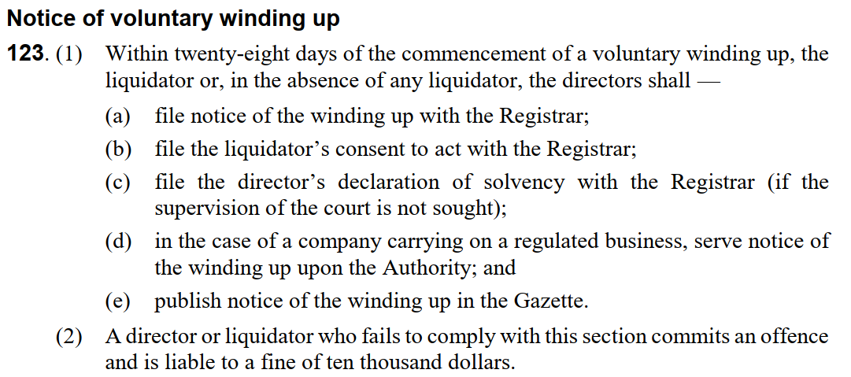
These must be performed as follows:
CA sub-section | Requirement | CWR form number(s)
123(1)(a) | File notice of the winding up with the Registrar | 19
123(1)(b) | File the liquidator’s consent to act with the Registrar | 20
123(1)(c) | File the directors’ declaration of solvency with the Registrar (if the supervision of the Court is not sought) | 21, signed by all directors
123(1)(d) | In the case of a company carrying on a regulated business, serve notice of the winding up upon the Cayman Islands Monetary Authority (the Authority) | 19 & 20 (stamped copies)
123(1)(e) | Publish notice of the winding up in the Gazette. | 19

As noted above, per s.123(2) CA, a director or liquidator who fails to comply with these provisions commits an offence and is liable to a fine of CI$ 10,000.
Question 2.3.3

Describe the basis upon which the company may resolve to remunerate Tom and Jerry in their capacity as the voluntary liquidators. (2)

CWR O 13, r 9(1) provides:
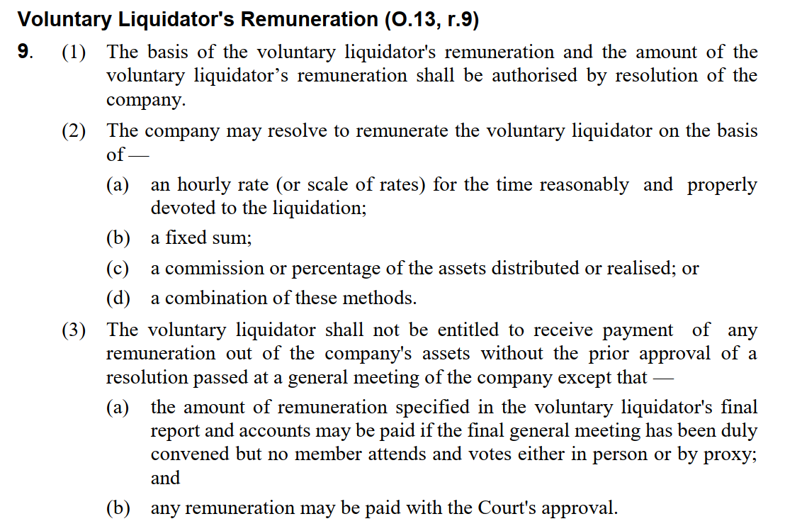
The remuneration therefore be on an hourly rate, a fixed sum, a commission of assets distributed or a combination thereof.
CWR O 13, r 8(3)(g) provides:

The payments must therefore also be accounted for and reported on.
Question 2.4

Assuming that the contributories petition the Grand Court of the Cayman Islands for an appointment of a provisional liquidator, what are the Court’s powers upon the hearing of a winding-up petition? (2)
s.95 CA provides insofar as is relevant:
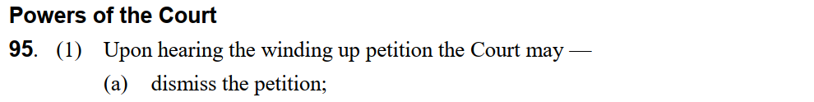
[…]
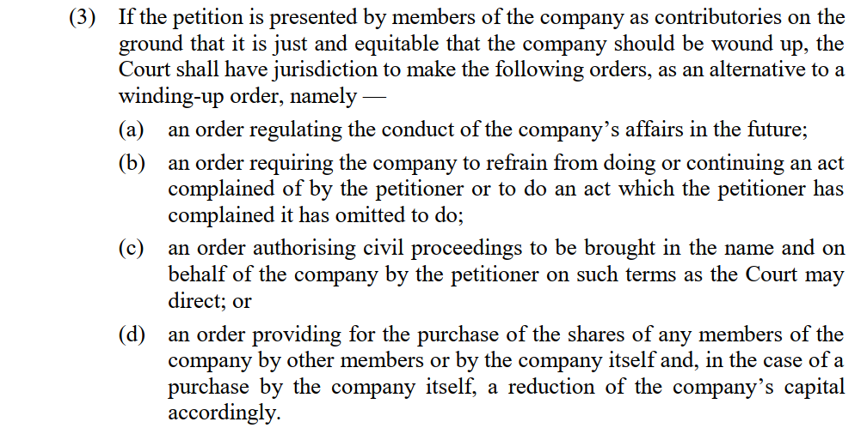
The Court may therefore dismiss the petition, adjourn it, make a provisional order, any other order that it sees fit, or it may make alternative orders per s.95(3).
A failure to consider alternative remedies under s.95(3) can be appealable. See the recent judgment of Martin JA at para 60 of CICA (Civil) Appeal 4 of 2022 - In the Matter of Virginia Solution SPC Ltd, delivered on 28 July 2023, in which a failure to consider alternative remedies was criticised by CICA (and the judgment overturned):
As the judge had recognised much earlier in her judgment (paragraph 19), the question of alternative remedies is dealt with by section 95(3) of the Act. That subsection provides as follows: [see above]. It follows that, once the judge had determined in the present case that the petitioner had established a prima facie case for winding up, she should have gone on[…] to consider whether any of the statutory remedies was a more appropriate method of dealing with the situation. One obvious possibility would have been an order under section 95(3)(b) “requiring the company… to do an act which the petitioner has complained it has omitted to do” […]. She did not consider this or any other of the statutory remedies. […] In my view these failures – to consider the statutory alternative remedies or whether or not there was functional deadlock – mean that her judgment could not have been supported even if she had been right that a case for a just and equitable winding up otherwise existed.

Question 2.5

Question 2.5.1

In a brief essay, explain who can apply to the Court to remove official liquidators, and in what circumstances. Who must such an application be served on? (4)
Authority. CA s.107 provides: Removal of official liquidators. An official liquidator may be removed from office by order of the Court made on the application of a creditor or contributory of the company. CWR O.5, r.6 also provides that:
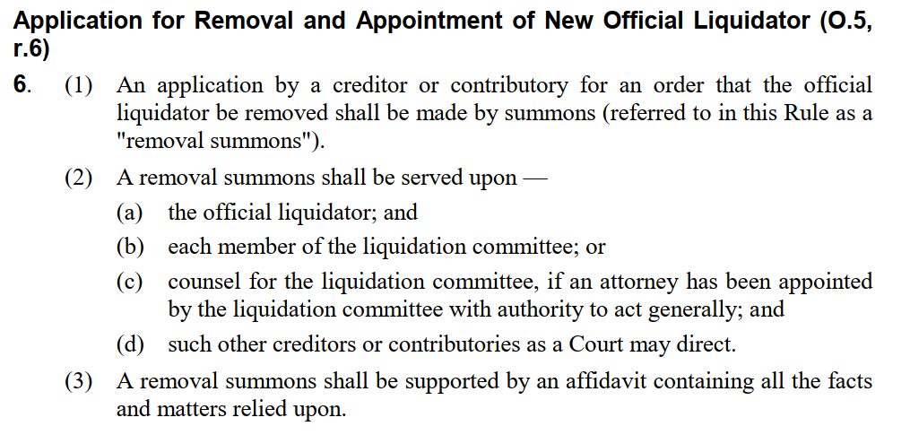
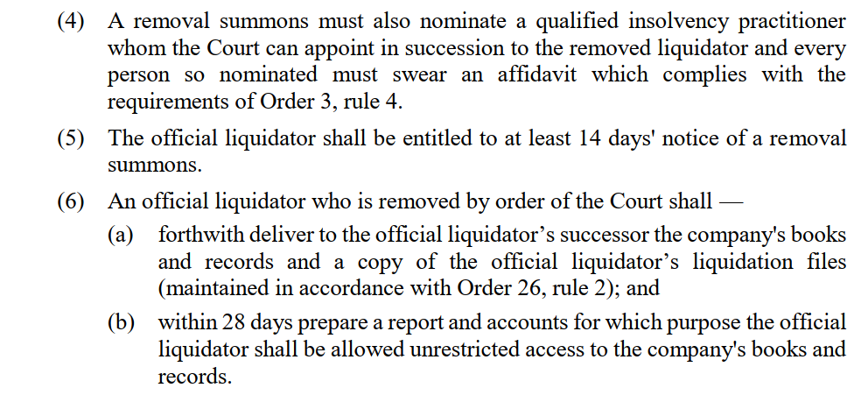
Therefore, applying this:
Applicants. A creditor (if an insolvent liquidation) or a contributory (in a solvent liquidation) can apply to the Court to remove official liquidators. This because they are the relevant parties with an interest in the distribution of the company’s assets. See Johnson and Deloitte & Touche AG [1997 CILR 120] and BTU Power Company 2019 (1) CILR Note 7.
Circumstances. Case law (BTU Power Company 2019 (1) CILR Note 7 and AMP Enterprises Ltd (t/a Total Home Entertainment) v Hoffinan [2002] BCC 996) reflects that, while the Court has broad discretion to remove liquidators, there must be good reasons. Examples include conflicts of interest or misconduct. Creditors’ preferences, or the fact that a creditor is merely disgruntled, are usually inadequate reasons for a removal. If such a removal may be in the interests of wider creditors the Court may however be willing to do so (Johnson and Deloitte & Touche AG [1997 CILR 120]).
We are instructed that “one of the shareholders reads that Jerry has been named in an Offshore Alert article suggesting that he has been defrauding companies in liquidation” and that “They wish to remove him as liquidator immediately, but do not have the support of the other shareholders to take that action”. Jerry would no doubt resist such allegations. Jerry is a qualified professional and officer of the court and therefore these allegations are particularly serious, and he would be likely to resist them.
As well as the process provided for in O.5, r.6, common law and human rights law give Jerry the opportunity to respond. "Audi alteram partem," or "audiatur et altera pars," translates from Latin as "hear the other side" or "let the other side also be heard." This principle upholds the concept that no individual should be subject to judgment without a fair hearing, where each involved party has the chance to respond to evidence presented against them. Recognised as basic principle of natural justice in English, and thus Cayman law, this encompasses several rights. These include the ability of a party or their legal representatives to confront opposing witnesses, effectively challenge the opposing party's evidence, bring forth their own witnesses and evidence, and have access to legal counsel, to adequately present their case. As well as these common law rights, Article 7 of the Constitution of the Cayman Islands reflects Article 6 of the European Convention on Human Rights, provides inter alia that "Everyone has the right to a fair and public hearing in the determination of his or her legal rights and obligations by an independent and impartial court within a reasonable time." Jerry would therefore likely be able to challenge any removal attempt.
The fact that other shareholders are not supporting the disgruntled shareholder who seeks Jerry’s removal would likely also be persuasive to the Court not to remove Jerry. The issue about only one audit having been performed, and the auditor’s resignation, however, would by contrast work against Jerry’s interests. In summary however, we need more information.
Service. As noted above in O.5, r.6 (2), any such application must be served on the OL, each liquidation committee member or their counsel if they have appointed an attorney with general authority, and other creditors or contributories as the Court may direct.
Question 2.5.2

Briefly explain why it makes sense that the class of potential applicant varies in accordance with the solvency of the company. (5)

- Insolvent companies. In insolvent companies, creditors are the primary stakeholders as they have the most to lose, as the assets of the company are inadequate to meet its liabilities. Therefore, they have a greater say in the removal of liquidators.
- Solvent companies. For solvent companies, the shareholders (contributories) are more likely to be affected by the liquidation process, as the company’s assets should be enough to meet creditor liabilities and therefore creditors should be made whole regardless of what happens. Hence, shareholders have more influence over the appointment or removal of liquidators.
This is also why liquidation committees are designed to be representative of the company’s stakeholders, with the task of consulting with the OL. The Court has inherent jurisdiction to deal with all matters relating to the winding up, but the liquidation committee is formed because the court will have regard to wishes of the creditors or contributories.
This differentiation makes sense as it aligns the power to influence the liquidation process with the interests most at risk in the respective scenarios. Please also see the Applicants paragraph in the answer above, which explains the rationale for whose wishes the Court will have regard to.
Question 2.6
During a liquidation there is an expected recovery into the liquidation estate. The amount is such that the liquidation estate is no longer deemed to be insolvent and the official liquidator can settle all of the outstanding creditor claims (including interest) in full. The official liquidator has subsequently filed a revised certificate of solvency (CWR Form No 14) with the court. What impact will the change in solvency have on the liquidation committee, assuming one has been constituted? (4)
Impact on liquidation committee. CA s.115 provides:
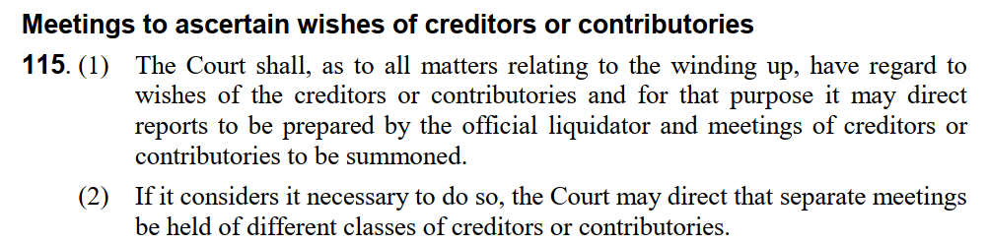
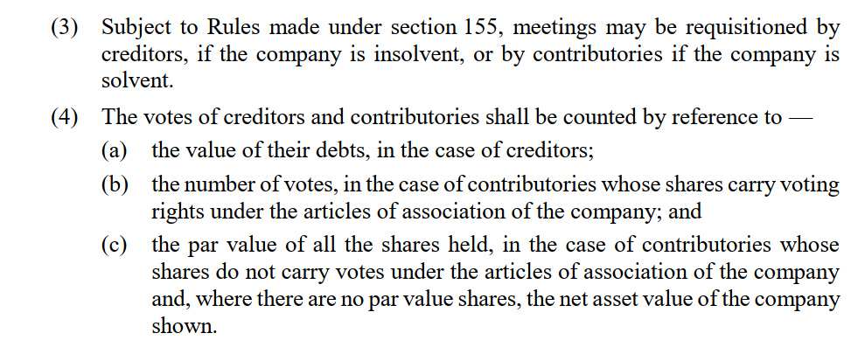
CWR O.8, r.1 & O.9, r.1 & r.3 provide respectively insofar as is most relevant (with highlighting added):
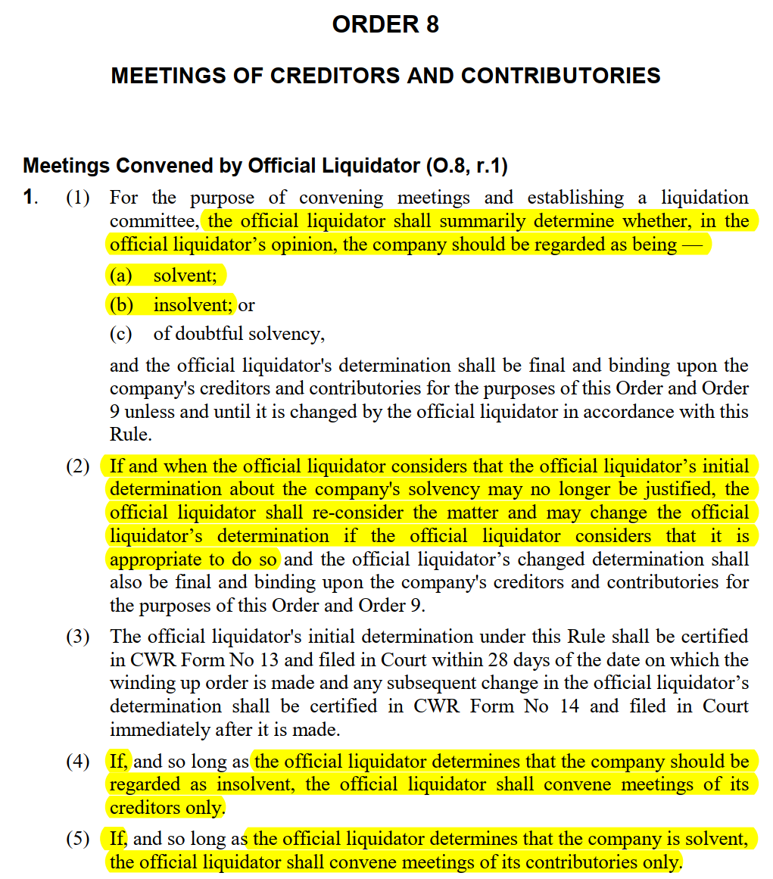
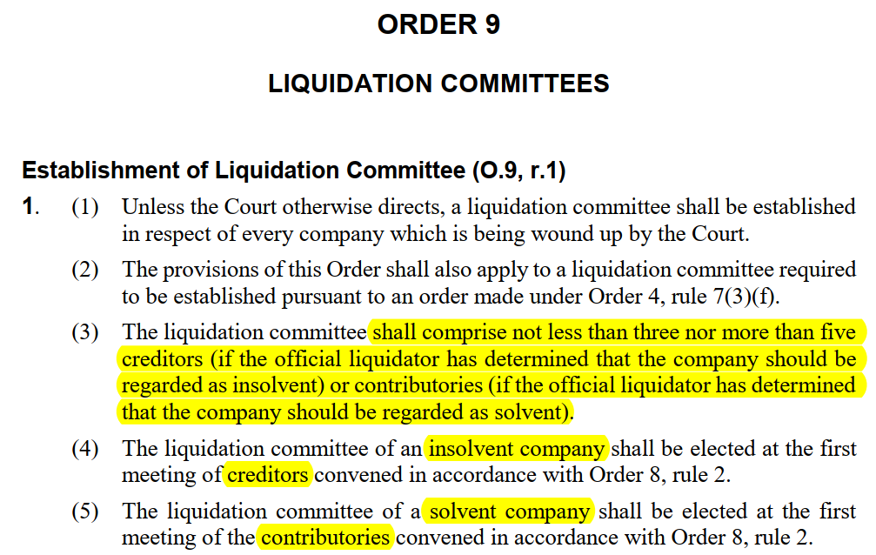
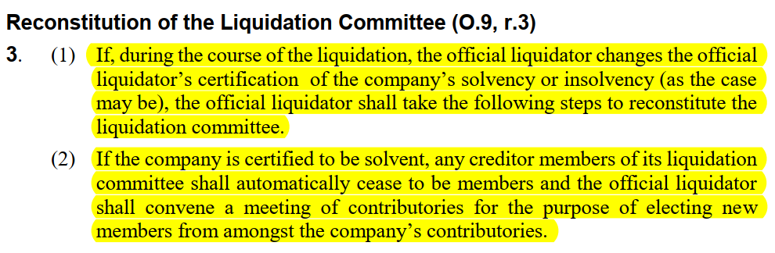
Therefore, when a liquidation estate becomes solvent, and all creditor claims can be settled:
- Shift in OL’s priority. The OL’s focus shifts from satisfying creditor claims to ensuring proper distribution to shareholders. This is because, previously, when the estate was deemed insolvent, the shareholders were likely to receive no returns as creditors were the priority.
- Role of committee. The liquidation committee, if constituted, will likely need to change membership (i.e. unless the creditors are also contributories). Any creditor members of the committee shall automatically cease to be members and the official liquidator must convene a meeting of contributories for the purpose of electing new members from amongst the company’s contributories. This is so that the committee can reassess its role and approach, focusing on the interests of the shareholders rather than the creditors.

Question 2.7

Discuss the steps that a liquidator will need to take following the making of an order for dissolution. (5)
CWR O.22, r.2(3) provides that the OL must file the order for dissolution with the Registrar of Companies within 14 days from the date upon which the order is perfected. CWR O.22, r.2(4) (a)-(d) also provide for possible supplementary directions as seen below, many of which are likely to be directed at the OL:
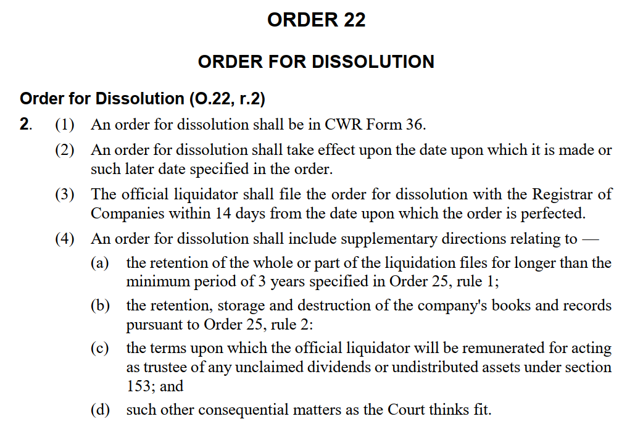

The OL will therefore need to follow whatever those directions are, e.g. organise the storage or destruction of the company’s books and records.
CA s.153 and CWR O.23 then provide for unclaimed dividends and undistributed assets, the former providing:
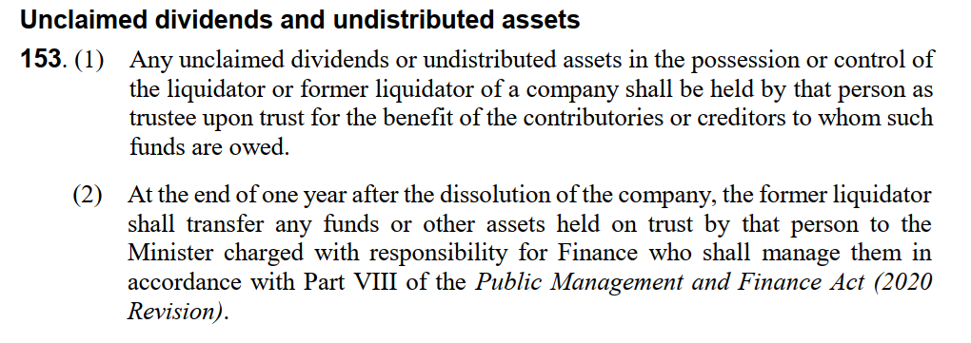
CWR O.23 is too long to cite in full, but covers:
ORDER 23: UNCLAIMED DIVIDENDS AND UNDISTRIBUTED ASSETS
Introduction (O.23, r.1)
Establishment of Trust Account (O.23, r.2)
Transfer of Undistributed Assets (O.23, r.3)
Payment out of Trust Account and Transfer of Undistributed Assets (O.23, r.4)
Former Liquidator's Trustee Fee and Expenses (O.23, r.5)
Transfer to the Financial Secretary (O.23, r.6)
The OL therefore may need to, e.g. establish a trust account, transfer assets, make payments as necessary, and transfer to the Financial Secretary any money or assets remaining at the end of one year from the date upon which the company was dissolved.
Finally, the OL must retain the liquidation files in safe custody for at least 3 years per CWR O.26, r.2:
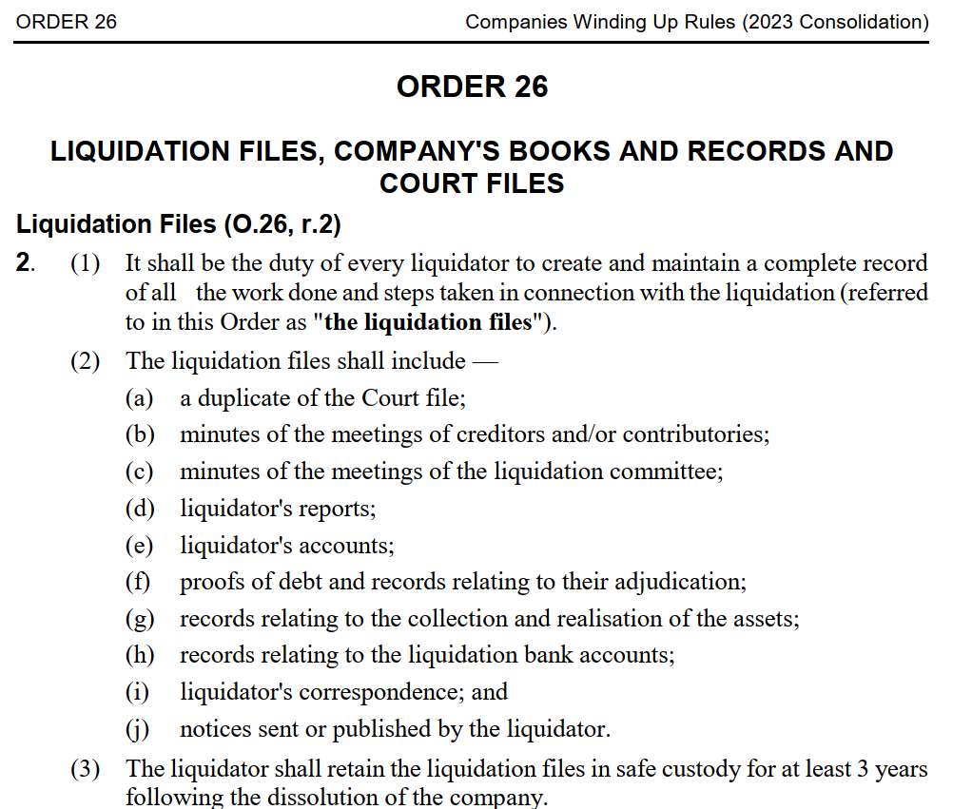
Question 2.8

Describe the general investigative powers and duties of a liquidator. (5)

The following overview of the general investigative powers and duties of a liquidator under the CA and CWR highlights their role in investigating company affairs, reporting findings, and managing company records and documents, all while adhering to legal standards and considerations of confidentiality and stakeholder interests:
- s.102 of the Companies Act:
  - Empowers the liquidator to investigate the company's failure causes and its overall business activities.
  - Requires thorough acquaintance with the company's affairs, mandating honesty and transparency in investigations (“make himself thoroughly acquainted with the affairs of the company; and to suppress nothing, and to conceal nothing, which has come to his knowledge in the course of his investigation, which is material to ascertain the exact truth in every case before the Court” Gooch’s Case 1872).
- Investigative scope:
  - Investigate company's promotion, business, dealings, and affairs.
  - Report findings to the court as deemed appropriate.
  - Assist CIMA and the Royal Cayman Islands Police Service in specific investigations (CA s.102(2)).
- Funding of investigations:
  - Investigations and prosecutions may be funded by the company's assets, with creditor or contributory approval depending on the company's solvency status (CA, s.102(3)).
- Statement of affairs:
  - Liquidators can require a statement from directors, officers, professional service providers, and employees about the company's affairs (CA s.101(1)).
  - Professional service providers do not include auditors due to their independent role (ICP Strategic Credit Income Fund Limited [2012 (1) CILR 383]).
  - The statement must include detailed financial information, verified by an affidavit (CA s.101(2)).
- Service of notices:
  - Notices under section 101 must be served personally, or alternatively through substituted service if necessary (Grand Court Rules, O.10 and O.65).
  - Non-compliance without reasonable cause is punishable with a fine (CA s.101(4)).
- Examination of relevant persons:
  - Liquidators can apply for court orders to examine relevant persons or secure company property (CA s.103(3)).
  - A duty is imposed on relevant persons to cooperate with the liquidator (CA s.103(2)).
  - Relevant persons include a broad range of individuals associated with the company (CA s.103(1)).
- Jurisdiction and court proceedings:
  - Court's jurisdiction extends to relevant persons outside the Cayman Islands (CA s.103(7)).
  - The Court can order affidavits or oral examinations for relevant persons (CA s.103(5)).
- Handling Company Records:
  - The OL must take control of the company;s books and records (CA Sch 3, Part II, para 1).
  - The Court may order transfer of company property to the liquidator (CA s.138(1)).
  - The OL is not personally liable for disposing of property unless negligent (CA s.138(2)).
- Inspection and Reporting:
  - The Court may order inspection of company documents by creditors and contributories (CA s.114 (1)(a)).
  - The OL must to prepare and provide reports to creditors and contributories (CA s.114(1)(b)).
- Confidentiality and Sealing of Documents:
  - The Court may seal documents to protect confidentiality and economic interests of stakeholders (In the matter of the Sphinx Group of Companies (in official liquidation) [2017 (1) CILR 176]).
  - Provisions may be made for unsealing documents under specific conditions (CWR O.24, r.6(2)).
  - Once disclosed, liquidator's reports are considered public and cannot be re-sealed (Re Harley International (Cayman) Limited [2012 (1) CILR 178]).
Question 2.9

Explain what is meant by the “relevant date” for the purposes of a section 101 of the Companies Act (2023 Revision) notice served by a liquidator in order to procure a statement of affairs from persons listed in section 101(3). (5)

The “relevant date” for the purposes of CA s.101, pers.101(6), means — (a) in a case where a provisional liquidator is appointed, the date of that person’s appointment; and (b) in any other case, the commencement of the winding up.
In the context of an official liquidation, as outlined in section 101 of the Companies Act (which is also applicable to provisional liquidators), the "relevant date" is recognized as the onset of the winding up process. Typically, this coincides with the filing of the winding up petition. However, this date might be earlier in certain circumstances.
These include situations where the company has already passed a resolution for voluntary winding up, the duration set for the company's operation in its articles of association has ended, a specific event necessitating winding up as per the company's articles of association has occurred, or a restructuring officer has been appointed.
In such instances, the initiation of the winding up is considered to have occurred at the time of these specific events. This interpretation is supported by the case of In the Matter of ICP Strategic Credit Income Fund Limited [2012 (1) CILR 383] and is further reinforced by section 7 of the Companies Act.

** END OF QUESTION 2 **

QUESTION 3 FOLLOWS ON NEXT PAGE / . . .
QUESTION 3 - CORPORATE RESCUE (20 MARKS)

Where appropriate, refer to the fact pattern below when answering the questions that follow.

FACT PATTERN

SMB TECH CORPORATION

SMB Tech Corporation (SMB Tech), a Cayman Islands-based company operating in the technology sector, boasts a global presence with subsidiaries spanning various jurisdictions, including the United States, the United Kingdom, and Hong Kong. However, SMB has recently encountered significant financial challenges stemming from an economic downturn and heightened competition within its industry. Considering these difficulties, SMB sought the advice of a reputable advisory firm, which cautioned that SMB Tech teetered on the brink of insolvency and urgently required a financial restructuring.

While exploring its strategic alternatives, SMB Tech found itself confronting mounting pressure from its creditors. One particularly assertive creditor, Tech Credit Systems (TCS), threatened to initiate winding-up proceedings against SMB Tech. In a bid to secure some respite, SMB Tech entered into a three-month standstill agreement with TCS. However, as the three-month period lapsed without concrete restructuring proposals in place, TCS exhibited signs of growing impatience.

The delay and indecision on the part of SMB Tech's management have further exacerbated tensions among certain contributories of the company. These contributories, expressing their dissatisfaction, have indicated an intent to petition the Grand Court of the Cayman Islands for the appointment of a provisional liquidator. Their chosen provisional liquidator is based in Hong Kong, and their motivation is grounded in a perceived loss of trust and confidence in SMB's directors.

SMB Tech’s financial obligations include unsecured debt governed by English law, amounting to GBP 6 million, owed to three creditors situated in the United Kingdom. The company hopes to negotiate a compromise on these liabilities as part of its restructuring efforts. Additionally, SMB Tech has undertaken guarantees for certain financial obligations of several subsidiaries. Notably, the creditors holding these guarantee liabilities have indicated a reluctance to endorse any proposed restructuring scheme.

Question 3.1

The chosen provisional liquidator by the contributories of SMB has professional indemnity insurance up to a limit of US$5 million in respect of each and every claim. The chosen provisional liquidator is unwilling to increase his professional indemnity liability insurance limit due to the increasing cost of insurance products in the market. Along with your reasons, provide an explanation as to whether the chosen provisional liquidator could be appointed by the Grand Court of the Cayman Islands. (5)

CA s.108 (1) provides: “A foreign practitioner may be appointed to act jointly with a qualified insolvency practitioner”.
CA s.89 defines:
- “‘Foreign practitioner” as person who is “qualified under the law of a foreign country to perform functions equivalent to those performed by official liquidators under this Act.”
- “Qualified insolvency practitioners” as “person holding the qualifications specified in the regulations made by the Insolvency Rules Committee under section 155 or such other qualifications as the Court considers appropriate for the conduct of the winding up of a company.”
Regulation 7 of the Insolvency Practitioners’ Regulations requires an insolvency practitioner to have professional indemnity insurance (up to a limit of at least US$10 million in respect of each and every claim and at least US$20 million in the aggregate, with a deductible of not more than US$1 million), and under Regulation 8 this also applies to a foreign practitioner:
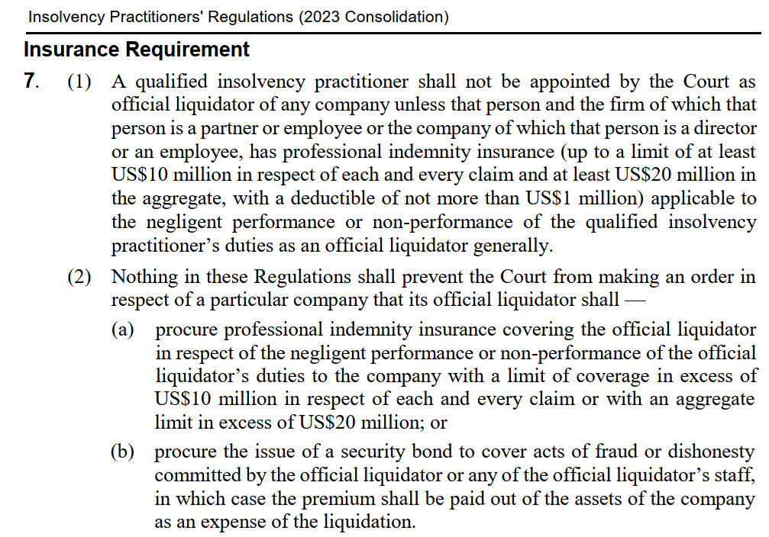
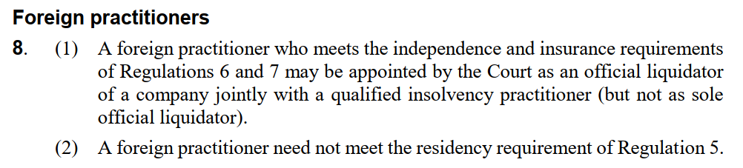
On the facts in the question therefore, the Hong Kong liquidator is unsuitable both:
- Because a foreign practitioner cannot act as a sole official liquidator (including provisional liquidator) of a Cayman Islands company, and also
- Because their insurance requirements are inadequate.
The contributories should therefore select either solely a Cayman Islands insolvency practitioner (IP) or a Cayman Islands insolvency practitioner to act jointly with a foreign IP, with both having the mandatory insurance levels in place.
This is almost certainly the best advice for the contributories to follow, as it avoids wasting costs on a nugatory application, because Regulation 7(1) appear unambiguous: “A qualified insolvency practitioner shall not be appointed […] unless that person and the firm [..] has professional indemnity insurance (up to a limit of at least US$10 million in respect of each and every claim and at least US$20 million in the aggregate, with a deductible of not more than US$1 million” (emphasis added).
For completeness however, there is recent jurisprudence in which a judge, when appointing provisional liquidators, construed ‘shall’ more widely than one might ordinarily have expected. In In the Matter of Atom Holdings FSD 54 of 2023 (IKJ), on 7 July 2023 (Atom Holdings), Kawaley J issued a winding-up order against Atom Holdings Ltd, a cryptocurrency exchange.
The (apparently defrauded) retail creditor petitioners lacked the financial means to offer a credible cross-undertaking in damages on their application for provisional liquidators. CWR O.4, r.3, includes that an applicant ‘shall give an undertaking to the Court to pay (a) any damage suffered by the company by reason of the appointment of the provisional liquidator; and (b) the remuneration and expenses of the provisional liquidator, in the event that the winding up petition is ultimately withdrawn or dismissed.’ (emphasis added).
However, rather than dismiss the otherwise meritorious application on that basis, the Court undertook a purposive interpretation of the relevant Cayman procedural rules and decided that a cross-undertaking was not necessary. Taking this approach allowed the Court to find that it had a discretion as to whether to require a cross-undertaking in damages, rather than this being a mandatory requirement for relief to be granted. This interpretation of “shall” was a seemingly novel development, but there is in fact common law precedent dating back centuries for distinguishing prima facie mandatory statutory provisions. In this question therefore, in principle, an attempt could be made to persuade the court to take an unconventional approach to Regulations 7 and 8, above.
Atom Holdings can however likely be distinguished from the facts in the question because in the former Kawaley J, rather than dismissing the otherwise meritorious application, undertook a purposive interpretation of the relevant rules to protect retail consumers who had been apparent the victims of fraud, and the alternative was to protect the apparent fraudsters. The fictitious provisional liquidator’s unwillingness to increase his professional indemnity liability insurance limit is by contrast a far less sympathetic case, and the issue could far more simply be solved, by simply applying for the appointment of a more suitable liquidator.
Question 3.2

What must the company demonstrate to the Court before the Court will appoint a restructuring officer? (2)

Section 91B(1) of the amended Companies Act allows a company to file a petition with the Grand Court for the designation of one or more restructuring officers. This is applicable when the company (i) faces or anticipates facing issues in meeting its debt obligations, and (ii) aims to propose a settlement or plan with its creditors (termed a Restructuring Petition).
The criteria for appointing restructuring officers mirror those formerly used for provisional liquidators under section 104 (3) of the Companies Act, now superseded by the amended legislation. Essentially, this involves a dual-criteria test:
- The company's current or potential inability to fulfil its debt commitments when they are due, and
- its plan to propose a compromise or arrangement to its creditors.

Question 3.3

What are the advertising requirements for a restructuring petition? (2)

In the absence of a specific directive from the Grand Court, the presentation of a Restructuring Petition necessitates its advertisement using CWR Form 3A. This involves:
- A single publication in a newspaper distributed within the Cayman Islands (CWR O.1A, r.1(3)).
- Publication in a newspaper in a country (or countries) where it is most likely to reach the company's creditors and contributories (CWR O.1A, r.1(4)).
These advertisements must be placed no later than seven business days following the submission of the Restructuring Petition and at least seven business days prior to the scheduled hearing date (CWR O.1A, r.1(6)).
This ensures that stakeholders are notified about the Restructuring Petition, and represents a shift from the previous framework where appointments of provisional liquidators were often initiated ex parte. Recent legal precedents however underscore the significance of informing stakeholders in nearly all situations, e.g. In the Matter of Midway Resources International (FSD 51 of 2021, unrep., Segal J, 30 March 2021).
Question 3.4

Describe at least six (6) elements of the new restructuring officer regime that assist in safeguarding the interests of creditors. (6)

On 31 August 2022, the Companies Act's Part V was amended, launching an efficient restructuring framework for distressed companies. The Companies (Amendment) Act and the Companies Winding Up (Amendment) Rules 2022 enable companies to seek the Grand Court's approval for appointing a restructuring officer. New sections 91A to 91J, introduced by the Companies (Amendment) Act, and a new section 1A in the Amendment Rules outline the restructuring process.
These amendments ensure safeguards for creditors and contributories. Key protections include:
(a) Stakeholders can petition for modifying or revoking the restructuring officers' appointment (CWR Form 16B) and for their removal and replacement (Form 16C), following criteria set in recent cases like In the Matter of Global Fidelity Bank, Ltd.
(b) The RO must report to stakeholders and transfer all relevant files to their successor if removed.
(c) Secured creditors retain rights to enforce their security independently of the Court and the restructuring officer (CA s.91H).
This list continues below as developed by Doyle J in case law.
Three notable cases under the new regime include:
- Oriente Group Limited, the regime's first case, where Kawaley J reaffirmed established principles for the restructuring officer regime. (FSD 231/2022)
- Rockley Photonics Holdings Limited, where steps towards a consensual restructuring and a Chapter 11 application in the US led to the appointment of Restructuring Officers and subsequent approval of the restructuring plan. (FSD 16 of 2023)
- Aubit International, where Doyle J dismissed the petition, emphasizing that restructuring officers should not be used for forensic investigations or asset recovery, but solely for financial restructuring, to avoid regime abuse and maintain international credibility. Doyle J's judgment, at [126] also highlighted 25 principles that will guide future litigation in this area. (In the Matter of Aubit International (Unrep, FSD 240 of 2023 (DDJ), 4 October 2023))
Doyle J’s principles – as with many of his judgments – provide an expansive statement of Cayman law. For the purposes of the question, elements of the new restructuring officer regime that assist in safeguarding the interests of creditors, drawn from Doyle J’s judgment, include:
- The Court's discretion is to be exercised to facilitate a company's recovery where appropriate, but it must guard against misuse of this jurisdiction by insolvent companies that persist in trading.
- Key considerations include assessing (i) if restructuring is more advantageous for creditors compared to winding up, (ii) the likelihood of a successful restructuring benefiting the entire creditor group, and (iii) whether restructuring is, in all circumstances, in the creditors' best interest.
- Creditors' perspectives are crucial. Normally, the Court expects to see some level of engagement with creditors before presenting a petition, aimed at shaping a restructuring proposal.
- The intention behind a restructuring plan must be realistic and genuine, grounded in substantial reasons. The Court does not require a fully developed plan, but enough groundwork to indicate potential success.
- In certain scenarios, even a basic, yet genuine, outline of a restructuring plan might be sufficient or persuasive enough to warrant the appointment of Restructuring Officers (ROs) to evaluate the plan's feasibility. However, without (a) significant creditor consultation and their backing, and (b) third-party professional verification of the plan's viability and its benefits over winding up, the Court might determine the absence of a sincere intention to pursue a viable and successful plan.
- The Court must be convinced that management genuinely needs and merits a "breathing space" to finalize a restructuring plan with a reasonable success probability and that this approach serves creditors' best interests, allowing the company to continue operating.
- Even with unanimous agreement among the company and its creditors on appointing ROs, the Court must independently ascertain its jurisdiction and decide if such an order is a proper use of its discretion.
- The petition must comply with the Act, Companies Winding Up Rules, and case law requirements, clearly outlining the grounds for the application.
Question 3.5

Outline the relief that is and is not available to the Court upon a restructuring petition. (5)

Upon the presentation of a restructuring petition in the Grand Court, the Court has specific powers, as well as certain limitations on what it cannot do. In summary:
Relief available to the court
- Appointment of restructuring officers (ROs). The Court can appoint one or more ROs to oversee and manage the restructuring process.
- Stay of proceedings. The Court may issue a stay on any ongoing or pending litigation against the company. This provides the company with a "breathing space" to focus on restructuring efforts without the distraction of legal battles.
- Approval of restructuring plans. The Court can review and approve proposed restructuring plans, ensuring they are fair and viable for the company's recovery and beneficial to the creditors.
- Supervision of restructuring process. The Court plays a supervisory role in the restructuring process, ensuring compliance with legal requirements and fairness to all parties involved.
Relief not available to the court
- Discharge of debts. The Court cannot unilaterally discharge or write off the company's debts without the agreement of creditors or adherence to legal processes.
- Altering secured creditors' rights. The Court generally cannot impair the rights of secured creditors to enforce their security without their consent or a legal basis for doing so.
- Compelling creditor participation. The Court cannot force creditors to participate in or accept the terms of a restructuring plan. Creditors' agreement to the plan is typically voluntary, although it can be bound by certain legal mechanisms if the requisite majority consents.
- Management replacement. The Court typically does not have the authority to replace the company's management. The role of the ROs is not to take over the management but to oversee the restructuring process.
- Automatic protection of guarantees. Guarantees extended by the company, especially those concerning third-party debts, are not automatically protected or stayed by the restructuring petition.
- Unilateral contract amendments. The Court cannot arbitrarily modify the terms of existing contracts to which the company is a party. Any changes to contractual obligations would typically require consent from the concerned parties or follow specific legal procedures.
In essence, the Court's role in a restructuring petition is to facilitate a fair and orderly process that aims to revive the company financially while protecting the interests of creditors and other stakeholders.

** END OF QUESTION 3 **

QUESTION 4 FOLLOWS ON NEXT PAGE / . . .

QUESTION 4 – GENERAL QUESTIONS (15 MARKS)

The questions below deal with exempted limited partnerships (ELPs), cross-border insolvency, the recognition of foreign judgments and consumer insolvency.

Question 4.1

In addition to the Limited Partnership Agreement, what governs the operation of ELPs? (3)

Limited partnerships have existed in the Cayman Islands in some form since at least 1963 based on the 1907 English Limited Partnerships Act. ELPs were first introduced in 1991, to provide symmetry with the corresponding law in Delaware, which had already developed a modern limited partnership model (via Delaware Revised Uniform Limited Partnership Act). Since then, the 1991 law has been amended 21 times, with the version currently in force the Exempted Limited Partnerships Act 2021 (the ELPA).
The operation of ELPs is governed therefore not only by ELPs’ respective Limited Partnership Agreements but also by the ELPA. This provides the statutory framework within which ELPs operate, outlining provisions related to the formation, management, and dissolution of these partnerships.
Like ordinary partnerships, general rules of equity and common law between partners apply to ELPs, except where inconsistent with the ELPA. Unlike ordinary partnerships, however, ELP Limited Partners (LPs) owe no fiduciary duties either to the ELP itself or to fellow LPs. As with shareholders in normal companies, LPs benefit from limited liability capped to the amount of their contribution. To maintain that limited liability however, LPs can have no active involvement in the ELP’s business in their capacity as LPs. Unlike companies, however, ELPs have no separate legal personality and cannot hold assets or pursue or defend claims in their own right. Instead, assets are held by the General Partner (GP) on statutory trust for the LPs.
ELPs are therefore also subject to – whether directly or by analogy – elements of trust law, company law, ordinary partnership law, and (non-exempted) limited partnership law. These principles fill any gaps not explicitly covered by the ELPA and the Limited Partnership Agreement.
Finally, there has been recent appellate commentary about the extent to which the Partnership Act or the Companies Act applies in the context of winding-up ELPs.
Question 4.2

When does the Cayman Islands court have jurisdiction to wind up a foreign company? (5)

CA s.91 provides:
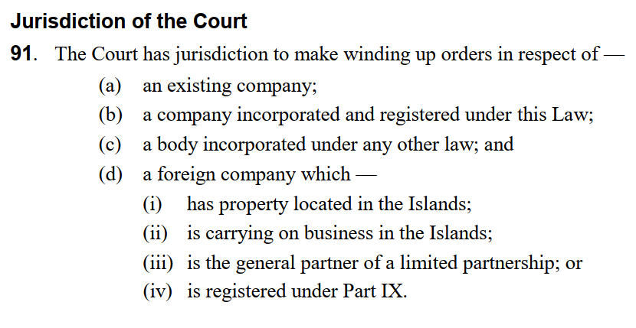
Under s.91(d) therefore, the Cayman Islands court has jurisdiction to wind up a foreign company if it has assets in the jurisdiction, conducts business in the Islands, is a GP of a limited partnership or is registered under Part IX of the Act (“Part IX - Overseas Companies”, ss.183-195).
The circumstances under which the Court may make an order are articulated in s.92:
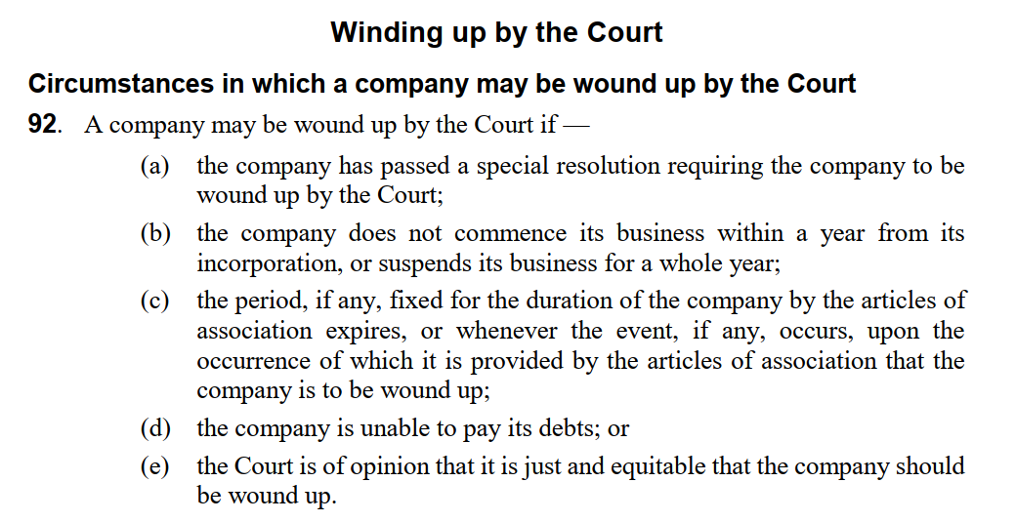
Standing to file a petition is articulated in CA s.94, but this is lengthy and therefore not précised here.
Question 4.3

Does a judgment of a foreign court need to be registered and / or enforced within the Cayman Islands before it is relied upon as the basis for seeking a winding up order? Provide reasons. (3)
Generally, foreign judgments are not enforceable per se in the Cayman Islands without steps being taken to have them recognised first. However, Kawaley J in In the matter of Guoan International Limited (FSD, unrep. 29 October 2021) ruled that creditors may rely upon foreign judgments as the basis for seeking a winding up order without first obtaining recognition and / or enforcement orders in respect of such foreign judgment from the Cayman Islands Court. The key paragraphs are as follows:
[11] The threshold question of the legal effect of a pending appeal against a final judgment on the right of a creditor to rely upon the judgment debt as the basis for seeking a winding-up order does not appear to have been directly considered before in any Cayman Islands considered judgment. […]
[17] In my judgment it is clearly the general Cayman Islands legal position that (a) a final and conclusive judgment of a foreign court cannot be challenged locally by parties bound by it and (b) the mere pendency of an appeal does not deprive a foreign judgment of its final and conclusive character. […]
[18] It remains to consider the more context-specific question of how these broad judgment recognition and issue estoppel principles apply in the winding-up context. It seemed counterintuitive to consider that such fundamental principles of general application should not apply in the winding-up context, absent express statutory provision to contrary effect […]
[21] In short, I was satisfied at the hearing of the present petition that the general principles according to which a final foreign judgment on the merits cannot be challenged by a party bound by it applied in the winding-up context and found no need to look for direct authority to this effect. Indeed, the Company’s counsel did not have the temerity to advance any contrary submission [...]
[24] For these reasons I accepted the Petitioners’ submission that they were entitled to a winding-up order as of right having served a Statutory Demand under section 93(a) of the Companies Act (2021 Revision). [...]
While only a first instance decision, Kawaley’s reasoning does not seem to brook contradiction, at least on the facts of that case. Therefore, the best argument would seem to be that a judgment of a foreign court may not need to be registered or enforced within the Cayman Islands before being relied upon as the basis for seeking a winding up order.
Question 4.4
State the main statutory powers and duties of the trustee in bankruptcy, and provide at least one example with reference to a section of the Bankruptcy Act. (4)
The main statutory powers and duties of a trustee in bankruptcy in the Cayman Islands are outlined in the Bankruptcy Act. Key powers and duties include:
- Following the issuance of a provisional or absolute order, the debtor's assets are immediately transferred to and become the responsibility of the Bankruptcy Trustee (Bankruptcy Act, s.37).
- In the interim period before the provisional order is finalized, the Trustee is tasked with safeguarding the debtor's property, ensuring it can be returned if the provisional order is rescinded (Bankruptcy Act, s.38).
- The Trustee is authorized to continue the debtor's business activities as necessary or beneficial for the effective conclusion or sale of the business (Bankruptcy Act, s.79). Additionally, the Trustee holds the authority to initiate or respond to legal actions concerning the debtor's assets (Bankruptcy Act, s.80).
- A key responsibility of the Trustee is to evaluate and decide on the validity of creditor claims (Bankruptcy Act, s.87). Once the order becomes absolute, the Trustee's primary focus shifts to administering the debtor's estate for the creditors' benefit (Bankruptcy Act, s.65).
- Finally, following the debtor's public examination, the Trustee is required to compile and submit a report detailing the debtor's financial situation and their conduct prior to and during the bankruptcy process (Bankruptcy Act, s.67).
The trustee's role is central to the administration of bankruptcy proceedings, ensuring that the bankrupt's assets are fairly and efficiently managed and distributed, and that the rights of all parties are upheld throughout the process.

TOTAL MARKS: [100]

** END OF ASSESSMENT **

Note to examiner: I have inserted statutory excerpts from this point forward, in the hope that it will be easier to distinguish between my answers and verbatim citations of the Companies Act and Companies Winding Up Rules. I wouldn’t do this in practice, but hopefully this will make it quicker and more painless to mark.
See Evans, Jim. “Mandatory and directory rules.” Legal Studies 1, no. 3 (1981): 227-256. Abstract: In dealing with rules of a procedural type lawyers often make a distinction which is referred to as that between ‘mandatory’, and ‘directory’ rules. (The terms ‘imperative’, ‘absolute’, ‘obligatory’, ‘compulsory’, and ‘peremptory’, have sometimes been used instead of ‘mandatory’.) The distinction has to do with the effect of breach of a rule on the process to which it relates. Very broadly, mandatory rules are those procedural rules the breach of which necessarily invalidates the process to which they relate, while directory rules are procedural rules the breach of which does not necessarily have this effect. This distinction has existed in the common law for about three hundred years… https://doi.org/10.1111/j.1748-121X.1981.tb00122.x
The CICA recently addressed ELPs’ unique governance in Aquapoint L.P. v Xiaohu Fan CICA (Civil) Appeal no. 0014 of 2022 (Grand Court cause no. FSD 0157 of 2021 (DDJ)), 4 October 2023. At first instance, referring to the decisions of Parker J in Padma Fund LP (Unrep. FSD judgment 8 October 2021) and Kawaley J in Formation Group (Cayman) Fund I (Unrep. FSD judgment 21 April 2022 ), the Judge noted that there is an unresolved issue as to whether the jurisdiction of the Grand Court to hear a petition presented by an LP to wind up an exempted limited partnership on the just and equitable basis is derived from s.35 of the Partnership Act, pursuant to s.3 of the ELP Act, and/or Part V of the Companies Act pursuant to s.36(3) of the ELP Act, the difference being whether petitions should be presented against the ELP itself, or against the ELP’s GP. Field JA closed CICA judgment’s with noting that both at first instance and on appeal, litigation had been conducted on the basis that English/Welsh/Commonwealth jurisprudence applied to petitions to wind up ELPs, “notwithstanding marked differences between an ELP and a partnership governed by the Partnership Act and a company incorporated under the Companies Act” and that he would have “been very interested to have heard a “further and in the alternative” case that the expression “just and equitable” in section 36 (3) (g) ELP Act was to be construed in an expansive and flexible way, taking full account of the special nature of an ELP and less account of the overseas jurisprudence”. This is therefore an open question.

