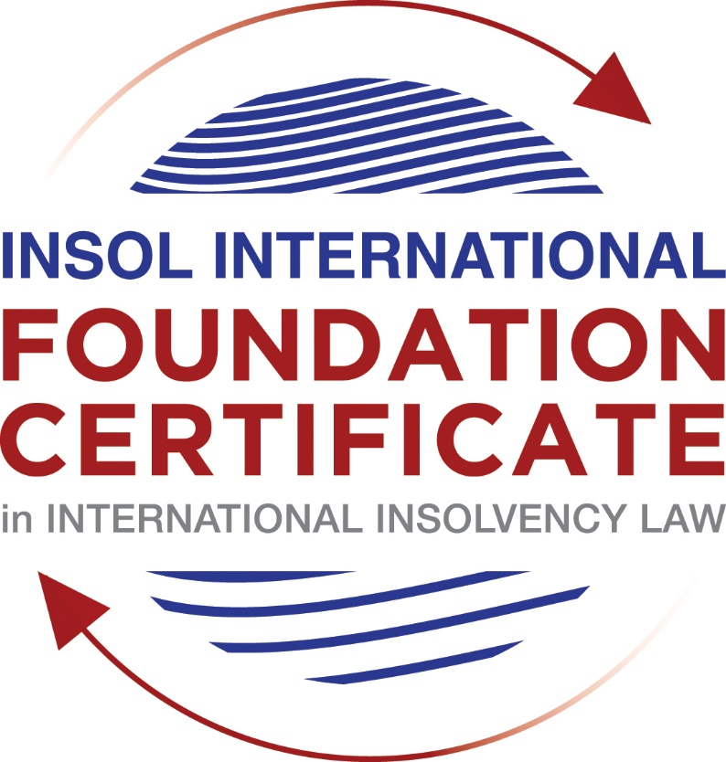

SUMMATIVE (FORMAL) ASSESSMENT: MODULE 3B

THE INSOLVENCY SYSTEM OF THE UNITED KINGDOM (ENGLAND AND WALES)

This is the summative (formal) assessment for Module 3B of this course and is compulsory for all candidates who selected this module as one of their compulsory modules from Module 3. Please read instruction 6.1 on the next page very carefully.

If you selected this module as one of your elective modules, please read instruction 6.2 on the next page very carefully.

The mark awarded for this assessment will determine your final mark for Module 3B. In order to pass this module, you need to obtain a mark of 50% or more for this assessment.

INSTRUCTIONS FOR COMPLETION AND SUBMISSION OF ASSESSMENT

Please read the following instructions very carefully before submitting / uploading your assessment on the Foundation Certificate web pages.

1. You must use this document for the answering of the assessment for this module. The answers to each question must be completed using this document with the answers populated under each question.

2. All assessments must be submitted electronically in MS Word format, using a standard A4 size page and a 11-point Arial font. This document has been set up with these parameters – please do not change the document settings in any way. DO NOT submit your assessment in PDF format as it will be returned to you unmarked.

3. No limit has been set for the length of your answers to the questions. However, please be guided by the mark allocation for each question. More often than not, one fact / statement will earn one mark (unless it is obvious from the question that this is not the case).

4. You must save this document using the following format: [student number.assessment3B]. An example would be something along the following lines: 202021IFU-314.assessment3B. Please also include the filename as a footer to each page of the assessment (this has been pre-populated for you, merely replace the words “studentnumber” with the student number allocated to you). Do not include your name or any other identifying words in your file name. Assessments that do not comply with this instruction will be returned to candidates unmarked.

5. Before you will be allowed to upload / submit your assessment via the portal on the Foundation Certificate web pages, you will be required to confirm / certify that you are the person who completed the assessment and that the work submitted is your own, original work. Please see the part of the Course Handbook that deals with plagiarism and dishonesty in the submission of assessments. Please note that copying and pasting from the Guidance Text into your answer is prohibited and constitutes plagiarism. You must write the answers to the questions in your own words.

6.1 If you selected Module 3B as one of your compulsory modules (see the e-mail that was sent to you when your place on the course was confirmed), the final time and date for the submission of this assessment is 23:00 (11 pm) GMT on 1 March 2021. The assessment submission portal will close at 23:00 (11 pm) GMT on 1 March 2021. No submissions can be made after the portal has closed and no further uploading of documents will be allowed, no matter the circumstances.

6.2 If you selected Module 3B as one of your elective modules (see the e-mail that was sent to you when your place on the course was confirmed), you have a choice as to when you may submit this assessment. You may either submit the assessment by 23:00 (11 pm) GMT on 1 March 2021 or by 23:00 (11 pm) BST on 31 July 2021. If you elect to submit by 1 March 2021, you may not submit the assessment again by 31 July 2021 (for example, in order to achieve a higher mark).

7. Prior to being populated with your answers, this assessment consists of 7 pages.

ANSWER ALL THE QUESTIONS

QUESTION 1 (multiple-choice questions) [10 marks in total]

Questions 1.1. – 1.10. are multiple-choice questions designed to assess your ability to think critically about the subject. Please read each question carefully before reading the answer options. Be aware that some questions may seem to have more than one right answer, but you are to look for the one that makes the most sense and is the most correct. When you have a clear idea of the question, find your answer and mark your selection on the answer sheet by highlighting the relevant paragraph in yellow. Select only ONE answer. Candidates who select more than one answer will receive no mark for that specific question.

Question 1.1

What is the initial period for a Moratorium under Part 1A of the Insolvency Act 1986 where the directors file relevant documents at court?

- 20 days.

- 20 business days.

- 40 days.

- 40 business days.

Question 1.2

What is the maximum length of a Moratorium under Part 1A of the Insolvency Act 1986 to which creditors can consent without any application to the court?

- 40 business days.

- One year and 20 business days.

- One year and 40 business days.

- One year.

Question 1.3

Which of the following is not a requirement for a company which wishes to enter into a Restructuring Plan under Part 26A of the Companies Act 2006?

- the company has encountered, or is likely to encounter, financial difficulties that are affecting, or will or may affect, its ability to carry on business as a going concern. [True]

- a compromise or arrangement is proposed between the company and its creditors, or any class of them, or its members, or any class of them.[True]

- the purpose of the compromise or arrangement is to eliminate, reduce or prevent, or mitigate the effect of, any of the said financial difficulties.[True]

- the company is, or is likely to become, unable to pay their debts, as defined under section 123 of the Insolvency Act 1986.

Question 1.4

What percentage of creditors must approve a Scheme of Arrangement under Part 26 of the Companies Act 2006?

- A majority in number and in value.

- A majority in number and 50% or more in value.

- A majority in number and 75% or more in value. [in each class]

- 75% or more in value.

Question 1.5

Which one of the following is not a debtor-in-possession procedure?

- Administration.

- Restructuring Plan.

- Scheme of Arrangement.

- Company Voluntary Arrangement.

Question 1.6

A liquidator may pay dividends to small value creditors based upon the information contained within the company’s statement of affairs or accounting records. In such circumstances, a creditor is deemed to have proved for the purposes of determination and payment of a dividend where the debt is no greater than how much?

- £500

- £750

- £1,000

- £2,000

Question 1.7

Which one of the following is not, in itself, a separate ground for disqualification of a director under the Company Directors Disqualification Act 1986?

- Wrongful trading.

- Breach of fiduciary duty.

- Being found guilty of an indictable offence in Great Britain.

- Being found guilty of an indictable offence overseas.

Question 1.8

The administrator is under a general duty to make a statement setting out proposals for achieving the purpose of administration. He or she must send out the statement of proposals as soon as reasonably practicable, and in any event within how many weeks of the date the company entered administration?

- 6

- 8

- 10

- 12

Question 1.9

Which of the following has the power to bring an action for wrongful trading under the Insolvency Act 1986?

- A monitor of a Moratorium.

- A supervisor of a Company Voluntary Arrangement.

- An administrator.

- An administrative receiver.

Question 1.10

Under section 176A of the Insolvency Act 1986, the prescribed part deducted from floating charge assets in favour of unsecured creditors is calculated as follows:

- 20% of the floating charge assets.

- 50% of the first £10,000 in value plus 20% of the excess in value above the £10,000 subject to a maximum amount of the prescribed part of £600,000.

- 20% of the first £50,000 in value plus 50% of the excess in value above the £50,000 subject to a maximum amount of prescribed part of £800,000.

- 50% of the first £10,000 in value plus 20% of the excess in value above the £10,000 subject to a maximum amount of prescribed part of £800,000.

QUESTION 2 (direct questions) [10 marks]

Question 2.1 [maximum 6 marks]

What is the difference between cash flow insolvency and balance sheet insolvency?

As laid out in Section 123 of the Insolvency Act. Cash flow insolvency is an inability to pay a liability that is due (or due in the ‘reasonably near future’) on time due to a lack of liquidity (cash) on hand.
Balance sheet insolvency is when Assets are worth less than Liabilities, i.e. Equity is negative, taking into account future and contingent liabilities.

Either or both may be grounds for a winding up order but given both tests include a degree of ‘futurity’ there is some uncertainty in distinguishing the two. Rulings such as Eurosail 2013 noted the definition of ‘reasonably near future’ is context dependent.
The discounting of future liabilities, and factoring of future expected profits requires overwhelming evidence to result in a determination of insolvency based on debts falling due in several years time.

Question 2.2 [maximum 4 marks]

List four (4) elements of the statutory moratorium imposed when a company enters administration.

A moratorium on creditor actions is a unique characteristic of administration. The purpose of the moratorium is to provide breathing space whilst an administrator is in post (up to a year) and includes a stay on the following actions, except with the consent of the administrator or leave of court:
- no resolution may be passed for the winding up of the company;
- no winding-up order may be made against the company (other than on public interest grounds);
- no step may be taken to enforce security over the company’s property;
- no step may be taken to repossess goods in the company’s possession under a hire-purchase agreement (which term includes retention of title contracts);
- a landlord may not exercise a right of forfeiture by peaceable re-entry in relation to premises let to the company;
- no legal process (including any legal proceedings or execution of any judgment) may be instituted or continued against the company or property of the company; and
- no administrative receiver may be appointed.
The moratorium is contingent on the monitor’s view that it is likely that a moratorium would result in the rescue of the company as a going concern, and should be terminated if it is felt that the company is unable to pay any of its Moratorium debts.

QUESTION 3 (essay-type questions) [15 marks in total]

Question 3.1 [maximum 6 marks]

Explain the main differences between a Part 26 Scheme of Arrangement and a Part 26A Restructuring Plan.

Part 26 Scheme of Arrangement was introduced in the Companies Act of 2006, and Part 26A Restructuring Plan was Introduced to the 2006 Companies Act in 2020. Both are debtor-in-possession procedure that require an initial application to the court, and an arrangement/plan voted on by different classes of creditors, that if approved, is binding on all creditors.

The main differences between Part 26 and Part 26A are:
- Whereas Part 26 is available to both solvent and insolvent companies (without a requirement to prove financial difficulties), Part 26A is only available to companies that have encountered or are likely to encounter financial difficulties likely to affect their ability to carry on business as a going concern.

- Whereas Part 26 schemes must be approved by a simple majority in number and a majority of 75% or more in value of the creditors or members present and voting, Part 26A approvals only require 75% or more of the value of the relevant creditors' debt or members' shares, i.e. no requirement in terms of number of creditors.

- A dissenting class of voters can be prevented from blocking the plan (i.e. cross-crammed down) if the court is satisfied that:
- none of the members of the dissenting class would be worse off than under a relevant alternative; and
- at least 75% by value of a class of creditor or members, which would receive a payment or have a genuine economic interest if the relevant alternative were pursued, had voted to approve the plan.

Practically Part 26 tends to be for larger companies given the time and costs involved, whereas Part 26A is geared towards smaller companies.

Question 3.2 [maximum 9 marks]

Explain the different ways in which overseas officeholders may be recognised and request the assistance of the court in England and Wales.

There are four ways an overseas officeholder may request the assistance of the courts in England and Wales:
- EU Regulation – under which recognition is automatic (though whether this will continue post-brexit is uncertain). This applies to companies with a COMI within the EU (apart from Denmark). The COMI determines the main proceedings and which laws apply.
- The 2006 Cross Border Insolvency Regulation (CBIR) - modelled on the UNCITRAL Model Law on Cross-Border Insolvency. Recognition is not automatic, requiring an application to the court for recognition, relief, and assistance. There are no reciprocity provisions for inward bound recognition.
- Section 426 of the Insolvency Act – a carry-over from the days of Empire and colonies, the courts in England and Wales may determine whether assistance should be granted – with the guidance the expectation that assistance should be provided unless it would be improper to do so. Jurisdictions covered include the Channel Islands, the Isle of Mann, Australia, Canada, Hong Kong, Ireland, Malaysia New Zealand and South Africa.
- Under Common Law – a domestic court has a common law power to assist a foreign insolvency officeholder (so far as it properly can subject to domestic law and domestic public policy). The cases of Singularis Holidings 2014, and Rubin 2012 respectively did Not uphold the ‘modified universalism’ principles of:
  - a domestic court has a common law power to assist a foreign court by doing whatever it could have done in a domestic insolvency, including exercising any domestic statutory powers; and
  - a domestic court has jurisdiction over the parties in an insolvency simply by virtue of its power to assist, and that the absence of jurisdiction in rem or in personam according to ordinary common law principles is not relevant.

An overseas creditor can only gain assistance in enforcing their overseas judgement if they fall under the Brussels Regulation 2012 (applicable to EU Member States) or Foreign Judgments (Reciprocal Enforcement) Act 1933. Jurisdictions covered by the latter include Australia, parts of Canada, India and Israel.

QUESTION 4 (fact-based application-type question) [15 marks in total]

Prior to going into liquidation in November 2020, under pressure from its bank, Stercus Bank plc, and in order to prevent it from demanding repayment of the company’s loans, Cork-In Limited granted a debenture in favour of Stercus Bank plc in January 2020. The debenture contained a floating charge over the whole of the company’s undertaking.

In June 2020, as the company continued to struggle, the directors approved the
sale of a company delivery van to Paul Watson (a director) for £5,000 in cash. The
van had been bought for £10,000 a year before.

A month before the company went into liquidation, Paul Watson received an irate phone call from one of the company’s key suppliers, Gary’s Grapes Limited. The supplier demanded immediate payment of all sums owing to it (even those invoices that had not become payable). Fearing being cut off by the supplier, Paul arranged for a cheque for the full amount to be sent that day.

The liquidator has asked for advice whether any action may be taken in respect of the floating charge in favour of Stercus Bank plc and the two subsequent transactions.

Using the facts above, answer the questions that follow.

Identify the relevant issues and statutory provisions and consider whether the liquidator may take any action in relation to:

Question 4.1 [maximum 5 marks]

The floating charge in favour of Stercus Bank plc;

For a preference to be actionable, it must have occurred within the two years prior to the onset of insolvency (if in favour of a connected person) or within the six months prior to the onset of insolvency (if in favour of a person not connected to the company).
In order to prove the floating charge provided Stercus Bank with under preference, the requirement is the need to show the company was influenced by a desire to prefer the creditor.

Section 245 of the Insolvency Acts lays out two new considerations for invalidation of floating charges.

Question 4.2 [maximum 5 marks]

The sale of the van; and

Applicable policy is “Transactions at Undervalue”. If $5000 is significantly less than the value of the van, then the court may reverse the sale. Usually the requirement is also for the transaction to cause the subsequent insolvency, but in the case of a connected person, like this director, the company can be presumed to have been insolvent, or to have become insolvent as a result of the transaction, unless the contrary is proved.

Question 4.3 [maximum 5 marks]

The payment to Gary’s Grapes Ltd.

Similar to the floating charge, the liquidator should determine under section 239 whether this was an undue preference granted to Gary’s Grapes.

* End of Assessment *

