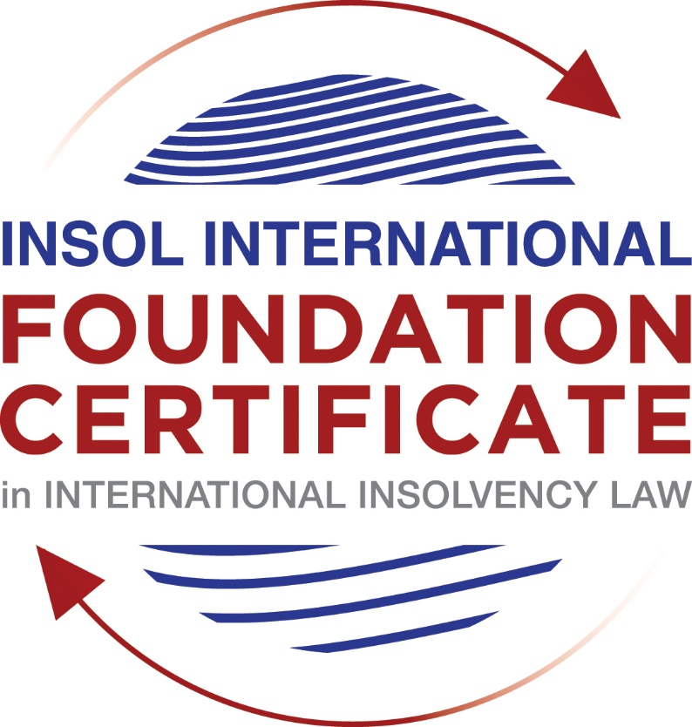

SUMMATIVE (FORMAL) ASSESSMENT: MODULE 3A

THE INSOLVENCY SYSTEM OF THE UNITED STATES

This is the summative (formal) assessment for Module 3A of this course and is compulsory for all candidates who selected this module as one of their compulsory modules from Module 3. Please read instruction 6.1 on the next page very carefully.

If you selected this module as one of your elective modules, please read instruction 6.2 on the next page very carefully.

The mark awarded for this assessment will determine your final mark for Module 3A. In order to pass this module, you need to obtain a mark of 50% or more for this assessment.

INSTRUCTIONS FOR COMPLETION AND SUBMISSION OF ASSESSMENT

Please read the following instructions very carefully before submitting / uploading your assessment on the Foundation Certificate web pages.

1. You must use this document for the answering of the assessment for this module. The answers to each question must be completed using this document with the answers populated under each question.

2. All assessments must be submitted electronically in MS Word format, using a standard A4 size page and a 11-point Arial font. This document has been set up with these parameters – please do not change the document settings in any way. DO NOT submit your assessment in PDF format as it will be returned to you unmarked.

3. No limit has been set for the length of your answers to the questions. However, please be guided by the mark allocation for each question. More often than not, one fact / statement will earn one mark (unless it is obvious from the question that this is not the case).

4. You must save this document using the following format: [student number.assessment3A]. An example would be something along the following lines: 202021IFU-314.assessment3A. Please also include the filename as a footer to each page of the assessment (this has been pre-populated for you, merely replace the words “studentnumber” with the student number allocated to you). Do not include your name or any other identifying words in your file name. Assessments that do not comply with this instruction will be returned to candidates unmarked.

5. Before you will be allowed to upload / submit your assessment via the portal on the Foundation Certificate web pages, you will be required to confirm / certify that you are the person who completed the assessment and that the work submitted is your own, original work. Please see the part of the Course Handbook that deals with plagiarism and dishonesty in the submission of assessments. Please note that copying and pasting from the Guidance Text into your answer is prohibited and constitutes plagiarism. You must write the answers to the questions in your own words.

6.1 If you selected Module 3A as one of your compulsory modules (see the e-mail that was sent to you when your place on the course was confirmed), the final time and date for the submission of this assessment is 23:00 (11 pm) GMT on 1 March 2021. The assessment submission portal will close at 23:00 (11 pm) GMT on 1 March 2021. No submissions can be made after the portal has closed and no further uploading of documents will be allowed, no matter the circumstances.

6.2 If you selected Module 3A as one of your elective modules (see the e-mail that was sent to you when your place on the course was confirmed), you have a choice as to when you may submit this assessment. You may either submit the assessment by 23:00 (11 pm) GMT on 1 March 2021 or by 23:00 (11 pm) BST on 31 July 2021. If you elect to submit by 1 March 2021, you may not submit the assessment again by 31 July 2021 (for example, in order to achieve a higher mark).

7. Prior to being populated with your answers, this assessment consists of 8 pages.

ANSWER ALL THE QUESTIONS

QUESTION 1 (multiple-choice questions) [10 marks in total]

Questions 1.1. – 1.10. are multiple-choice questions designed to assess your ability to think critically about the subject. Please read each question carefully before reading the answer options. Be aware that some questions may seem to have more than one right answer, but you are to look for the one that makes the most sense and is the most correct. When you have a clear idea of the question, find your answer and mark your selection on the answer sheet by highlighting the relevant paragraph in yellow. Select only ONE answer. Candidates who select more than one answer will receive no mark for that specific question.

Question 1.1

FabCo, based in Utah, owes SupplyCo, based in Mexico, US$10,000 on a past-due invoice. May SupplyCo file an involuntary petition to place FabCo into chapter 11 bankruptcy proceedings?

- Yes.

- Yes, if FabCo has fewer than 12 non-contingent, non-insider creditors.

- Yes, if other creditors owed at least US$5,775 join in the petition.

- No, because SupplyCo doesn’t know whether FabCo is insolvent.

- No, because SupplyCo is not a US company.

Question 1.2

Which of the following is a mandatory, rather than discretionary, basis to deny recognition of a foreign judgment under state law based on one of the Uniform Acts?

- The foreign judgment is subject to appeal in the foreign country.

- The foreign judgment is an injunction.

- The foreign judgment was issued by a court, contrary to the parties’ agreement to arbitrate.

- The defendant did not have sufficient notice of the foreign proceeding to put on a defense.

- The foreign judgment is inconsistent with another final judgment on the same subject matter.

Question 1.3

Which of the following is likely to be a party in interest in the bankruptcy of XYZ Corp?

- A shareholder in ABC Corp, to which XYZ Corp is substantially indebted.

- A journalist writing about XYZ Corp’s bankruptcy.

- A shareholder in MNO Corp, which owns all of XYZ Corp’s shares.

- A retired employee of XYZ Corp who receives payments from the company’s pension plan.

- A non-profit organization that advocates for companies like XYZ Corp to be held responsible for climate change.

Question 1.4

If a debtor rejects an executory trademark license agreement under which it licenses a trademark to its counterparty, which of the following is true:

- The counterparty must immediately stop using the trademark.

- The counterparty can continue using the trademark for the remaining period of the license.

- The counterparty has a claim for damages for breach of contract.

- Both (a) and (c).

- Both (b) and (c).

Question 1.5

In which of the following circumstances may a counterparty enforce a contractual ipso facto clause?

- The contract would obligate the counterparty to extend a loan to the debtor.

- The contract is a lease of real property.

- The clause is triggered by the bankruptcy filing of a third party, not the debtor.

- Both (a) and (c).

- Ipso facto clauses are never enforceable against a debtor.

Question 1.6

What does a chapter 11 debtor have exclusivity to propose for the first 120 days of proceedings?

- Avoidance actions.

- A plan of reorganization.

- DIP financing.

- Lifting the automatic stay.

- Formation of an equity committee.

Question 1.7

Which of the following is not a requirement to confirm a “cramdown” plan?

- Acceptance of the plan by all classes of secured creditors.

- Acceptance of the plan by at least one class of impaired, non-insider creditors.

- The plan is fair and equitable to dissenting classes of creditors.

- The plan does not discriminate unfairly against dissenting classes of creditors.

- The dissenting creditors receive no less than they would under a liquidation scenario.

Question 1.8

When may distributions to creditors diverge from the absolute priority rule?

- In a chapter 7 proceeding with consent of the affected senior creditor.

- In a chapter 7 proceeding with consent of the affected junior creditor.

- In a chapter 11 proceeding with consent of the affected senior creditor.

- In a chapter 11 proceeding with consent of the affected junior creditor.

- The absolute priority rule cannot be deviated from.

Question 1.9

Who may serve as a foreign representative to seek recognition of a foreign proceeding under chapter 15?

- An officer of the debtor if it is a debtor-in-possession in the foreign proceeding.

- The board of directors of the debtor if it is a debtor-in-possession in the foreign proceeding.

- An insolvency professional appointed by the court overseeing the foreign proceeding.

- An insolvency professional appointed by a creditor where the foreign proceeding is an involuntary receivership.

- All of the above.

Question 1.10

Which of the following is not available as relief in a chapter 15 proceeding?

- Sale of US property free and clear pursuant to section 363.

- Prosecution of avoidance actions pursuant to section 544 .

- Entrusting the management of US assets to the foreign representative.

- Application of the automatic stay under section 362 to the debtor’s interests in US property.

- Discovery about the debtor’s assets.

QUESTION 2 (direct questions) [10 marks]

Question 2.1 [maximum 1 mark]

What two alternative qualifications render a corporation eligible to be a debtor in a US chapter 7 or 11 proceeding?

According to Section 109, a corporation that has (i) a place of business or (ii) property in the US may be a debtor in a US chapter 7 or 11 proceeding.

Question 2.2 [maximum 2 marks]

What is an executory contract?

There is no definition of an executory contract in Bankruptcy Code. However, generally speaking it is defined through case law as a contract under which there are material unperformed obligations on both sides.

Question 2.3 [maximum 2 marks]

What is a “priming lien” and what requirements must be met for such a lien to be granted to secure DIP financing?

A “priming lien” is a lien that is senior or equal to a pre-petition lien on estate property. The requirements for a court to grant a priming lien are (i) financing cannot be obtained in any other ways and (ii) there is adequate protection of the interest of the lien holder on the property of the estate on which the priming lien will be granted.

Question 2.4 [maximum 2 marks]

In voting on a plan of reorganization, which class(es) of creditors are (i) deemed to accept the plan, (ii) deemed to reject the plan and (iii) permitted to vote on the plan? What vote is necessary for a class of creditors to accept a plan?

(i) A class that is not impaired under the plan is deemed to accept the plan according to Section 1126(f) of Bankruptcy Code.
(ii) A class whose claims or interests will not receive any property under the plan is deemed to reject the plan according to Section 1126(g) of Bankruptcy Code.
(iii) impaired classes are permitted to vote on the plan.

Favourable votes by creditors of the class holding (i) at least two-thirds in amount and (ii) more than one-half in number of the allowed claims are necessary for a class of creditors to accept a plan.

Question 2.5 [maximum 3 marks]

How does the automatic stay available in chapter 15 proceedings differ from that available in chapter 11 proceedings?

The automatic stay available in chapter 15 proceedings has a carve-out that allows the filing of a bankruptcy proceeding under Bankruptcy Code even after the recognition while the automatic stay available in chapter 11 proceedings does not have such a carve-out.

QUESTION 3 (essay-type questions) [15 marks in total]

Question 3.1 [maximum 3 marks]

What fiduciary duties do directors of Delaware corporations owe and to whom are the duties owed in the ordinary course of business? To whom are duties owed when the corporation is potentially or actually insolvent?

Directors of Delaware corporations owe fiduciary duties of loyalty to the corporation’s best interest and duties of care in educated decision-making. Those duties are subject to the business judgment rule which includes a rebuttable presumption that the directors have acted in good faith and with reasonably informed.

Directors of a Delaware corporation owe these duties only to the corporation and its shareholders, i.e., not to its creditors not only in the ordinary course of business but also when the corporation is potentially or actually insolvent.

Question 3.2 [maximum 3 marks]

Describe the circumstances in which a bankruptcy court may enter a final order, who reviews appeals from bankruptcy court orders and how non-final orders are reviewed.

As the US Supreme Court held that the bankruptcy court’s power to enter a final order is unconstitutional under Article III even in a core proceeding, the parties’ consent is required for the bankruptcy court to issue a final order.

Generally, appeals from bankruptcy court orders are reviewed by the district court in the relevant district while in some circuits, such appeals are reviewed by a Bankruptcy Appellate Panel (BAP) convened by the bankruptcy court judges. In very limited circumstances, such appeals may be reviewed by the circuit court of appeals.

Non-final orders by a bankruptcy court are reviewed de novo as to all findings of fact and conclusions of law to which a party objected.

Question 3.3 [maximum 4 marks]

Describe how claims for recovery of preferences, fraudulent conveyance and constructive fraudulent conveyance differ.

These claims are similar in terms that they aim at recovery for the estate from pre-petition transferees. The key difference between the avoidance of preferences and fraudulent conveyance is the purpose - the purpose of avoidance of preferences is to procure equal and fair treatment among similarly situated creditors of an insolvent debtor while the purpose of avoidance of fraudulent conveyance is to recover damages arising from a transaction that is conducted for a fraudulent intent and detrimental to the debtor and its creditors. This leads to a few differences of the factors of these claims. For example, if the transferee was not a creditor of the debtor, the choice of the claim must be avoidance of fraudulent conveyance. Also, for preferences, the debtor must be insolvent at the time of the transfer, and the transfer must be made during 90 days prior to the petition date (1 year, for an insider transferee). On the other hand, for fraudulent conveyance, the debtor does not have to be insolvent at the time of the transfer as long as the transfer was made within a two year period prior to the petition date.

The key difference between (actual) fraudulent conveyance and constructive fraudulent conveyance is that while one of the requirements of (actual) fraudulent conveyance is fraudulent intent as stipulated in Section 548(a), the constructive fraudulent conveyance does not require to prove the fraudulent intent when the debtor received less than reasonably equivalent value in exchange for the transfer, and the certain requirements under Section 548(a)(1)(B) of Bankruptcy Code are proven.

Question 3.4 [maximum 5 marks]

How does a US bankruptcy court determine whether a foreign proceeding is a main or non-main proceeding under chapter 15?

Under chapter 15, if a foreign proceeding is commenced in the debtor’s “COMI (center of main interests)”, the proceeding falls under a foreign main proceeding. There is a rebuttable presumption that the debtor’s registered office is its COMI under Section 1516(c) of Bankruptcy Code. There are some factors that should be considered when determining the debtor’s COMI as follows (In re SPhinX, Ltd):
- location of headquarters;
- location of management;
- location of primary assets;
- location of a majority of debtor’s creditors or a majority of the creditors that will be affected by the relief requested by the foreign representative; and
- jurisdiction whose law will apply to most disputes.

In addition, debtor’s COMI should be ascertainable by its creditors or other third parties based on objective evidence (Morning Mist).

In the case that the proceeding cannot be recognized as a foreign main proceeding but the debtor has an “establishment”, the proceeding can be recognized as a foreign non-main proceeding. An establishment is defined as any place of operations where the debtor carries out a nontransitory economic activity under Section 1502(2) of Bankruptcy Code.

QUESTION 4 (fact-based application-type question) [15 marks in total]

Question 4.1 [maximum 5 marks]

Rental Corporation is a publicly-traded company that leases office space from office building owners and sublets the space to small businesses. It has recently announced that it is being investigated by the US Department of Justice Fraud Division (DOJ) regarding allegedly fraudulent misstatements of revenues; shortly after the announcement, a securities class action litigation was filed against Rental Corporation in New York federal court. Due to the increase in the numbers of businesses operating remotely, Rental Corporation has suffered a decline in revenues. As a result, it has failed to pay rent on some of its office space leases and it has just defaulted on its quarterly payment on its credit facility. What would be the effect of a chapter 11 petition being filed by Rental Corporation on each of (i) the DOJ investigation, (ii) the securities class action litigation; (iii) the delinquent leases and (iv) the credit facility?

On the filing of a chapter 11 petition by Rental Corporation (“RC”), the automatic stay comes into effect and prevents RC’s creditors from implementing its rights against RC. Therefore, (ii) the securities class action litigation and any exercise of rights deriving from (iv) the credit facility would be stayed.
However, as regulatory investigations are exempted from the stay under Section 362(b) of Bankruptcy Code, (i) the DOJ investigation would not be affected by the RC’s chapter 11 petition.
Also, the right to eviction of a debtor-tenant from non-residential property where the lease has expired is exempted from the stay under Section 362(b) of Bankruptcy Code, (iii) the delinquent leases would not be affected by the RC’s chapter 11 petition.

Question 4.2 [maximum 5 marks]

Considering the facts set forth in Question 4.1, what protections does the Bankruptcy Code provide to lessors of office space to Rental Corporation?

According to Section 365(a), RC, subject to the court’s approval, may assume or reject any unexpired lease.
In relation to this provision, Section 365(d)(2) of the Bankruptcy Code provides a protection to the lessor of office space to Rental Corporation - such lessor may request that the court order the debtor to determine within a specified period of time whether to assume or reject such lease so that such lessor will not be put on an overly unstable position.

Question 4.3 [maximum 5 marks]

Paint Corporation formulates house paint according to proprietary and patented recipes at its factory in the United States, which it sells to home improvement stores under a number of distribution contracts. The US Environmental Protection Agency is investigating whether Paint Corporation’s operations are causing harmful chemicals to contaminate a nearby river. Paint Corporation is concerned it cannot afford the clean-up that may be required and is seeking to sell its business. Home Corporation is interested in buying the business, but does not want the potentially contaminated property (it can manufacture paint at its own factory) and is concerned about obtaining consent from all the home improvement stores to assign the distribution contracts. How would a sale under section 363 of the Bankruptcy Code address these issues?

A 363 sale under the Bankruptcy Code enables the purchaser to obtain the property of the debtor free and clear of the creditors interests. Therefore, it is likely that even if the property is contaminated and people affected by such contamination potentially hold claims against Paint Corporation, such people will not be able to sue the purchaser.
The debtor is able to transfer its interests in important contracts even if they include provisions that put restrictions on assignment or bankruptcy filing. Therefore, it is easier for the purchaser to obtain consent from the home improvement stores to assign the distribution contracts compared to the situation where Paint Corporation is not under its bankruptcy proceedings.

* End of Assessment *

