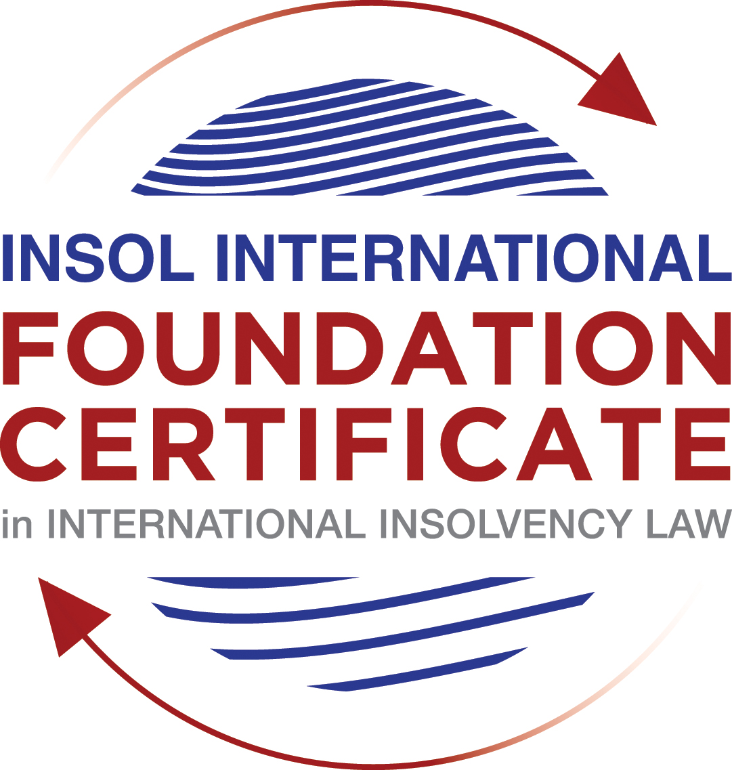

SUMMATIVE (FORMAL) ASSESSMENT: MODULE 3A

THE INSOLVENCY SYSTEM OF THE UNITED STATES

This is the summative (formal) assessment for Module 3A of this course and is compulsory for all candidates who selected this module as one of their compulsory modules from Module 3. Please read instruction 6.1 on the next page very carefully.

If you selected this module as one of your elective modules, please read instruction 6.2 on the next page very carefully.

The mark awarded for this assessment will determine your final mark for Module 3A. In order to pass this module, you need to obtain a mark of 50% or more for this assessment.

INSTRUCTIONS FOR COMPLETION AND SUBMISSION OF ASSESSMENT

Please read the following instructions very carefully before submitting / uploading your assessment on the Foundation Certificate web pages.

1. You must use this document for the answering of the assessment for this module. The answers to each question must be completed using this document with the answers populated under each question.

2. All assessments must be submitted electronically in MS Word format, using a standard A4 size page and a 11-point Arial font. This document has been set up with these parameters – please do not change the document settings in any way. DO NOT submit your assessment in PDF format as it will be returned to you unmarked.

3. No limit has been set for the length of your answers to the questions. However, please be guided by the mark allocation for each question. More often than not, one fact / statement will earn one mark (unless it is obvious from the question that this is not the case).

4. You must save this document using the following format: [student number.assessment3A]. An example would be something along the following lines: 202021IFU-314.assessment3A. Please also include the filename as a footer to each page of the assessment (this has been pre-populated for you, merely replace the words “studentnumber” with the student number allocated to you). Do not include your name or any other identifying words in your file name. Assessments that do not comply with this instruction will be returned to candidates unmarked.

5. Before you will be allowed to upload / submit your assessment via the portal on the Foundation Certificate web pages, you will be required to confirm / certify that you are the person who completed the assessment and that the work submitted is your own, original work. Please see the part of the Course Handbook that deals with plagiarism and dishonesty in the submission of assessments. Please note that copying and pasting from the Guidance Text into your answer is prohibited and constitutes plagiarism. You must write the answers to the questions in your own words.

6.1 If you selected Module 3A as one of your compulsory modules (see the e-mail that was sent to you when your place on the course was confirmed), the final time and date for the submission of this assessment is 23:00 (11 pm) GMT on 1 March 2021. The assessment submission portal will close at 23:00 (11 pm) GMT on 1 March 2021. No submissions can be made after the portal has closed and no further uploading of documents will be allowed, no matter the circumstances.

6.2 If you selected Module 3A as one of your elective modules (see the e-mail that was sent to you when your place on the course was confirmed), you have a choice as to when you may submit this assessment. You may either submit the assessment by 23:00 (11 pm) GMT on 1 March 2021 or by 23:00 (11 pm) BST on 31 July 2021. If you elect to submit by 1 March 2021, you may not submit the assessment again by 31 July 2021 (for example, in order to achieve a higher mark).

7. Prior to being populated with your answers, this assessment consists of 8 pages.

ANSWER ALL THE QUESTIONS

QUESTION 1 (multiple-choice questions) [10 marks in total]

Questions 1.1. – 1.10. are multiple-choice questions designed to assess your ability to think critically about the subject. Please read each question carefully before reading the answer options. Be aware that some questions may seem to have more than one right answer, but you are to look for the one that makes the most sense and is the most correct. When you have a clear idea of the question, find your answer and mark your selection on the answer sheet by highlighting the relevant paragraph in yellow. Select only ONE answer. Candidates who select more than one answer will receive no mark for that specific question.

Question 1.1

FabCo, based in Utah, owes SupplyCo, based in Mexico, US$10,000 on a past-due invoice. May SupplyCo file an involuntary petition to place FabCo into chapter 11 bankruptcy proceedings?

- Yes.

- Yes, if FabCo has fewer than 12 non-contingent, non-insider creditors.

- Yes, if other creditors owed at least US$5,775 join in the petition.

- No, because SupplyCo doesn’t know whether FabCo is insolvent.

- No, because SupplyCo is not a US company.

Question 1.2

Which of the following is a mandatory, rather than discretionary, basis to deny recognition of a foreign judgment under state law based on one of the Uniform Acts?

- The foreign judgment is subject to appeal in the foreign country.

- The foreign judgment is an injunction.

- The foreign judgment was issued by a court, contrary to the parties’ agreement to arbitrate.

- The defendant did not have sufficient notice of the foreign proceeding to put on a defense.

- The foreign judgment is inconsistent with another final judgment on the same subject matter.

Question 1.3

Which of the following is likely to be a party in interest in the bankruptcy of XYZ Corp?

- A shareholder in ABC Corp, to which XYZ Corp is substantially indebted.

- A journalist writing about XYZ Corp’s bankruptcy.

- A shareholder in MNO Corp, which owns all of XYZ Corp’s shares.

- A retired employee of XYZ Corp who receives payments from the company’s pension plan.

- A non-profit organization that advocates for companies like XYZ Corp to be held responsible for climate change.

Question 1.4

If a debtor rejects an executory trademark license agreement under which it licenses a trademark to its counterparty, which of the following is true:

- The counterparty must immediately stop using the trademark.

- The counterparty can continue using the trademark for the remaining period of the license.

- The counterparty has a claim for damages for breach of contract.

- Both (a) and (c).

- Both (b) and (c).

Question 1.5

In which of the following circumstances may a counterparty enforce a contractual ipso facto clause?

- The contract would obligate the counterparty to extend a loan to the debtor.

- The contract is a lease of real property.

- The clause is triggered by the bankruptcy filing of a third party, not the debtor.

- Both (a) and (c).

- Ipso facto clauses are never enforceable against a debtor.

Question 1.6

What does a chapter 11 debtor have exclusivity to propose for the first 120 days of proceedings?

- Avoidance actions.

- A plan of reorganization.

- DIP financing.

- Lifting the automatic stay.

- Formation of an equity committee.

Question 1.7

Which of the following is not a requirement to confirm a “cramdown” plan?

- Acceptance of the plan by all classes of secured creditors.

- Acceptance of the plan by at least one class of impaired, non-insider creditors.

- The plan is fair and equitable to dissenting classes of creditors.

- The plan does not discriminate unfairly against dissenting classes of creditors.

- The dissenting creditors receive no less than they would under a liquidation scenario.

Question 1.8

When may distributions to creditors diverge from the absolute priority rule?

- In a chapter 7 proceeding with consent of the affected senior creditor.

- In a chapter 7 proceeding with consent of the affected junior creditor.

- In a chapter 11 proceeding with consent of the affected senior creditor.

- In a chapter 11 proceeding with consent of the affected junior creditor.

- The absolute priority rule cannot be deviated from.

Question 1.9

Who may serve as a foreign representative to seek recognition of a foreign proceeding under chapter 15?

- An officer of the debtor if it is a debtor-in-possession in the foreign proceeding.

- The board of directors of the debtor if it is a debtor-in-possession in the foreign proceeding.

- An insolvency professional appointed by the court overseeing the foreign proceeding.

- An insolvency professional appointed by a creditor where the foreign proceeding is an involuntary receivership.

- All of the above.

Question 1.10

Which of the following is not available as relief in a chapter 15 proceeding?

- Sale of US property free and clear pursuant to section 363.

- Prosecution of avoidance actions pursuant to section 544.

- Entrusting the management of US assets to the foreign representative.

- Application of the automatic stay under section 362 to the debtor’s interests in US property.

- Discovery about the debtor’s assets.

QUESTION 2 (direct questions) [10 marks]

Question 2.1 [maximum 1 mark]

What two alternative qualifications render a corporation eligible to be a debtor in a US chapter 7 or 11 proceeding?

- Presence of the debtor, its/his assets or place of business in the United States
- Cannot fall within the category of parties who cannot be recognized as debtors
  - Chapter 7 (s. 109(b)) – certain parties including railroads, insurance companies, banks and certain other financial institutions cannot be debtors
  - Chapter 11 (s. 109(d)) - certain parties including stockbrokers and commodity brokers cannot be debtors

Question 2.2 [maximum 2 marks]

What is an executory contract?

- This is a contract where both parties to the contract have material obligations to perform. Under the Bankruptcy Code, a debtor can elect to
  - Assume an executory contract – in which case the debtor would be expected to remedy the defaults
  - Reject the contract – here the debtor is deemed to have breached the contract immediately before the petition date, giving the counterparty an unsecured pre-petition claim in damages
  - Assume the contract and assign it to a third party – such third party must give adequate assurances of future performance

Question 2.3 [maximum 2 marks]

What is a “priming lien” and what requirements must be met for such a lien to be granted to secure DIP financing?

A lien on property senior to, or with the same priority as, existing liens on the same property.

A priming DIP financing is only available as a last resort when the debtor is unable to obtain any other type of financing (unsecured loans on an administrative priority basis or non-priming DIPs) and either consent of pre-petition secured creditors (generally those who see value in the DIP loan preserving their existing collateral) or a bankruptcy court determination that such secured creditors are adequately protected from the diminution in value of their collateral as a result of the priming lien.

Question 2.4 [maximum 2 marks]

In voting on a plan of reorganization, which class(es) of creditors are (i) deemed to accept the plan, (ii) deemed to reject the plan and (iii) permitted to vote on the plan? What vote is necessary for a class of creditors to accept a plan?

- Section 1126 of the Code refers to the Acceptance of a plan
- According to s. 1126(c) and (d), A given class of creditors approves the plan if a simple majority of the creditors in the Class (other than those whose acceptance or rejection of such plan was not in good faith, or was not solicited or procured in good faith), holding at least two-thirds of the value of claims in the class, vote in favour or, for equity interests, if two-thirds in amount of interests vote in favour.
- According to s. 1126(g) – an unimpaired class is deemed to accept the plan
- According to s. 1126(f) – “a class is deemed not to have accepted a plan if such plan provides that the claims or interests of such class do not entitle the holders of such claims or interests to receive or retain any property under the plan on account of such claims or interests”. Therefore, the class that receives nothing is deemed to have rejected the plan.
- Therefore, it is the ‘impaired classes’ who are allowed to vote on the plan.

Question 2.5 [maximum 3 marks]

How does the automatic stay available in chapter 15 proceedings differ from that available in chapter 11 proceedings?

- Automatic stays are dealt with under Section 362 of the US Bankruptcy Code.
- However, additionally, sections 1520 and 1521 deal with automatic stays under Chapter 15
- The automatic stay under chapter 15 proceeding is subject to a carveout to permit the filing of a plenary US bankruptcy proceeding even after the recognition of a foreign proceeding. (section 1520(c)).
- Unlike, under Chapter 11 when the automatic stay grants automatic protection, when an automatic stay is granted under Chapter 15 it does not result in automatic relief. To be granted automatic relief, the foreign judgement has to be recognised by the US Courts.
- However, the debtor may be entitled to ‘provisional relief’ after filing but before recognition (section 1519)
- The automatic stay under Chapter 11 is applicable to the debtors’ assets worldwide, but the automatic stay under chapter 15 is applicable only to the territory of the US (s. 1520(a)(1))

QUESTION 3 (essay-type questions) [15 marks in total]

Question 3.1 [maximum 3 marks]

What fiduciary duties do directors of Delaware corporations owe and to whom are the duties owed in the ordinary course of business? To whom are duties owed when the corporation is potentially or actually insolvent?

- The main duties that directors owe include the duties of loyalty, disclosure, good faith and oversight. Other core attributes include disinterestedness and independence.
- Directors owe a fiduciary duty of loyalty to act in the best interest of the corporation.
- The directors also need to exercise a duty of care in educated decision-making and need to be well informed. However, they are protected from liability for errors of judgment by the business judgment rule.
- Under the business judgment rule, the board of directors is presumed to have acted in good faith on the basis of reasonable information. This presumption can be rebutted only by showing that a majority of the board in fact were not reasonably informed, did not honestly believe that their decision was in the corporation’s best interest, or were not acting in good faith. Unless the presumption is rebutted, the directors will not be liable in the absence of a showing of gross negligence.
- As for whom the duties are owed to, it was made clear in the case of North Am Catholic Educational Programming Foundation, Inc v Gheewalla, 930 A.2d 92, 103 (Del 2007) that the directors’ duties do not shift from the shareholders to the creditors even when potentially or actually insolvent

Question 3.2 [maximum 3 marks]

Describe the circumstances in which a bankruptcy court may enter a final order, who reviews appeals from bankruptcy court orders and how non-final orders are reviewed.

- Court that may enter a final order
  - The district courts have the power to grant a final order
  - The 28 USC, section 157(a) empowers the district court to refer any proceedings under title 11 of the USC to the bankruptcy judges for the district.
  - The bankruptcy courts can determine ‘core proceedings’ (identified under 28 USC, s. 157(b)(2)) but can only hear non-core proceedings if they are sufficiently related to a bankruptcy proceedings, although they cannot make a final determination. In such proceeding, the bankruptcy judge “shall submit proposed findings of fact and conclusions of law to the district court, and any final order or judgment shall be entered by the district judge after considering the bankruptcy judge’s proposed findings and conclusions” (vide 28 USC, s. 157(c)). Therefore, the bankruptcy courts can only grant the final orders in relation to core proceedings.
- Who reviews appeals
  - appeals from bankruptcy court decisions are heard:
    - by the district court in which they sit or
    - in certain circuits, by a Bankruptcy Appellate Panel (BAP)
  - appeals against the order of a district court or BAP are reviewed by a circuit court of appeal
- How non-final orders are reviewed
  - Non-final or interlocutory orders of the bankruptcy court are reviewed by the district court or BAP. They review de novo all findings of fact and conclusions of law to which a party has objected.

Question 3.3 [maximum 4 marks]

Describe how claims for recovery of preferences, fraudulent conveyance and constructive fraudulent conveyance differ.

- Preferences
  - This is a transfer from the debtor to the creditor or for the creditors benefit, during the ‘suspect period’, before the petition
  - There is no need to show any fault of either the debtor or the recipient in connection with the payment having been made, and the recipient creditor suffers no penalty other than return of the transfer
  - The suspect period for transfers to
    - Third parties – 90 days prior to the petition date
    - Insiders – one year prior to the petition date
  - Transfer needs to be made when the debtor is insolvent
  - The recipient/creditor can claim defences, unlike in the case of a fraudulent conveyance and constructive fraudulent conveyance
- Fraudulent conveyance
  - Need to show that the debtor made a transfer with actual intent to “with actual intent to hinder, delay, or defraud any entity to which the debtor was or became . . . indebted.” (vide 11 USC 548(a)). This differs from Preferences, where you do not need to show any fault.
  - A debtor may expect to be ‘indebted’ due to the transfer
  - Intent may be proven circumstantially, by reference to “badges of fraud” developed in state fraudulent transfer law
  - Recipient can keep the property if taken for value and in good faith, unlike in the case of a Preference, where if the elements of s. 547 are satisfied and none of the defences apply, then the property must be returned to the debtors estate
- Constructive fraudulent conveyance
  - Needs to only be proven that the debtor received less than reasonably equivalent value in exchange for a transfer or incurrence of obligation and
  - that one of the following additional factors was present
    - the debtor was insolvent at the time of or became insolvent as a result of the transaction; (this differs from the Preferences as the debtor needs to have been insolvent at the time of the transfer)
    - the debtor was unreasonably undercapitalized for the business or transactions it was engaged in or planned to engage in;
    - the debtor intended to or believe it would incur debts beyond its ability to pay on maturity; or
    - the transfer was made to or for the benefit of an insider, or the debtor incurred an obligation under an employment contract with an insider outside the ordinary course of business
  - Recipient can keep the property if taken for value and in good faith, unlike in the case of a Preference, where if the elements of s. 547 are satisfied and none of the defences apply, then the property must be returned to the debtors estate

Question 3.4 [maximum 5 marks]

How does a US bankruptcy court determine whether a foreign proceeding is a main or non-main proceeding under chapter 15?

- The significance of the distinction between a main or non-main proceeding is that it determines the scope of relief available to the debtor following recognition.
- For example, immediately upon recognition as a foreign “main” proceeding, the automatic stay is implemented, preventing creditors from acting against a debtor’s assets. However, if the foreign proceeding is recognized as “non-main,” a Foreign Representative must request the court to invoke the automatic stay. Another example of relief immediately offered in a foreign “main” proceeding is the ability to invoke Bankruptcy Code Section 363, allowing a debtor to use, sell or lease property outside the ordinary course of business.
- If the proceedings do not fall into either category, recognition may be refused altogether.
- Foreign main proceedings
  - Foreign main proceedings are those that are commenced in the debtor’s center of main interests (COMI) – 11 USC s. 1502(4). This is a concept imported to US law from European law.
  - A debtor’s COMI is presumed to be its place of incorporation, but this is rebuttable.
  - There are several factors that are relevant in proving a debtor’s COMI, such as
    - location of headquarters;
    - location of management;
    - location of primary assets;
    - location of a majority of debtor’s creditors or a majority of the creditors that will be affected by the relief requested by the foreign representative; and
    - jurisdiction whose law will apply to most disputes
  - A debtor’s COMI should be ascertainable by its creditors or other third parties on the basis of objective evidence. Therefore, it cannot be based on the debtor’s subjective assessment.
  - It appears that the COMI is to be assessed as of the date of the US petition, not the commencement of foreign proceedings, a process has been developed of shifting COMI through the conduct of the foreign proceedings themselves. (case of Bear Stearns)
- Foreign non-main proceeding
  - A "foreign non-main proceeding" (a proceeding pending in a country where the debtor has an establishment, but not its center of main interests). - 11 USC s. 1502(5)
  - An establishment constitutes a place where it carried out non-transitory economic activity – prior to the commencement of chapter 15 proceedings (s. 1502(2))

QUESTION 4 (fact-based application-type question) [15 marks in total]

Question 4.1 [maximum 5 marks]

Rental Corporation is a publicly-traded company that leases office space from office building owners and sublets the space to small businesses. It has recently announced that it is being investigated by the US Department of Justice Fraud Division (DOJ) regarding allegedly fraudulent misstatements of revenues; shortly after the announcement, a securities class action litigation was filed against Rental Corporation in New York federal court. Due to the increase in the numbers of businesses operating remotely, Rental Corporation has suffered a decline in revenues. As a result, it has failed to pay rent on some of its office space leases and it has just defaulted on its quarterly payment on its credit facility. What would be the effect of a chapter 11 petition being filed by Rental Corporation on each of (i) the DOJ investigation, (ii) the securities class action litigation; (iii) the delinquent leases and (iv) the credit facility?

Unless a trustee is appointed, the debtor-in-possession is free to continue to operate its business in the ordinary course. This is one of the major advantages of proceeding under Chapter 11.

Effects of initiating a Chapter 11 proceeding
- Automatic stay
- Accepting or rejecting executory contracts
- Dealing with the property in a manner beneficial to the debtor (within the framework of the Title 11 USC)

- As for the effect on the DOJ investigation, as it is a regulatory investigation, the DOJ investigation is not subject to the automatic stay as per s.362(b)
- As for the effect on the securities class action litigation, it is not affected by the automatic stay as security contracts are not subject to the automatic stay as per s.362(b)
- Once a Chapter 11 petition is filed and the automatic stay comes into effect, any act to obtain possession or control of property of the estate is prevented. Therefore, delinquent leases
- In a Chapter 11 bankruptcy filing, unexpired leases become property of the bankruptcy estate. This allows the debtor to decide whether to assume the lease, or reject the lease. If assumed, the lease remains in effect. If rejected, the tenant is automatically deemed in breach of the agreement which allows the landlord to terminate the lease. (s. 365)
- Since the lease of Rental Corporation appears not to have expired and is not a residential property, the debtor has 120 days to decide whether to assume or reject the lease.
- If the debtor, that is Rental Corporation decides to assume the lease, then it must cure defaults and give the counterparty sufficient assurances of its future performance (s. 365(b)(1))
- Any attempt to collect on pre-petition claims cannot be enforced after the filing of a chapter 11 petition. Therefore, the debtor cannot be sued on the pre-petition claim arising under the credit facility.

Question 4.2 [maximum 5 marks]

Considering the facts set forth in Question 4.1, what protections does the Bankruptcy Code provide to lessors of office space to Rental Corporation?

- 11 U.S.C. § 365(d)(3) states that “timely perform all the obligations of the debtor" are required. Accordingly, the debtors are obliged to pay all post-petition rent when it is due.
- Since the payment of rent is stayed by the automatic stay, it is open to the lessor to move the court to lift the automatic stay and demand payment of the rent.
- The lessor can also file a Motion for adequate protection.
- Where the executory contract is rejected by the debtor, the lessor is entitled to
  - an administrative expense claim for the lessee’s use of the premises during the bankruptcy; and
  - lease rejection damages

Question 4.3 [maximum 5 marks]

Paint Corporation formulates house paint according to proprietary and patented recipes at its factory in the United States, which it sells to home improvement stores under a number of distribution contracts. The US Environmental Protection Agency is investigating whether Paint Corporation’s operations are causing harmful chemicals to contaminate a nearby river. Paint Corporation is concerned it cannot afford the clean-up that may be required and is seeking to sell its business. Home Corporation is interested in buying the business, but does not want the potentially contaminated property (it can manufacture paint at its own factory) and is concerned about obtaining consent from all the home improvement stores to assign the distribution contracts. How would a sale under section 363 of the Bankruptcy Code address these issues?

Under s 363(f), an asset may be sold free and clear with creditor consent, where the creditor interest is disputed or where the value of the property exceeds the value of the interest. In such circumstances, a creditor’s interest will attach to the proceeds of the sale, and it will receive priority in distribution of those proceeds.

As for the consent from all the home improvement stores to assign the distribution contracts, the debtor need not obtain the consent of all the lienholders as the lienholders do not have an automatic ground to object to the sale although they are entitled to part or whole of the proceeds of the sale (sections 363(c)(2) and (e)).

The sale assets can be sold free of security (liens), subject, broadly, to the lienholders' consent

The debtor, that is Paint Corp, can enter into a tentative asset purchase agreement with the ‘stalking horse bidder’. Then the debtor can file a motion with the bankruptcy court seeking approval of a sale of the debtor's assets at a bankruptcy auction. Therefore, the debtor and the potential buyer can agree on the terms of the purchase.

Under s. 365(c) and (e), the debtor can transfer its interests in key contracts that are required to operate the business (such as supply and employment contracts), even where they contain contractual restrictions on assignment or purport to terminate upon a bankruptcy filing. Licensees of patents and copyrights owned by the debtor are protected such that their licenses may not be terminated in connection with the sale of the intellectual property without their consent (s. 365(n)).

Therefore, in the course of the sale Paint Corp can transfer its key contracts, including the distribution contracts. However, prior to transferring the proprietary and patented recipes, Paint Corp would have to obtain the consent of any licensees to whom it has granted a licence of any IP rights.

Another advantage under the 363 sale would be that the Buyer has the ability to choose to assume certain favorable executory contracts and leases despite anti-assignment clauses, which are generally unenforceable in bankruptcy (s 365(f)(1)). Therefore, Paint Corp can choose which contracts it wants to assume and reject accordingly, including the distribution contracts.

While the ability to obtain property free from liens is an advantage of a sale under s. 363, it has its limitations. Such as:
- Lienholders must receive notice of the sale, or else they can later assert rights against the assets based on due process violations
- Some liabilities cannot be eliminated, such as environmental liabilities and successor liabilities relating to certain types of tort claims.

Therefore, Home Corp may not be able to obtain the property free of its environmental issues and The US Environmental Protection Agency’s investigation. This may affect Home Corp’s decision to purchase the property.

Another advantage is that an automatic stay is awarded to prevent any party’s terminating contracts essential to the business.

(Source: Buying Assets in a Section 363 Bankruptcy Sale: Overview, by Practical Law Bankruptcy & Restructuring and Practical Law Corporate & Securities)

* End of Assessment *

Chapter 15 Bankruptcy – A Powerful Tool for Cross-Border Distressed Entities, < https://www.sfgh.com/siteFiles/News/Chapter%2015%20Bankruptcy%20%E2%80%93%20A%20Powerful%20Tool%20for%20Cross-Border%20Distressed%20Entities.pdf>
https://www.bc-llp.com/tenant-files-chapter-11-bankruptcy/

