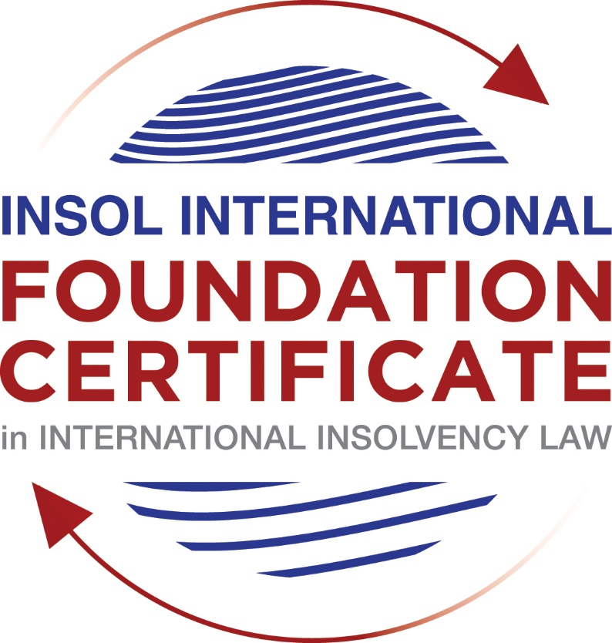

SUMMATIVE (FORMAL) ASSESSMENT: MODULE 3A

THE INSOLVENCY SYSTEM OF THE UNITED STATES

This is the summative (formal) assessment for Module 3A of this course and is compulsory for all candidates who selected this module as one of their compulsory modules from Module 3. Please read instruction 6.1 on the next page very carefully.

If you selected this module as one of your elective modules, please read instruction 6.2 on the next page very carefully.

The mark awarded for this assessment will determine your final mark for Module 3A. In order to pass this module, you need to obtain a mark of 50% or more for this assessment.

INSTRUCTIONS FOR COMPLETION AND SUBMISSION OF ASSESSMENT

Please read the following instructions very carefully before submitting / uploading your assessment on the Foundation Certificate web pages.

1. You must use this document for the answering of the assessment for this module. The answers to each question must be completed using this document with the answers populated under each question.

2. All assessments must be submitted electronically in MS Word format, using a standard A4 size page and a 11-point Arial font. This document has been set up with these parameters – please do not change the document settings in any way. DO NOT submit your assessment in PDF format as it will be returned to you unmarked.

3. No limit has been set for the length of your answers to the questions. However, please be guided by the mark allocation for each question. More often than not, one fact / statement will earn one mark (unless it is obvious from the question that this is not the case).

4. You must save this document using the following format: [student number.assessment3A]. An example would be something along the following lines: 202021IFU-314.assessment3A. Please also include the filename as a footer to each page of the assessment (this has been pre-populated for you, merely replace the words “studentnumber” with the student number allocated to you). Do not include your name or any other identifying words in your file name. Assessments that do not comply with this instruction will be returned to candidates unmarked.

5. Before you will be allowed to upload / submit your assessment via the portal on the Foundation Certificate web pages, you will be required to confirm / certify that you are the person who completed the assessment and that the work submitted is your own, original work. Please see the part of the Course Handbook that deals with plagiarism and dishonesty in the submission of assessments. Please note that copying and pasting from the Guidance Text into your answer is prohibited and constitutes plagiarism. You must write the answers to the questions in your own words.

6.1 If you selected Module 3A as one of your compulsory modules (see the e-mail that was sent to you when your place on the course was confirmed), the final time and date for the submission of this assessment is 23:00 (11 pm) GMT on 1 March 2021. The assessment submission portal will close at 23:00 (11 pm) GMT on 1 March 2021. No submissions can be made after the portal has closed and no further uploading of documents will be allowed, no matter the circumstances.

6.2 If you selected Module 3A as one of your elective modules (see the e-mail that was sent to you when your place on the course was confirmed), you have a choice as to when you may submit this assessment. You may either submit the assessment by 23:00 (11 pm) GMT on 1 March 2021 or by 23:00 (11 pm) BST on 31 July 2021. If you elect to submit by 1 March 2021, you may not submit the assessment again by 31 July 2021 (for example, in order to achieve a higher mark).

7. Prior to being populated with your answers, this assessment consists of 8 pages.

ANSWER ALL THE QUESTIONS

QUESTION 1 (multiple-choice questions) [10 marks in total]

Questions 1.1. – 1.10. are multiple-choice questions designed to assess your ability to think critically about the subject. Please read each question carefully before reading the answer options. Be aware that some questions may seem to have more than one right answer, but you are to look for the one that makes the most sense and is the most correct. When you have a clear idea of the question, find your answer and mark your selection on the answer sheet by highlighting the relevant paragraph in yellow. Select only ONE answer. Candidates who select more than one answer will receive no mark for that specific question.

Question 1.1

FabCo, based in Utah, owes SupplyCo, based in Mexico, US$10,000 on a past-due invoice. May SupplyCo file an involuntary petition to place FabCo into chapter 11 bankruptcy proceedings?

- Yes.

- Yes, if FabCo has fewer than 12 non-contingent, non-insider creditors.

- Yes, if other creditors owed at least US$5,775 join in the petition.

- No, because SupplyCo doesn’t know whether FabCo is insolvent.

- No, because SupplyCo is not a US company.

Question 1.2

Which of the following is a mandatory, rather than discretionary, basis to deny recognition of a foreign judgment under state law based on one of the Uniform Acts?

- The foreign judgment is subject to appeal in the foreign country.

- The foreign judgment is an injunction.

- The foreign judgment was issued by a court, contrary to the parties’ agreement to arbitrate.

- The defendant did not have sufficient notice of the foreign proceeding to put on a defense.

- The foreign judgment is inconsistent with another final judgment on the same subject matter.

Question 1.3

Which of the following is likely to be a party in interest in the bankruptcy of XYZ Corp?

- A shareholder in ABC Corp, to which XYZ Corp is substantially indebted.

- A journalist writing about XYZ Corp’s bankruptcy.

- A shareholder in MNO Corp, which owns all of XYZ Corp’s shares.

- A retired employee of XYZ Corp who receives payments from the company’s pension plan.

- A non-profit organization that advocates for companies like XYZ Corp to be held responsible for climate change.

Question 1.4

If a debtor rejects an executory trademark license agreement under which it licenses a trademark to its counterparty, which of the following is true:

- The counterparty must immediately stop using the trademark.

- The counterparty can continue using the trademark for the remaining period of the license.

- The counterparty has a claim for damages for breach of contract.

- Both (a) and (c).

- Both (b) and (c).

Question 1.5

In which of the following circumstances may a counterparty enforce a contractual ipso facto clause?

- The contract would obligate the counterparty to extend a loan to the debtor.

- The contract is a lease of real property.

- The clause is triggered by the bankruptcy filing of a third party, not the debtor.

- Both (a) and (c).

- Ipso facto clauses are never enforceable against a debtor.

Question 1.6

What does a chapter 11 debtor have exclusivity to propose for the first 120 days of proceedings?

- Avoidance actions.

- A plan of reorganization.

- DIP financing.

- Lifting the automatic stay.

- Formation of an equity committee.

Question 1.7

Which of the following is not a requirement to confirm a “cramdown” plan?

- Acceptance of the plan by all classes of secured creditors.

- Acceptance of the plan by at least one class of impaired, non-insider creditors.

- The plan is fair and equitable to dissenting classes of creditors.

- The plan does not discriminate unfairly against dissenting classes of creditors.

- The dissenting creditors receive no less than they would under a liquidation scenario.

Question 1.8

When may distributions to creditors diverge from the absolute priority rule?

- In a chapter 7 proceeding with consent of the affected senior creditor.

- In a chapter 7 proceeding with consent of the affected junior creditor.

- In a chapter 11 proceeding with consent of the affected senior creditor.

- In a chapter 11 proceeding with consent of the affected junior creditor.

- The absolute priority rule cannot be deviated from.

Question 1.9

Who may serve as a foreign representative to seek recognition of a foreign proceeding under chapter 15?

- An officer of the debtor if it is a debtor-in-possession in the foreign proceeding.

- The board of directors of the debtor if it is a debtor-in-possession in the foreign proceeding.

- An insolvency professional appointed by the court overseeing the foreign proceeding.

- An insolvency professional appointed by a creditor where the foreign proceeding is an involuntary receivership.

- All of the above.

Question 1.10

Which of the following is not available as relief in a chapter 15 proceeding?

- Sale of US property free and clear pursuant to section 363.

- Prosecution of avoidance actions pursuant to section 544 .

- Entrusting the management of US assets to the foreign representative.

- Application of the automatic stay under section 362 to the debtor’s interests in US property.

- Discovery about the debtor’s assets.

QUESTION 2 (direct questions) [10 marks]

Question 2.1 [maximum 1 mark]

What two alternative qualifications render a corporation eligible to be a debtor in a US chapter 7 or 11 proceeding?

Place of business or if any of its assets is in the United States.

Question 2.2 [maximum 2 marks]

What is an executory contract?

Executory contract is not defined in the statute. The meaning of executory contract is derived from the case laws. A contract is termed as executory if there are material obligations to be performed on both the sides.

Question 2.3 [maximum 2 marks]

What is a “priming lien” and what requirements must be met for such a lien to be granted to secure DIP financing?

Priming lien is the last option in the post commencement financing if the debtor is unable to obtain financing on any other terms available such as secured debt with a lien on unencumbered estate property or a secured debt with a junior lien on unencumbered estate property. Priming lien is a lien granted by the court which is a senior or equal to a pre-petition lien on estate property. This lien is granted only if the debtor can demonstrate that the interest of the secured creditor being primed is adequately protected.

Question 2.4 [maximum 2 marks]

In voting on a plan of reorganization, which class(es) of creditors are (i) deemed to accept the plan, (ii) deemed to reject the plan and (iii) permitted to vote on the plan? What vote is necessary for a class of creditors to accept a plan?

An unimpaired class is deemed to accept the plan. If a class is not receiving anything then they are deemed to reject the plan. An impaired class is permitted to vote on the plan. A class of creditors approves the plan if a simple majority of the creditors in the class, holding at least 2/3rd in value of claims in the class approve.

Question 2.5 [maximum 3 marks]

How does the automatic stay available in chapter 15 proceedings differ from that available in chapter 11 proceedings?

Chapter 15 proceedings automatic stay provides for a carve out. It permits filing of the plenary US bankruptcy proceedings even after recognition of the foreign judgement by the US court.

QUESTION 3 (essay-type questions) [15 marks in total]

Question 3.1 [maximum 3 marks]

What fiduciary duties do directors of Delaware corporations owe and to whom are the duties owed in the ordinary course of business? To whom are duties owed when the corporation is potentially or actually insolvent?

Director liabilities come under state laws i.e., the laws of the state of incorporation will be applicable. In UK Insolvency Laws, directors’ liabilities are well defined and there is a greater degree of analysis and duties casted upon the directors. However, in US, the director liabilities are limited. Directors owe fiduciary duties towards the best interest of the corporation and its shareholders (not its creditors) and are required to exercise a duty of care in making an educated decision making. This is applicable even when the corporation is potentially insolvent or is in zone of insolvency or indeed is insolvent. Consequently, there is no concept of wrongful trading under US Insolvency.

The directors are protected under the business judgment rule. This rule assumes that the board of directors acted in good faith based on reasonable information. This assumption can be rebutted only if it can be proven that the Board didn’t act in good faith, was not reasonably informed and failed to exercise due care.

Question 3.2 [maximum 3 marks]

Describe the circumstances in which a bankruptcy court may enter a final order, who reviews appeals from bankruptcy court orders and how non-final orders are reviewed.

US federal courts of system are established under Article III of the constitution. They consist of three levels of courts: trial level district courts, regional courts of appeal called circuit courts and the Supreme Court. Bankruptcy courts were not part of the federal courts system originally. They were established by legislation created under Article 1 power of the US Constitution. It is also pertinent to highlight those judges who have not been appointed under Article III of the US Constitution cannot exercise jurisdiction over matters subject to Article III.

The referral statute created in response to the striking down of the unconstitutional provisions of 1978 Bankruptcy Code creates a distinction between Core and Non-Core proceedings. Bankruptcy judges can hear only core proceedings. They can also hear non-core proceedings but there should be sufficient nexus with the bankruptcy proceedings, but no final decision can be made in this regard. Instead of taking final decisions, the bankruptcy courts will submit the findings of fact and conclusions of law to the district courts and the district courts will take the final decision. However, in Stern v. Marshall, the US Supreme Court ruled that even in the core proceedings, the bankruptcy courts cannot invade Article III of jurisdiction. Consequently, amendments to bankruptcy rules were introduced. Bankruptcy courts can now enter a final order on motion challenging the bankruptcy petition before the district court under delegated authority. The US Supreme court has also clarified that bankruptcy courts can adjudicate core proceedings by issuing a report and recommending review by the district courts like how it happens in non-core proceedings or with the consent of the parties.

Appeals from the bankruptcy courts are heard by the district courts of that district. However, in certain courts, appeals are heard by a Bankruptcy Appellate Panel (BAP). But the party my request that the appeal be heard by the district court. From the district court, the further appeal, that is appeal right lies to the circuit court of appeals.

Non final orders or interlocutory orders resolve only issues and claims. Interlocutory order can be appealed only with leave of the appellate court.

Question 3.3 [maximum 4 marks]

Describe how claims for recovery of preferences, fraudulent conveyance and constructive fraudulent conveyance differ.

Preference is a transfer of debtor’s property to a creditor for an antecedent debt owed by the debtor prior to the petition period and such transfer happening during the suspect period. The suspect period is 90 days prior to the petition date for the third parties but one year for insiders. Further, the transfer should result in recipient getting more amount than he would have received in Chapter 7 liquidation. In the event the transfer fulfils above conditions, the recipient will be required to return the property to the estate. There is no requirement of finding faults in either debtor or the recipient. The intention behind the clause is to ensure equal treatment of similarly situated creditors. The defence for creditor in preference transaction is that the creditor gave a contemporaneous new value to the debtor in the form of money, goods, services, or credit. There are many other defences such as ordinary course of business etc.

As against preferences, where the suspect period for third parties is 90 days prior to the petition date, for fraudulent conveyances it is two years prior to the petition date. In actual fraudulent conveyance the intent of the debtor should be shown. That is the intent to hinder, delay or defraud any entity to which the debtor was or became indebted. Intent can be proven circumstantially, by references to “badges of fraud” developed in a state fraudulent transfer law.

A constructive fraudulent transfer can be proven if the debtor receives less than reasonably equivalent value in exchange for incurrence of an obligation or transfer along with satisfaction of the following conditions: (a) debtor was insolvent at the time of transfer or became insolvent after the transfer; (b) debtor was unreasonably captialised for the business it was engaged in; (c) debtor incurred or intended to incur debts beyond its ability to pay on maturity; (d) the transfer was to an insider. Consequently, in constructive fraudulent transfer there is no ‘intent’ requirement.

Question 3.4 [maximum 5 marks]

How does a US bankruptcy court determine whether a foreign proceeding is a main or non-main proceeding under chapter 15?

The recognition of foreign proceedings as main or non-main proceedings under Chapter 15 is an important aspect as it will determine the relief. Foreign main proceedings are determined based on the centre of main interest (COMI). However, COMI is not a concept recognised in US. Debtor’s COMI is presumed to be the state of incorporation, but it is rebuttable by including following aspects in the analysis:
- Location of headquarters.
- Location of management.
- Location of primary assets.
- Majority of the debtor’s creditors or its creditors that will be affected by the relief.
- Jurisdiction, whose law will apply most to the disputes.

Further, a debtor’s COMI should be ascertainable if its creditors or third parties can ascertain basis the objective evidence.

A non-main proceeding can be open in a jurisdiction if the debtor has an establishment and it carried about non-transitory economic activity prior to the commencement of Chapter 15 proceedings.

QUESTION 4 (fact-based application-type question) [15 marks in total]

Question 4.1 [maximum 5 marks]

Rental Corporation is a publicly-traded company that leases office space from office building owners and sublets the space to small businesses. It has recently announced that it is being investigated by the US Department of Justice Fraud Division (DOJ) regarding allegedly fraudulent misstatements of revenues; shortly after the announcement, a securities class action litigation was filed against Rental Corporation in New York federal court. Due to the increase in the numbers of businesses operating remotely, Rental Corporation has suffered a decline in revenues. As a result, it has failed to pay rent on some of its office space leases and it has just defaulted on its quarterly payment on its credit facility. What would be the effect of a chapter 11 petition being filed by Rental Corporation on each of (i) the DOJ investigation, (ii) the securities class action litigation; (iii) the delinquent leases and (iv) the credit facility?

On Chapter 11 petition, there is a worldwide automatic stay. The scope of the stay is very wide, and it applies to debtor estates anywhere in the world. Consequently, the credit facility provided cannot be enforced as enforcement of any pre-petition claims are barred under automatic stay. Similarly, there will be a stay against the securities class action litigation as it will be considered as pre-petition claims. However, the automatic stay comes with certain statutory exceptions such as criminal proceedings, regulatory investigations, family law matters, eviction of debtor-tenant from a non-residential property where the lease has expired etc. Consequently, the chapter 11 petition will have no bearing on DOJ investigation as it is in relation fraud.

In case of delinquent leases, the automatic stay will be applicable as lessors will be barred from taking re-possession of the property leased.

Question 4.2 [maximum 5 marks]

Considering the facts set forth in Question 4.1, what protections does the Bankruptcy Code provide to lessors of office space to Rental Corporation?

The automatic stay can be lifted if the lessors can prove that there is lack of adequate protection to them as the value of the property may decline during the proceedings and lessors many end up making less than full recovery. This can be undertaken by moving a relief stay motion. Further, the lessors will be entitled to file a claim for pre-petition claims. Also, for this motion to go through, valuation will be a key factor, which is often a litigated matter.

Question 4.3 [maximum 5 marks]

Paint Corporation formulates house paint according to proprietary and patented recipes at its factory in the United States, which it sells to home improvement stores under a number of distribution contracts. The US Environmental Protection Agency is investigating whether Paint Corporation’s operations are causing harmful chemicals to contaminate a nearby river. Paint Corporation is concerned it cannot afford the clean-up that may be required and is seeking to sell its business. Home Corporation is interested in buying the business, but does not want the potentially contaminated property (it can manufacture paint at its own factory) and is concerned about obtaining consent from all the home improvement stores to assign the distribution contracts. How would a sale under section 363 of the Bankruptcy Code address these issues?

Paint Corporation should initiate a debtor in possession under Chapter 11 and operate under automatic stay. Chapter 11 is used to sell all or substantially all the assets of the debtor to another corporate entity or a strategic investor. As the debtor can deal with the property in an ordinary course of business the value that will be fetched for selling the business will be high and it can initiate a 363 sale. 363 Sale is a sale with the court approval and the property will be sold with free and clear of creditor interests. Further, the good faith purchase will be allowed to retain the property even the approval is reversed in appeal.

One of the key aspects 0f 363 Sale, which is relevant for this fact situation is, the debtor can transfer the interest in key contracts such as supply or employment contract even if the contract as restrictions on assignment or termination due to bankruptcy. Consequently, the Home Corporation, which is interested in the business but not the factory can take 363 Sale approach for assigning all the distribution contracts of Paint Corporation to Home Corporation subject to giving enough assurances to the counter parties i.e., home improvement stores that all the obligations of the debtor will be fulfilled.

* End of Assessment *

