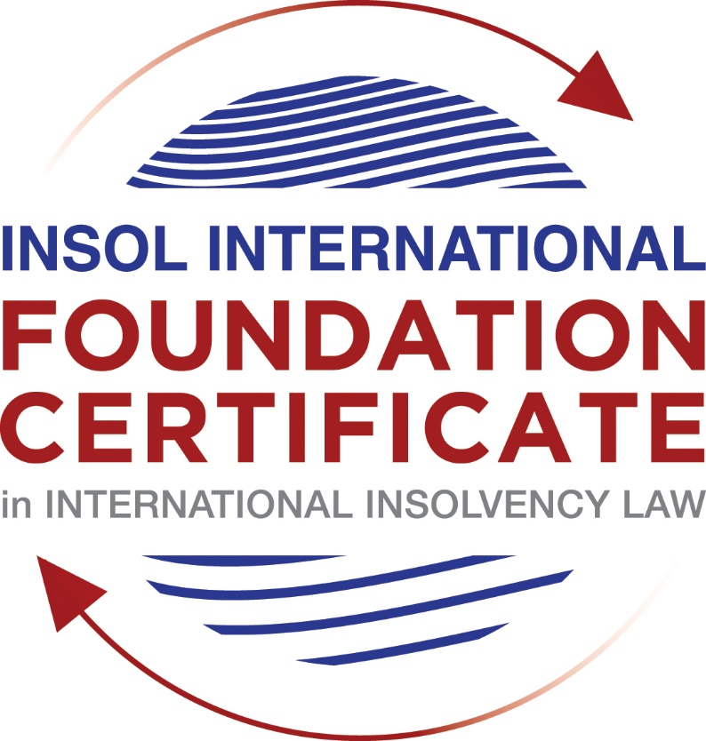

SUMMATIVE (FORMAL) ASSESSMENT: MODULE 3B

THE INSOLVENCY SYSTEM OF THE UNITED KINGDOM (ENGLAND AND WALES)

This is the summative (formal) assessment for Module 3B of this course and is compulsory for all candidates who selected this module as one of their compulsory modules from Module 3. Please read instruction 6.1 on the next page very carefully.

If you selected this module as one of your elective modules, please read instruction 6.2 on the next page very carefully.

The mark awarded for this assessment will determine your final mark for Module 3B. In order to pass this module, you need to obtain a mark of 50% or more for this assessment.

INSTRUCTIONS FOR COMPLETION AND SUBMISSION OF ASSESSMENT

Please read the following instructions very carefully before submitting / uploading your assessment on the Foundation Certificate web pages.

1. You must use this document for the answering of the assessment for this module. The answers to each question must be completed using this document with the answers populated under each question.

2. All assessments must be submitted electronically in MS Word format, using a standard A4 size page and a 11-point Arial font. This document has been set up with these parameters – please do not change the document settings in any way. DO NOT submit your assessment in PDF format as it will be returned to you unmarked.

3. No limit has been set for the length of your answers to the questions. However, please be guided by the mark allocation for each question. More often than not, one fact / statement will earn one mark (unless it is obvious from the question that this is not the case).

4. You must save this document using the following format: [student number.assessment3B]. An example would be something along the following lines: 202021IFU-314.assessment3B. Please also include the filename as a footer to each page of the assessment (this has been pre-populated for you, merely replace the words “studentnumber” with the student number allocated to you). Do not include your name or any other identifying words in your file name. Assessments that do not comply with this instruction will be returned to candidates unmarked.

5. Before you will be allowed to upload / submit your assessment via the portal on the Foundation Certificate web pages, you will be required to confirm / certify that you are the person who completed the assessment and that the work submitted is your own, original work. Please see the part of the Course Handbook that deals with plagiarism and dishonesty in the submission of assessments. Please note that copying and pasting from the Guidance Text into your answer is prohibited and constitutes plagiarism. You must write the answers to the questions in your own words.

6.1 If you selected Module 3B as one of your compulsory modules (see the e-mail that was sent to you when your place on the course was confirmed), the final time and date for the submission of this assessment is 23:00 (11 pm) GMT on 1 March 2021. The assessment submission portal will close at 23:00 (11 pm) GMT on 1 March 2021. No submissions can be made after the portal has closed and no further uploading of documents will be allowed, no matter the circumstances.

6.2 If you selected Module 3B as one of your elective modules (see the e-mail that was sent to you when your place on the course was confirmed), you have a choice as to when you may submit this assessment. You may either submit the assessment by 23:00 (11 pm) GMT on 1 March 2021 or by 23:00 (11 pm) BST on 31 July 2021. If you elect to submit by 1 March 2021, you may not submit the assessment again by 31 July 2021 (for example, in order to achieve a higher mark).

7. Prior to being populated with your answers, this assessment consists of 7 pages.

ANSWER ALL THE QUESTIONS

QUESTION 1 (multiple-choice questions) [10 marks in total]

Questions 1.1. – 1.10. are multiple-choice questions designed to assess your ability to think critically about the subject. Please read each question carefully before reading the answer options. Be aware that some questions may seem to have more than one right answer, but you are to look for the one that makes the most sense and is the most correct. When you have a clear idea of the question, find your answer and mark your selection on the answer sheet by highlighting the relevant paragraph in yellow. Select only ONE answer. Candidates who select more than one answer will receive no mark for that specific question.

Question 1.1

What is the initial period for a Moratorium under Part 1A of the Insolvency Act 1986 where the directors file relevant documents at court?

- 20 days.

- 20 business days.

- 40 days.

- 40 business days.

Question 1.2

What is the maximum length of a Moratorium under Part 1A of the Insolvency Act 1986 to which creditors can consent without any application to the court?

- 40 business days.

- One year and 20 business days.

- One year and 40 business days.

- One year.

Question 1.3

Which of the following is not a requirement for a company which wishes to enter into a Restructuring Plan under Part 26A of the Companies Act 2006?

- the company has encountered, or is likely to encounter, financial difficulties that are affecting, or will or may affect, its ability to carry on business as a going concern.

- a compromise or arrangement is proposed between the company and its creditors, or any class of them, or its members, or any class of them.

- the purpose of the compromise or arrangement is to eliminate, reduce or prevent, or mitigate the effect of, any of the said financial difficulties.

- the company is, or is likely to become, unable to pay their debts, as defined under section 123 of the Insolvency Act 1986.

Question 1.4

What percentage of creditors must approve a Scheme of Arrangement under Part 26 of the Companies Act 2006?

- A majority in number and in value.

- A majority in number and 50% or more in value.

- A majority in number and 75% or more in value.

- 75% or more in value.

Question 1.5

Which one of the following is not a debtor-in-possession procedure?

- Administration.

- Restructuring Plan.

- Scheme of Arrangement.

- Company Voluntary Arrangement.

Question 1.6

A liquidator may pay dividends to small value creditors based upon the information contained within the company’s statement of affairs or accounting records. In such circumstances, a creditor is deemed to have proved for the purposes of determination and payment of a dividend where the debt is no greater than how much?

- £500

- £750

- £1,000

- £2,000

Question 1.7

Which one of the following is not, in itself, a separate ground for disqualification of a director under the Company Directors Disqualification Act 1986?

- Wrongful trading.

- Breach of fiduciary duty.

- Being found guilty of an indictable offence in Great Britain.

- Being found guilty of an indictable offence overseas.

Question 1.8

The administrator is under a general duty to make a statement setting out proposals for achieving the purpose of administration. He or she must send out the statement of proposals as soon as reasonably practicable, and in any event within how many weeks of the date the company entered administration?

- 6

- 8

- 10

- 12

Question 1.9

Which of the following has the power to bring an action for wrongful trading under the Insolvency Act 1986?

- A monitor of a Moratorium.

- A supervisor of a Company Voluntary Arrangement.

- An administrator.

- An administrative receiver.

Question 1.10

Under section 176A of the Insolvency Act 1986, the prescribed part deducted from floating charge assets in favour of unsecured creditors is calculated as follows:

- 20% of the floating charge assets.

- 50% of the first £10,000 in value plus 20% of the excess in value above the £10,000 subject to a maximum amount of the prescribed part of £600,000.

- 20% of the first £50,000 in value plus 50% of the excess in value above the £50,000 subject to a maximum amount of prescribed part of £800,000.

- 50% of the first £10,000 in value plus 20% of the excess in value above the £10,000 subject to a maximum amount of prescribed part of £800,000.

QUESTION 2 (direct questions) [10 marks]

Question 2.1 [maximum 6 marks]

What is the difference between cash flow insolvency and balance sheet insolvency?

A company is in balance sheet insolvency if the value of their assets is lower than the value of liabilities, including any future or contingent liability as well as their current liabilities. On the other hand, cash flow insolvency refers to the capacity of the debtor to pay its debts within the deadlines. A debtor may not be in a balance sheet insolvency, for instance, if its fixed assets represent a big amount in the balance sheet, but if the debtor has not liquid assets to pay matured debts, it will be in a cash flow insolvency. Either of those tests could serve to request a liquidation order.

The test was developed in the case of BNY Corporate Trustee Services Ltd v Eurosail-UK 2007-3BL plc

Question 2.2 [maximum 4 marks]

List four (4) elements of the statutory moratorium imposed when a company enters administration.

- While a company is in administration a moratorium no resolution may be passed for the winding up of the company;
- No step may be taken to enforce security over the company’s property except with the consent of the administrator or the permission of the court;
- No step may be taken to repossess goods in the company’s possession under a hire-purchase agreement (which term includes retention of title contracts) except with the consent of the administrator or the permission of the court;
- No administrative receiver may be appointed.

QUESTION 3 (essay-type questions) [15 marks in total]

Question 3.1 [maximum 6 marks]

Explain the main differences between a Part 26 Scheme of Arrangement and a Part 26A Restructuring Plan.

From point of view of the scope, solvent and insolvent companies or are likely to become insolvent could use the scheme of arrangement. Conversely, the restructuring plan of Part 26A is applicable when a company is in financial difficulties or is likely to encounter financial difficulties to carry on business as a going concern.

From point of view of the majorities to approve the plan, under the scheme of the arrangement, voting rights will be required from both classes of creditors, secured and non-secured in the simple majority in number and a majority of 75% or more in value of creditors. On the other hand, a restructuring plan could be approved if is voted by 75% or more in value of the creditors or class of creditors, or members or class of members.

Since the provisions are applicable, in the restructuring plan pursuant to Part 26A the Court has the ability to cram down a dissenting class who does not approve the restructuring plan. The cram down power applies 1) if none of the dissenting class would be any worse off than they would be in the event of liquidation or administration proceeding, and 2) the arrangement has been agreed by 75% in value of at least one class of creditors or members. This mechanism is not available for the scheme of arrangement pursuant to Part 26.

Question 3.2 [maximum 9 marks]

Explain the different ways in which overseas officeholders may be recognised and request the assistance of the court in England and Wales.

First, under the EU Regulation (Regulation EU 2015/848), a company that has its COMI in an EU Member State may request for recognition of the main insolvency proceeding according to EU Regulation and it will be recognized in England and Wales if it complies requirements established in the same EU Regulation. Instead, if COMI is in England and Wales, such proceeding will be governed by the UK Laws and any appointment will be recognized in any EU Member State. In the last case, UK Laws will be applicable for all aspects, except for the security interests of creditors and employment rights because it will govern pursuant to the regulation of the EU Member State.

Furthermore, pursuant to EU Regulation, there are some applicable rules for the treatment of assets in other EU Regulations such as secondary insolvency proceedings, synthetic proceedings, among others.

Second, pursuant to the CBIR (Cross Border Insolvency Regulations 2006 SI 2006/1030) the UK incorporated the UNCITRAL Model Law on Cross-Border Insolvency with some amendments, for instance, the CBIR does not contain dispositions on reciprocity. Pursuant CBIR, any insolvency practitioner from any overseas jurisdiction may request in England and Wales the recognition of a foreign insolvency proceeding. In contrast to EU Regulation, recognition of a foreign insolvency proceeding and reliefs pursuant UNCITRAL Model Law are not automatically, it requires an application before to the local court.

Third, section 426 of the Act includes provisions to grant assistance in favor of listed jurisdictions. Pursuant to that section, an order from a UK Court related to insolvency may be enforceable in every United Kingdom. The duty of assistance is applicable too for the Channel Islands and the Isle of Man, and any other country or territory specified by the Secretary of State, such as Australia, Canada, Hong Kong, Ireland, Malaysia New Zealand, and South Africa.

Finally, the common law supposes that fairness between creditors requires a universal application for insolvency proceedings, but not a theory of modified universalism. Case law has developed requirements of the application of common law to grant assistance, nonetheless, is better adhere to some regulation such as EU Regulation, CBIR or section 423.

QUESTION 4 (fact-based application-type question) [15 marks in total]

Prior to going into liquidation in November 2020, under pressure from its bank, Stercus Bank plc, and in order to prevent it from demanding repayment of the company’s loans, Cork-In Limited granted a debenture in favour of Stercus Bank plc in January 2020. The debenture contained a floating charge over the whole of the company’s undertaking.

In June 2020, as the company continued to struggle, the directors approved the sale of a company delivery van to Paul Watson (a director) for £5,000 in cash. The van had been bought for £10,000 a year before.

A month before the company went into liquidation, Paul Watson received an irate phone call from one of the company’s key suppliers, Gary’s Grapes Limited. The supplier demanded immediate payment of all sums owing to it (even those invoices that had not become payable). Fearing being cut off by the supplier, Paul arranged for a cheque for the full amount to be sent that day.

The liquidator has asked for advice whether any action may be taken in respect of the floating charge in favour of Stercus Bank plc and the two subsequent transactions.

Using the facts above, answer the questions that follow.

Identify the relevant issues and statutory provisions and consider whether the liquidator may take any action in relation to:

Question 4.1 [maximum 5 marks]

The floating charge in favour of Stercus Bank plc;

Pursuant to section 245 of the Act, is prohibited for the debtor to grant security over a floating charge. For the purpose to determine if the debtor broke that prohibition is necessary that security had been granted shortly before a company enters a formal insolvency procedure, and when the debtor is unable to pay its debts as is described in Section 123 of the Act.

In this case, Stercus Bank plc is not connected to the debtor (assuming that is Cork-In Limited). Thus, the suspect period would be of 12 months period before the beginning of the insolvency proceeding. This requirement is fulfilled in this case because the act prohibited was made in January of 2020 and the commencement of the insolvency proceeding was in November of 2020. Thus, liquidator may begin actions in favour od Stercus Bank to lift security over floating charge.

Question 4.2 [maximum 5 marks]

The sale of the van; and

Regarding the sale of the van, the liquidator may attack that operation pursuant to section 238.3 of the Insolvency Act of 1986, as a transaction at undervalue. The liquidator must demonstrate that the sale was made during two years period before the commencement of the liquidation proceeding. In this case, it was made in Jun of 2020, it is, 5 months before the commencement of the insolvency proceeding (November 2020).

Pursuant to the Act, the company is presumed to have been insolvent, or to have become insolvent as a result of the transaction, because the transaction was made with a connected person (as Paul, in this case, because is a director). However, the presumption admits proving in contrary. For instance, Paul could hold that the transaction was made first, in good faith, and second in benefit of the company.

Nonetheless, Paul is not a supplier of the company and for that reason, the Court may hold that the transaction did not represent any benefit to the debtor. In this case, the Court may revoke the sale and order to make restitution as if the transaction had not taken place.

In addition, the liquidator may promote a disqualification of Paul as director, pursuant to the Company Directors Disqualification Act 1986 (CDDA), to avoid that Paul becomes again as a director or act as a receiver of a company’s property, protecting the public confidence.

Question 4.3 [maximum 5 marks]

The payment to Gary’s Grapes Ltd.

T The liquidator may begin an action pursuant to section 239 of the Act because of the following considerations:

1. Gary’s Grapes Ltd. was a creditor of the company at the moment of the transaction.
2. The payment made granted preference to Gary’s Grapes Ltd. in comparison to other company’s creditors.
3. The company wanted to grant a preference under the assumption that Gary’s Grapes Ltd. is its supplier.
4. The transaction occurred just 1 month before the beginning of the liquidation proceeding. (The Act requires the transaction had occurred in the two years period before the commencement of the liquidation proceeding)

The liquidator must demonstrate that the company had no capacity to pay its debts or was in an insolvency status.

* End of Assessment *

