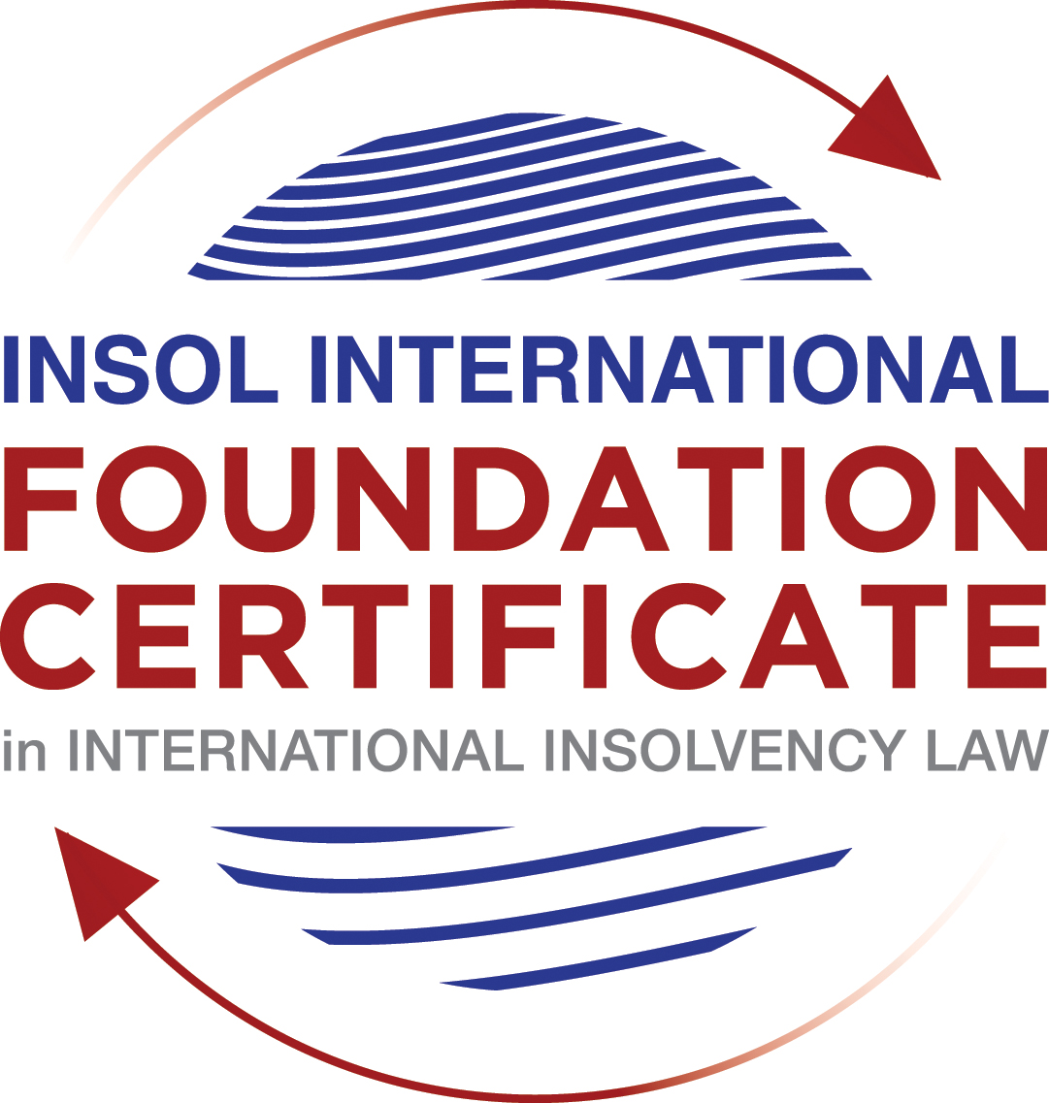

SUMMATIVE (FORMAL) ASSESSMENT: MODULE 5A

BERMUDA

This is the summative (formal) assessment for Module 5A of this course and is compulsory for all candidates who selected this module as one of their elective modules.

The mark awarded for this assessment will determine your final mark for Module 5A. In order to pass this module, you need to obtain a mark of 50% or more for this assessment.

INSTRUCTIONS FOR COMPLETION AND SUBMISSION OF ASSESSMENT

Please read the following instructions very carefully before submitting / uploading your assessment on the Foundation Certificate web pages.

1. You must use this document for the answering of the assessment for this module. The answers to each question must be completed using this document with the answers populated under each question.

2. All assessments must be submitted electronically in Microsoft Word format, using a standard A4 size page and an 11-point Arial font. This document has been set up with these parameters – please do not change the document settings in any way. DO NOT submit your assessment in PDF format as it will be returned to you unmarked.

3. No limit has been set for the length of your answers to the questions. However, please be guided by the mark allocation for each question. More often than not, one fact / statement will earn one mark (unless it is obvious from the question that this is not the case).

4. You must save this document using the following format: [studentnumber.assessment5A]. An example would be something along the following lines: 202021IFU-314.assessment5A. Please also include the filename as a footer to each page of the assessment (this has been pre-populated for you, merely replace the words “studentnumber” with the student number allocated to you). Do not include your name or any other identifying words in your file name. Assessments that do not comply with this instruction will be returned to candidates unmarked.

5. Before you will be allowed to upload / submit your assessment via the portal on the Foundation Certificate web pages, you will be required to confirm / certify that you are the person who completed the assessment and that the work submitted is your own, original work. Please see the part of the Course Handbook that deals with plagiarism and dishonesty in the submission of assessments. Please note that copying and pasting from the Guidance Text into your answer is prohibited and constitutes plagiarism. You must write the answers to the questions in your own words.

6. The final submission date for this assessment is 31 July 2021. The assessment submission portal will close at 23:00 (11 pm) GMT on 31 July 2021. No submissions can be made after the portal has closed and no further uploading of documents will be allowed, no matter the circumstances.

7. Prior to being populated with your answers, this assessment consists of 7 pages.

ANSWER ALL THE QUESTIONS

QUESTION 1 (multiple-choice questions) [10 marks in total]

Questions 1.1. – 1.10. are multiple-choice questions designed to assess your ability to think critically about the subject. Please read each question carefully before reading the answer options. Be aware that some questions may seem to have more than one right answer, but you are to look for the one that makes the most sense and is the most correct. When you have a clear idea of the question, find your answer and mark your selection on the answer sheet by highlighting the relevant paragraph in yellow. Select only ONE answer. Candidates who select more than one answer will receive no mark for that specific question.

Question 1.1
When is a Bermuda company deemed to be unable to pay its debts under section 161 and section 162 of the Companies Act 1981?

- Only when it is balance sheet insolvent.

- Only when it is cash flow insolvent.

- When it is balance sheet insolvent and cash flow insolvent.

- When it is either balance sheet insolvent, or cash flow insolvent, or a valid statutory demand has not been satisfied within a period of three weeks after service on the company’s registered office, or if a judgment in favour of a creditor remains unsatisfied.

Question 1.2

Who may appoint a Provisional Liquidator over a Bermuda company?

- A secured creditor.

- An unsecured creditor.

- The company itself (whether acting by its directors or its shareholders).

- The Supreme Court of Bermuda.

Question 1.3

In what order are the following paid in a compulsory liquidation under Bermuda law?

a) Preferential creditors; b) unsecured creditors; c) costs and expenses of the liquidation procedure; d) floating charge holders.

- a, b, c, d

- c, d, a, b

- c, a, d, b

- a, c, d, b

Question 1.4

What percentage of unsecured creditors must vote in favour of a creditors’ Scheme of Arrangement for it to be approved?

- Over 50% in value.

- 50% or more in value.

- Over 75% in value.

- A majority of each class of creditors present and voting, representing 75% or more in value.

Question 1.5

What is the clawback period for fraudulent preferences under section 237 of the Companies Act 1981?

- Two (2) years.

- One (1) month.

- Twelve (12) months.

- Six (6) months.

Question 1.6

What types of transactions are reviewable in the event of an insolvent liquidation?

- Only fraudulent conveyances.

- Only floating charges.

- Only post-petition dispositions.

- All of the above.

Question 1.7

How many insurance policyholders are required to present a petition for the winding up of an insolvent insurance company under section 34 of the Insurance Act 1978?

- At least five (5).

- One (1) is sufficient.

- At least 10 or more owning policies of an aggregate value of not less than BMD 50,000.

- At least 10.

Question 1.8

Where do secured creditors rank in a liquidation?

- Behind unsecured creditors.

- Behind preferential creditors.

- Behind the costs and expenses of liquidation.

- In priority to all other creditors, since they can enforce their security outside of the liquidation.

Question 1.9

Summary proceedings against a company’s directors for breach of duty (or misfeasance) may be brought by a liquidator under which provision of the Companies Act?

- Section 237 of the Companies Act 1981.

- Section 238 of the Companies Act 1981.

- Section 247 of the Companies Act 1981.

- Section 158 of the Companies Act 1981.

Question 1.10

What is a segregated account representative of an insolvent Segregated Accounts Company required to do under section 10 of the Segregated Accounts Companies Act 2000?

- Resign immediately.

- File a Suspicious Transaction Report forthwith.

- Make a written report to the Registrar of Companies within 30 days of reaching the view that there is a reasonable likelihood of a segregated account or the general account becoming insolvent.

- Notify the directors, creditors and account owners within 28 days.

QUESTION 2 (direct questions) [10 marks]

Question 2.1 [maximum 4 marks]

In what circumstances may be a Provisional Liquidator be appointed?
A Provisional Liquidator can be appointed prior to the final hearing of a compulsory winding up petition under Section 170(2) of the Companies Act 1981 if there is a good prima facie case that a winding up order will be made and if the court considers that a Provisional Liquidator should be appointed under the circumstances of the case to protect the best interests of creditors, such as a risk of dissipation of assets or the need for independent supervision and control.

With the benefit of a stay of other legal proceedings, a “soft-touch” Provisional Liquidator could be appointed for the purpose of restructuring. The board of directors manages the Scheme of Arrangement under the supervision of an independent Court officer, i.e. A provisional liquidator .

Question 2.2 [maximum 2 marks]

When can rights of set-off be exercised after the commencement of a liquidation of a Bermuda company?

Set-off can only be exercised after the commencement of a liquidation if:-
- the debts giving rise to the set-off were incurred prior to the commencement of liquidation and have crystallized as monetary payment liabilities;
- The transaction giving rise to the debts was not a fraudulent preference or a fraudulent conveyance; or
- The dealings between the parties were mutual (that is, the parties giving rise to the debt are identical to the parties giving rise to the credit and the parties have contracted with each other in the same capacity).

Question 2.3 [maximum 4 marks]

Describe three possible ways of taking security over assets under Bermuda law?

Under Bermuda law, there were three ways which a creditor can take security over assets which include:-

- Legal mortgage which the legal title of the debtor’s property being transferred to the creditor as security of a debt though the debtor remains in possession of the property. The debtor could only regain the legal title upon satisfaction of repayment of the debt.
- Equitable Mortgage which the debtor retain both the legal title and possession of the property but transfer the beneficial interest of the property to the creditor. An equitable mortgage does not take priority over a third party who, without notice of the creditor’s beneficial interest, acquires the legal title to the property in good faith and for value.
- Fixed charged over property that does not result in a transfer of legal or beneficial ownership but gives the creditor a right to take possession of the property with a right of sale, in the event of a default by the debtor; The debtor may not deal with any property that is subject to a fixed charge without the consent of the creditor. Upon exercise of the power of sale, the proceeds of sale may be applied by the creditor towards payment of the debt in priority to and without reference to other unsecured creditors.

QUESTION 3 (essay-type questions) [15 marks in total]

Question 3.1 [maximum 8 marks]

Write a brief essay on the basis upon which foreign liquidators are granted recognition and assistance in Bermuda.

An appointment of the foreign liquidator in a foreign court judgment has no direct legal effect in Bermuda and such a foreign judgment is not enforceable in Bermuda. Hence, to obtain recognition and assistance in Bermuda, foreign liquidators being appointed by the court of the company’s domicile could obtain the recognition from the Supreme Court of Bermuda under the common law system, instead of the statutory provisions. The Supreme Court of Bermuda has a discretion pursuant to such recognition and to assist the primary liquidation court in Bermuda.

The Privy Council usually assist when necessary to the foreign court of insolvency jurisdiction, but not available to a voluntary winding-up which is a private arrangement. Also, the Bermuda Court is more likely to recognize winding-up orders of foreign courts and assist foreign liquidators when it was proven of the following:-
- there is a sufficient connection between the foreign court’s jurisdiction and the foreign company
- there are documents, assets, or liabilities of the foreign company within the jurisdiction of Bermuda; and
- there is no public policy reason under Bermudian law to the contrary.

In recent judgments of the Privy Council, Singularis Holdings Limited v PricewaterhouseCoopers and PricewaterhouseCoopers v Saad Investments Comany Limited, the court ruled that the court does not have a power to assist foreign liquidators to do something which they could not do under the law by which they were appointed where in the case of a domestic insolvency. The exercise of the Court’s power must be consistent with the substantive law and public policy of the assisting court in Bermuda.

Question 3.2 [maximum 7 marks]

Write a brief essay on the circumstances in which a foreign Court judgment will not be registered or enforced in Bermuda.

A foreign Court judgment will be declined to be registered or enforced in Bermuda if the Supreme Court of Bermuda is satisfied that:-

- the foreign Court judgment is not covered by the 1958 Act or was registered in contravention of the 1958 Act;
- the foreign court had no jurisdiction in the circumstances of the case;
- the debtor did not receive notice of the proceedings in the foreign jurisdiction in sufficient time to enable time to defend the proceedings and did not appear’
- the foreign court judgment was obtained by fraud;
- the rights under it are not vested in the person by whom the application for registration was made;
- the foreign judgment conflicts with another prior judgment from another court;
- the foreign court judgment is not final and conclusive
- the foreign court judgment is for taxes, fines or penalties;
- the enforcement of the foreign judgment might be contrary to the public policy of Bermuda.

QUESTION 4 (fact-based application-type question) [15 marks in total]

ELBOW LIMITED (“the Company”) was incorporated in 2019 as an exempt Bermuda company, with offices and a substantial business presence in Hong Kong. The Company was formed with the intention of investing in illiquid assets in the form of litigation funding loans and distressed debt in Asian markets.

Having funded a hopeless court case in Hong Kong against VICTORY LIMITED, a costs order was made by the Hong Kong Court against ELBOW LIMITED in favour of VICTORY LIMITED in the sum of USD 2 million, payable in full within 14 days.

At the due date for payment of the costs order to VICTORY LIMITED, ELBOW LIMITED’s assets were fully invested and its investments, although illiquid, were valued in the aggregate sum of USD 10 million.

The Company’s directors decided that it was in the best interests of ELBOW LIMITED and its shareholders not to satisfy the Hong Kong Court judgment and not to liquidate any of its assets to cash given the risk that an urgent “fire-sale” would completely destroy the value of those assets.

The Company’s directors subsequently borrowed an additional USD 5 million from its bank, LENDBANK, secured by way of a floating charge against all of its illiquid assets. Out of the USD 5 million received from LENDBANK, ELBOW LIMITED’s directors immediately paid themselves a bonus payment of USD 2 million and they also paid a dividend to the Company’s shareholders in the sum of USD 3 million.

VICTORY LIMITED only found out about these transactions two weeks later, through a report received from a disgruntled former employee of ELBOW LIMITED.

Using the facts above, answer the questions that follow.

Question 4.1 [maximum 7 marks]

What actions could VICTORY LIMITED take to try to recover its cost order against ELBOW LIMITED? Please consider (a) the jurisdictions in which it could take such action, bearing in mind the potential need for enforcement; (b) the defendants against whom it could take such action; (c) the pros and cons of litigation as opposed to insolvency proceedings; and (d) the causes of action that may be available against the various potential defendants.

The cost order was specified that ELBOW LIMITED should pay in full of USD$2 million within 14 days. Since ELBOW LIMITED did not repay at the due date. VICTORY LIMITED as the the judgment creditor, could request ELBOW LIMITED to be called to the court to answer questions in respect of its assets by the virtue of the provisions of Order 48 or Order 49B of the Rules of the High Court under Hong Kong jurisdiction. The Hong Kong court has the power to order ELBOW LIMITED to attend before the Registrar or such officer as the court may appoint and be examined to disclose its assets and explain what property or financial resources that could be used for satisfying the judgment. Since the cost order made by the Hong Kong Court against ELBOW LIMITED in favour of VICTORY LIMITED, it would be easier for Hong Kong Court to recognize the costs order previously made within Hong Kong. Hence, it would be more favourable for VICTORY LIMITED to take out actions against ELBOW LIMITED to recover the costs order in Hong Kong.

In a recent case of Re Lamtex Holdings Limited, the Hong Kong Court ordered the winding-up of a Bermuda-incorporated company which has business in Hong Kong and Mainland China and had already been placed into “soft-touch” provisional liquidation in Bermuda, a place where its jurisdiction of incorporation. The Hong Kong Court observed the Company had substantial business in Hong Kong and it was not disputed that the company’s COMI was in Hong Kong. The Hong Kong Court considered that there was no doctrinal reason why the common law in Hong Kong could not be adapted to extend to the recognition of insolvencies other than a company’s jurisdiction. While no creditor had appeared to oppose the winding-up petition in Hong Kong and given that Hong Kong had not yet adopted the Model Law and there was no statutory framework for dealing with cross-border insolveny matters, Hong Kong Court ordered the winding-up.

Apart from the recognition of the cost order previously made in Hong Kong, ELBOW LIMITED (“the Company”) was incorporated in 2019 with offices and a substantial business presence in Hong Kong. If the COMI of ELBOW LIMITED could be proven in Hong Kong, a winding up petition could be made against ELBOW LIMITED so as to appoint the provisional liquidator to safeguard against the risk of dissipation of the company's assets or the need for an independent investigation of the affairs of the company including in respect of officer malfeasance.

Apart from the costs and uncertainties to prove the COMI of ELBOW Limited, which was a Bermuda incorporated company, was in Hong Kong which might be some of the cons of insolvency proceedings over litigation, there are several advantages for insolvency proceedings over litigation which was as follows:-
- Though an appointment of the foreign liquidator in Hong Kong has no direct legal effect in Bermuda and such a foreign judgment is not enforceable in Bermuda. Hence, foreign liquidators being appointed by the court of the company’s domicile could obtain the recognition and assistance in Bermuda from the Supreme Court of Bermuda under the common law system. The Supreme Court of Bermuda has a discretion pursuant to such recognition and to assist the primary liquidation court in Bermuda. Therefore, the decision of Hong Kong Court of winding-up proceedings could be recognized by Bermuda or other parts of the world so as to protect the company’s assets.
- There were rules and penalties under insolvency proceedings which requested directors must act in the best interests of the company’s creditors. the provisional liquidator was given the power to investigate any fraudulent trading, fraudulent conveyance ad misfeasance. Hence, the provisional liquidator could apply to court and recover such assets.

ELBOW LIMITED’s directors immediately paid themselves a bonus payment of USD 2 million and they also paid a dividend to the Company’s shareholders in the sum of USD 3 million. If there was no reasonable grounds for believing the company to distribute dividends to shareholders and receive the bonus while it is unable to pay its liabilities as they become due, the directors of the company might be suspected to have fraudulently conveyances or removal of assets. The subject assets might have to be returned as the company’s assets.

Question 4.2 [maximum 8 marks]

To what extent would it be open to ELBOW LIMITED to try to take steps to restructure its debt obligations? How and where would it do so? Please consider whether it would be more appropriate to take steps before the Hong Kong courts, the Bermuda courts, or both and, if so, why?

If ELBOW LIMITED attempted to restructure its debt obligations, ELBOW LIMITED can perform mediation and take an informal workout which comprises contractual arrangements between ELBOW LIMITED and its creditors. For an out-of-court process, the workout process can be done at any point in time. It is up to the creditors to agree on an acceptable arrangement between ELBOW LIMITED and themselves. Apart from informal workout with creditors, ELBOW LIMITED could take further steps to restructure its debts obligations by scheme of arrangements.

If taking steps before Bermuda courts

The only formal rescue procedure set out in Bermuda in the Companies Act 1981 is the Scheme of Arrangement. The scheme procedures in Bermuda involve 4 steps. Firstly, the company should obtain the court’s approval to grant leave for the scheme proponent to convene meetings of creditors. Then, a majority in number (over 50%) within each class which represents at least 75% in value of creditors present and voted in favour of the proposed scheme at the meetings of creditors. Thirdly, court’s approval is a discretionary but the court must be satisfied that the statutory requirements have been met and each class of the creditors was fairly represented at each meeting. Lastly, a copy of the sanction order should be delivered to the Registrar of Companies to mark the scheme of arrangement to be effective.

The company can also opt for a hybrid option under which the scheme is conducted within a “soft touch” provisional liquidation which is used to implement a restructuring within the protective environment of a provisional liquidation but without the necessity of winding up the company. The board of directors normally manages the scheme process under the supervision of the provisional liquidator.

If taking steps before Hong Kong courts

Schemes of arrangements
Very similar to Bermuda, a scheme of arrangement in Hong Kong is a court sanctioned arrangement between the debtor and all its creditors which gives statutory effect to bind all creditors. The scheme procedures involve 3 steps. Firstly, the company should obtain the court’s approval to grant leave for the scheme proponent to convene meetings of creditors. Then, a majority in number (over 50%) of each class which represents at least 75% in value of creditors present and voted in favour of the proposed scheme at the meetings of creditors. Lastly, after the approval in the creditors’ meetings, the proposed scheme will be submitted to the Hong Kong court to scrutinize the compliance with the procedural requirements and the fairness of the proposed arrangement between the company and its creditors before sanctioning the scheme of arrangement.

However, in Hong Kong, the court would only exercise its discretion to appoint a provisional liquidator if it is satisfied that there is good prima facie case for the winding-up order and that the company’s assets are in jeopardy. Thus, the provisional liquidator cannot be appointed solely for the purpose for restructuring of the company in Hong Kong.

in Re Legend International, the Hong Kong Court of Appeal clarified that it was impermissible to appoint a provisional liquidator for the express purpose of pursuing a rescue and that a provisional liquidator could only be appointed for the purpose of a winding-up. The court stated:

"...it is clear on the wording of those sections that the appointment of a provisional liquidator must be for the purposes of a winding-up. Provided that those purposes exist there is no objection to extra powers being given to the provisional liquidator(s), for example those that would enable the presentation of an application [for a scheme of arrangement]...The power of the court under section 192 is to appoint a liquidator or liquidators for the purposes of the winding-up not for the purposes of avoiding the winding-up."

In the case of Re China Solar explained that the view taken by the court in Re Legend International stated that:

"[W]here the matters associated with a winding-up are absent, in particular where the company's assets are not in jeopardy, it would not be appropriate to order a provisional liquidation, despite the company's general need for a restructuring."

Therefore, if ELBOW LIMITED attempted to restructure its debt obligations, it is improper to pursue a soft touch provisional liquidation in Hong Kong for the sole purpose of a restructuring unless the objective of ELBOW LIMITED is to wind up the company or ELBOW LIMITED would like to prove for a proper purpose for the provisional liquidation, namely to safeguard against the risk of dissipation of the company's assets or the need for an independent investigation of the affairs of the company including in respect of officer malfeasance.

Conclusion

Under this circumstances, it might be more advisable for ELBOW LIMITED to carry out a hybrid option under which the scheme is conducted within a “soft touch” provisional liquidation in Bermuda. Following the appointment of the provisional liquidators in Bermuda, they could seek the recognition and assistance in Hong Kong and an adjournment of the Hong Kong winding-up petition so as to give ELBOW LIMITED breathing room to progress a restructuring. The common law doctrine of “modified universalism” guides the Hong Kong Court when determining cross-border issues arising in insolvencies. Traditionally, the doctrine provides that the place of incorporation of the company should be the system of distribution in an insolvency context and that a winding-up of a foreign company’s assets in Hong Kong should be ancillary to that. Thus, any winding-up proceedings in Hong Kong would be stayed in favour of foreign proceedings opened in Bermuda if the COMI of ELBOW LIMITED was proved to be in Bermuda.

* End of Assessment *

