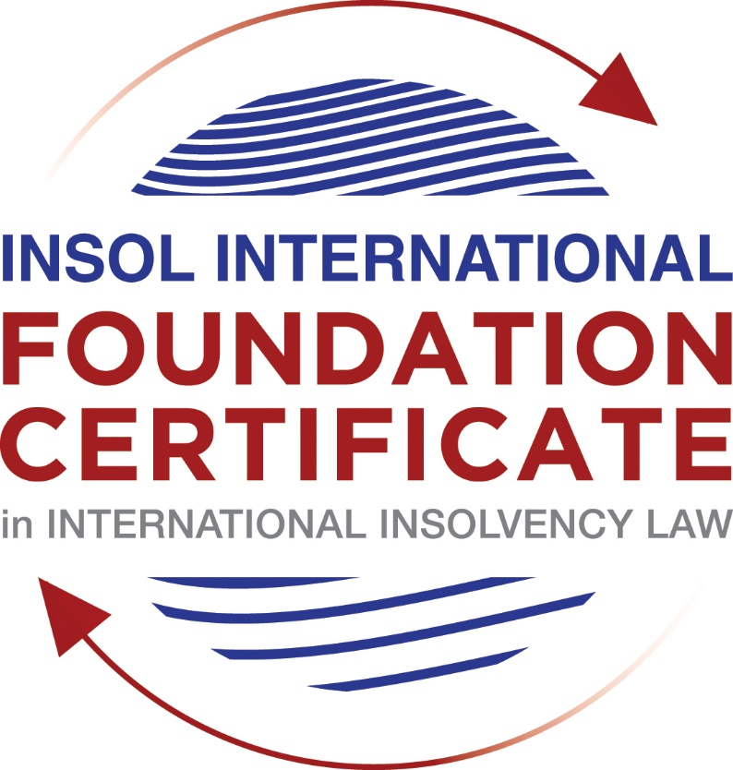

SUMMATIVE (FORMAL) ASSESSMENT: MODULE 3B

THE INSOLVENCY SYSTEM OF THE UNITED KINGDOM (ENGLAND AND WALES)

This is the summative (formal) assessment for Module 3B of this course and is compulsory for all candidates who selected this module as one of their compulsory modules from Module 3. Please read instruction 6.1 on the next page very carefully.

If you selected this module as one of your elective modules, please read instruction 6.2 on the next page very carefully.

The mark awarded for this assessment will determine your final mark for Module 3B. In order to pass this module, you need to obtain a mark of 50% or more for this assessment.

INSTRUCTIONS FOR COMPLETION AND SUBMISSION OF ASSESSMENT

Please read the following instructions very carefully before submitting / uploading your assessment on the Foundation Certificate web pages.

1. You must use this document for the answering of the assessment for this module. The answers to each question must be completed using this document with the answers populated under each question.

2. All assessments must be submitted electronically in MS Word format, using a standard A4 size page and a 11-point Arial font. This document has been set up with these parameters – please do not change the document settings in any way. DO NOT submit your assessment in PDF format as it will be returned to you unmarked.

3. No limit has been set for the length of your answers to the questions. However, please be guided by the mark allocation for each question. More often than not, one fact / statement will earn one mark (unless it is obvious from the question that this is not the case).

4. You must save this document using the following format: [student number.assessment3B]. An example would be something along the following lines: 202021IFU-314.assessment3B. Please also include the filename as a footer to each page of the assessment (this has been pre-populated for you, merely replace the words “studentnumber” with the student number allocated to you). Do not include your name or any other identifying words in your file name. Assessments that do not comply with this instruction will be returned to candidates unmarked.

5. Before you will be allowed to upload / submit your assessment via the portal on the Foundation Certificate web pages, you will be required to confirm / certify that you are the person who completed the assessment and that the work submitted is your own, original work. Please see the part of the Course Handbook that deals with plagiarism and dishonesty in the submission of assessments. Please note that copying and pasting from the Guidance Text into your answer is prohibited and constitutes plagiarism. You must write the answers to the questions in your own words.

6.1 If you selected Module 3B as one of your compulsory modules (see the e-mail that was sent to you when your place on the course was confirmed), the final time and date for the submission of this assessment is 23:00 (11 pm) GMT on 1 March 2021. The assessment submission portal will close at 23:00 (11 pm) GMT on 1 March 2021. No submissions can be made after the portal has closed and no further uploading of documents will be allowed, no matter the circumstances.

6.2 If you selected Module 3B as one of your elective modules (see the e-mail that was sent to you when your place on the course was confirmed), you have a choice as to when you may submit this assessment. You may either submit the assessment by 23:00 (11 pm) GMT on 1 March 2021 or by 23:00 (11 pm) BST on 31 July 2021. If you elect to submit by 1 March 2021, you may not submit the assessment again by 31 July 2021 (for example, in order to achieve a higher mark).

7. Prior to being populated with your answers, this assessment consists of 7 pages.

ANSWER ALL THE QUESTIONS

QUESTION 1 (multiple-choice questions) [10 marks in total]

Questions 1.1. – 1.10. are multiple-choice questions designed to assess your ability to think critically about the subject. Please read each question carefully before reading the answer options. Be aware that some questions may seem to have more than one right answer, but you are to look for the one that makes the most sense and is the most correct. When you have a clear idea of the question, find your answer and mark your selection on the answer sheet by highlighting the relevant paragraph in yellow. Select only ONE answer. Candidates who select more than one answer will receive no mark for that specific question.

Question 1.1

What is the initial period for a Moratorium under Part 1A of the Insolvency Act 1986 where the directors file relevant documents at court?

- 20 days.

- 20 business days.

- 40 days.

- 40 business days.

Question 1.2

What is the maximum length of a Moratorium under Part 1A of the Insolvency Act 1986 to which creditors can consent without any application to the court?

- 40 business days.

- One year and 20 business days.

- One year and 40 business days.

- One year.

Question 1.3

Which of the following is not a requirement for a company which wishes to enter into a Restructuring Plan under Part 26A of the Companies Act 2006?

- the company has encountered, or is likely to encounter, financial difficulties that are affecting, or will or may affect, its ability to carry on business as a going concern.

- a compromise or arrangement is proposed between the company and its creditors, or any class of them, or its members, or any class of them.

- the purpose of the compromise or arrangement is to eliminate, reduce or prevent, or mitigate the effect of, any of the said financial difficulties.

- the company is, or is likely to become, unable to pay their debts, as defined under section 123 of the Insolvency Act 1986.

Question 1.4

What percentage of creditors must approve a Scheme of Arrangement under Part 26 of the Companies Act 2006?

- A majority in number and in value.

- A majority in number and 50% or more in value.

- A majority in number and 75% or more in value.

- 75% or more in value.

Question 1.5

Which one of the following is not a debtor-in-possession procedure?

- Administration.

- Restructuring Plan.

- Scheme of Arrangement.

- Company Voluntary Arrangement.

Question 1.6

A liquidator may pay dividends to small value creditors based upon the information contained within the company’s statement of affairs or accounting records. In such circumstances, a creditor is deemed to have proved for the purposes of determination and payment of a dividend where the debt is no greater than how much?

- £500

- £750

- £1,000

- £2,000

Question 1.7

Which one of the following is not, in itself, a separate ground for disqualification of a director under the Company Directors Disqualification Act 1986?

- Wrongful trading.

- Breach of fiduciary duty.

- Being found guilty of an indictable offence in Great Britain.

- Being found guilty of an indictable offence overseas.

Question 1.8

The administrator is under a general duty to make a statement setting out proposals for achieving the purpose of administration. He or she must send out the statement of proposals as soon as reasonably practicable, and in any event within how many weeks of the date the company entered administration?

- 6

- 8

- 10

- 12

Question 1.9

Which of the following has the power to bring an action for wrongful trading under the Insolvency Act 1986?

- A monitor of a Moratorium.

- A supervisor of a Company Voluntary Arrangement.

- An administrator.

- An administrative receiver.

Question 1.10

Under section 176A of the Insolvency Act 1986, the prescribed part deducted from floating charge assets in favour of unsecured creditors is calculated as follows:

- 20% of the floating charge assets.

- 50% of the first £10,000 in value plus 20% of the excess in value above the £10,000 subject to a maximum amount of the prescribed part of £600,000.

- 20% of the first £50,000 in value plus 50% of the excess in value above the £50,000 subject to a maximum amount of prescribed part of £800,000.

- 50% of the first £10,000 in value plus 20% of the excess in value above the £10,000 subject to a maximum amount of prescribed part of £800,000.

QUESTION 2 (direct questions) [10 marks]

Question 2.1 [maximum 6 marks]

What is the difference between cash flow insolvency and balance sheet insolvency?

The difference between cash flow insolvency and balance sheet insolvency lies in the scope of the analysis in terms of time.

On the one hand, in the cash flow insolvency scenario, the company is unable to pay a debt (currently owed or payable shortly). On the other hand, a balance sheet insolvency involves the analysis of the value of the company's assets compared to its liabilities; in this case, the liabilities subject to the analysis are the present ones and the future and contingent liabilities (Walton, 2020).

In Eurosail the Supreme Court explained the scope of the analysis by emphasizing that the "cash flow" test applies for the near future and the next level of analysis consisted in comparing the value of the present assets with the value of liabilities through the "balance sheet" test (Walton, 2020).

Question 2.2 [maximum 4 marks]

List four (4) elements of the statutory moratorium imposed when a company enters administration.

1) An administrative receiver cannot be appointed (Walton, 2020).
2) A legal process (this category includes any legal proceeding or execution of any judgment) may be continued or instituted against the company or property of the company only with the permission of the court or the consent of the administrator (Walton, 2020).
3) It is not possible to proceed with any measure to enforce security over the company’s property; the above-mentioned could only be carried out with the permission of the court or the consent of the administrator (Walton, 2020).
4) The right of forfeiture by peaceable re-entry cannot be exercised by the landlord, the foregoing with respect to premises let to the company. The above-mentioned could only be carried out with the permission of the court or the consent of the administrator (Walton, 2020).

QUESTION 3 (essay-type questions) [15 marks in total]

Question 3.1 [maximum 6 marks]

Explain the main differences between a Part 26 Scheme of Arrangement and a Part 26A Restructuring Plan.

First, it is important to highlight that the 2020 Act introduced 26A Restructuring Plan, and such proceeding has elements of: (i) the Chapter 11 of the United States Bankruptcy Code and (ii) Part 26 schemes (Walton, 2020).

By virtue of the foregoing, Part 26A restructuring plan adopted a different scope of application. The following are the most relevant differences between Part 26 Scheme of arrangement and Part 26A Restructuring plan:

- Subjects of the proceeding
- Part 26 Scheme of arrangement: This scheme is available for solvent and insolvent companies (Walton, 2020).
- Part 26A Restructuring plan: Regarding the subjects that can use this procedure, this instrument is only available for companies in financial distress. In addition, its scope of application is extended to all types of companies, even overseas companies that be wound up in England and Wales (Walton, 2020).

- Cram down
- Part 26 Scheme of arrangement: The cram down of a whole dissenting class is not possible. Whilst a cram down on minority creditors in a particular class can be done (Walton, 2020).
- Part 26A Restructuring plan: In contrast to Part 26 Scheme of arrangement, despite the dissenting class Part 26A Restructuring plan allows the court to sanction a plan as long as the following conditions are met: (i) None of the dissenters will be worse off than under the relevant alternative and (ii) the agreement was voted favourably by 75% in value of at least one class of the members or creditors who have the potential to receive a payment or have a real economic interest in the relevant alternative (Walton, 2020).
- Require majority to approve the scheme
- Part 26 Scheme of arrangement: The court will sanction the arrangement if 75% or more in value of: (i) the members or class of members or (ii) the creditors or class of creditors approved the terms of the Plan (Walton, 2020).
- Part 26A Restructuring plan: The scheme must be approved by a simple majority in number and a majority of 75% or more in value of the creditors or members present and voting (Walton, 2020).

Question 3.2 [maximum 9 marks]

Explain the different ways in which overseas officeholders may be recognised and request the assistance of the court in England and Wales.

The following are the possible ways by which an overseas office-holder may ask the assistance of the courts in England and Wales:
- Common Law: According to this approach, the fairness between creditors necessarily requires an idealistic world where it should be a single insolvency proceeding (Walton, 2020). The basis for recognition is based on the principle of "judicial comity" under which the recognition is extended to the bankruptcy laws of other countries circumscribed in the English jurisdiction (Jones Day Publication, 2009).
- EU Regulation: This instrument establishes the rules for determining the competent jurisdiction to initiate insolvency proceedings and the applicable law. Regarding the appointment, it should be recognized automatically in all the member states, and the Insolvency Practioner is granted with all the powers, except for some limitations (Walton, 2020).
- The CBIR: It is necessary to take into account that pursuant CBIR the recognition of an overseas insolvency procedure is not automatic. The foregoing because is required to present an application to the court in order to obtain the corresponding recognition and assistance (Walton, 2020).
- Section 426 of the act: Pursuant Section 426 of the act, UK courts may provide assistance to certain jurisdictions (listed jurisdictions). In addition, it is pertinent to highlight that the assistance can be provided according to UK law or the law of the overseas territory. Regarding the scope of the assistance, this regulation obliges the UK courts to assist other UK courts and the courts of any relevant territory (Walton, 2020).

QUESTION 4 (fact-based application-type question) [15 marks in total]

Prior to going into liquidation in November 2020, under pressure from its bank, Stercus Bank plc, and in order to prevent it from demanding repayment of the company’s loans, Cork-In Limited granted a debenture in favour of Stercus Bank plc in January 2020. The debenture contained a floating charge over the whole of the company’s undertaking.

In June 2020, as the company continued to struggle, the directors approved the
sale of a company delivery van to Paul Watson (a director) for £5,000 in cash. The
van had been bought for £10,000 a year before.

A month before the company went into liquidation, Paul Watson received an irate phone call from one of the company’s key suppliers, Gary’s Grapes Limited. The supplier demanded immediate payment of all sums owing to it (even those invoices that had not become payable). Fearing being cut off by the supplier, Paul arranged for a cheque for the full amount to be sent that day.

The liquidator has asked for advice whether any action may be taken in respect of the floating charge in favour of Stercus Bank plc and the two subsequent transactions.

Using the facts above, answer the questions that follow.

Identify the relevant issues and statutory provisions and consider whether the liquidator may take any action in relation to:

Question 4.1 [maximum 5 marks]

The floating charge in favour of Stercus Bank plc;

Relevant Issues | Statutory provisions | Liquidator's course of action
- The Liquidation of Cork-In Limited was commenced in November 2020.  - The transaction was carried out within the relevant time (11 months prior to the commencement of the liquidation). The abovementioned taking into account that Stercus Bank is not connected with the debtor.  - At the time of the transaction, Stercus Bank was a creditor of Cork-In Limited.  - At the time of the transaction, the debtor was in financial difficulties. | - Section 245 of the Act 1986 - Avoidance of certain floating charges | - In accordance with the relevant issues previously identified, the liquidator can attack the transaction pursuant to Section 245of Act 1986. In this case, the liquidator must bear in mind that the main purpose of the action is to invalid the floating charge given by Cork-In Limited to Stercus Bank on the understanding that the bank did not provide a new consideration.

Question 4.2 [maximum 5 marks]

The sale of the van; and

Relevant Issues | Statutory provisions | Liquidator's course of action
- The Liquidation of Cork-In Limited was commenced in November 2020.  - The transaction was carried out within the relevant time defined by section 240 of the Act 1986 (5 months prior to the commencement of the liquidation).  - The value under which the directors approved the sale of the company´s delivery van does not coincide with the market value of the asset. The above taking into account the purchase value and the depreciation of the van.  - The company sold the van to Paul Watson (Director of the company).  - At the time of the transaction, the debtor was in financial difficulties. | - Section 238 of the Act 1986 - Transactions at an undervalue  - Section 240 of the Act 1986 - Relevant time | - In accordance with the relevant issues previously identified, the liquidator may attack the sale of the company´s van pursuant to Section 238 of Act 1986. In this case, the liquidator must bear in mind that he has to show that the value of the sale was significantly less in comparison to the consideration provided by the company (the price paid for the van). If the courts decide that the sale of the van was an undervalue transaction, the judge must restore the initial position as if the transaction had not been carried out.

Question 4.3 [maximum 5 marks]

The payment to Gary’s Grapes Ltd.

Relevant Issues | Statutory provisions | Liquidator's course of action
- The Liquidation of Cork-In Limited was commenced in November 2020.  - The transaction was carried out within the relevant time defined by section 240 of the Act (1 month prior to the commencement of the liquidation).  - At the time of the transaction, Gary's Grapes was a creditor of Cor-In Limited.  - The payment made by Paul Watson put Gary's Grapes in a better position than the others creditors considering that the amount paid covered some invoices that had not become payable at that time (October 2020).  - The payment was made with the objective of avoiding a cut-off from Gary’s Grapes Limited.  - At the time of the transaction, the debtor was in financial difficulties. | - Section 239 of the Act 1986 - Preferences  - Section 240 of the Act 1986 - Relevant time | - In accordance with the relevant issues previously identified, the liquidator can attack the transaction pursuant to Section 239 of Act 1986. In this case, the liquidator must bear in mind that he has to show that the circumstances listed in Section 239 of the Act 1986 actually happened.  - The relevant facts of the case allow us to infer that the "attack" will have a high probability of success considering that the only element that could be undermined is related to the intention to put Gary’s Grapes Limited in a better position in the event of a liquidation.

References
- Walton, P. (September de 2020). Insolvency System of the United. London, United Kingdom.
- Jones Day Publication. (September de 2009). U.K. Perspective Recognition of Overseas Insolvency Procedures: Spoiled for Choice? Obtenido de https://www.jonesday.com/en/insights/2009/09/uk-perspective-recognition-of-overseas-insolvency-procedures-spoiled-for-choice

* End of Assessment *

