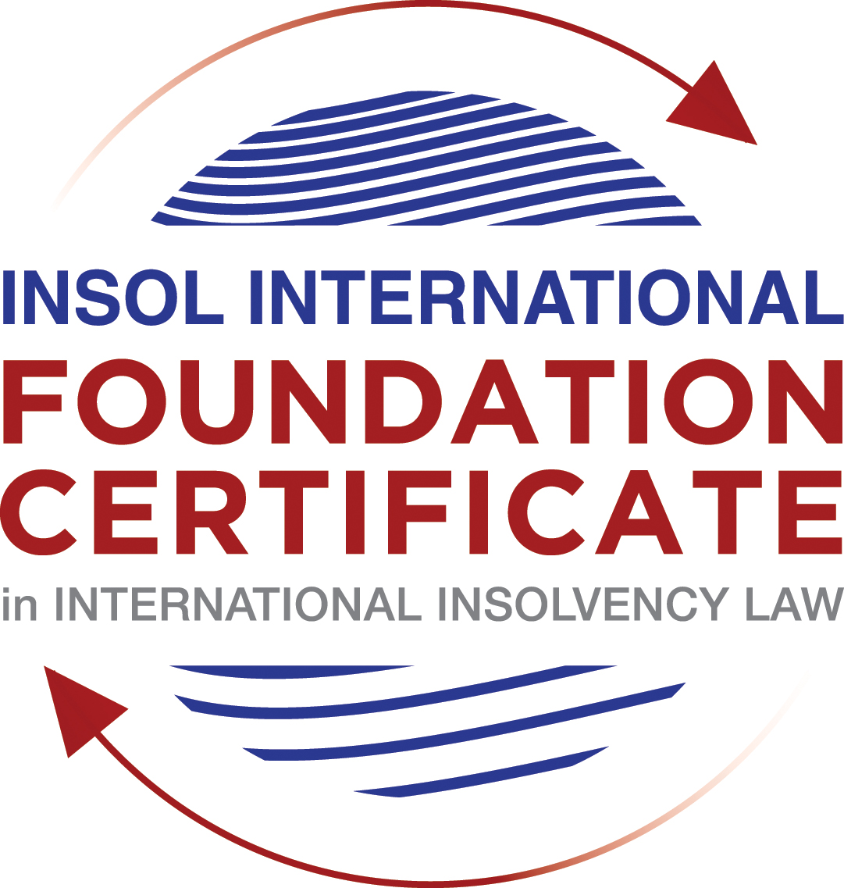

SUMMATIVE (FORMAL) ASSESSMENT: MODULE 3A

THE INSOLVENCY SYSTEM OF THE UNITED STATES

This is the summative (formal) assessment for Module 3A of this course and is compulsory for all candidates who selected this module as one of their compulsory modules from Module 3. Please read instruction 6.1 on the next page very carefully.

If you selected this module as one of your elective modules, please read instruction 6.2 on the next page very carefully.

The mark awarded for this assessment will determine your final mark for Module 3A. In order to pass this module, you need to obtain a mark of 50% or more for this assessment.

INSTRUCTIONS FOR COMPLETION AND SUBMISSION OF ASSESSMENT

Please read the following instructions very carefully before submitting / uploading your assessment on the Foundation Certificate web pages.

1. You must use this document for the answering of the assessment for this module. The answers to each question must be completed using this document with the answers populated under each question.

2. All assessments must be submitted electronically in MS Word format, using a standard A4 size page and a 11-point Arial font. This document has been set up with these parameters – please do not change the document settings in any way. DO NOT submit your assessment in PDF format as it will be returned to you unmarked.

3. No limit has been set for the length of your answers to the questions. However, please be guided by the mark allocation for each question. More often than not, one fact / statement will earn one mark (unless it is obvious from the question that this is not the case).

4. You must save this document using the following format: [student number.assessment3A]. An example would be something along the following lines: 202021IFU-314.assessment3A. Please also include the filename as a footer to each page of the assessment (this has been pre-populated for you, merely replace the words “studentnumber” with the student number allocated to you). Do not include your name or any other identifying words in your file name. Assessments that do not comply with this instruction will be returned to candidates unmarked.

5. Before you will be allowed to upload / submit your assessment via the portal on the Foundation Certificate web pages, you will be required to confirm / certify that you are the person who completed the assessment and that the work submitted is your own, original work. Please see the part of the Course Handbook that deals with plagiarism and dishonesty in the submission of assessments. Please note that copying and pasting from the Guidance Text into your answer is prohibited and constitutes plagiarism. You must write the answers to the questions in your own words.

6.1 If you selected Module 3A as one of your compulsory modules (see the e-mail that was sent to you when your place on the course was confirmed), the final time and date for the submission of this assessment is 23:00 (11 pm) GMT on 1 March 2021. The assessment submission portal will close at 23:00 (11 pm) GMT on 1 March 2021. No submissions can be made after the portal has closed and no further uploading of documents will be allowed, no matter the circumstances.

6.2 If you selected Module 3A as one of your elective modules (see the e-mail that was sent to you when your place on the course was confirmed), you have a choice as to when you may submit this assessment. You may either submit the assessment by 23:00 (11 pm) GMT on 1 March 2021 or by 23:00 (11 pm) BST on 31 July 2021. If you elect to submit by 1 March 2021, you may not submit the assessment again by 31 July 2021 (for example, in order to achieve a higher mark).

7. Prior to being populated with your answers, this assessment consists of 8 pages.

ANSWER ALL THE QUESTIONS

QUESTION 1 (multiple-choice questions) [10 marks in total]

Questions 1.1. – 1.10. are multiple-choice questions designed to assess your ability to think critically about the subject. Please read each question carefully before reading the answer options. Be aware that some questions may seem to have more than one right answer, but you are to look for the one that makes the most sense and is the most correct. When you have a clear idea of the question, find your answer and mark your selection on the answer sheet by highlighting the relevant paragraph in yellow. Select only ONE answer. Candidates who select more than one answer will receive no mark for that specific question.

Question 1.1

FabCo, based in Utah, owes SupplyCo, based in Mexico, US$10,000 on a past-due invoice. May SupplyCo file an involuntary petition to place FabCo into chapter 11 bankruptcy proceedings?

- Yes.

- Yes, if FabCo has fewer than 12 non-contingent, non-insider creditors.

- Yes, if other creditors owed at least US$5,775 join in the petition.

- No, because SupplyCo doesn’t know whether FabCo is insolvent.

- No, because SupplyCo is not a US company.

Question 1.2

Which of the following is a mandatory, rather than discretionary, basis to deny recognition of a foreign judgment under state law based on one of the Uniform Acts?

- The foreign judgment is subject to appeal in the foreign country.

- The foreign judgment is an injunction.

- The foreign judgment was issued by a court, contrary to the parties’ agreement to arbitrate.

- The defendant did not have sufficient notice of the foreign proceeding to put on a defense.

- The foreign judgment is inconsistent with another final judgment on the same subject matter.

Question 1.3

Which of the following is likely to be a party in interest in the bankruptcy of XYZ Corp?

- A shareholder in ABC Corp, to which XYZ Corp is substantially indebted.

- A journalist writing about XYZ Corp’s bankruptcy.

- A shareholder in MNO Corp, which owns all of XYZ Corp’s shares.

- A retired employee of XYZ Corp who receives payments from the company’s pension plan.

- A non-profit organization that advocates for companies like XYZ Corp to be held responsible for climate change.

Question 1.4

If a debtor rejects an executory trademark license agreement under which it licenses a trademark to its counterparty, which of the following is true:

- The counterparty must immediately stop using the trademark.

- The counterparty can continue using the trademark for the remaining period of the license.

- The counterparty has a claim for damages for breach of contract.

- Both (a) and (c).

- Both (b) and (c).

Question 1.5

In which of the following circumstances may a counterparty enforce a contractual ipso facto clause?

- The contract would obligate the counterparty to extend a loan to the debtor.

- The contract is a lease of real property.

- The clause is triggered by the bankruptcy filing of a third party, not the debtor.

- Both (a) and (c).

- Ipso facto clauses are never enforceable against a debtor.

Question 1.6

What does a chapter 11 debtor have exclusivity to propose for the first 120 days of proceedings?

- Avoidance actions.

- A plan of reorganization.

- DIP financing.

- Lifting the automatic stay.

- Formation of an equity committee.

Question 1.7

Which of the following is not a requirement to confirm a “cramdown” plan?

- Acceptance of the plan by all classes of secured creditors.

- Acceptance of the plan by at least one class of impaired, non-insider creditors.

- The plan is fair and equitable to dissenting classes of creditors.

- The plan does not discriminate unfairly against dissenting classes of creditors.

- The dissenting creditors receive no less than they would under a liquidation scenario.

Question 1.8

When may distributions to creditors diverge from the absolute priority rule?

- In a chapter 7 proceeding with consent of the affected senior creditor.

- In a chapter 7 proceeding with consent of the affected junior creditor.

- In a chapter 11 proceeding with consent of the affected senior creditor.

- In a chapter 11 proceeding with consent of the affected junior creditor.

- The absolute priority rule cannot be deviated from.

Question 1.9

Who may serve as a foreign representative to seek recognition of a foreign proceeding under chapter 15?

- An officer of the debtor if it is a debtor-in-possession in the foreign proceeding.

- The board of directors of the debtor if it is a debtor-in-possession in the foreign proceeding.

- An insolvency professional appointed by the court overseeing the foreign proceeding.

- An insolvency professional appointed by a creditor where the foreign proceeding is an involuntary receivership.

- All of the above.

Question 1.10

Which of the following is not available as relief in a chapter 15 proceeding?

- Sale of US property free and clear pursuant to section 363.

- Prosecution of avoidance actions pursuant to section 544.

- Entrusting the management of US assets to the foreign representative.

- Application of the automatic stay under section 362 to the debtor’s interests in US property.

- Discovery about the debtor’s assets.

QUESTION 2 (direct questions) [10 marks]

Question 2.1 [maximum 1 mark]

What two alternative qualifications render a corporation eligible to be a debtor in a US chapter 7 or 11 proceeding?

[The United States of America is considered a debtor-friendly jurisdiction. The key requirement for eligibility to be a debtor in a US bankruptcy proceeding is, predominantly the location of the debtor, is place of business or assets in the US.

Alternatively, a corporation may be eligible to be a debtor in the US (under a chapter 7 or 11 bankruptcy proceeding) by way of intangible assets such as:
- payment of a retainer to a US insolvency counsel; or
- a claim under a US law.]

Question 2.2 [maximum 2 marks]

What is an executory contract?

[In terms of case law, an executory contract is an agreement that contains obligations of performance on both sides. In other words, both parties to the agreement have certain duties to perform before the contract could be considered fully executed. Whether it is a chapter 7 or chapter 11 proceeding, the debtor may decide to either reject, assume, or assume and assign the contract. Examples of executory contracts include rental, equipment and car lease agreements, development agreements and agreements that involve intellectual property (i.e. trademark licenses.)]

Question 2.3 [maximum 2 marks]

What is a “priming lien” and what requirements must be met for such a lien to be granted to secure DIP financing?

[A priming lien is a hypothecation on estate property (that is ‘senior’ to existing liens) and used to facilitate post-petition financing. Essentially, this type of financing is utilized by debtors who are undergoing a chapter 11 bankruptcy and is still in possession of their business as a going concern. The financing is available where the debtor is unable to secure any other form of financing which is critical in funding essential business operations. A debtor who is able to secure a priming lien must demonstrate to the existing secured creditors (with liens against estate property) that they are ‘adequately protected’ from the devaluation of their collateral as a result of the priming lien. It should be noted that this is generally subject to the permission of the bankruptcy court.]

Question 2.4 [maximum 2 marks]

In voting on a plan of reorganization, which class(es) of creditors are (i) deemed to accept the plan, (ii) deemed to reject the plan and (iii) permitted to vote on the plan? What vote is necessary for a class of creditors to accept a plan?

[In voting on a plan of reorganization, the class(es) of creditors that are:
- Deemed to accept the plan are an unimpaired class of creditors.
- Deemed to reject the plan are the class of creditors that will not receive anything.
- Permitted to vote on the plan are the holders of a claim or interest in the estate of the debtor, pursuant to section 502.

The vote necessary for a class of creditors to accept a plan:
The vote necessary for a class of creditors to accept a plan is “a simple majority of the creditors in the class, holding at least two-thirds of the value of claims in the class, vote in favour or, for equity interest, if two-thirds in the amount of the interests vote in favour”.]

Question 2.5 [maximum 3 marks]

How does the automatic stay available in chapter 15 proceedings differ from that available in chapter 11 proceedings?

[As it relates to a chapter 11 bankruptcy, the process of filing a petition for bankruptcy involves completing and submitting the applicable form (at any time) and it is at the point of submission the stay comes into effect. Under section 362 of the Bankruptcy Code, the automatic stay prevents creditors from taking any action to possess or exercise control over property of the debtor or the estate, wherever located and by whomever held- this includes property located outside of the United States.

However, a chapter 15 proceeding which is only initiated by the petition of a foreign representative of a debtor does not have an automatic stay feature. The stay is activated upon the petition to the court for recognition of a ‘foreign main proceeding’ and is limited to property located in the United States.]

QUESTION 3 (essay-type questions) [15 marks in total]

Question 3.1 [maximum 3 marks]

What fiduciary duties do directors of Delaware corporations owe and to whom are the duties owed in the ordinary course of business? To whom are duties owed when the corporation is potentially or actually insolvent?

[The fiduciary duties directors owe:
The fiduciary duties of a director of a corporation incorporated in Delaware, are the duty of care and the duty of loyalty. Under the state laws of Delaware, the duty of care requires that directors as fiduciaries should be guided by relevant information when making decisions on behalf of Delaware corporations. The duty of loyalty on the other hand, requires that a director to act in good faith and in a manner that is in the best interest of the corporation and its shareholders.

To whom duties are owed:
Generally, under Delaware state law, directors owe fiduciary duties to the corporation and its shareholders but not to its creditors. This is the case whether it is in the ordinary course of action or in a circumstance where the corporation is potentially or actually insolvent.]

Question 3.2 [maximum 3 marks]

Describe the circumstances in which a bankruptcy court may enter a final order, who reviews appeals from bankruptcy court orders and how non-final orders are reviewed.

[As stated by the lecturer for this module, there have been some developments in the US insolvency system with respect to the scope of the jurisdiction of bankruptcy courts and their power to enter final judgements. This is evident in the Stern v Marshall matter and precedent set with respect to final judgements in bankruptcy.

Circumstances for entering a final order:
While core proceedings may be heard and determined in the bankruptcy courts, non-core proceedings may only be entertained in bankruptcy courts if the court is satisfied that the proceeding has a bankruptcy element, but it cannot issue a final order. Under these circumstances, the bankruptcy court must submit its findings to the district court for the final order.

Who reviews appeals from bankruptcy court orders:
Bankruptcy courts are secondary to district courts and therefore, bankruptcy appeals must go through the district court. Appeals from bankruptcy court orders are heard and reviewed by a Bankruptcy Appellate Panel (“BAP”).

How non-final orders are reviewed:
Non-final orders from core-proceedings of either the district court or the BAP orders are reviewed by a circuit court of appeal (without reference to the previous legal conclusions or assumption) on the basis of conclusions of law and for abuse of discretion. In like manner, a non-core proceeding is also reviewed by the BAP and district court (using similar review standards) to which a party has objected.]

Question 3.3 [maximum 4 marks]

Describe how claims for recovery of preferences, fraudulent conveyance and constructive fraudulent conveyance differ.

[There are several methods and means by which a Trustee or a DIP may recover value for its creditors; one of which is by the avoidance of certain transactions which occurred prior to the debtor entering into bankruptcy. This recovery effort involves the recovery of property for the estate which occurred as a result of pre-petition transactions or transfers.

Pursuant to section 547 of the US Bankruptcy code, preferences involve the transfer of interest of a property of the debtor to a pre-existing creditor in the period prior to the bankruptcy proceeding being filed (either 90-days for a third-party or 1 year for insiders) at a time when the debtor was insolvent. Furthermore, it is deemed as preference if such transaction permits the creditor to obtain a better result than it would have received in the liquidation of the debtor.

An illustration of preference actions are security interests that were executed prior to the bankruptcy filing. Under the US bankruptcy system, there is no requirement to impose fault on either party other than the possible return of the transfer to the debtor.

Actual fraudulent conveyances transfers are made with the intent to defraud creditors and as such these transactions are avoidable. The ‘badges of fraud’ may be used to prove a circumstance of intent. Constructive fraudulent conveyance on the other hand, are transactions where the debtor received less than the equivalent value of the exchange.

In defence of either conveyance, the recipient may retain the property or prove their position that the transaction was conducted in good faith.

Certain pre-petition transactions (that fall into either category above) which for instance involve securities or commodity contracts cannot be avoided. The US insolvency system has instituted ‘safe harbours’ for such transactions with the view to protecting the public space.]

Question 3.4 [maximum 5 marks]

How does a US bankruptcy court determine whether a foreign proceeding is a main or non-main proceeding under chapter 15?

[Determination of whether a foreign proceeding is a ‘foreign main proceeding’ is primarily based on the determination of a debtor’s center of main interest (“COMI”). Chapter 15 is heavily premised on the adoption of UNCITRAL’s Model Law on Cross-Border Insolvency and although the concept of COMI is not defined within the model, in US law, a debtor’s COMI is determined based on certain factors which include the location of:

- The headquarters or central place of business operations;
- Where the company’s management is based; and
- The majority of creditors are based.
In addition to the factors listed above, the jurisdiction of domestic laws in other states are relevant.

Proceedings that take place in a jurisdiction other than the debtor’s COMI may be recognized as a ‘foreign non-main proceeding’. This is determined if the debtor only has an establishment in the jurisdiction. An establishment is a jurisdiction where (excluding factors of a COMI) the debtor has conducted non-transitory economic activity (by human means or goods).]

QUESTION 4 (fact-based application-type question) [15 marks in total]

Question 4.1 [maximum 5 marks]

Rental Corporation is a publicly-traded company that leases office space from office building owners and sublets the space to small businesses. It has recently announced that it is being investigated by the US Department of Justice Fraud Division (DOJ) regarding allegedly fraudulent misstatements of revenues; shortly after the announcement, a securities class action litigation was filed against Rental Corporation in New York federal court. Due to the increase in the numbers of businesses operating remotely, Rental Corporation has suffered a decline in revenues. As a result, it has failed to pay rent on some of its office space leases and it has just defaulted on its quarterly payment on its credit facility. What would be the effect of a chapter 11 petition being filed by Rental Corporation on each of (i) the DOJ investigation, (ii) the securities class action litigation; (iii) the delinquent leases and (iv) the credit facility?

[The effect of a chapter 11 petition filed by Rental Corporation:

- The DOJ investigation – Pursuant to section 548 of the US Bankruptcy Code, the DOJ would be required to prove that:
  - Rental Corporation was in violation of the securities laws of the Securities Exchange Act;
  - there was in fact, intentions of fraud, deceit, or manipulation with respect to statements of revenue; and
  - that the aforementioned actions were in connection with the purchase or sale of any registered security.
The DOJ in this circumstance may refer to the “badges of fraud” for the purposes of proving whether Rental Corporation intentionally committed the act. If it is proven otherwise, Rental Corporation may have legal recourse for dismissal, with respect to the securities class action litigation.

- The securities class action litigation – Although an automatic stay is a distinctive feature of chapter 11 bankruptcy proceedings, it is subject to certain statutory exceptions. Pursuant to section 362(b)(6), “The exercise of rights under commodity, forward or security contracts” are statutory exceptions. Rental Corporation is a publicly traded entity and an injunction of this nature could prove to be more harmful to the public trading space than is warranted to protect the debtor. Rental Corporation will need to heavily consider their position and whether a chapter 11 bankruptcy is appropriate as the company will not be protected in the securities class action lawsuit.

- The delinquent leases – Generally, rental leases are regarded as executory contracts which contain ipso fact clauses. Agreements which contain these clauses may be rendered inoperable in circumstances of bankruptcy and the debtor’s ability to assign is further increased by the voidance of these clauses. In the circumstances of a chapter 11 bankruptcy, the debtor has until confirmation or approval of its plan for reorganization, to decide on whether to reject, assume or assign the rental contract. Although this decision is based the business judgment of the debtor, “unexpired leases of non-residential property are required to be made within 120 days of the order for relief” with an option for extension by consent of the landlord. This is in line with the provisions set out in section 365(d)(4) of the bankruptcy code.

- The credit facility – under chapter 11 bankruptcy proceedings, Rental Corporation as the option to continue its business operations as a going concern. This may require additional financing and the court has the authority to grant a ‘priming lien’. In the circumstance where this credit facility is secured by an asset of the estate, a priming lien may be senior to the existing lien.]

Question 4.2 [maximum 5 marks]

Considering the facts set forth in Question 4.1, what protections does the Bankruptcy Code provide to lessors of office space to Rental Corporation?

- [Rental Corporation failed to pay rent on some of its office space leases. If Rental Corporation files a petition for bankruptcy, the landlord is entitled to a pre-petition claim which must be filed in the form of a proof of claim, on or before the bar date specified by the court.
- The landlord’s pre-petition claim for the unpaid rental amounts due on some of its office space leases will be treated as a secured claim with respect to the security deposit it holds on behalf of Rental Corporation.
- Further, the landlord is also entitled to a post-petition unsecured claim for rental amounts due which exceeds the value of the security deposit from Rental Corporation. However, section 365(d)(3) of the Bankruptcy Code requires that Rental Corporation satisfy the obligations under the lease agreement until they make a decision to either assume, reject or assign the lease.
- In the event that Rental Corporation files for a chapter 11 bankruptcy, they will be required to pay the full amount of the post-petition rent in order to confirm the company’s plan of reorganization.
- An automatic stay is initiated on Rental Corporation’s petition for chapter 11 bankruptcy. The landlord has the option to apply for relief from the stay on the basis of inadequate protection where the value of the office space could decline during the course of the chapter 11 proceedings.]

Question 4.3 [maximum 5 marks]

Paint Corporation formulates house paint according to proprietary and patented recipes at its factory in the United States, which it sells to home improvement stores under a number of distribution contracts. The US Environmental Protection Agency is investigating whether Paint Corporation’s operations are causing harmful chemicals to contaminate a nearby river. Paint Corporation is concerned it cannot afford the clean-up that may be required and is seeking to sell its business. Home Corporation is interested in buying the business, but does not want the potentially contaminated property (it can manufacture paint at its own factory) and is concerned about obtaining consent from all the home improvement stores to assign the distribution contracts. How would a sale under section 363 of the Bankruptcy Code address these issues?

- [One key feature of a sale of property under section 363 of the Bankruptcy Code is the sale of property, free and clear of liens, creditor claims and encumbrances. In this instance the purchase price of the property is higher it is ultimately a ‘win-win’ scenario for both parties.
- Home Corporation is concerned about obtaining consent from all the home improvement stores to assign the distribution contracts. Covered under a 363 sale is the transfer of intellectual property (which in this case includes the proprietary and patented paint recipes). “Licensees of patents owned by Paint Corporation are protected such that their licenses may not be terminated in connection with the sale of the intellectual property without their consent”.
- Home Corporation is interested in buying the business but does not want the potentially contaminated property. Paint Corporation will need to consider whether the sale of the property is more lucrative if it is sold collectively or separately. The implications of a collective sale could be a rejection by creditors on the basis that such a transaction would be considered a ‘sub rosa plan’.
- Paint Corporation may wish to conduct an auction for the sale of its property with a “stalking bidder”.
- In the event that a 363 sale of the property is successful, Paint Corporation will need to take appropriate steps to ensure that the marketing process was carried out in fairness to all parties concerned.]

* End of Assessment *

Hereinafter referred to as “United States” or “USA”.
INSOL International, Module 3A, Guidance Text, Insolvency System of the United States (2020/2021), section 5.3.2 (Eligibility of the debtor), p.9. Hereinafter referred to as “the Guidance Text”.
Eisenbach III, Robert L., Cooley LLP, “Executory Contracts – What are they and why do they matter in bankruptcy?”, In The (Red)- The Business Bankruptcy Blog, at << https://bankruptcy.cooley.com/2006/07/articles/business-bankruptcy-issues/executory-contracts-what-are-they-and-why-do-they-matter-in-bankruptcy/>>, accessed 15 July 2021.
Otherwise referred to as a ‘super-senior lien’.
The debtor in this scenario is referred to as a “DIP”- Debtor in possession and is commonly associated with chapter 11 bankruptcies.
U.S. Bankruptcy Code § 1126 (f) – “…a class that is not impaired under a plan…are conclusively presumed to have accepted the plan”.
U.S. Bankruptcy Code § 1126 (g) – “…a class is deemed not to have accepted a plan if such plan provides that the claims or interests of such class do not entitle the holders of such claims or interests to receive or retain any property under the plan”.
U.S. Bankruptcy Code § 1126 (a) – “The holder of a claim or interest…may accept or reject a plan.”
Hall, Laura R., INSOL International “Module 3A Guidance Text, Insolvency System of the United States”, 2020, p.36. Hereinafter referred to as “the Guidance Text”. References to the video content for this module will be stated throughout this assessment paper.
Article 2(b) of The UNCITRAL Model Law on Cross-Border Insolvency defines a foreign main proceeding as; “a foreign proceeding taking place in the State where the debtor has the centre of main interests”.
Sutton, S Jeffrey, Chief Judge, United States Court of Appeals for the Sixth Circuit, “What is Bankruptcy Appellate Panel?” – A Bankruptcy Appellate Panel (BAP) is a group of judges in the United States bankruptcy court who are appointed to hear appeals from certain bankruptcy cases under the supervision of the United States courts of appeals.
DIP is the abbreviation for Debtor-in-possession.
Also known as transactions at undervalue.
Idem, footnote 10.
Article 2(c) of The UNCITRAL Model Law on Cross-Border Insolvency defines a foreign non-main proceeding as: “a foreign proceeding, other than a foreign main proceeding, taking place in a State where the debtor has an establishment”.
The Guidance Text, section 5.4.5 (Executory contracts), p.28.
Hereinafter referred to as a “363 sale”.
The Guidance Text, section 5.4.3.2 (Chapter 11), p.24

