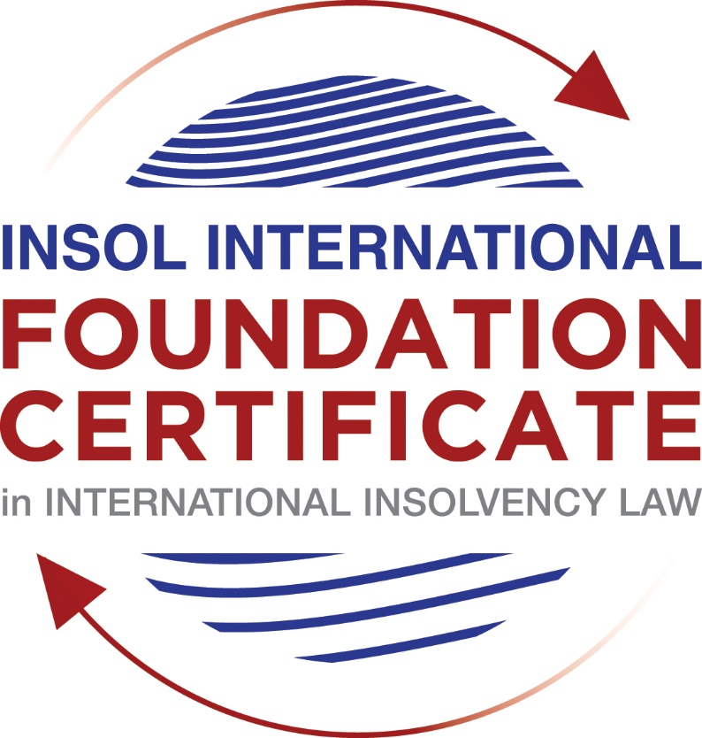

SUMMATIVE (FORMAL) ASSESSMENT: MODULE 3B

THE INSOLVENCY SYSTEM OF THE UNITED KINGDOM (ENGLAND AND WALES)

This is the summative (formal) assessment for Module 3B of this course and is compulsory for all candidates who selected this module as one of their compulsory modules from Module 3. Please read instruction 6.1 on the next page very carefully.

If you selected this module as one of your elective modules, please read instruction 6.2 on the next page very carefully.

The mark awarded for this assessment will determine your final mark for Module 3B. In order to pass this module, you need to obtain a mark of 50% or more for this assessment.

INSTRUCTIONS FOR COMPLETION AND SUBMISSION OF ASSESSMENT

Please read the following instructions very carefully before submitting / uploading your assessment on the Foundation Certificate web pages.

1. You must use this document for the answering of the assessment for this module. The answers to each question must be completed using this document with the answers populated under each question.

2. All assessments must be submitted electronically in MS Word format, using a standard A4 size page and a 11-point Arial font. This document has been set up with these parameters – please do not change the document settings in any way. DO NOT submit your assessment in PDF format as it will be returned to you unmarked.

3. No limit has been set for the length of your answers to the questions. However, please be guided by the mark allocation for each question. More often than not, one fact / statement will earn one mark (unless it is obvious from the question that this is not the case).

4. You must save this document using the following format: [student number.assessment3B]. An example would be something along the following lines: 202021IFU-314.assessment3B. Please also include the filename as a footer to each page of the assessment (this has been pre-populated for you, merely replace the words “studentnumber” with the student number allocated to you). Do not include your name or any other identifying words in your file name. Assessments that do not comply with this instruction will be returned to candidates unmarked.

5. Before you will be allowed to upload / submit your assessment via the portal on the Foundation Certificate web pages, you will be required to confirm / certify that you are the person who completed the assessment and that the work submitted is your own, original work. Please see the part of the Course Handbook that deals with plagiarism and dishonesty in the submission of assessments. Please note that copying and pasting from the Guidance Text into your answer is prohibited and constitutes plagiarism. You must write the answers to the questions in your own words.

6.1 If you selected Module 3B as one of your compulsory modules (see the e-mail that was sent to you when your place on the course was confirmed), the final time and date for the submission of this assessment is 23:00 (11 pm) GMT on 1 March 2021. The assessment submission portal will close at 23:00 (11 pm) GMT on 1 March 2021. No submissions can be made after the portal has closed and no further uploading of documents will be allowed, no matter the circumstances.

6.2 If you selected Module 3B as one of your elective modules (see the e-mail that was sent to you when your place on the course was confirmed), you have a choice as to when you may submit this assessment. You may either submit the assessment by 23:00 (11 pm) GMT on 1 March 2021 or by 23:00 (11 pm) BST on 31 July 2021. If you elect to submit by 1 March 2021, you may not submit the assessment again by 31 July 2021 (for example, in order to achieve a higher mark).

7. Prior to being populated with your answers, this assessment consists of 7 pages.

ANSWER ALL THE QUESTIONS

QUESTION 1 (multiple-choice questions) [10 marks in total]

Questions 1.1. – 1.10. are multiple-choice questions designed to assess your ability to think critically about the subject. Please read each question carefully before reading the answer options. Be aware that some questions may seem to have more than one right answer, but you are to look for the one that makes the most sense and is the most correct. When you have a clear idea of the question, find your answer and mark your selection on the answer sheet by highlighting the relevant paragraph in yellow. Select only ONE answer. Candidates who select more than one answer will receive no mark for that specific question.

Question 1.1

What is the initial period for a Moratorium under Part 1A of the Insolvency Act 1986 where the directors file relevant documents at court?

- 20 days.

- 20 business days.

- 40 days.

- 40 business days.

Question 1.2

What is the maximum length of a Moratorium under Part 1A of the Insolvency Act 1986 to which creditors can consent without any application to the court?

- 40 business days.

- One year and 20 business days.

- One year and 40 business days.

- One year.

Question 1.3

Which of the following is not a requirement for a company which wishes to enter into a Restructuring Plan under Part 26A of the Companies Act 2006?

- the company has encountered, or is likely to encounter, financial difficulties that are affecting, or will or may affect, its ability to carry on business as a going concern.

- a compromise or arrangement is proposed between the company and its creditors, or any class of them, or its members, or any class of them.

- the purpose of the compromise or arrangement is to eliminate, reduce or prevent, or mitigate the effect of, any of the said financial difficulties.

- the company is, or is likely to become, unable to pay their debts, as defined under section 123 of the Insolvency Act 1986.

Question 1.4

What percentage of creditors must approve a Scheme of Arrangement under Part 26 of the Companies Act 2006?

- A majority in number and in value.

- A majority in number and 50% or more in value.

- A majority in number and 75% or more in value.

- 75% or more in value.

Question 1.5

Which one of the following is not a debtor-in-possession procedure?

- Administration.

- Restructuring Plan.

- Scheme of Arrangement.

- Company Voluntary Arrangement.

Question 1.6

A liquidator may pay dividends to small value creditors based upon the information contained within the company’s statement of affairs or accounting records. In such circumstances, a creditor is deemed to have proved for the purposes of determination and payment of a dividend where the debt is no greater than how much?

- £500

- £750

- £1,000

- £2,000

Question 1.7

Which one of the following is not, in itself, a separate ground for disqualification of a director under the Company Directors Disqualification Act 1986?

- Wrongful trading.

- Breach of fiduciary duty.

- Being found guilty of an indictable offence in Great Britain.

- Being found guilty of an indictable offence overseas.

Question 1.8

The administrator is under a general duty to make a statement setting out proposals for achieving the purpose of administration. He or she must send out the statement of proposals as soon as reasonably practicable, and in any event within how many weeks of the date the company entered administration?

- 6

- 8

- 10

- 12

Question 1.9

Which of the following has the power to bring an action for wrongful trading under the Insolvency Act 1986?

- A monitor of a Moratorium.

- A supervisor of a Company Voluntary Arrangement.

- An administrator.

- An administrative receiver.

Question 1.10

Under section 176A of the Insolvency Act 1986, the prescribed part deducted from floating charge assets in favour of unsecured creditors is calculated as follows:

- 20% of the floating charge assets.

- 50% of the first £10,000 in value plus 20% of the excess in value above the £10,000 subject to a maximum amount of the prescribed part of £600,000.

- 20% of the first £50,000 in value plus 50% of the excess in value above the £50,000 subject to a maximum amount of prescribed part of £800,000.

- 50% of the first £10,000 in value plus 20% of the excess in value above the £10,000 subject to a maximum amount of prescribed part of £800,000.

QUESTION 2 (direct questions) [10 marks]

Question 2.1 [maximum 6 marks]

What is the difference between cash flow insolvency and balance sheet insolvency?

Section 123 of the Insolvency Act 1986 contains two insolvency tests: (i) cash flow test and (ii) balance sheet tests. The origins of the tests can be traced to BNY Corporate Trustee Services Ltd. v. Eurosail-UK 2007 – 3BL. A balance sheet insolvency is where a company’s assets are worth less that its liabilities (taking into account future and contingent liabilities as well as present liabilities) and cash flow insolvency is where a company cannot pay a currently owed debt (or one payable in the reasonably near future). The fundamental difference between the two tests is that in order to show cash flow insolvency the company cannot pay its dets when they fall due and for balance sheet the liabilities are greater that its assets. Both tests can be applied in order to show a company is unable to pay its debts to justify a winding up order.

Question 2.2 [maximum 4 marks]

List four (4) elements of the statutory moratorium imposed when a company enters administration.

In the administration process, as soon as the administrator is appointed, a wide-ranging moratorium comes into effect which prevents creditors taking any form of enforcement action against the company whether by court action, repossession of goods or enforcement of security. In Re Atlantic Computer Systems, the purpose of moratorium was outlined to give the administrator time to formulate proposals and lay them before the creditors, and then implement any proposals approved by the creditors.

Under section 234 of Insolvency Act 1986, once a moratorium is imposed in administration:

- no resolution may be passed for the winding up of the company
- no winding up order may be made against the company other than on public interest grounds
- no step may be taken to enforce security over the company’s property except with the consent of the administrator or permission of the court
- no step maybe taken to repossess goods in the company’s possession under a hire purchase agreement (which term includes retention of title contracts) except with the consent of the administrator or the permission of the court
- a landlord may not exercise a right of forfeiture by peaceable re-entry in relation to premises let to the company except with the consent of the administrator or the permission of the court.
- no legal process (including any legal proceedings or execution of any judgment) may be instituted or continued against the company or property of the company except with the consent of the administrator or the permission of the court
- no administrative receiver may be appointed.

QUESTION 3 (essay-type questions) [15 marks in total]

Question 3.1 [maximum 6 marks]

Explain the main differences between a Part 26 Scheme of Arrangement and a Part 26A Restructuring Plan.

Points of Difference | Scheme of Arrangement Part 26 | Restructuring Plan Part 26A
Availability | Is available to a company with or without the reason of inability to pay debts | Only available to a company which has encounter or is likely to encounter, financial difficulties that are affecting or will or may affect its ability to carry on business as a going concern
Voting | A majority in number of each class must approve as well as 75% in value | Only requires 75% in value to approve
Cross Class Cram Down | Does not contain cross class cram down protections | Contains cross class cram down protections

Question 3.2 [maximum 9 marks]

Explain the different ways in which overseas officeholders may be recognised and request the assistance of the court in England and Wales.

There are four ways /possibilities under which an overseas officeholder may be recognised or request the assistance of the court in England and Wales:

- CBIR: The UNCITRAL Model Law on Cross Border Insolvency was incorpordated into the Cross Border Insolvency Regulations 2006 (CBIR). Since there is no reciprocity provision in the CBIR, there is no real limit on the inward bound consequences for cross border insolvency. Overseas office holders may apply to the court in England and Wales to be recognised in the jurisdiction. The outward bound benefits for the UK are limited to other states who have adopted the model law.

- Section 426, Insolvency Act: Section 426 provisions the UK courts to provide assistance to overseas courts from certain listed jurisdictions. Under this provision court orders made in insolvency matters by UK courts are strictly enforceable in all parts of the UK. In addition there is a positive obligation on court-court assistance and also the courts of any relevant country or territory. The use of the provision is subject to the discretion of the court to determine whether any assistance needs to be granted. UK courts can also apply laws of overseas territories while providing assistance to an overseas court.

- EU Regulation: The EU Regulation is a cross border regulation to harmonise insolvency laws across EU Member States. It establishes rules on the jurisdiction to commence insolvency proceedings and the law which applies to insolvency proceedings on the principle of the Centre of Main Interest. For example, where a company has its COMI (registered office or main place of business) in England and Wales, only the courts in England and Wales will have jurisdiction to open main proceedings. If, therefore, a company with its COMI in England and Wales is placed into administration or liquidation, it will be the rules laid down in the Act and the Rules that govern the process across EU. In relation to recognition, other EU jurisdictions will automatically recognise the procedure and the officeholder will be able to exercise all his powers over assets situated in other member states.

With the UK leaving the EU, the EU Regulation will no longer be available for the UK officeholders when their insolvencies involved assets in other member states. The outward bound aspect of the EU Regulation will be lost unless treaty based negotiations are conducted. The inward bound aspects of the EU Regulation which are a part of the UK law remain and therefore are capable of being relied upon by member state officeholders.

- Common Law: UK Courts have common law powers to assist domestic insolvencies. This approach has restrictive interpretation and a system of modified universalism would avoid the need for office holders to be appointed in parallel proceedings in multiple jurisdictions. The principle would recognised the overseas officeholder and provide the same remedies to that officeholder as if such equivalent proceedings had commenced in the UK. An officeholder would be better advised to use the above three legislative options.

QUESTION 4 (fact-based application-type question) [15 marks in total]

Prior to going into liquidation in November 2020, under pressure from its bank, Stercus Bank plc, and in order to prevent it from demanding repayment of the company’s loans, Cork-In Limited granted a debenture in favour of Stercus Bank plc in January 2020. The debenture contained a floating charge over the whole of the company’s undertaking.

In June 2020, as the company continued to struggle, the directors approved the
sale of a company delivery van to Paul Watson (a director) for £5,000 in cash. The
van had been bought for £10,000 a year before.

A month before the company went into liquidation, Paul Watson received an irate phone call from one of the company’s key suppliers, Gary’s Grapes Limited. The supplier demanded immediate payment of all sums owing to it (even those invoices that had not become payable). Fearing being cut off by the supplier, Paul arranged for a cheque for the full amount to be sent that day.

The liquidator has asked for advice whether any action may be taken in respect of the floating charge in favour of Stercus Bank plc and the two subsequent transactions.

Using the facts above, answer the questions that follow.

Identify the relevant issues and statutory provisions and consider whether the liquidator may take any action in relation to:

Question 4.1 [maximum 5 marks]

The floating charge in favour of Stercus Bank plc;

A floating charge gives the secured creditor the power to appoint an administrator who will take control of the charge assets and will attempt amongst other things to realise them to pay off the secured creditor. In this case, a floating charge usually fives the secured creditor the power to appoint an administrator who will take control of the charged assets and will attempt, amongst other things to realise them to pay off the secured creditor.

In terms of priority of payment, it will usually be the case that the holders of fixed charges will be paid first usually outside of any formal insolvency, the expenses procedure including the remuneration of the officeholder, then preferential creditors will be paid and then floating charges post deduction under section 176A, then unsecured creditors, that is those without the benefit of any security or title to assets, who will commonly be ordinary trade suppliers and taxation authorities. If the company is found ultimately to be solvent, in that there is a surpluse after payment of all its liabilities that surplus will be returned to the members according to their rights under the company’s constitution.

Stercus Bank is a preferential creditor.

Question 4.2 [maximum 5 marks]

The sale of the van; and

A liquidator may only realise assets that belong to the company. If debts have been effectively assigned or are subject to hire purchase or retention to title contracts, the liquidator will have no right to those assets as is the case with the van.

If there are sufficient funds to pay all the creditors any surplus is distributed amongst the shareholders according to the company’s constitution.

Question 4.3 [maximum 5 marks]

The payment to Gary’s Grapes Ltd.

As an unsecured creditor, Gary Grapes Ltd will be paid out last. The transaction between Paul and Gary Grapes will be set off for the liquidation value.

* End of Assessment *

