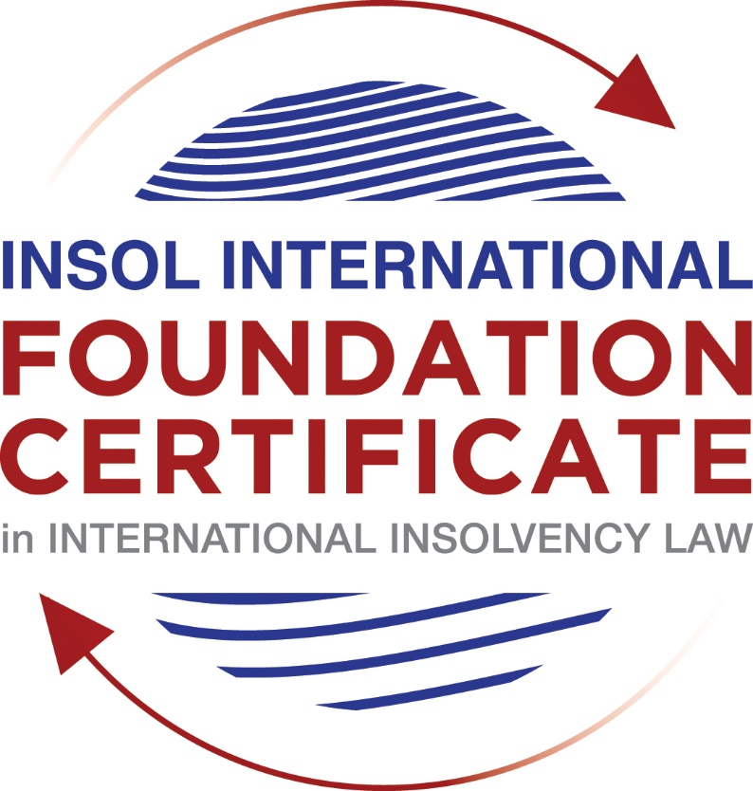

SUMMATIVE (FORMAL) ASSESSMENT: MODULE 3B

THE INSOLVENCY SYSTEM OF THE UNITED KINGDOM (ENGLAND AND WALES)

This is the summative (formal) assessment for Module 3B of this course and is compulsory for all candidates who selected this module as one of their compulsory modules from Module 3. Please read instruction 6.1 on the next page very carefully.

If you selected this module as one of your elective modules, please read instruction 6.2 on the next page very carefully.

The mark awarded for this assessment will determine your final mark for Module 3B. In order to pass this module, you need to obtain a mark of 50% or more for this assessment.

INSTRUCTIONS FOR COMPLETION AND SUBMISSION OF ASSESSMENT

Please read the following instructions very carefully before submitting / uploading your assessment on the Foundation Certificate web pages.

1. You must use this document for the answering of the assessment for this module. The answers to each question must be completed using this document with the answers populated under each question.

2. All assessments must be submitted electronically in MS Word format, using a standard A4 size page and a 11-point Arial font. This document has been set up with these parameters – please do not change the document settings in any way. DO NOT submit your assessment in PDF format as it will be returned to you unmarked.

3. No limit has been set for the length of your answers to the questions. However, please be guided by the mark allocation for each question. More often than not, one fact / statement will earn one mark (unless it is obvious from the question that this is not the case).

4. You must save this document using the following format: [student number.assessment3B]. An example would be something along the following lines: 202021IFU-314.assessment3B. Please also include the filename as a footer to each page of the assessment (this has been pre-populated for you, merely replace the words “studentnumber” with the student number allocated to you). Do not include your name or any other identifying words in your file name. Assessments that do not comply with this instruction will be returned to candidates unmarked.

5. Before you will be allowed to upload / submit your assessment via the portal on the Foundation Certificate web pages, you will be required to confirm / certify that you are the person who completed the assessment and that the work submitted is your own, original work. Please see the part of the Course Handbook that deals with plagiarism and dishonesty in the submission of assessments. Please note that copying and pasting from the Guidance Text into your answer is prohibited and constitutes plagiarism. You must write the answers to the questions in your own words.

6.1 If you selected Module 3B as one of your compulsory modules (see the e-mail that was sent to you when your place on the course was confirmed), the final time and date for the submission of this assessment is 23:00 (11 pm) GMT on 1 March 2021. The assessment submission portal will close at 23:00 (11 pm) GMT on 1 March 2021. No submissions can be made after the portal has closed and no further uploading of documents will be allowed, no matter the circumstances.

6.2 If you selected Module 3B as one of your elective modules (see the e-mail that was sent to you when your place on the course was confirmed), you have a choice as to when you may submit this assessment. You may either submit the assessment by 23:00 (11 pm) GMT on 1 March 2021 or by 23:00 (11 pm) BST on 31 July 2021. If you elect to submit by 1 March 2021, you may not submit the assessment again by 31 July 2021 (for example, in order to achieve a higher mark).

7. Prior to being populated with your answers, this assessment consists of 7 pages.

ANSWER ALL THE QUESTIONS

QUESTION 1 (multiple-choice questions) [10 marks in total]

Questions 1.1. – 1.10. are multiple-choice questions designed to assess your ability to think critically about the subject. Please read each question carefully before reading the answer options. Be aware that some questions may seem to have more than one right answer, but you are to look for the one that makes the most sense and is the most correct. When you have a clear idea of the question, find your answer and mark your selection on the answer sheet by highlighting the relevant paragraph in yellow. Select only ONE answer. Candidates who select more than one answer will receive no mark for that specific question.

Question 1.1

What is the initial period for a Moratorium under Part 1A of the Insolvency Act 1986 where the directors file relevant documents at court?

- 20 days.

- 20 business days.

- 40 days.

- 40 business days.

Question 1.2

What is the maximum length of a Moratorium under Part 1A of the Insolvency Act 1986 to which creditors can consent without any application to the court?

- 40 business days.

- One year and 20 business days.

- One year and 40 business days.

- One year.

Question 1.3

Which of the following is not a requirement for a company which wishes to enter into a Restructuring Plan under Part 26A of the Companies Act 2006?

- the company has encountered, or is likely to encounter, financial difficulties that are affecting, or will or may affect, its ability to carry on business as a going concern.

- a compromise or arrangement is proposed between the company and its creditors, or any class of them, or its members, or any class of them.

- the purpose of the compromise or arrangement is to eliminate, reduce or prevent, or mitigate the effect of, any of the said financial difficulties.

- the company is, or is likely to become, unable to pay their debts, as defined under section 123 of the Insolvency Act 1986.

Question 1.4

What percentage of creditors must approve a Scheme of Arrangement under Part 26 of the Companies Act 2006?

- A majority in number and in value.

- A majority in number and 50% or more in value.

- A majority in number and 75% or more in value.

- 75% or more in value.

Question 1.5

Which one of the following is not a debtor-in-possession procedure?

- Administration.

- Restructuring Plan.

- Scheme of Arrangement.

- Company Voluntary Arrangement.

Question 1.6

A liquidator may pay dividends to small value creditors based upon the information contained within the company’s statement of affairs or accounting records. In such circumstances, a creditor is deemed to have proved for the purposes of determination and payment of a dividend where the debt is no greater than how much?

- £500

- £750

- £1,000

- £2,000

Question 1.7

Which one of the following is not, in itself, a separate ground for disqualification of a director under the Company Directors Disqualification Act 1986?

- Wrongful trading.

- Breach of fiduciary duty.

- Being found guilty of an indictable offence in Great Britain.

- Being found guilty of an indictable offence overseas.

Question 1.8

The administrator is under a general duty to make a statement setting out proposals for achieving the purpose of administration. He or she must send out the statement of proposals as soon as reasonably practicable, and in any event within how many weeks of the date the company entered administration?

- 6

- 8

- 10

- 12

Question 1.9

Which of the following has the power to bring an action for wrongful trading under the Insolvency Act 1986?

- A monitor of a Moratorium.

- A supervisor of a Company Voluntary Arrangement.

- An administrator.

- An administrative receiver.

Question 1.10

Under section 176A of the Insolvency Act 1986, the prescribed part deducted from floating charge assets in favour of unsecured creditors is calculated as follows:

- 20% of the floating charge assets.

- 50% of the first £10,000 in value plus 20% of the excess in value above the £10,000 subject to a maximum amount of the prescribed part of £600,000.

- 20% of the first £50,000 in value plus 50% of the excess in value above the £50,000 subject to a maximum amount of prescribed part of £800,000.

- 50% of the first £10,000 in value plus 20% of the excess in value above the £10,000 subject to a maximum amount of prescribed part of £800,000.

QUESTION 2 (direct questions) [10 marks]

Question 2.1 [maximum 6 marks]

What is the difference between cash flow insolvency and balance sheet insolvency?

[The main methods for determining insolvency are cash flow and balance sheet
insolvency. The distinction between cash flow and balance sheet insolvency is that a
corporation or person is cash flow or commercially insolvent when it is unable to pay bills
owed that were past due. In this case, the company/person has assets but no way of
monetizing them.

Balance sheet or technical insolvency, on the other hand, happens when the value of a
company's assets fall below a certain threshold.
The value of a company's assets is less than the value of its liabilities i.e having insufficient
funds to pay off all debts.

The Supreme Court in BNY Corporate Trustee Services Ltd v Eurosail [2013] UKSC 28
upheld the Court of Appeal’s decision that Eurosail was not “balance sheet insolvent” under
the s123(2) test, holding that:
The fact that a company’s latest audited balance sheet showed a net deficit did not necessarily
mean that the company was “balance sheet insolvent” for the purposes of s123(2) IA; instead,
the court must be satisfied that, on the balance of probabilities:

(i) a company has insufficient assets to be able to meet all of its liabilities, including prospective
and contingent liabilities, if and when they eventually fall due;

(ii) there will therefore “eventually be a deficiency”.

Characteristics of the company after it has arrived "the point of no return because of incurable
deficiency in its assets" is not the valid test for balance-sheet insolvency and should not
pass into widespread use.]

The cash-flow test is concerned with debts that are currently due as well as those that are due
in the future in the foreseeable future. What constitutes the "reasonably near future" will be
determined by all of these circumstances, including the nature of the company's business in
particular.

The cash-flow test is used when the court must consider more than the reasonably near future,
becomes purely speculative, and the balance-sheet test is the only sensible way to assess
insolvency.

The balance sheet test is a legal test that requires the court to determine what value to attribute
to the prospective and contingent liabilities of a company. The court must compare present
assets with present and future liabilities and, making allowance for contingencies and deferred
payments, assess whether the company can be reasonably expected to meet all of its
liabilities.

Question 2.2 [maximum 4 marks]

List four (4) elements of the statutory moratorium imposed when a company enters administration.

[a. No resolution may be passed for the winding up of the company;

b. No winding-up order may be made against the company (other than on public interest
grounds);

c. No step may be taken to enforce security over the company’s property except with the
consent of the administrator or the permission of the court;

d. A landlord may not exercise a right of forfeiture by peaceable re-entry in relation to premises
let to the company except with the consent of the administrator or the permission of the
court]

QUESTION 3 (essay-type questions) [15 marks in total]

Question 3.1 [maximum 6 marks]

Explain the main differences between a Part 26 Scheme of Arrangement and a Part 26A Restructuring Plan.

[There are three main differences:
1. Part 26A is only available to a company which has encountered, or is likely to encounter, financial difficulties that are affecting, or will or may affect, its ability to carry on business as a going concern;
2. A majority in number of each class of creditors must approve a Part 26 Scheme (as well as 75% in value) whilst a Part 26A Plan only requires 75% in value. The relevant threshold for approval is 75% in value (gross value of debt) of creditors in each class who vote. The anticipated requirement that more than half of the value of unconnected creditors vote in favour does not appear in the Act. Similarly, the numerosity test in Schemes does not apply to the Restructuring Plan.

3. Part 26A contains provision for a cross class cram down which is not available under Part
26. Even though a class does not vote in favour, creditors in that class may be bound by the plan if the cross-class cram-down rules are met. Those rules are:

a. At least one class of creditors “who would receive a payment, or have a genuine economic interest in the company, in the event of the relevant alternative” voted in favour of the Restructuring Plan;
b. The dissenting creditors would not be “any worse off” under that plan than they would have been in the event of “whatever the court considers would be most likely to occur in relation to the company” should the plan be rejected (which may not necessarily be the immediate liquidation of the debtor company, although this would probably be the correct comparator in many cases, given the eligibility criteria);
c. The court is prepared to sanction the Restructuring Plan.]

Question 3.2 [maximum 9 marks]

Explain the different ways in which overseas officeholders may be recognised and request the assistance of the court in England and Wales.

[There are four possible ways in which oversee officeholders may be recognised. These are – under the EU Regulation, the CBIR, section 426 of the Act or at common law.

- EU Regulation on Insolvency Proceedings (Insolvency Regulation) - The general principle of the Regulation is that any judgement opening insolvency proceedings handed down by a court of a member state is to be recognised in all the other member states from the time that it becomes effective in the state where proceedings are opened.

- Cross Border Insolvency Regulations 2006 (CBIR), which adopt the UNCITRAL model law on cross-border insolvency, are well used and relatively familiar to those working in the cross-border insolvency space.

- Section 426 of the Insolvency Act 1986, which is a lesser-used but unique tool available where recognition is sought in the UK of an insolvency taking place in a designated jurisdiction. Under Section 426(4), the courts having jurisdiction in relation to insolvency law in any part of the UK shall assist the courts having the corresponding jurisdiction in any other part of the UK or any relevant country or territory.

The relevant countries/territories are currently: Anguilla, Australia, the Bahamas, Bermuda, Botswana, Brunei, Canada, Cayman Islands, the Channel Islands (Jersey, Guernsey, Alderney, Sark, and Herm), Falkland Islands, Gibraltar, Hong Kong, Isle of Man, Malaysia, Montserrat, New Zealand, the Republic of Ireland, South Africa, Saint Helena, Turks and Caicos Islands, Tuvalu and the British Virgin Islands.

- Common law Recognition (Principle of comity. Common-law recognition has been based on the principle of judicial comity, under which English courts have extended recognition and given effect to the bankruptcy laws of other countries within the English jurisdiction.
Recognition under common law is likely to be less significant going forward and will be confined to cases that do not fall within the three methods of recognition discussed above. One residual circumstance in which it will still be of importance involves receivers who are not appointed in relation to a “foreign proceeding” for the purposes of the Cross-Border Regulations (and where there is no foreign representative who has successfully obtained recognition under them in relation to the relevant assets).

English courts recognized overseas receivers at common law if:
i. There is a sufficient connection between the foreign court and the debtor (incorporation in the country in which the receiver is appointed will be sufficient connection, as will the circumstance where the country of incorporation itself recognizes the receiver or there is a factual connection, such as a place of management);

ii. Recognition is not contrary to public policy;

iii. There is no fraud or unfairness in relation to the appointment of the receiver.

QUESTION 4 (fact-based application-type question) [15 marks in total]

Prior to going into liquidation in November 2020, under pressure from its bank, Stercus Bank plc, and in order to prevent it from demanding repayment of the company’s loans, Cork-In Limited granted a debenture in favour of Stercus Bank plc in January 2020. The debenture contained a floating charge over the whole of the company’s undertaking.

In June 2020, as the company continued to struggle, the directors approved the
sale of a company delivery van to Paul Watson (a director) for £5,000 in cash. The
van had been bought for £10,000 a year before.

A month before the company went into liquidation, Paul Watson received an irate phone call from one of the company’s key suppliers, Gary’s Grapes Limited. The supplier demanded immediate payment of all sums owing to it (even those invoices that had not become payable). Fearing being cut off by the supplier, Paul arranged for a cheque for the full amount to be sent that day.

The liquidator has asked for advice whether any action may be taken in respect of the floating charge in favour of Stercus Bank plc and the two subsequent transactions.

Using the facts above, answer the questions that follow.

Identify the relevant issues and statutory provisions and consider whether the liquidator may take any action in relation to:

Question 4.1 [maximum 5 marks]

The floating charge in favour of Stercus Bank plc;

[The major feature of a floating charge is that, until it crystallises, the chargor is entitled to deal with the charged assets in the normal course of business without any further consent from the chargee. On the other hand, a fixed charge requires the chargee to exercise a significant degree of control over the said charged asset.

In the absence of any special provisions in the relevant document, a floating charge crystallises either upon the appointment of a receiver or upon the commencement of liquidation. In the case of Government Stocks and Securities Investments Co Ltd v Manila Rly Co his Lordship stated that a charge should also crystallise upon the company ceasing to trade as a going concern.]

Question 4.2 [maximum 5 marks]

The sale of the van; and

[Debts secured by a floating charge are paid from the sale proceeds of the assets secured by the floating charge.
Before any payment can be made to any floating charge holder, the liquidator must first consider the application of section 176A of the Act. Section 176A applies to a company with a floating charge created on or after 15 September 2003 and the company has gone into liquidation. A prescribed part of the proceeds must be made available to unsecured creditors as provided under the Enterprise Act.
The prescribed part is calculated as 50% of the floating charge proceeds up to a cap of GB£10,000. If the floating charge proceeds are greater than GB£10,000, the prescribed part is calculated as GB£5,000 plus 20% of the proceeds]

Question 4.3 [maximum 5 marks]

The payment to Gary’s Grapes Ltd.

[Gary is an unsecured creditor and as an unsecured creditors he can claim interest on the debt up to the date of liquidation under certain circumstances. The creditor may state their intention to charge interest within the initial agreement, for example, or provided notice in a reminder that interest will become due.
Under the UK creditors ranking, the unsecured creditor would rank last based on the scenario]

* End of Assessment *

