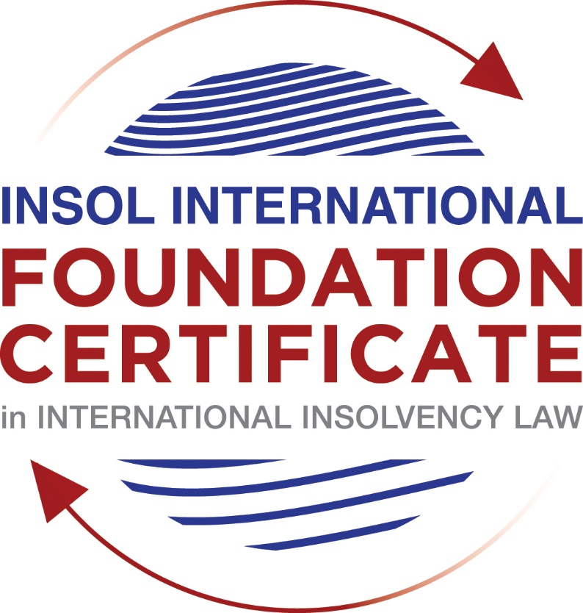

SUMMATIVE (FORMAL) ASSESSMENT: MODULE 3B

THE INSOLVENCY SYSTEM OF THE UNITED KINGDOM (ENGLAND AND WALES)

This is the summative (formal) assessment for Module 3B of this course and is compulsory for all candidates who selected this module as one of their compulsory modules from Module 3. Please read instruction 6.1 on the next page very carefully.

If you selected this module as one of your elective modules, please read instruction 6.2 on the next page very carefully.

The mark awarded for this assessment will determine your final mark for Module 3B. In order to pass this module, you need to obtain a mark of 50% or more for this assessment.

INSTRUCTIONS FOR COMPLETION AND SUBMISSION OF ASSESSMENT

Please read the following instructions very carefully before submitting / uploading your assessment on the Foundation Certificate web pages.

1. You must use this document for the answering of the assessment for this module. The answers to each question must be completed using this document with the answers populated under each question.

2. All assessments must be submitted electronically in MS Word format, using a standard A4 size page and a 11-point Arial font. This document has been set up with these parameters – please do not change the document settings in any way. DO NOT submit your assessment in PDF format as it will be returned to you unmarked.

3. No limit has been set for the length of your answers to the questions. However, please be guided by the mark allocation for each question. More often than not, one fact / statement will earn one mark (unless it is obvious from the question that this is not the case).

4. You must save this document using the following format: [student number.assessment3B]. An example would be something along the following lines: 202021IFU-314.assessment3B. Please also include the filename as a footer to each page of the assessment (this has been pre-populated for you, merely replace the words “studentnumber” with the student number allocated to you). Do not include your name or any other identifying words in your file name. Assessments that do not comply with this instruction will be returned to candidates unmarked.

5. Before you will be allowed to upload / submit your assessment via the portal on the Foundation Certificate web pages, you will be required to confirm / certify that you are the person who completed the assessment and that the work submitted is your own, original work. Please see the part of the Course Handbook that deals with plagiarism and dishonesty in the submission of assessments. Please note that copying and pasting from the Guidance Text into your answer is prohibited and constitutes plagiarism. You must write the answers to the questions in your own words.

6.1 If you selected Module 3B as one of your compulsory modules (see the e-mail that was sent to you when your place on the course was confirmed), the final time and date for the submission of this assessment is 23:00 (11 pm) GMT on 1 March 2021. The assessment submission portal will close at 23:00 (11 pm) GMT on 1 March 2021. No submissions can be made after the portal has closed and no further uploading of documents will be allowed, no matter the circumstances.

6.2 If you selected Module 3B as one of your elective modules (see the e-mail that was sent to you when your place on the course was confirmed), you have a choice as to when you may submit this assessment. You may either submit the assessment by 23:00 (11 pm) GMT on 1 March 2021 or by 23:00 (11 pm) BST on 31 July 2021. If you elect to submit by 1 March 2021, you may not submit the assessment again by 31 July 2021 (for example, in order to achieve a higher mark).

7. Prior to being populated with your answers, this assessment consists of 7 pages.

ANSWER ALL THE QUESTIONS

QUESTION 1 (multiple-choice questions) [10 marks in total]

Questions 1.1. – 1.10. are multiple-choice questions designed to assess your ability to think critically about the subject. Please read each question carefully before reading the answer options. Be aware that some questions may seem to have more than one right answer, but you are to look for the one that makes the most sense and is the most correct. When you have a clear idea of the question, find your answer and mark your selection on the answer sheet by highlighting the relevant paragraph in yellow. Select only ONE answer. Candidates who select more than one answer will receive no mark for that specific question.

Question 1.1

What is the initial period for a Moratorium under Part 1A of the Insolvency Act 1986 where the directors file relevant documents at court?

- 20 days.

- 20 business days.

- 40 days.

- 40 business days.

Question 1.2

What is the maximum length of a Moratorium under Part 1A of the Insolvency Act 1986 to which creditors can consent without any application to the court?

- 40 business days.

- One year and 20 business days.

- One year and 40 business days.

- One year.

Question 1.3

Which of the following is not a requirement for a company which wishes to enter into a Restructuring Plan under Part 26A of the Companies Act 2006?

- the company has encountered, or is likely to encounter, financial difficulties that are affecting, or will or may affect, its ability to carry on business as a going concern.

- a compromise or arrangement is proposed between the company and its creditors, or any class of them, or its members, or any class of them.

- the purpose of the compromise or arrangement is to eliminate, reduce or prevent, or mitigate the effect of, any of the said financial difficulties.

- the company is, or is likely to become, unable to pay their debts, as defined under section 123 of the Insolvency Act 1986.

Question 1.4

What percentage of creditors must approve a Scheme of Arrangement under Part 26 of the Companies Act 2006?

- A majority in number and in value.

- A majority in number and 50% or more in value.

- A majority in number and 75% or more in value.

- 75% or more in value.

Question 1.5

Which one of the following is not a debtor-in-possession procedure?

- Administration.

- Restructuring Plan.

- Scheme of Arrangement.

- Company Voluntary Arrangement.

Question 1.6

A liquidator may pay dividends to small value creditors based upon the information contained within the company’s statement of affairs or accounting records. In such circumstances, a creditor is deemed to have proved for the purposes of determination and payment of a dividend where the debt is no greater than how much?

- £500

- £750

- £1,000

- £2,000

Question 1.7

Which one of the following is not, in itself, a separate ground for disqualification of a director under the Company Directors Disqualification Act 1986?

- Wrongful trading.

- Breach of fiduciary duty.

- Being found guilty of an indictable offence in Great Britain.

- Being found guilty of an indictable offence overseas.

Question 1.8

The administrator is under a general duty to make a statement setting out proposals for achieving the purpose of administration. He or she must send out the statement of proposals as soon as reasonably practicable, and in any event within how many weeks of the date the company entered administration?

- 6

- 8

- 10

- 12

Question 1.9

Which of the following has the power to bring an action for wrongful trading under the Insolvency Act 1986?

- A monitor of a Moratorium.

- A supervisor of a Company Voluntary Arrangement.

- An administrator.

- An administrative receiver.

Question 1.10

Under section 176A of the Insolvency Act 1986, the prescribed part deducted from floating charge assets in favour of unsecured creditors is calculated as follows:

- 20% of the floating charge assets.

- 50% of the first £10,000 in value plus 20% of the excess in value above the £10,000 subject to a maximum amount of the prescribed part of £600,000.

- 20% of the first £50,000 in value plus 50% of the excess in value above the £50,000 subject to a maximum amount of prescribed part of £800,000.

- 50% of the first £10,000 in value plus 20% of the excess in value above the £10,000 subject to a maximum amount of prescribed part of £800,000.

QUESTION 2 (direct questions) [10 marks]

Question 2.1 [maximum 6 marks]

What is the difference between cash flow insolvency and balance sheet insolvency?

The balance sheet insolvency stands for a status in which the value of the company’s assets is worth less than the value of its liabilities (future and contingent liabilities and present liabilities have to be taken into account). Therefore, a cash flow insolvency is deemed to happen when the company in question is unable to pay its debts as they become due.

Question 2.2 [maximum 4 marks]

List four (4) elements of the statutory moratorium imposed when a company enters administration.

- No resolution may be passed for the company in liquidation;
- No winding-up order may be made against the company
- No security can be enforced over company’s property without consent;
- No administrative receiver can be appointed.

QUESTION 3 (essay-type questions) [15 marks in total]

Question 3.1 [maximum 6 marks]

Explain the main differences between a Part 26 Scheme of Arrangement and a Part 26A Restructuring Plan.

The part 26 Scheme of Arrangement if binding on all creditors and secured and unsecured creditors must vote separate into each of its classes. It can be used for companies both in solvent or insolvent state. It is a court led proceeding and it must be commenced with a court application.

The approval rate on this proceeding is required to be a majority of creditors in number as well as 75% or more in value for each class.

The part 26A Restructuring plan is like the Part 26, since it demands a court application to be commenced, and by which is asked to order class meetings of creditors and members.

The approval rate on this proceeding is required to be 75% or more in value of creditors or class of creditors, or members or class of members.

This proceeding enables the court to cram down a dissenting class who does not approves the Plan. There are two conditions that must be met. If both of them are achieved, the court may sanction the plan despite the non-approval: the first one is that none of the dissenting class would be any worse off than they would be in the event of the “relevant alternative” which normally would be a liquidation or administration, the second one is that the arrangement has been approved by at least 75% in value of one class of creditors or members who would receive a payment or have an economic interest in the company, in the event of the “relevant alternative”

Therefore, as the Part 26A enables the cross cram down it may be seen as a more advantageous proceeding, since in part 26, if one class do not vote in favor, the proposal may not ratified by the Court.

Question 3.2 [maximum 9 marks]

Explain the different ways in which overseas officeholders may be recognised and request the assistance of the court in England and Wales.

There are four possibilities in which overseas officeholders may be recognised and request assistance of the court in England and Wales. These possibilities are regulated under the EU Regulation, the CBIR, section 426 of the Act or at common law.

The EU Regulation states that if a company has is COMI in the UK, only the UK will have the jurisdiction to open a main insolvency proceeding. This proceeding would be governed by the UK law. Any appointment therefore would be automatically recognised in all Members States and the insolvency practitioners would be able to exercise all powers, subjected to some exceptions.

The CBIR possibility demands no reciprocity, therefore insolvency practitioners from any overseas’ jurisdiction may apply to the court to be recognised in the jurisdiction. Under the model law, although the recognition of foreign proceedings is not automatic, this means that it requires an application to a local court in order to the recognition and relief to be granted.

The Section 426 contains provisions for the UK Courts to aid overseas courts from listed jurisdictions. The court orders made in insolvency matters by a court in the UK are only enforceable on all parts of the UK. In addition, courts in UK have the obligation to assist each other or any relevant country or territory. Therefore, it is in the court’s discretion to determine whether the assistance would be granted to such countries. In these cases, Courts may apply UK law or the overseas’ law in order to provide the assistance to the overseas’ court.

The common law possibility and the extend of the ability of the common law to assist have been reduced in a significant way. The effect is that the case law still approaches the modified universalism in which will assist overseas officeholder looking for assistance in the UK, but is should be noted that the advice is to apply one of the legislative approaches listed above.

QUESTION 4 (fact-based application-type question) [15 marks in total]

Prior to going into liquidation in November 2020, under pressure from its bank, Stercus Bank plc, and in order to prevent it from demanding repayment of the company’s loans, Cork-In Limited granted a debenture in favour of Stercus Bank plc in January 2020. The debenture contained a floating charge over the whole of the company’s undertaking.

In June 2020, as the company continued to struggle, the directors approved the
sale of a company delivery van to Paul Watson (a director) for £5,000 in cash. The
van had been bought for £10,000 a year before.

A month before the company went into liquidation, Paul Watson received an irate phone call from one of the company’s key suppliers, Gary’s Grapes Limited. The supplier demanded immediate payment of all sums owing to it (even those invoices that had not become payable). Fearing being cut off by the supplier, Paul arranged for a cheque for the full amount to be sent that day.

The liquidator has asked for advice whether any action may be taken in respect of the floating charge in favour of Stercus Bank plc and the two subsequent transactions.

Using the facts above, answer the questions that follow.

Identify the relevant issues and statutory provisions and consider whether the liquidator may take any action in relation to:

Question 4.1 [maximum 5 marks]

The floating charge in favour of Stercus Bank plc;

Regarding the Stercus Bank, the liquidator can file for a floating charge avoidance, since the granting of the floating charge was 11 months before entering into a liquidation proceeding. This transaction may be qualified as a Section 245 and the granting can be considered invalid, but the debt remains.

Question 4.2 [maximum 5 marks]

The sale of the van; and

The sale of the van can be questioned in two ways. The first one regarding the Section 238, which relates to a transaction made prior to the liquidation and made with an undervalue. This transaction must had been took during the relevant time of 2 years prior to the liquidation proceeding. Since this transaction was done directly with a director, therefore a connected person, the company is presumed to have been insolvent. If the requisites are met, the transaction is made invalid, and the court will the demand the restoring of the asset to the state.

On the other hand, this transaction can also be used the disqualify the director with grounds on the Company Directors Disqualification Act of 1986 since it acted in bad faith when made the transaction and therefore did not exercised its fiduciary duty.

Question 4.3 [maximum 5 marks]

The payment to Gary’s Grapes Ltd.

Despite the director’s disqualification stated above, this kind of transaction can be disqualified since it aimed to prefer a creditor in prejudice of the others subject to the liquidation. The transaction was made only a month before entering into liquidation proceeding and qualified in the 239 Section, which aims to prevent the company from placing one of its creditors in a better position than the others right before entering into liquidation.

* End of Assessment *

