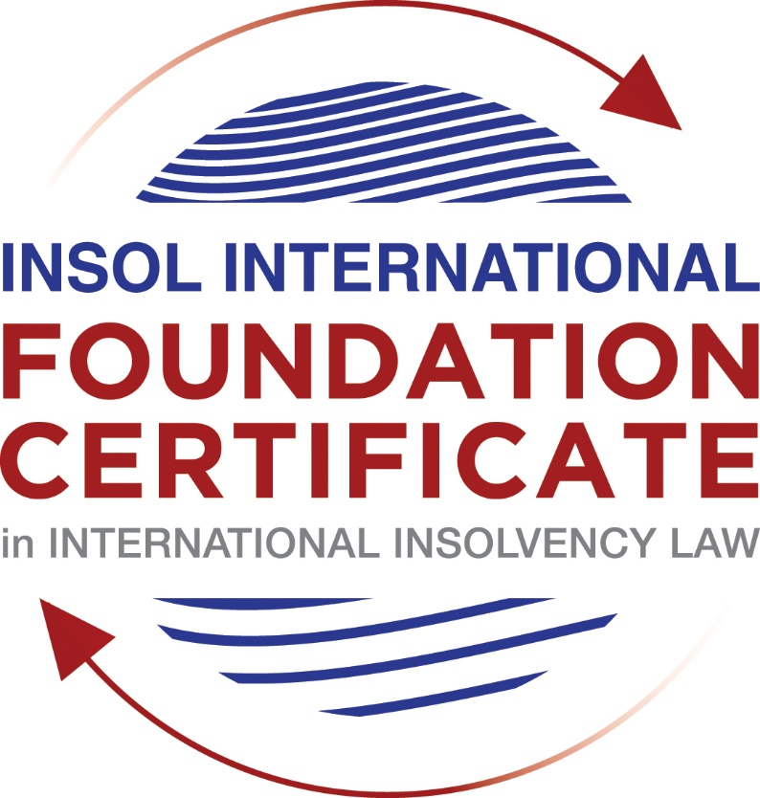

SUMMATIVE (FORMAL) ASSESSMENT: MODULE 3B

THE INSOLVENCY SYSTEM OF THE UNITED KINGDOM (ENGLAND AND WALES)

This is the summative (formal) assessment for Module 3B of this course and is compulsory for all candidates who selected this module as one of their compulsory modules from Module 3. Please read instruction 6.1 on the next page very carefully.

If you selected this module as one of your elective modules, please read instruction 6.2 on the next page very carefully.

The mark awarded for this assessment will determine your final mark for Module 3B. In order to pass this module, you need to obtain a mark of 50% or more for this assessment.

INSTRUCTIONS FOR COMPLETION AND SUBMISSION OF ASSESSMENT

Please read the following instructions very carefully before submitting / uploading your assessment on the Foundation Certificate web pages.

1. You must use this document for the answering of the assessment for this module. The answers to each question must be completed using this document with the answers populated under each question.

2. All assessments must be submitted electronically in MS Word format, using a standard A4 size page and a 11-point Arial font. This document has been set up with these parameters – please do not change the document settings in any way. DO NOT submit your assessment in PDF format as it will be returned to you unmarked.

3. No limit has been set for the length of your answers to the questions. However, please be guided by the mark allocation for each question. More often than not, one fact / statement will earn one mark (unless it is obvious from the question that this is not the case).

4. You must save this document using the following format: [student number.assessment3B]. An example would be something along the following lines: 202021IFU-314.assessment3B. Please also include the filename as a footer to each page of the assessment (this has been pre-populated for you, merely replace the words “studentnumber” with the student number allocated to you). Do not include your name or any other identifying words in your file name. Assessments that do not comply with this instruction will be returned to candidates unmarked.

5. Before you will be allowed to upload / submit your assessment via the portal on the Foundation Certificate web pages, you will be required to confirm / certify that you are the person who completed the assessment and that the work submitted is your own, original work. Please see the part of the Course Handbook that deals with plagiarism and dishonesty in the submission of assessments. Please note that copying and pasting from the Guidance Text into your answer is prohibited and constitutes plagiarism. You must write the answers to the questions in your own words.

6.1 If you selected Module 3B as one of your compulsory modules (see the e-mail that was sent to you when your place on the course was confirmed), the final time and date for the submission of this assessment is 23:00 (11 pm) GMT on 1 March 2021. The assessment submission portal will close at 23:00 (11 pm) GMT on 1 March 2021. No submissions can be made after the portal has closed and no further uploading of documents will be allowed, no matter the circumstances.

6.2 If you selected Module 3B as one of your elective modules (see the e-mail that was sent to you when your place on the course was confirmed), you have a choice as to when you may submit this assessment. You may either submit the assessment by 23:00 (11 pm) GMT on 1 March 2021 or by 23:00 (11 pm) BST on 31 July 2021. If you elect to submit by 1 March 2021, you may not submit the assessment again by 31 July 2021 (for example, in order to achieve a higher mark).

7. Prior to being populated with your answers, this assessment consists of 7 pages.

ANSWER ALL THE QUESTIONS

QUESTION 1 (multiple-choice questions) [10 marks in total]

Questions 1.1. – 1.10. are multiple-choice questions designed to assess your ability to think critically about the subject. Please read each question carefully before reading the answer options. Be aware that some questions may seem to have more than one right answer, but you are to look for the one that makes the most sense and is the most correct. When you have a clear idea of the question, find your answer and mark your selection on the answer sheet by highlighting the relevant paragraph in yellow. Select only ONE answer. Candidates who select more than one answer will receive no mark for that specific question.

Question 1.1

What is the initial period for a Moratorium under Part 1A of the Insolvency Act 1986 where the directors file relevant documents at court?

- 20 days.

- 20 business days.

- 40 days.

- 40 business days.

Question 1.2

What is the maximum length of a Moratorium under Part 1A of the Insolvency Act 1986 to which creditors can consent without any application to the court?

- 40 business days.

- One year and 20 business days.

- One year and 40 business days.

- One year.

Question 1.3

Which of the following is not a requirement for a company which wishes to enter into a Restructuring Plan under Part 26A of the Companies Act 2006?

- the company has encountered, or is likely to encounter, financial difficulties that are affecting, or will or may affect, its ability to carry on business as a going concern.

- a compromise or arrangement is proposed between the company and its creditors, or any class of them, or its members, or any class of them.

- the purpose of the compromise or arrangement is to eliminate, reduce or prevent, or mitigate the effect of, any of the said financial difficulties.

- the company is, or is likely to become, unable to pay their debts, as defined under section 123 of the Insolvency Act 1986.

Question 1.4

What percentage of creditors must approve a Scheme of Arrangement under Part 26 of the Companies Act 2006?

- A majority in number and in value.

- A majority in number and 50% or more in value.

- A majority in number and 75% or more in value.

- 75% or more in value.

Question 1.5

Which one of the following is not a debtor-in-possession procedure?

- Administration.

- Restructuring Plan.

- Scheme of Arrangement.

- Company Voluntary Arrangement.

Question 1.6

A liquidator may pay dividends to small value creditors based upon the information contained within the company’s statement of affairs or accounting records. In such circumstances, a creditor is deemed to have proved for the purposes of determination and payment of a dividend where the debt is no greater than how much?

- £500

- £750

- £1,000

- £2,000

Question 1.7

Which one of the following is not, in itself, a separate ground for disqualification of a director under the Company Directors Disqualification Act 1986?

- Wrongful trading.

- Breach of fiduciary duty.

- Being found guilty of an indictable offence in Great Britain.

- Being found guilty of an indictable offence overseas.

Question 1.8

The administrator is under a general duty to make a statement setting out proposals for achieving the purpose of administration. He or she must send out the statement of proposals as soon as reasonably practicable, and in any event within how many weeks of the date the company entered administration?

- 6

- 8

- 10

- 12

Question 1.9

Which of the following has the power to bring an action for wrongful trading under the Insolvency Act 1986?

- A monitor of a Moratorium.

- A supervisor of a Company Voluntary Arrangement.

- An administrator.

- An administrative receiver.

Question 1.10

Under section 176A of the Insolvency Act 1986, the prescribed part deducted from floating charge assets in favour of unsecured creditors is calculated as follows:

- 20% of the floating charge assets.

- 50% of the first £10,000 in value plus 20% of the excess in value above the £10,000 subject to a maximum amount of the prescribed part of £600,000.

- 20% of the first £50,000 in value plus 50% of the excess in value above the £50,000 subject to a maximum amount of prescribed part of £800,000.

- 50% of the first £10,000 in value plus 20% of the excess in value above the £10,000 subject to a maximum amount of prescribed part of £800,000.

QUESTION 2 (direct questions) [10 marks]

Question 2.1 [maximum 6 marks]

What is the difference between cash flow insolvency and balance sheet insolvency?

According to section 123 of the Insolvency Act 1986, when it is proved to the satisfaction of court that the company is unable to pay its debts as they fall due in near future it is called cash flow insolvency or cash flow test of insolvency whereas when it is proved to the satisfaction of court that the value of company’s assets is less than the value of its liabilities it is called balance sheet insolvency or balance sheet test of insolvency. The liabilities include contingent and prospective liabilities also.

It can be situation where the company not cash flow insolvent i.e., the company is able to meet its liabilities when they fall due but is balance sheet insolvent. However, the section 123 permits either or both tests to be satisfied in order to show that the company is unable to pay its debts.

The balance sheet insolvency is also considered as technical insolvency whereas the cash flow insolvency is an actual insolvency.

In other words, the cash-flow insolvency occurs when an insolvent debtor can’t make a payment because he doesn’t have the money whereas the balance-sheet insolvency occurs when debtor’s debts exceed its assets.

Other difference between the two is that the cash flow insolvency test checks the ability to make payments due in near future where as in balance sheet insolvency test, the value of present assets is compared with present as well as future liabilities and contingent liabilities which may or may not arise after using suitable discounting.

Question 2.2 [maximum 4 marks]

List four (4) elements of the statutory moratorium imposed when a company enters administration.

The statutory moratorium is imposed to put on the actions with purpose to give administrator time to formulate the proposal, put it before creditors and if approved, implement it.

The following are the elements of the statutory moratorium imposed when a company enters administration: -

1. No resolution or order of winding up against the company may be made except on the grounds of public interest.

2. Steps to enforce security over the company’s property may not be taken except with the consent of administrator or consent of court.

3. Steps to repossess goods in the company’s possession under a hire purchase agreement where the terms include retention of title contracts, may not be taken except with the consent of administrator or consent of court.

4. Stay on all legal proceedings and execution of judgements against the company. Further stay on vacancy of premises taken on rent by the company and stay on appointment of administrative receiver.

QUESTION 3 (essay-type questions) [15 marks in total]

Question 3.1 [maximum 6 marks]

Explain the main differences between a Part 26 Scheme of Arrangement and a Part 26A Restructuring Plan.

Following are the main differences between Part 26 Scheme of Arrangement and a Part 26A Restructuring Plan: -

1. Part 26A is a new provision as compared to Part 26 to the Companies act 2006 since former was introduced through 2020 act.

2. Part 26A is only available to the relevant companies who has encountered or likely to encounter financial distress that is affecting or will or may affect its ability to carry business as a going concern whereas Part 26, scheme of arrangement can be used by the company whether it is solvent or insolvent.

3. The specific purpose of Part 26A Restructuring Plan is to eliminate or reduce or prevent from the effect of the financial difficulty whereas Part 26 scheme of arrangement may have the purpose of elimination or reduction of financial distress.

4. In Part 26A, the court may sanction such Restructuring Plan if it is approved by creditors or members or class of creditors representing 75% or more in value. Whereas in Part 26 a simple majority in numbers also required along with the approval from creditors or members or class of creditors representing 75% or more in value.

5. Another provision that differs Part 26A from Part 26 is cross class cram down i.e., the ability of court to cram down a dissenting class which does not approves the Restructuring Plan is available under Part 26A. The Restructuring Plan shall be binding on all the creditor if it is approved and sanctioned by the court whereas no such provision is available under Part 26 Scheme of Arrangement.

Question 3.2 [maximum 9 marks]

Explain the different ways in which overseas officeholders may be recognised and request the assistance of the court in England and Wales.

Following are the ways in which overseas officeholders may be recognised and request the assistance of the court in England and Wales: -

1. European Insolvency Regulation (EIR) Recast 2015: - Cross-border insolvency matters which has their centre of main interest (COMI) within any European Union member state except Denmark are governed by EU Regulation. EIR Recast enables all other member states to automatically recognise the main insolvency proceedings opened in COMI. The office holder in COMI is empowered to exercise all his powers over the assets situated in other member states. Further, the option of opening of secondary proceedings is there where the debtor has an establishment in order to secure interest of local creditor and Insolvency practitioner of main proceedings to give an undertaking under article 36 in order to avoid secondary insolvency proceedings.

2. UNCITRAL Model Law on Cross-Border insolvency: - Here the Insolvency Practitioner from any overseas jurisdiction where an insolvency proceeding has been opened may apply to the court in England and Wales to be recognised and gain relief in the UK jurisdiction as it is not automatic recognition like in EU Regulation.

3. Co-operation between courts exercising jurisdiction in relation to insolvency: - Section 426 of the Insolvency Act 1986 contains provisions where UK courts are required to provide assistance to the courts of certain listed overseas jurisdictions. The jurisdictions which are currently benefited from “inward-bound” effect of section 426 are Australia, Canada, Hong Kong, Ireland, Malasia, New Zealand and South Africa. However, its courts discretion to decide whether to grand relief or not, especially where it would be improper to do so.

4. Common Law Jurisdiction to grant assistance to foreign insolvency proceedings: - This is another possible way through which an UK court may grant assistance to a foreign insolvency proceeding in a similar way as stated above in section 426 of the act.

QUESTION 4 (fact-based application-type question) [15 marks in total]

Prior to going into liquidation in November 2020, under pressure from its bank, Stercus Bank plc, and in order to prevent it from demanding repayment of the company’s loans, Cork-In Limited granted a debenture in favour of Stercus Bank plc in January 2020. The debenture contained a floating charge over the whole of the company’s undertaking.

In June 2020, as the company continued to struggle, the directors approved the
sale of a company delivery van to Paul Watson (a director) for £5,000 in cash. The
van had been bought for £10,000 a year before.

A month before the company went into liquidation, Paul Watson received an irate phone call from one of the company’s key suppliers, Gary’s Grapes Limited. The supplier demanded immediate payment of all sums owing to it (even those invoices that had not become payable). Fearing being cut off by the supplier, Paul arranged for a cheque for the full amount to be sent that day.

The liquidator has asked for advice whether any action may be taken in respect of the floating charge in favour of Stercus Bank plc and the two subsequent transactions.

Using the facts above, answer the questions that follow.

Identify the relevant issues and statutory provisions and consider whether the liquidator may take any action in relation to:

Question 4.1 [maximum 5 marks]

The floating charge in favour of Stercus Bank plc;

Under section 245 of the Act, there is a provision for floating charge avoidance. Where the company was insolvent as per section 123 of the Act and within relevant period i.e., six months in case of non-connected person(s) and two years in case of connected person(s) creates a floating charge to secure an existing unsecured debt, the said charge created shall be reversed. The said section or avoidance does not applies on creation of floating charge on new debt. The new debt here does not mean restructuring of old debt or repayment of old debt by new debt. There should be fresh consideration at the time of creation of floating charge.

In the given case, the Cork-In Limited granted a debenture in favour of Stercus Bank plc in January 2020 in order to prevent it from demanding repayment of the company’s existing loans and the said debenture contained a floating charge over the whole of the company’s undertaking. Section 245 applies here since creation of floating charge was within relevant period of one year, the company also falls within section 123 of the Act and creation of floating charge was to secure an existing unsecured debt as no fresh consideration was received against such debentures i.e., there is no new debt. The court at its discretion may order for avoidance of the said floating charge under section 245.

Question 4.2 [maximum 5 marks]

The sale of the van; and

As per section 238 of the Insolvency Act, if a company enters into a transaction or transfers an asset to another person as gift or for no consideration or for a consideration which is significantly less than the value in money oy money’s worth within relevant period i.e., two years prior to the date of commencement of administration or Liquidation is considered as an Undervalue Transaction provided that at the time of said transaction either the company was insolvent or became insolvent with the impact of the said transaction according to section 123 of the act.

In such case the administrator or the liquidator may request the court to pass an order to reverse or nullify such under value transaction and if are giving opportunity to prove that the transaction entered by the company is in good faith, the court still believes that the said transaction is an Undervalue Transaction, the court may pass such order to restore the position to what it would have been if the said transaction not entered.
Since the facts given in case, it is clearly stated that the company was in financial distress and the Van was sold to a connected person, a director for a significant less value (at 50% of cost value within just one year of purchase) in cash within relevant period. It can be considered as undervalue transaction and the liquidator may file an application to court for the reversal of same under section 238 avoidance of undervalue transactions.

Question 4.3 [maximum 5 marks]

The payment to Gary’s Grapes Ltd.

Prior to the commencement of insolvency and within relevant period i.e., six months in case of non-connected person(s) and two years in case of connected person(s), if the company/debtor does something or enters in a transaction influenced by the desire to place a creditor in a better position than other creditors, the said transaction will be considered as preferential transaction under section 239 of the Insolvency Act 1986 provided that at the time of said preference either the company was insolvent or became insolvent with the impact of the said preference according to section 123 of the act.

In order to avoid such preferential transaction or reverse or restore the effect of such Preference the liquidator or administrator can file an application with court.

In the given case, Cork-In Limited was in financial distress at the time of the payment to Gary’s Grapes Ltd has been made in relevant period i.e., within six months prior to commencement of the proceedings, since it is not a connected person. Further, full payment including payment for the invoices that had not yet become payable can be considered as putting then in better position than other creditors but the desire or intention is missing, since the said act was to prevent company from immediate liquidation as it was in Fear being cut off by one of the key suppliers. Therefore, it is advised to the liquidation to does not consider the said transaction as preference.

* End of Assessment *

