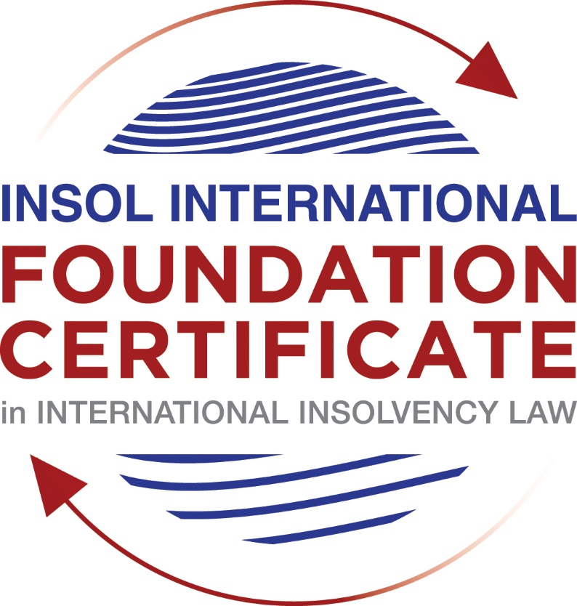

SUMMATIVE (FORMAL) ASSESSMENT: MODULE 3B

THE INSOLVENCY SYSTEM OF THE UNITED KINGDOM (ENGLAND AND WALES)

This is the summative (formal) assessment for Module 3B of this course and is compulsory for all candidates who selected this module as one of their compulsory modules from Module 3. Please read instruction 6.1 on the next page very carefully.

If you selected this module as one of your elective modules, please read instruction 6.2 on the next page very carefully.

The mark awarded for this assessment will determine your final mark for Module 3B. In order to pass this module, you need to obtain a mark of 50% or more for this assessment.

INSTRUCTIONS FOR COMPLETION AND SUBMISSION OF ASSESSMENT

Please read the following instructions very carefully before submitting / uploading your assessment on the Foundation Certificate web pages.

1. You must use this document for the answering of the assessment for this module. The answers to each question must be completed using this document with the answers populated under each question.

2. All assessments must be submitted electronically in MS Word format, using a standard A4 size page and a 11-point Arial font. This document has been set up with these parameters – please do not change the document settings in any way. DO NOT submit your assessment in PDF format as it will be returned to you unmarked.

3. No limit has been set for the length of your answers to the questions. However, please be guided by the mark allocation for each question. More often than not, one fact / statement will earn one mark (unless it is obvious from the question that this is not the case).

4. You must save this document using the following format: [student number.assessment3B]. An example would be something along the following lines: 202021IFU-314.assessment3B. Please also include the filename as a footer to each page of the assessment (this has been pre-populated for you, merely replace the words “studentnumber” with the student number allocated to you). Do not include your name or any other identifying words in your file name. Assessments that do not comply with this instruction will be returned to candidates unmarked.

5. Before you will be allowed to upload / submit your assessment via the portal on the Foundation Certificate web pages, you will be required to confirm / certify that you are the person who completed the assessment and that the work submitted is your own, original work. Please see the part of the Course Handbook that deals with plagiarism and dishonesty in the submission of assessments. Please note that copying and pasting from the Guidance Text into your answer is prohibited and constitutes plagiarism. You must write the answers to the questions in your own words.

6.1 If you selected Module 3B as one of your compulsory modules (see the e-mail that was sent to you when your place on the course was confirmed), the final time and date for the submission of this assessment is 23:00 (11 pm) GMT on 1 March 2021. The assessment submission portal will close at 23:00 (11 pm) GMT on 1 March 2021. No submissions can be made after the portal has closed and no further uploading of documents will be allowed, no matter the circumstances.

6.2 If you selected Module 3B as one of your elective modules (see the e-mail that was sent to you when your place on the course was confirmed), you have a choice as to when you may submit this assessment. You may either submit the assessment by 23:00 (11 pm) GMT on 1 March 2021 or by 23:00 (11 pm) BST on 31 July 2021. If you elect to submit by 1 March 2021, you may not submit the assessment again by 31 July 2021 (for example, in order to achieve a higher mark).

7. Prior to being populated with your answers, this assessment consists of 7 pages.

ANSWER ALL THE QUESTIONS

QUESTION 1 (multiple-choice questions) [10 marks in total]

Questions 1.1. – 1.10. are multiple-choice questions designed to assess your ability to think critically about the subject. Please read each question carefully before reading the answer options. Be aware that some questions may seem to have more than one right answer, but you are to look for the one that makes the most sense and is the most correct. When you have a clear idea of the question, find your answer and mark your selection on the answer sheet by highlighting the relevant paragraph in yellow. Select only ONE answer. Candidates who select more than one answer will receive no mark for that specific question.

Question 1.1

What is the initial period for a Moratorium under Part 1A of the Insolvency Act 1986 where the directors file relevant documents at court?

- 20 days.

- 20 business days.

- 40 days.

- 40 business days.

Question 1.2

What is the maximum length of a Moratorium under Part 1A of the Insolvency Act 1986 to which creditors can consent without any application to the court?

- 40 business days.

- One year and 20 business days.

- One year and 40 business days.

- One year.

Question 1.3

Which of the following is not a requirement for a company which wishes to enter into a Restructuring Plan under Part 26A of the Companies Act 2006?

- the company has encountered, or is likely to encounter, financial difficulties that are affecting, or will or may affect, its ability to carry on business as a going concern.

- a compromise or arrangement is proposed between the company and its creditors, or any class of them, or its members, or any class of them.

- the purpose of the compromise or arrangement is to eliminate, reduce or prevent, or mitigate the effect of, any of the said financial difficulties.

- the company is, or is likely to become, unable to pay their debts, as defined under section 123 of the Insolvency Act 1986.

Question 1.4

What percentage of creditors must approve a Scheme of Arrangement under Part 26 of the Companies Act 2006?

- A majority in number and in value.

- A majority in number and 50% or more in value.

- A majority in number and 75% or more in value.

- 75% or more in value.

Question 1.5

Which one of the following is not a debtor-in-possession procedure?

- Administration.

- Restructuring Plan.

- Scheme of Arrangement.

- Company Voluntary Arrangement.

Question 1.6

A liquidator may pay dividends to small value creditors based upon the information contained within the company’s statement of affairs or accounting records. In such circumstances, a creditor is deemed to have proved for the purposes of determination and payment of a dividend where the debt is no greater than how much?

- £500

- £750

- £1,000

- £2,000

Question 1.7

Which one of the following is not, in itself, a separate ground for disqualification of a director under the Company Directors Disqualification Act 1986?

- Wrongful trading.

- Breach of fiduciary duty.

- Being found guilty of an indictable offence in Great Britain.

- Being found guilty of an indictable offence overseas.

Question 1.8

The administrator is under a general duty to make a statement setting out proposals for achieving the purpose of administration. He or she must send out the statement of proposals as soon as reasonably practicable, and in any event within how many weeks of the date the company entered administration?

- 6

- 8

- 10

- 12

Question 1.9

Which of the following has the power to bring an action for wrongful trading under the Insolvency Act 1986?

- A monitor of a Moratorium.

- A supervisor of a Company Voluntary Arrangement.

- An administrator.

- An administrative receiver.

Question 1.10

Under section 176A of the Insolvency Act 1986, the prescribed part deducted from floating charge assets in favour of unsecured creditors is calculated as follows:

- 20% of the floating charge assets.

- 50% of the first £10,000 in value plus 20% of the excess in value above the £10,000 subject to a maximum amount of the prescribed part of £600,000.

- 20% of the first £50,000 in value plus 50% of the excess in value above the £50,000 subject to a maximum amount of prescribed part of £800,000.

- 50% of the first £10,000 in value plus 20% of the excess in value above the £10,000 subject to a maximum amount of prescribed part of £800,000.

QUESTION 2 (direct questions) [10 marks]

Question 2.1 [maximum 6 marks]

What is the difference between cash flow insolvency and balance sheet insolvency?

As it has been explained in the Guidance Text, a debtor company will be said to be insolvent
if it is either Balance Sheet insolvent or Cash Flow insolvent.

To these purposes, a company will be deemed to be Balance Sheet insolvent if the value of
Its assets is less than its liabilities (taking into account any future or contingent liabilities as
well as its current liabilities).

However, a company will be Cash Flow insolvent where it is unable to pay its debts as they
fall due.

Question 2.2 [maximum 4 marks]

List four (4) elements of the statutory moratorium imposed when a company enters administration.

In this case, the moratorium prevents certain actions against the company. These are some
of them:

- No resolution may be passed for the winding up of the company;
- No winding-up order may be made against the company (other than on public
interest grounds);
- No step may be taken to enforce security over the company’s property except
with the consent of the administrator or the permission of the court;
- No step may be taken to repossess goods in the company’s possession under a hire-purchase agreement (which term includes retention of title contracts) except with the consent of the administrator or the permission of the court;

QUESTION 3 (essay-type questions) [15 marks in total]

Question 3.1 [maximum 6 marks]

Explain the main differences between a Part 26 Scheme of Arrangement and a Part 26A Restructuring Plan.

The principal differences between schemes and part 26A restructuring plans are:

- Part 26A (restructuring plans) is only available to a company which has encountered, or is likely to encounter, financial difficulties that are affecting, or will or may affect, its ability to carry on business as a going concern;

- a majority in number of each class of creditors must approve a Part 26 Scheme (as well as 75% in value) whilst a Part 26A Plan only requires 75% in value. Therefore, plan votes are calculated solely by the value of the relevant creditors' debt or members' shares (75% must vote in favour), so no numerosity requirement applies.

- Part 26A contains provision for a cross class cram down which is not available under Part 26.

Question 3.2 [maximum 9 marks]

Explain the different ways in which overseas officeholders may be recognised and request the assistance of the court in England and Wales.

There are four possibilities:

- EU Regulation: Cross-border insolvency proceedings which involve companies with their COMI within any EU Member State (apart from Denmark) are governed by the EU Regulation on Insolvency Proceedings. The main goal of the EU regulation is not to harmonize insolvency law within the EU, but to provide rules that determine which of the individual jurisdictions’ insolvency regime applies in a particular case. As it has been explained in the Guidance Text, One of the great benefits of the EU Regulation is that it works across the EU for both “inwardbound” (where a Member State officeholder is automatically recognised in the UK) and “outward-bound” (where a UK officeholder is recognised in other Member States) insolvencies.

- The CBIR: the model law was incorporated into UK law, with only minor amendments, by the Cross Border Insolvency Regulations 2006 SI 2006/1030 (CBIR). In this case, there are no reciprocity provisions in the CBIR and so there is no real limit on the “inward bound” consequences for cross-border insolvency. This means that insolvency practitioners from any overseas’ jurisdiction may apply to the court in England and Wales to be recognised in the jurisdiction. However, regarding the “outward-bound” benefits for the UK are limited to other States who have adopted the Model Law. The main disadvantage of the Model Law compared to the EU Regulation, is that under the Model Law recognition of foreign insolvency proceedings is not automatic, but it requires an application to a local court to gain recognition and relief.

- Section 426 of the Act: this section contains provisions for UK courts to provide assistance to overseas courts from certain listed jurisdictions. As it has been explained in the Guidance Text, under section 426 court orders made in insolvency matters by a court in the United Kingdom are strictly enforceable in all parts of the United Kingdom. Furthermore, there is a positive obligation on the courts of the United Kingdom to assist each other, and also the courts of “any relevant country or territory” (these are the Channel Islands and the Isle of Man, and any other country or territory specified by the Secretary of State). Countries who currently benefit from the “inward-bound” effect of section 426 include Australia, Canada, Hong Kong, Ireland, Malaysia New Zealand and South Africa. It is to the court’s discretion to determine if any assistance should be
granted. Nevertheless, it has been said that they should provide assistance unless it would not be proper to do so in the circumstances. Courts in the UK may apply UK law
or the law of the overseas territory in providing assistance to the overseas’ court.

- Common law: case law at one point suggested that UK courts had a power at common law to exercise any powers which would be available to the overseas jurisdiction requesting assistance in a domestic insolvency. However, this approach should be interpreted in a restrictive way.

QUESTION 4 (fact-based application-type question) [15 marks in total]

Prior to going into liquidation in November 2020, under pressure from its bank, Stercus Bank plc, and in order to prevent it from demanding repayment of the company’s loans, Cork-In Limited granted a debenture in favour of Stercus Bank plc in January 2020. The debenture contained a floating charge over the whole of the company’s undertaking.

In June 2020, as the company continued to struggle, the directors approved the
sale of a company delivery van to Paul Watson (a director) for £5,000 in cash. The
van had been bought for £10,000 a year before.

A month before the company went into liquidation, Paul Watson received an irate phone call from one of the company’s key suppliers, Gary’s Grapes Limited. The supplier demanded immediate payment of all sums owing to it (even those invoices that had not become payable). Fearing being cut off by the supplier, Paul arranged for a cheque for the full amount to be sent that day.

The liquidator has asked for advice whether any action may be taken in respect of the floating charge in favour of Stercus Bank plc and the two subsequent transactions.

Using the facts above, answer the questions that follow.

Identify the relevant issues and statutory provisions and consider whether the liquidator may take any action in relation to:

Question 4.1 [maximum 5 marks]

The floating charge in favour of Stercus Bank plc;

The liquidator could ask for the floating charge to be invalidated according to section 245 of the Act, given that none of the conditions for considering that the bank in favour of which the floating mortgage has been granted has provided them with new funding are met.

As it has been explained in the Guidance Text, if the person in whose favour the floating charge is created is connected with the company, the relevant time is any time within the period of two years prior to the onset of insolvency. If the person in whose favour the floating charge is created is not connected with the company, the relevant time is any time within the period of 12 months prior to the onset of insolvency, but only if at the time of the creation of the charge the company was either unable to pay its debts (within the meaning in section 123 of the Act) or became unable to do so in consequence of the transaction, as is this case.

Question 4.2 [maximum 5 marks]

The sale of the van; and

The sale of the van could be considered a transaction under value, since it was a transaction entered into shortly before the company entered liquidation. In addition, it was sold for less than the value in money or money’s worth, of the consideration provided by the company.

This transaction was carried out at the relevant time, this is, two years two years prior to the commencement of the liquidation, so the liquidator could attack the transaction.

Question 4.3 [maximum 5 marks]

The payment to Gary’s Grapes Ltd.

With the payment to Gary it could be considered that this creditor has been placed in a better position than the others, since it has been paid in full when he was an unsecured creditor.

For a preference to be actionable, it must have occurred within the six months prior to the onset of insolvency (if in favour of a person not connected to the company, as it happens in this case).

However, to have to bear in mind that in some decisión it has been held that where the company was influenced solely by commercial considerations, specifically attempts to ensure that the company continued trading, there could be no desire to prefer.

As Gary’s Grapes Limited was one of the key suppliers of the company, we could considered that there wasn’t intention to prefer that creditor since it was an attempt to ensure the continuation of the company’s activity.

* End of Assessment *

