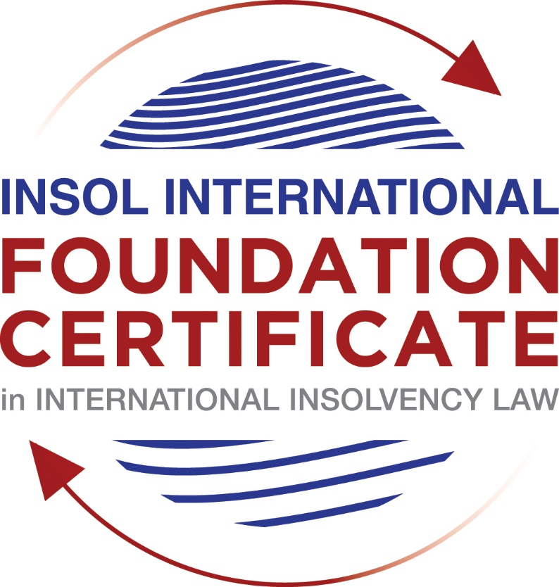

SUMMATIVE (FORMAL) ASSESSMENT: MODULE 3B

THE INSOLVENCY SYSTEM OF THE UNITED KINGDOM (ENGLAND AND WALES)

This is the summative (formal) assessment for Module 3B of this course and is compulsory for all candidates who selected this module as one of their compulsory modules from Module 3. Please read instruction 6.1 on the next page very carefully.

If you selected this module as one of your elective modules, please read instruction 6.2 on the next page very carefully.

The mark awarded for this assessment will determine your final mark for Module 3B. In order to pass this module, you need to obtain a mark of 50% or more for this assessment.

INSTRUCTIONS FOR COMPLETION AND SUBMISSION OF ASSESSMENT

Please read the following instructions very carefully before submitting / uploading your assessment on the Foundation Certificate web pages.

1. You must use this document for the answering of the assessment for this module. The answers to each question must be completed using this document with the answers populated under each question.

2. All assessments must be submitted electronically in MS Word format, using a standard A4 size page and a 11-point Arial font. This document has been set up with these parameters – please do not change the document settings in any way. DO NOT submit your assessment in PDF format as it will be returned to you unmarked.

3. No limit has been set for the length of your answers to the questions. However, please be guided by the mark allocation for each question. More often than not, one fact / statement will earn one mark (unless it is obvious from the question that this is not the case).

4. You must save this document using the following format: [student number.assessment3B]. An example would be something along the following lines: 202021IFU-314.assessment3B. Please also include the filename as a footer to each page of the assessment (this has been pre-populated for you, merely replace the words “studentnumber” with the student number allocated to you). Do not include your name or any other identifying words in your file name. Assessments that do not comply with this instruction will be returned to candidates unmarked.

5. Before you will be allowed to upload / submit your assessment via the portal on the Foundation Certificate web pages, you will be required to confirm / certify that you are the person who completed the assessment and that the work submitted is your own, original work. Please see the part of the Course Handbook that deals with plagiarism and dishonesty in the submission of assessments. Please note that copying and pasting from the Guidance Text into your answer is prohibited and constitutes plagiarism. You must write the answers to the questions in your own words.

6.1 If you selected Module 3B as one of your compulsory modules (see the e-mail that was sent to you when your place on the course was confirmed), the final time and date for the submission of this assessment is 23:00 (11 pm) GMT on 1 March 2021. The assessment submission portal will close at 23:00 (11 pm) GMT on 1 March 2021. No submissions can be made after the portal has closed and no further uploading of documents will be allowed, no matter the circumstances.

6.2 If you selected Module 3B as one of your elective modules (see the e-mail that was sent to you when your place on the course was confirmed), you have a choice as to when you may submit this assessment. You may either submit the assessment by 23:00 (11 pm) GMT on 1 March 2021 or by 23:00 (11 pm) BST on 31 July 2021. If you elect to submit by 1 March 2021, you may not submit the assessment again by 31 July 2021 (for example, in order to achieve a higher mark).

7. Prior to being populated with your answers, this assessment consists of 7 pages.

ANSWER ALL THE QUESTIONS

QUESTION 1 (multiple-choice questions) [10 marks in total]

Questions 1.1. – 1.10. are multiple-choice questions designed to assess your ability to think critically about the subject. Please read each question carefully before reading the answer options. Be aware that some questions may seem to have more than one right answer, but you are to look for the one that makes the most sense and is the most correct. When you have a clear idea of the question, find your answer and mark your selection on the answer sheet by highlighting the relevant paragraph in yellow. Select only ONE answer. Candidates who select more than one answer will receive no mark for that specific question.

Question 1.1

What is the initial period for a Moratorium under Part 1A of the Insolvency Act 1986 where the directors file relevant documents at court?

- 20 days.

- 20 business days.

- 40 days.

- 40 business days.

Question 1.2

What is the maximum length of a Moratorium under Part 1A of the Insolvency Act 1986 to which creditors can consent without any application to the court?

- 40 business days.

- One year and 20 business days.

- One year and 40 business days.

- One year.

Question 1.3

Which of the following is not a requirement for a company which wishes to enter into a Restructuring Plan under Part 26A of the Companies Act 2006?

- the company has encountered, or is likely to encounter, financial difficulties that are affecting, or will or may affect, its ability to carry on business as a going concern.

- a compromise or arrangement is proposed between the company and its creditors, or any class of them, or its members, or any class of them.

- the purpose of the compromise or arrangement is to eliminate, reduce or prevent, or mitigate the effect of, any of the said financial difficulties.

- the company is, or is likely to become, unable to pay their debts, as defined under section 123 of the Insolvency Act 1986.

Question 1.4

What percentage of creditors must approve a Scheme of Arrangement under Part 26 of the Companies Act 2006?

- A majority in number and in value.

- A majority in number and 50% or more in value.

- A majority in number and 75% or more in value.

- 75% or more in value.

Question 1.5

Which one of the following is not a debtor-in-possession procedure?

- Administration.

- Restructuring Plan.

- Scheme of Arrangement.

- Company Voluntary Arrangement.

Question 1.6

A liquidator may pay dividends to small value creditors based upon the information contained within the company’s statement of affairs or accounting records. In such circumstances, a creditor is deemed to have proved for the purposes of determination and payment of a dividend where the debt is no greater than how much?

- £500

- £750

- £1,000

- £2,000

Question 1.7

Which one of the following is not, in itself, a separate ground for disqualification of a director under the Company Directors Disqualification Act 1986?

- Wrongful trading.

- Breach of fiduciary duty.

- Being found guilty of an indictable offence in Great Britain.

- Being found guilty of an indictable offence overseas.

Question 1.8

The administrator is under a general duty to make a statement setting out proposals for achieving the purpose of administration. He or she must send out the statement of proposals as soon as reasonably practicable, and in any event within how many weeks of the date the company entered administration?

- 6

- 8

- 10

- 12

Question 1.9

Which of the following has the power to bring an action for wrongful trading under the Insolvency Act 1986?

- A monitor of a Moratorium.

- A supervisor of a Company Voluntary Arrangement.

- An administrator.

- An administrative receiver.

Question 1.10

Under section 176A of the Insolvency Act 1986, the prescribed part deducted from floating charge assets in favour of unsecured creditors is calculated as follows:

- 20% of the floating charge assets.

- 50% of the first £10,000 in value plus 20% of the excess in value above the £10,000 subject to a maximum amount of the prescribed part of £600,000.

- 20% of the first £50,000 in value plus 50% of the excess in value above the £50,000 subject to a maximum amount of prescribed part of £800,000.

- 50% of the first £10,000 in value plus 20% of the excess in value above the £10,000 subject to a maximum amount of prescribed part of £800,000.

QUESTION 2 (direct questions) [10 marks]

Question 2.1 [maximum 6 marks]

What is the difference between cash flow insolvency and balance sheet insolvency?

According to the corporate insolvency law, a debtor company is said to be insolvent if it is either balance sheet insolvent or cash flow insolvent.

On the one hand, a balance sheet insolvent is where a company´s assets are less than its liabilities (taking into account any future or contingent liabilities as well as its current liabilities).

On the other hand, a company is cash flow insolvent where it is unable to pay its debts as they fall due (or one payable in the reasonably near future).

The fundamental difference between the two tests is that in order to show cash flow insolvency, it must be shown that a company cannot pay its debts as they fall due. Even if a company is able to meet its current liabilities it may still be viewed as insolvent on the “balance sheet” test as it may have liabilities (including account being taken of the company’s future and contingent liabilities) greater than it has assets.

Question 2.2 [maximum 4 marks]

List four (4) elements of the statutory moratorium imposed when a company enters administration.

While a company is in administration a moratorium prevents the following actions against the company: (i) no resolution may be passed for the winding up of the company; (ii) no winding-up order may be made against the company (other than on public interest grounds); (iii) no step may be taken to enforce security over the company’s property except with the consent of the administrator or the permission of the court; (iv) no step may be taken to repossess goods in the company’s possession under a hire-purchase agreement (which term includes retention of title contracts) except with the consent of the administrator or the permission of the court; (v) a landlord may not exercise a right of forfeiture by peaceable re-entry in relation to premises let to the company except with the consent of the administrator or the permission of the court; (vi) no legal process (including any legal proceedings or execution of any judgment) may be instituted or continued against the company or property of the company except with the consent of the administrator or the permission of the court; and, (vii) no administrative receiver may be appointed.

QUESTION 3 (essay-type questions) [15 marks in total]

Question 3.1 [maximum 6 marks]

Explain the main differences between a Part 26 Scheme of Arrangement and a Part 26A Restructuring Plan.

One of the differences is that in the Part 26A Restructuring Plan the court may sanction the compromise or arrangement if a number representing 75% or more in value of the creditors or class of creditors, or members or class of members (as the case may be) agree to terms of the Restructuring Plan. This is differs from a Part 26 Scheme which requires a majority in number as well as 75% or more in value of each class to approve the Scheme.

The other main characteristic which distinguishes the Part 26A Restructuring Plan from a Part 26 Scheme is the ability of the court to cramdown a dissenting class who does not approve the Restructuring Plan. In circumstances where one or more classes dissent, if Conditions A and B below are met, the fact that the dissenting class has not agreed to the Restructuring Plan will not prevent the court from granting sanction.

Condition A is that none of the members of the dissenting class would be worse off than under a relevant alternative; and

Condition B is that at least 75% by value of a class of creditor or members, which would receive a payment or have a genuine economic interest if the relevant alternative were pursued, had still voted in favour of the plan.

Finally, Part 26A restructuring plans are only available to companies that have encountered or are likely to encounter financial difficulties likely to affect their ability to carry on business as a going concern whereas a scheme of arrangement may be used by both companies which are solvent and those which are insolvent.

Question 3.2 [maximum 9 marks]

Explain the different ways in which overseas officeholders may be recognised and request the assistance of the court in England and Wales.

- The EU Regulation on Insolvency Proceedings

These proceedings involve companies with their centre of main interests (COMI) within any EU Member State (apart from Denmark).

The approach of this way is not to harmonise the different insolvency regimes within the EU but instead it provides rules for deciding which of the individual jurisdictions’ insolvency regime applies in a particular case. For instance, where a company has its COMI in England and Wales, only the courts in England and Wales will have jurisdiction to open main proceedings. If a company with its COMI in England and Wales is placed into administration or liquidation, it will be the rules laid down in the Act and the Rules which govern the process across the EU (with some exceptions involving the rights of secured creditors and employees).

- The Cross Border Insolvency Regulations 2006 SI 2006/1030 (CBIR)

There are no reciprocity provisions in the CBIR and so there is no real limit on the “inward bound” consequences for cross-border insolvency. Insolvency practitioners from any overseas’ jurisdiction may apply to the court in England and Wales to be recognised in the jurisdiction. Furthermore, the “outward-bound” benefits for the UK are limited to other nations who only 44 countries have adopted the UNCITRAL Model Law on Cross-Border Insolvency.

- Section 426 of the Act

Section 426 of the Act contains provisions for UK courts to provide assistance to overseas courts from certain listed jurisdictions. In addition, court orders made in insolvency matters by a court in the United Kingdom are strictly enforceable in all parts of the United Kingdom. In addition, there is a positive obligation on the courts of the United Kingdom to assist each other, and also the courts of any relevant country or territory.

- Common law

English common law has traditionally taken the view that fairness between creditors requires that, ideally, insolvency proceedings should have universal application. There should be a single insolvency in which all creditors are entitled to prove. A system of “modified” universalism would avoid the need for officeholders to be appointed in parallel proceedings in multiple jurisdictions. It would recognise the overseas’ officeholder and provide the same remedies to that officeholder as if such equivalent proceedings had commenced in the UK.

QUESTION 4 (fact-based application-type question) [15 marks in total]

Prior to going into liquidation in November 2020, under pressure from its bank, Stercus Bank plc, and in order to prevent it from demanding repayment of the company’s loans, Cork-In Limited granted a debenture in favour of Stercus Bank plc in January 2020. The debenture contained a floating charge over the whole of the company’s undertaking.

In June 2020, as the company continued to struggle, the directors approved the
sale of a company delivery van to Paul Watson (a director) for £5,000 in cash. The
van had been bought for £10,000 a year before.

A month before the company went into liquidation, Paul Watson received an irate phone call from one of the company’s key suppliers, Gary’s Grapes Limited. The supplier demanded immediate payment of all sums owing to it (even those invoices that had not become payable). Fearing being cut off by the supplier, Paul arranged for a cheque for the full amount to be sent that day.

The liquidator has asked for advice whether any action may be taken in respect of the floating charge in favour of Stercus Bank plc and the two subsequent transactions.

Using the facts above, answer the questions that follow.

Identify the relevant issues and statutory provisions and consider whether the liquidator may take any action in relation to:

Question 4.1 [maximum 5 marks]

The floating charge in favour of Stercus Bank plc;

I recommend liquidator attack the floating change in favour of Stercus Bank plc.

In this case, this floating change was created for a not connected person with the company (debtor), so the relevant time to attack it is any time within the period of 12 months prior to the onset of insolvency, from November 2019 to November 2020, where this floating is within of this period of time because it was celebrated in January 2020.

Furthermore, other requirements to this is that at the time of the creation of the charge the company was either unable to pay its debts (within the meaning in section 123 of the Act) or became unable to do so in consequence of the transaction. I think that the company can prove the first one due to a company is deemed to be unable to pay its debts under section 123 of the Act if: (c) it is proved to the satisfaction of the court that the company is unable to pay its debts as they fall due (cash flow insolvency); or, (d) it is proved to the satisfaction of the court that the value of the company’s assets is less than the amount of its liabilities, taking into account its contingent and prospective liabilities (balance sheet insolvency).

So, the debtor can demonstrate to the courts that the debtor could not pay its debts, or its assets were less than the number of its liabilities at the time of the creation of the charge (in January 2020) owing to the fact that according to Question 4 says that the debtor could not repay the loans granted from this bank.

Question 4.2 [maximum 5 marks]

The sale of the van; and

I recommend attacking this transaction at an undervalue. I will explain my arguments.

The section 238 of the Act claims that: “… (3) entered into a transaction with another person for a consideration which, in money or money’s worth, was, at the date of the transaction, significantly less than the value, in money or money’s worth, of the consideration provided by the company”.

In this case, the director paid half of the price for the delivery van when this vehicle was bought one year later in £10,000, for this reason, I strongly believe that £5000 for this van is a value less than the current, in one year an asset does not lose half of its value.

Furthermore, this transaction was celebrated in June 2020, two years prior to the commencement of the liquidation (November 2020).

In addition, Paul Watson who is a connected person to Cork-In must prove that this transaction caused the insolvency of the company due to the fact that in the case of a transaction with a connected person, however, the company is presumed to have been insolvent, or to have become insolvent as a result of the transaction, unless the contrary is proved.

Question 4.3 [maximum 5 marks]

The payment to Gary’s Grapes Ltd.

I recommend attacking this transaction as preference.

Under section 239, the liquidator must show:

- the person whom it is alleged has been preferred was, at the time of the transaction, a creditor of the company.

Gary’s Grapes Limited was a creditor of Cork-In at the time of the transaction.

- something was done, or suffered to be done, by the company which had the effect of putting that person in a better position, in the event of the company going into insolvent liquidation, than the position he or she would have been in if that thing had not been done (that is, that the person has been preferred);

The director of Cork-In, Paul Watson, paid to Gary’s Grapes Limited all invoices even those that had not become payable, in this case, the insolvent company granted the creditor this preference in relation to the rest of the debtor´s creditors.

- the company was, in giving the preference, influenced by a desire to produce the effect referred to in (b) above (the desire to prefer) in relation to the person preferred; and,

I know that pressure was applied by the creditor (cutting off the supplies) is not relevant but pressure should be considered relevant only to whether there is the requisite desire.

The director of Cork-In, Paul Watson, paid to Gary’s grapes limited all invoices even those that had not become payable, in this case, the insolvent company granted the creditor this preference in relation to the rest of the debtor´s creditors.

In court decisions such as Re MC Bacon Ltd, it has been held that where the company was influenced solely by commercial considerations, specifically attempts to ensure that the company continued trading, there could be no desire to prefer. However, in the case of question 4, the creditor did not push Cork-In in order to grant it a preference. Conversely, the director of the company thought that the supplier would cut off the supplies if the company, so I strongly believe that the debtor always had the desire to grant this preference.

In the ordinary course of business, any director would pay invoices not become payable except when he or she desires to grant a preference in relation to other creditors.

- the preference was given at a relevant time.

Gary’s grapes limited was a not connected creditor to the company, the transaction could be attacked within six months prior to the onset of insolvency and the payment was made one month before that.

In conclusion, this transaction accomplishes all requirements to be attacked at preferences.

* End of Assessment *

