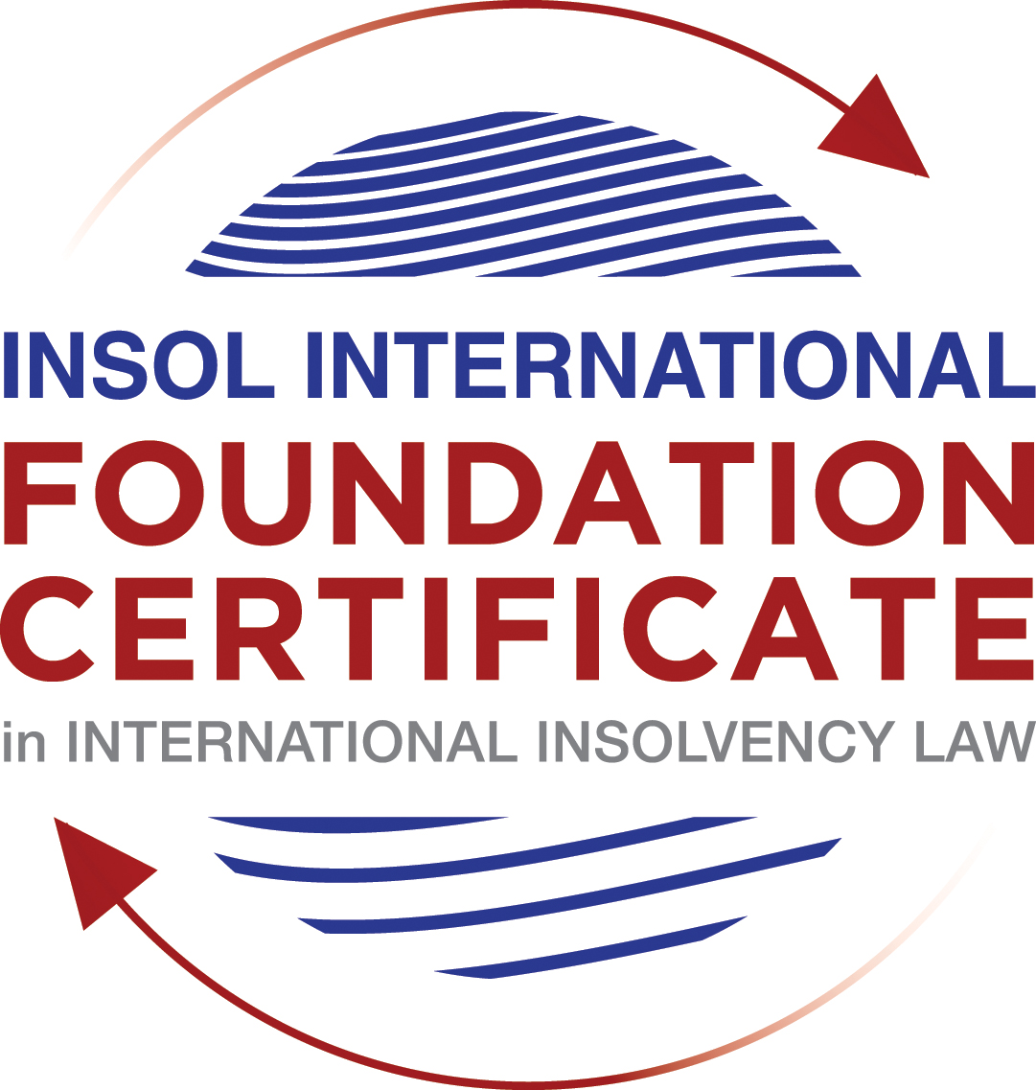

SUMMATIVE (FORMAL) ASSESSMENT: MODULE 5A

BERMUDA

This is the summative (formal) assessment for Module 5A of this course and is compulsory for all candidates who selected this module as one of their elective modules.

The mark awarded for this assessment will determine your final mark for Module 5A. In order to pass this module, you need to obtain a mark of 50% or more for this assessment.

INSTRUCTIONS FOR COMPLETION AND SUBMISSION OF ASSESSMENT

Please read the following instructions very carefully before submitting / uploading your assessment on the Foundation Certificate web pages.

1. You must use this document for the answering of the assessment for this module. The answers to each question must be completed using this document with the answers populated under each question.

2. All assessments must be submitted electronically in Microsoft Word format, using a standard A4 size page and an 11-point Arial font. This document has been set up with these parameters – please do not change the document settings in any way. DO NOT submit your assessment in PDF format as it will be returned to you unmarked.

3. No limit has been set for the length of your answers to the questions. However, please be guided by the mark allocation for each question. More often than not, one fact / statement will earn one mark (unless it is obvious from the question that this is not the case).

4. You must save this document using the following format: [studentnumber.assessment5A]. An example would be something along the following lines: 202021IFU-314.assessment5A. Please also include the filename as a footer to each page of the assessment (this has been pre-populated for you, merely replace the words “studentnumber” with the student number allocated to you). Do not include your name or any other identifying words in your file name. Assessments that do not comply with this instruction will be returned to candidates unmarked.

5. Before you will be allowed to upload / submit your assessment via the portal on the Foundation Certificate web pages, you will be required to confirm / certify that you are the person who completed the assessment and that the work submitted is your own, original work. Please see the part of the Course Handbook that deals with plagiarism and dishonesty in the submission of assessments. Please note that copying and pasting from the Guidance Text into your answer is prohibited and constitutes plagiarism. You must write the answers to the questions in your own words.

6. The final submission date for this assessment is 31 July 2021. The assessment submission portal will close at 23:00 (11 pm) GMT on 31 July 2021. No submissions can be made after the portal has closed and no further uploading of documents will be allowed, no matter the circumstances.

7. Prior to being populated with your answers, this assessment consists of 7 pages.

ANSWER ALL THE QUESTIONS

QUESTION 1 (multiple-choice questions) [10 marks in total]

Questions 1.1. – 1.10. are multiple-choice questions designed to assess your ability to think critically about the subject. Please read each question carefully before reading the answer options. Be aware that some questions may seem to have more than one right answer, but you are to look for the one that makes the most sense and is the most correct. When you have a clear idea of the question, find your answer and mark your selection on the answer sheet by highlighting the relevant paragraph in yellow. Select only ONE answer. Candidates who select more than one answer will receive no mark for that specific question.

Question 1.1

When is a Bermuda company deemed to be unable to pay its debts under section 161 and section 162 of the Companies Act 1981?

- Only when it is balance sheet insolvent.

- Only when it is cash flow insolvent.

- When it is balance sheet insolvent and cash flow insolvent.

- When it is either balance sheet insolvent, or cash flow insolvent, or a valid statutory demand has not been satisfied within a period of three weeks after service on the company’s registered office, or if a judgment in favour of a creditor remains unsatisfied.

Question 1.2

Who may appoint a Provisional Liquidator over a Bermuda company?

- A secured creditor.

- An unsecured creditor.

- The company itself (whether acting by its directors or its shareholders).

- The Supreme Court of Bermuda.

Question 1.3

In what order are the following paid in a compulsory liquidation under Bermuda law?

a) Preferential creditors; b) unsecured creditors; c) costs and expenses of the liquidation procedure; d) floating charge holders.

- a, b, c, d

- c, d, a, b

- c, a, d, b

- a, c, d, b

Question 1.4

What percentage of unsecured creditors must vote in favour of a creditors’ Scheme of Arrangement for it to be approved?

- Over 50% in value.

- 50% or more in value.

- Over 75% in value.

- A majority of each class of creditors present and voting, representing 75% or more in value.

Question 1.5

What is the clawback period for fraudulent preferences under section 237 of the Companies Act 1981?

- Two (2) years.

- One (1) month.

- Twelve (12) months.

- Six (6) months.

Question 1.6

What types of transactions are reviewable in the event of an insolvent liquidation?

- Only fraudulent conveyances.

- Only floating charges.

- Only post-petition dispositions.

- All of the above.

Question 1.7

How many insurance policyholders are required to present a petition for the winding up of an insolvent insurance company under section 34 of the Insurance Act 1978?

- At least five (5).

- One (1) is sufficient.

- At least 10 or more owning policies of an aggregate value of not less than BMD 50,000.

- At least 10.

Question 1.8

Where do secured creditors rank in a liquidation?

- Behind unsecured creditors.

- Behind preferential creditors.

- Behind the costs and expenses of liquidation.

- In priority to all other creditors, since they can enforce their security outside of the liquidation.

Question 1.9

Summary proceedings against a company’s directors for breach of duty (or misfeasance) may be brought by a liquidator under which provision of the Companies Act?

- Section 237 of the Companies Act 1981.

- Section 238 of the Companies Act 1981.

- Section 247 of the Companies Act 1981.

- Section 158 of the Companies Act 1981.

Question 1.10

What is a segregated account representative of an insolvent Segregated Accounts Company required to do under section 10 of the Segregated Accounts Companies Act 2000?

- Resign immediately.

- File a Suspicious Transaction Report forthwith.

- Make a written report to the Registrar of Companies within 30 days of reaching the view that there is a reasonable likelihood of a segregated account or the general account becoming insolvent.

- Notify the directors, creditors and account owners within 28 days.

QUESTION 2 (direct questions) [10 marks]

Question 2.1 [maximum 4 marks]

In what circumstances may be a Provisional Liquidator be appointed?

A provisional liquidator can be appointed where: (i) there is a good prima facie case that a winding up order will be made and the court considers that a provisional liquidator should be appointed in the circumstances of the case. The appointment is usually made where there is a risk of dissipation of assets or the need for independent supervision and control of the company. The case Re Stewardship Credit Arbitrage Fund Ltd is an example of this.
A provisional liquidator may also be appointed following an application for the appointment of a liquidator and if the company contemplates restructuring. The provisional liquidator appointed in this matter is called a soft touch provisional liquidator and he may apply for a statutory stay of all proceedings against the company while the company and its creditors agree an informal “work-out” or a scheme of arrangement. In this circumstance, the company’s directors retain control of the company and the provisional liquidator supervises the work-out deal.

Question 2.2 [maximum 2 marks]

When can rights of set-off be exercised after the commencement of a liquidation of a Bermuda company?

Section 37 of the Bankruptcy Act 1989 provides for companies in liquidation to have mandatory set off in the event of liquidation. The rights of set-off after commencement of liquidation can only be exercised in specific scenarios. Namely: (i) the debts giving rise to the set-off were incurred prior to the commencement of liquidation and have crystallised as monetary payment liabilities; (ii) the transaction giving rise to the debts was not a fraudulent preference or a fraudulent conveyance; or (iii) the parties entered dealings mutually ie the same parties have entered into transactions giving rise to the credit.

Question 2.3 [maximum 4 marks]

Describe three possible ways of taking security over assets under Bermuda law?

A security interest in an asset will be determined by the terms of the parties’ agreement, the nature of the property being secured and the nature of the debtor’s interest in the property being secured. There are a number of statutory provisions that govern taking security as well. Generally, for immovable or movable property and certain intangible property, a creditor may take security such as: (i) a legal mortgage; (ii) equitable mortgage; or (iii) a fixed charge.
A legal mortgage is created by transferring the legal title of the debtor’s property to the creditor as security for the debt. The debtor remains in possession of the property but only regains legal title when the debt has been paid in full.
An equitable mortgage allows the debtor to retain legal title and possession of the property but he transfers the beneficial interest to the creditor.
A fixed charge attaches to a specific asset of the debtor where neither the legal or beneficial interest is transferred to the creditor but in the event of a default by the debtor, the creditor has a right to take possession of that property with a right to sell it.

QUESTION 3 (essay-type questions) [15 marks in total]

Question 3.1 [maximum 8 marks]

Write a brief essay on the basis upon which foreign liquidators are granted recognition and assistance in Bermuda.

Bermuda does not have a statutory equivalent which recognises and implements the provisions of the UNCITRAL Model Law on Cross Border Insolvency. The basis on which foreign liquidators are granted recognition and assistance in Bermuda is therefore by common law principles. We will therefore examine the principles established by common law for recognising and assisting foreign liquidators and the limits or constraints to granting assistance.
The Supreme Court of Bermuda had followed the Privy Council decision of Cambridge Gas Transportation Corp v Navigator Holdings plc to hold that as a matter of common law, it may recognise liquidators appointed by the court of the company’s domicile, as well as recognise the effects of the winding up order made by that court. The Bermuda Supreme Court recognises that it has discretion to assist the primary liquidation court by doing acts that would be permitted if the liquidation was a domestic insolvency. The Cambridge decision has now been overtaken by later decisions referred to below.
There have been developments in the common law by two Privy Council judgments from the Bermuda Court of Appeal which affects the nature of assistance the Bermuda court can lend to foreign liquidators. The relevant decisions are Singularis Holdings Limited v PricewaterhouseCoopers and Pricewaterhousecoopers v Saad Investments Company Limited. Firstly, the court will always exercise its discretion based on the facts of each case and the powers that it is being asked to recognise or confer. The Bermuda court will always exercise its discretionary power in a manner that is consistent with its substantive laws and public policy. There are therefore 3 factors that the Court will use to determine what assistance it can offer to assist foreign liquidators. They are firstly, whether there is sufficient connection between the foreign court’s jurisdiction and the foreign company that makes the foreign court the most convenient jurisdiction to make a winding up order over the company and appoint liquidators. Secondly, the court will consider whether there are documents, assets or liabilities of the foreign company within the jurisdiction of Bermuda to warrant recognition. It is relevant therefore to consider whether the foreign company has conducted business within Bermuda directly or by agents or branches and whether the company has any former directors or officers or managers within Bermuda. It is also relevant if the foreign company needs to be involved in litigation or arbitration within Bermuda. Thirdly, the court will consider whether there is any public policy reason under Bermuda law that would negate against recognising the foreign liquidator.
There are clear circumstances laid down by common law where a foreign liquidator will not be recognised. For example, where the appointment of the liquidator is by private arrangement such as a voluntary liquidation, the court has ruled that it does not have power to recognise that appointment. Another example is that the Bermuda court does not have power to assist foreign liquidators do something which they could not do under the law appointing them.

Question 3.2 [maximum 7 marks]

Write a brief essay on the circumstances in which a foreign Court judgment will not be registered or enforced in Bermuda.

A foreign judgment does not have effect in Bermuda unless steps are taken for that order to be recognised and enforced. The method by which a foreign judgment will be recognised and or enforced will depend on the country thereby determining whether it is statute or common law that will stipulate terms for recognition or enforcement. There are established principles at common law for determining when judgments can be registered. If the foreign judgment being registered is contrary to the principles established at common law, the foreign judgment will not be registered. These are: (i) the judgment is not a final and conclusive money judgment. In the decision Laep Investments Ltd v Emerging Markets Special Situations 3 Ltd, the Bermuda court held that a stay order issued by the Brazil courts meant that a Brazilian arbitration award was not final and conclusive for the purpose of enforcement in Bermuda; (ii) the judgment was obtained from a court that did not have jurisdiction over the defendant; (iii) the judgment that is in respect of taxes, fines or penalties; (iv) recognition and enforcement of the judgment would contravene the public policy of Bermuda and (v) the rules of natural justice were not observed in the foreign proceedings.
Under statute, Bermuda law allows the recognition and enforcement of final money judgments from superior courts in the United Kingdom and specific commonwealth countries through the Judgments (Reciprocal Enforcement) Act 1958 (the 1958 Act). Even where a country can invoke this statute, the court will not recognise and enforce any judgment from these recognised countries where: (i) the judgment is not from a superior court but is from an inferior court, (ii) the judgment is not covered by the 1958 Act or was registered in contravention of the 1958 Act; (iii) the foreign court had no jurisdiction in the circumstances of the case; (iv) the defendant did not receive notice of the proceedings in the foreign jurisdiction in sufficient time to enable him to defend the proceedings and did not appear; (v) the judgment was obtained by fraud and (vi) the rights under the judgment are not vested in the person who has made the application for registration of the judgment.

QUESTION 4 (fact-based application-type question) [15 marks in total]

ELBOW LIMITED (“the Company”) was incorporated in 2019 as an exempt Bermuda company, with offices and a substantial business presence in Hong Kong. The Company was formed with the intention of investing in illiquid assets in the form of litigation funding loans and distressed debt in Asian markets.

Having funded a hopeless court case in Hong Kong against VICTORY LIMITED, a costs order was made by the Hong Kong Court against ELBOW LIMITED in favour of VICTORY LIMITED in the sum of USD 2 million, payable in full within 14 days.

At the due date for payment of the costs order to VICTORY LIMITED, ELBOW LIMITED’s assets were fully invested and its investments, although illiquid, were valued in the aggregate sum of USD 10 million.

The Company’s directors decided that it was in the best interests of ELBOW LIMITED and its shareholders not to satisfy the Hong Kong Court judgment and not to liquidate any of its assets to cash given the risk that an urgent “fire-sale” would completely destroy the value of those assets.

The Company’s directors subsequently borrowed an additional USD 5 million from its bank, LENDBANK, secured by way of a floating charge against all of its illiquid assets. Out of the USD 5 million received from LENDBANK, ELBOW LIMITED’s directors immediately paid themselves a bonus payment of USD 2 million and they also paid a dividend to the Company’s shareholders in the sum of USD 3 million.

VICTORY LIMITED only found out about these transactions two weeks later, through a report received from a disgruntled former employee of ELBOW LIMITED.

Using the facts above, answer the questions that follow.

Question 4.1 [maximum 7 marks]

What actions could VICTORY LIMITED take to try to recover its cost order against ELBOW LIMITED? Please consider (a) the jurisdictions in which it could take such action, bearing in mind the potential need for enforcement; (b) the defendants against whom it could take such action; (c) the pros and cons of litigation as opposed to insolvency proceedings; and (d) the causes of action that may be available against the various potential defendants.

Proceedings in which Jurisdiction- Victory Limited could serve a statutory demand on Elbow Limited in HK for the sum of the Judgment debt. Alternatively, Victory Limited can apply for judgment summons against Elbow Limited and seek enforcement in HK against any property owned by Elbow Limited which is located in HK.
In Bermuda, Victory Limited can seek to recognise the HK money judgment in Bermuda on the basis that it satisfies the criteria at common law for registration. The registered HK judgment will become as though it were an order of the Bermuda court. Victory Limited can then seek enforcement of the judgment debt against assets held by Elbow Limited in Bermuda. The instructions do not make it clear the location of the illiquid assets. If Elbow Limited fails to pay the judgment debt then Victory Limited can seek the appointment of a liquidator over the company and seek the interim appointment of provisional liquidators to preserve the assets of Elbow Limited.
Defendants against whom action can be taken- issuing a statutory demand against Elbow Limited or seeking judgment summons against it in HK or Bermuda following recognition of the judgment would only require the company to be a defendant.
Any lawsuit against the directors or the shareholders of Elbow Limited would only be possible if they were personally liable to Victory Limited for the judgment debt. To issue proceedings against the directors or shareholders for failure to discharge the judgment debt is best brought by a liquidator who is given statutory power to bring claims against directors of the company for breach of fiduciary duties.
Pros and Cons of litigation versus insolvency- The pros of litigation are that any recoveries would be payable solely to Victory Limited instead of being placed in a pool for all creditors. Cons of litigation are: (i) litigation can be protracted and expensive; (ii) payment after another judgment is not guaranteed because if Elbow Limited failed to honour the judgment debt it is not likely to respond to litigation suing on the judgment debt; (iii) an enforcement order may enable Victory Limited to seek enforcement against the assets of Elbow Limited. On the other hand, if liquidation proceedings are commenced against Elbow Limited in HK and Bermuda, the liquidator will have more extensive powers to claw back on distributions to shareholders and bonus payments to directors.
Causes of action – if litigation is commenced as mentioned, the main cause of action is an unpaid judgment debt. The directors or shareholders of Elbow Limited do not owe a duty of care to the company’s creditors so Victory Limited may not have a cause of action directly against the directors or shareholders. The liquidators can commence proceedings in Bermuda and Hong Kong choosing Hong Kong as the primary proceedings and Bermuda as the ancillary proceedings against the directors for breach of fiduciary duties for failing the discharge the company’s indebtedness to Victory Limited, obtaining a loan but failing to use the proceeds to discharge the company’s debt. The liquidators can also bring action against the directors for funding a claim that was hopeless from the outset which caused the company to incur a $2million judgment debt. The liquidators would only be able to challenge the floating charge created in favour of Lendbank where the grant of the floating charge is shown to make the company insolvent and where there was no cash consideration given to the company in exchange for the floating charge. We are aware that Lendbank loaned the company $5million.

Question 4.2 [maximum 8 marks]

To what extent would it be open to ELBOW LIMITED to try to take steps to restructure its debt obligations? How and where would it do so? Please consider whether it would be more appropriate to take steps before the Hong Kong courts, the Bermuda courts, or both and, if so, why?

Can Elbow Limited restructure? The main restructuring mechanism available in Hong Kong and Bermuda is a scheme of arrangement. While a scheme of arrangement is not an insolvency related process it may be used after the appointment of a liquidator or provisional liquidator. Elbow Limited does have a $10million illiquid asset that can be used to form a restructuring agreement.
How and where it would it do so? It would be best for Elbow Limited to seek a scheme of arrangement in both Hong Kong and Bermuda as it has a substantial business presence in Hong Kong. We know Elbow Limited is a Bermuda incorporated company but we are not told where its illiquid asset investments are based. To commence a scheme of arrangement in Bermuda, the company itself can make an application to the Court or a liquidator or creditor of the company ie Victory Limited or Lendbank. If the application is made by Elbow Limited then it will need to notify its creditors and the summons to the creditors will include advertisement of a meeting. Where there are differences in rights between creditors and two or more creditors are unable to consult together, it will be necessary to separate the creditors into different classes for the purpose of voting the scheme. Victory Limited and Lendbank are creditors of Elbow Limited and both likely to be unable to consult together as the nature of interest differs between Lendbank who has a floating charge over the assets of Elbow Limited and Victory Limited who is owed a judgment debt. Section 239 of the Companies Act 1981 provides that a floating charge created on the undertaking or property of the company created within 12 months of the commencement of winding up shall be invalid unless it can be proved that the company was solvent after the creation of the charge except where cash was paid to the company for the creation of the charge. In this case Lendbank gave a consideration of a $5million loan to Elbow Limited. After creating the separate classes of creditors, each class must vote on the scheme of arrangement at a meeting convened for that approving the scheme. The vote needed from each class of creditors is 75% in value from each class of creditors approving the scheme and the Court also has to approve the scheme. The Court will want to be satisfied that it benefits creditors generally and that due process was followed. The scheme document has to be submitted to the Registrar of companies in Bermuda for the scheme to be valid. If the scheme is commenced by the directors of the company then the directors will remain in control of the company with a scheme administrator being used to implement the scheme. If the scheme of arrangement is commenced by the creditors then it is the liquidators who will control the process. A provisional liquidator may be put in place to implement the restructuring.
Would steps need to be taken before HK and Bermuda courts and why- it will be necessary to commence restructuring proceedings before both the Bermuda court and the Hong Kong court to prevent any challenges to the scheme by any dissenting creditors who are based in either jurisdiction ie Bermuda or HK. The scheme is necessary in both jurisdictions as Elbow limited has a substantial business presence in Hong Kong and it is also registered in Bermuda. In Titan Petrochemicals Group, the Bermuda court recognised that it frequently approves parallel schemes linking Bermuda with countries like UK, Hong Kong and Singapore. Another reason it is important to implement parallel schemes is because it is unclear whether at common law, the Bermuda court has jurisdiction to recognise a foreign order recognising a scheme of arrangement. While the court has approved such a foreign scheme where there was no opposition as in Re C&J Energy Services Ltd, it is unclear what the legal position would be if the scheme were challenged by a dissenting creditor.

* End of Assessment *

