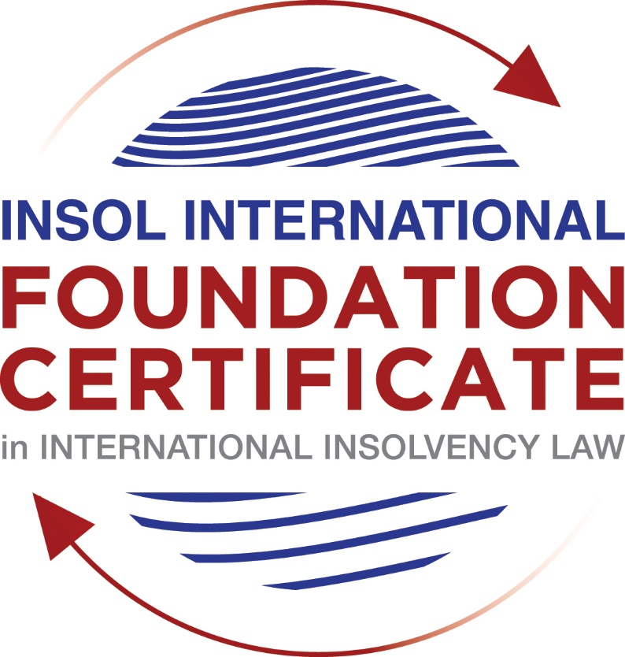

SUMMATIVE (FORMAL) ASSESSMENT: MODULE 3B

THE INSOLVENCY SYSTEM OF THE UNITED KINGDOM (ENGLAND AND WALES)

This is the summative (formal) assessment for Module 3B of this course and is compulsory for all candidates who selected this module as one of their compulsory modules from Module 3. Please read instruction 6.1 on the next page very carefully.

If you selected this module as one of your elective modules, please read instruction 6.2 on the next page very carefully.

The mark awarded for this assessment will determine your final mark for Module 3B. In order to pass this module, you need to obtain a mark of 50% or more for this assessment.

INSTRUCTIONS FOR COMPLETION AND SUBMISSION OF ASSESSMENT

Please read the following instructions very carefully before submitting / uploading your assessment on the Foundation Certificate web pages.

1. You must use this document for the answering of the assessment for this module. The answers to each question must be completed using this document with the answers populated under each question.

2. All assessments must be submitted electronically in MS Word format, using a standard A4 size page and a 11-point Arial font. This document has been set up with these parameters – please do not change the document settings in any way. DO NOT submit your assessment in PDF format as it will be returned to you unmarked.

3. No limit has been set for the length of your answers to the questions. However, please be guided by the mark allocation for each question. More often than not, one fact / statement will earn one mark (unless it is obvious from the question that this is not the case).

4. You must save this document using the following format: [student number.assessment3B]. An example would be something along the following lines: 202021IFU-314.assessment3B. Please also include the filename as a footer to each page of the assessment (this has been pre-populated for you, merely replace the words “studentnumber” with the student number allocated to you). Do not include your name or any other identifying words in your file name. Assessments that do not comply with this instruction will be returned to candidates unmarked.

5. Before you will be allowed to upload / submit your assessment via the portal on the Foundation Certificate web pages, you will be required to confirm / certify that you are the person who completed the assessment and that the work submitted is your own, original work. Please see the part of the Course Handbook that deals with plagiarism and dishonesty in the submission of assessments. Please note that copying and pasting from the Guidance Text into your answer is prohibited and constitutes plagiarism. You must write the answers to the questions in your own words.

6.1 If you selected Module 3B as one of your compulsory modules (see the e-mail that was sent to you when your place on the course was confirmed), the final time and date for the submission of this assessment is 23:00 (11 pm) GMT on 1 March 2021. The assessment submission portal will close at 23:00 (11 pm) GMT on 1 March 2021. No submissions can be made after the portal has closed and no further uploading of documents will be allowed, no matter the circumstances.

6.2 If you selected Module 3B as one of your elective modules (see the e-mail that was sent to you when your place on the course was confirmed), you have a choice as to when you may submit this assessment. You may either submit the assessment by 23:00 (11 pm) GMT on 1 March 2021 or by 23:00 (11 pm) BST on 31 July 2021. If you elect to submit by 1 March 2021, you may not submit the assessment again by 31 July 2021 (for example, in order to achieve a higher mark).

7. Prior to being populated with your answers, this assessment consists of 7 pages.

ANSWER ALL THE QUESTIONS

QUESTION 1 (multiple-choice questions) [10 marks in total]

Questions 1.1. – 1.10. are multiple-choice questions designed to assess your ability to think critically about the subject. Please read each question carefully before reading the answer options. Be aware that some questions may seem to have more than one right answer, but you are to look for the one that makes the most sense and is the most correct. When you have a clear idea of the question, find your answer and mark your selection on the answer sheet by highlighting the relevant paragraph in yellow. Select only ONE answer. Candidates who select more than one answer will receive no mark for that specific question.

Question 1.1

What is the initial period for a Moratorium under Part 1A of the Insolvency Act 1986 where the directors file relevant documents at court?

- 20 days.

- 20 business days.

- 40 days.

- 40 business days.

Question 1.2

What is the maximum length of a Moratorium under Part 1A of the Insolvency Act 1986 to which creditors can consent without any application to the court?

- 40 business days.

- One year and 20 business days.

- One year and 40 business days.

- One year.

Question 1.3

Which of the following is not a requirement for a company which wishes to enter into a Restructuring Plan under Part 26A of the Companies Act 2006?

- the company has encountered, or is likely to encounter, financial difficulties that are affecting, or will or may affect, its ability to carry on business as a going concern.

- a compromise or arrangement is proposed between the company and its creditors, or any class of them, or its members, or any class of them.

- the purpose of the compromise or arrangement is to eliminate, reduce or prevent, or mitigate the effect of, any of the said financial difficulties.

- the company is, or is likely to become, unable to pay their debts, as defined under section 123 of the Insolvency Act 1986.

Question 1.4

What percentage of creditors must approve a Scheme of Arrangement under Part 26 of the Companies Act 2006?

- A majority in number and in value.

- A majority in number and 50% or more in value.

- A majority in number and 75% or more in value.

- 75% or more in value.

Question 1.5

Which one of the following is not a debtor-in-possession procedure?

- Administration.

- Restructuring Plan.

- Scheme of Arrangement.

- Company Voluntary Arrangement.

Question 1.6

A liquidator may pay dividends to small value creditors based upon the information contained within the company’s statement of affairs or accounting records. In such circumstances, a creditor is deemed to have proved for the purposes of determination and payment of a dividend where the debt is no greater than how much?

- £500

- £750

- £1,000

- £2,000

Question 1.7

Which one of the following is not, in itself, a separate ground for disqualification of a director under the Company Directors Disqualification Act 1986?

- Wrongful trading.

- Breach of fiduciary duty.

- Being found guilty of an indictable offence in Great Britain.

- Being found guilty of an indictable offence overseas.

Question 1.8

The administrator is under a general duty to make a statement setting out proposals for achieving the purpose of administration. He or she must send out the statement of proposals as soon as reasonably practicable, and in any event within how many weeks of the date the company entered administration?

- 6

- 8

- 10

- 12

Question 1.9

Which of the following has the power to bring an action for wrongful trading under the Insolvency Act 1986?

- A monitor of a Moratorium.

- A supervisor of a Company Voluntary Arrangement.

- An administrator.

- An administrative receiver.

Question 1.10

Under section 176A of the Insolvency Act 1986, the prescribed part deducted from floating charge assets in favour of unsecured creditors is calculated as follows:

- 20% of the floating charge assets.

- 50% of the first £10,000 in value plus 20% of the excess in value above the £10,000 subject to a maximum amount of the prescribed part of £600,000.

- 20% of the first £50,000 in value plus 50% of the excess in value above the £50,000 subject to a maximum amount of prescribed part of £800,000.

- 50% of the first £10,000 in value plus 20% of the excess in value above the £10,000 subject to a maximum amount of prescribed part of £800,000.

QUESTION 2 (direct questions) [10 marks]

Question 2.1 [maximum 6 marks]

What is the difference between cash flow insolvency and balance sheet insolvency?

[Cash flow insolvency supposes a situation wherein a company is unable to pay its debt as they fall due whereas balance sheet insolvency means the sum total of a company’s liabilities surpasses its assets.
However, drawing a line between cash flow insolvency could be at times difficult. One may wonder if in considering debts in cash flow evaluation one would need to include some imminent futuristic debts or not. The position of the courts now is to consider both debts currently owed and debts in a reasonable near future. This tendency is one which has turned to intertwine cashflow and balance sheet insolvency.]

Question 2.2 [maximum 4 marks]

List four (4) elements of the statutory moratorium imposed when a company enters administration.

[-Impossibility for the appointment of an administrative receiver
-Landlord may not exercise the right of forfeiture by peaceable re-entry in relation to the premise except upon consent of the administrator or court.
-Bar to winding up resolution by shareholder
-No winding order against the company except upon grounds of public interest
]

QUESTION 3 (essay-type questions) [15 marks in total]

Question 3.1 [maximum 6 marks]

Explain the main differences between a Part 26 Scheme of Arrangement and a Part 26A Restructuring Plan.

[-Part 26 scheme of arrangement though used by insolvent companies too, was originally intended only for solvent companies while on the other hand a part 26A is available only to companies having or likely to have financial difficulties.
-Part 26 A scheme also enjoys the cramdown prerogative on dissenting creditors which Part 26 scheme lacks.
-]

Question 3.2 [maximum 9 marks]

Explain the different ways in which overseas officeholders may be recognised and request the assistance of the court in England and Wales.

[- The first of such ways of recognition used to be provided by virtue of the European Insolvency Regulation Recast was warranted automatic recognition of insolvency proceedings in member states with the exception of Denmark but with the departure of the UK from EU, uncertainty hovers.

-The second possibility is provided by the Uncitral Model law which was incorporated into the UK law with slight modifications by virtue of the Cross-border Insolvency Regulation 2006. This regulation calls for in-bound and out-bound recognition of insolvency proceedings upon application and recognition by the courts. The out-bound recognition is only for countries that have adopted the Uncitral Model law.

-The third possibility is under section 426 of CBIR which provides for recognition and assistance from listed former overseas territories of the UK.

The fourth possibility lies on the assumption of common law jurisdiction to grant assistance to foreign insolvency proceedings. Though case has substantially brought a shift in this assumption, foreign office holders could apply for assistance under this head.

]

QUESTION 4 (fact-based application-type question) [15 marks in total]

Prior to going into liquidation in November 2020, under pressure from its bank, Stercus Bank plc, and in order to prevent it from demanding repayment of the company’s loans, Cork-In Limited granted a debenture in favour of Stercus Bank plc in January 2020. The debenture contained a floating charge over the whole of the company’s undertaking.

In June 2020, as the company continued to struggle, the directors approved the
sale of a company delivery van to Paul Watson (a director) for £5,000 in cash. The
van had been bought for £10,000 a year before.

A month before the company went into liquidation, Paul Watson received an irate phone call from one of the company’s key suppliers, Gary’s Grapes Limited. The supplier demanded immediate payment of all sums owing to it (even those invoices that had not become payable). Fearing being cut off by the supplier, Paul arranged for a cheque for the full amount to be sent that day.

The liquidator has asked for advice whether any action may be taken in respect of the floating charge in favour of Stercus Bank plc and the two subsequent transactions.

Using the facts above, answer the questions that follow.

Identify the relevant issues and statutory provisions and consider whether the liquidator may take any action in relation to:

Question 4.1 [maximum 5 marks]

The floating charge in favour of Stercus Bank plc;

[The major issue here is to determine if the timeframe of the creation of the floating charge is in accordance with section 245 of the Insolvency Act 1986.
The main aim of the above-mentioned statutory provision to prevent pre-existing creditors from obtaining the security of a floating charge shortly before formal insolvency proceedings. For the case in hand, the floating charge in favour of Stercus bank is issued barely 10 months before insolvency proceedings and at such a time wherein it is clear the company is in financial turmoil. The issuance of the floating charge does not meet the statutory timeframe requirement of two years for persons connected to the company considering that they are recognised lenders of the company. In this light the liquidator can successfully take action by avoiding the floating charge.]

Question 4.2 [maximum 5 marks]

The sale of the van; and

[The issue here is whether the sale of the van could be viewed as a transaction at undervalue. The answer is of course to the affirmative looking at the purchase price of the van.
Section 238 of the Act gives the liquidator power to attack such transactions for the interest of its creditors. The transaction occurred at such a time wherein the company was unable to pay its debt and again falls within the two years bracket prior to insolvency. Proving good faith here would be an uphill task meaning it should be very easy for the liquidator to succeed in avoiding this transaction.]

Question 4.3 [maximum 5 marks]

The payment to Gary’s Grapes Ltd.

[The issue here would be to determine if the payment made to Gary’s Grapes would fall under preference payment as qualified under section 239 0f the Act.
Preference entails an act carried by the company shortly before entering a formal insolvency procedure that puts a creditor in a better position than other creditors of the company.
The liquidator can easily prove that Gary has been preferred since he was creditor of the company at the time of the transaction.]

* End of Assessment *

