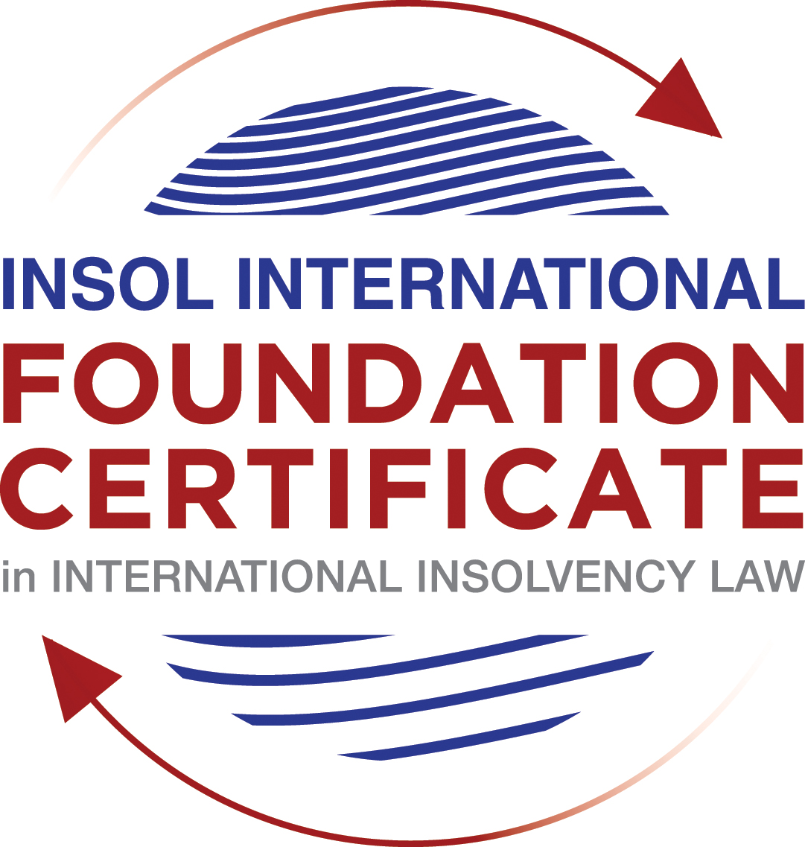

SUMMATIVE (FORMAL) ASSESSMENT: MODULE 3A

THE INSOLVENCY SYSTEM OF THE UNITED STATES

This is the summative (formal) assessment for Module 3A of this course and is compulsory for all candidates who selected this module as one of their compulsory modules from Module 3. Please read instruction 6.1 on the next page very carefully.

If you selected this module as one of your elective modules, please read instruction 6.2 on the next page very carefully.

The mark awarded for this assessment will determine your final mark for Module 3A. In order to pass this module, you need to obtain a mark of 50% or more for this assessment.

INSTRUCTIONS FOR COMPLETION AND SUBMISSION OF ASSESSMENT

Please read the following instructions very carefully before submitting / uploading your assessment on the Foundation Certificate web pages.

1. You must use this document for the answering of the assessment for this module. The answers to each question must be completed using this document with the answers populated under each question.

2. All assessments must be submitted electronically in MS Word format, using a standard A4 size page and a 11-point Arial font. This document has been set up with these parameters – please do not change the document settings in any way. DO NOT submit your assessment in PDF format as it will be returned to you unmarked.

3. No limit has been set for the length of your answers to the questions. However, please be guided by the mark allocation for each question. More often than not, one fact / statement will earn one mark (unless it is obvious from the question that this is not the case).

4. You must save this document using the following format: [student number.assessment3A]. An example would be something along the following lines: 202021IFU-314.assessment3A. Please also include the filename as a footer to each page of the assessment (this has been pre-populated for you, merely replace the words “studentnumber” with the student number allocated to you). Do not include your name or any other identifying words in your file name. Assessments that do not comply with this instruction will be returned to candidates unmarked.

5. Before you will be allowed to upload / submit your assessment via the portal on the Foundation Certificate web pages, you will be required to confirm / certify that you are the person who completed the assessment and that the work submitted is your own, original work. Please see the part of the Course Handbook that deals with plagiarism and dishonesty in the submission of assessments. Please note that copying and pasting from the Guidance Text into your answer is prohibited and constitutes plagiarism. You must write the answers to the questions in your own words.

6.1 If you selected Module 3A as one of your compulsory modules (see the e-mail that was sent to you when your place on the course was confirmed), the final time and date for the submission of this assessment is 23:00 (11 pm) GMT on 1 March 2021. The assessment submission portal will close at 23:00 (11 pm) GMT on 1 March 2021. No submissions can be made after the portal has closed and no further uploading of documents will be allowed, no matter the circumstances.

6.2 If you selected Module 3A as one of your elective modules (see the e-mail that was sent to you when your place on the course was confirmed), you have a choice as to when you may submit this assessment. You may either submit the assessment by 23:00 (11 pm) GMT on 1 March 2021 or by 23:00 (11 pm) BST on 31 July 2021. If you elect to submit by 1 March 2021, you may not submit the assessment again by 31 July 2021 (for example, in order to achieve a higher mark).

7. Prior to being populated with your answers, this assessment consists of 8 pages.

ANSWER ALL THE QUESTIONS

QUESTION 1 (multiple-choice questions) [10 marks in total]

Questions 1.1. – 1.10. are multiple-choice questions designed to assess your ability to think critically about the subject. Please read each question carefully before reading the answer options. Be aware that some questions may seem to have more than one right answer, but you are to look for the one that makes the most sense and is the most correct. When you have a clear idea of the question, find your answer and mark your selection on the answer sheet by highlighting the relevant paragraph in yellow. Select only ONE answer. Candidates who select more than one answer will receive no mark for that specific question.

Question 1.1

FabCo, based in Utah, owes SupplyCo, based in Mexico, US$10,000 on a past-due invoice. May SupplyCo file an involuntary petition to place FabCo into chapter 11 bankruptcy proceedings?

- Yes.

- Yes, if FabCo has fewer than 12 non-contingent, non-insider creditors.

- Yes, if other creditors owed at least US$5,775 join in the petition.

- No, because SupplyCo doesn’t know whether FabCo is insolvent.

- No, because SupplyCo is not a US company.

Question 1.2

Which of the following is a mandatory, rather than discretionary, basis to deny recognition of a foreign judgment under state law based on one of the Uniform Acts?

- The foreign judgment is subject to appeal in the foreign country.

- The foreign judgment is an injunction.

- The foreign judgment was issued by a court, contrary to the parties’ agreement to arbitrate.

- The defendant did not have sufficient notice of the foreign proceeding to put on a defense.

- The foreign judgment is inconsistent with another final judgment on the same subject matter.

Question 1.3

Which of the following is likely to be a party in interest in the bankruptcy of XYZ Corp?

- A shareholder in ABC Corp, to which XYZ Corp is substantially indebted.

- A journalist writing about XYZ Corp’s bankruptcy.

- A shareholder in MNO Corp, which owns all of XYZ Corp’s shares.

- A retired employee of XYZ Corp who receives payments from the company’s pension plan.

- A non-profit organization that advocates for companies like XYZ Corp to be held responsible for climate change.

Question 1.4

If a debtor rejects an executory trademark license agreement under which it licenses a trademark to its counterparty, which of the following is true:

- The counterparty must immediately stop using the trademark.

- The counterparty can continue using the trademark for the remaining period of the license.

- The counterparty has a claim for damages for breach of contract.

- Both (a) and (c).

- Both (b) and (c).

Question 1.5

In which of the following circumstances may a counterparty enforce a contractual ipso facto clause?

- The contract would obligate the counterparty to extend a loan to the debtor.

- The contract is a lease of real property.

- The clause is triggered by the bankruptcy filing of a third party, not the debtor.

- Both (a) and (c).

- Ipso facto clauses are never enforceable against a debtor.

Question 1.6

What does a chapter 11 debtor have exclusivity to propose for the first 120 days of proceedings?

- Avoidance actions.

- A plan of reorganization.

- DIP financing.

- Lifting the automatic stay.

- Formation of an equity committee.

Question 1.7

Which of the following is not a requirement to confirm a “cramdown” plan?

- Acceptance of the plan by all classes of secured creditors.

- Acceptance of the plan by at least one class of impaired, non-insider creditors.

- The plan is fair and equitable to dissenting classes of creditors.

- The plan does not discriminate unfairly against dissenting classes of creditors.

- The dissenting creditors receive no less than they would under a liquidation scenario.

Question 1.8

When may distributions to creditors diverge from the absolute priority rule?

- In a chapter 7 proceeding with consent of the affected senior creditor.

- In a chapter 7 proceeding with consent of the affected junior creditor.

- In a chapter 11 proceeding with consent of the affected senior creditor.

- In a chapter 11 proceeding with consent of the affected junior creditor.

- The absolute priority rule cannot be deviated from.

Question 1.9

Who may serve as a foreign representative to seek recognition of a foreign proceeding under chapter 15?

- An officer of the debtor if it is a debtor-in-possession in the foreign proceeding.

- The board of directors of the debtor if it is a debtor-in-possession in the foreign proceeding.

- An insolvency professional appointed by the court overseeing the foreign proceeding.

- An insolvency professional appointed by a creditor where the foreign proceeding is an involuntary receivership.

- All of the above.

Question 1.10

Which of the following is not available as relief in a chapter 15 proceeding?

- Sale of US property free and clear pursuant to section 363.

- Prosecution of avoidance actions pursuant to section 544 .

- Entrusting the management of US assets to the foreign representative.

- Application of the automatic stay under section 362 to the debtor’s interests in US property.

- Discovery about the debtor’s assets.

QUESTION 2 (direct questions) [10 marks]

Question 2.1 [maximum 1 mark]

What two alternative qualifications render a corporation eligible to be a debtor in a US chapter 7 or 11 proceeding?

Answer 2.1
- Presence of debtor on the United States.
- Presence of debtors business or any of its assets in the United States.

Question 2.2 [maximum 2 marks]

What is an executory contract?

Answer 2.2

A contract becomes executory contract where neither the debtor being one of the parties to the contract has not performed its obligations and the counter-parties have performed its obligations.

Executory contracts have a relevance in bankruptcy as these can either be assigned, rejected or assumed by the Bankruptcy Trustee as per relevant provisions of the law.

Question 2.3 [maximum 2 marks]

What is a “priming lien” and what requirements must be met for such a lien to be granted to secure DIP financing?

Answer 2.3

If the debtor is unable to obtain unsecured debt or a secured debt on unencumbered property or a secured debt on already encumbered property junior to the existing lien, then the court may allow the debtor to raise debt on Priming Lien.

Priming lien allows a lien which is senior or at least equal to lien on encumbered assets that existed prior to filing of petition for bankruptcy.

Requirements:
- The debtor has to demonstrate that the interest of secured creditors being primed is adequately protected.
- Approval of court is required.

Question 2.4 [maximum 2 marks]

In voting on a plan of reorganization, which class(es) of creditors are (i) deemed to accept the plan, (ii) deemed to reject the plan and (iii) permitted to vote on the plan? What vote is necessary for a class of creditors to accept a plan?

Answer 2.4

For a plan under Bankruptcy Code to be approved by the classes of creditors, the voting share
is as follows:
- Two-Thirds of value in claims by creditors, or Two-thirds of value interests of equity interest holders,

And

- Simple majority by number of creditors in class.

There is also a concept of deemed acceptance and rejection on the basis of impairment and the amount they receive which is explained below:

- A class which is unimpaired is deemed to have accepted the plan.
- A class which received nothing is deemed to have rejected the plan.
- Classes which are impaired are permitted to vote on the plan.

Question 2.5 [maximum 3 marks]

How does the automatic stay available in chapter 15 proceedings differ from that available in chapter 11 proceedings?

Answer 2.5
An automatic stay is available in both the proceedings under chapter 15 and 11 which comes
into effect as the petition if filed. This stay is intended to provide the debtor with a breathing
space to negotiate and realise the value for creditors.

The stay in chapter 11 includes various actions such as a stay on the litigation of pre-petition
claims, actions to enforce a lien on the property, actions to obtain possession and control, set
off etc.

However, the stay in chapter 15 is subject to recognition of an application for a foreign main
proceeding and is not automatic. The stay available is further subject to a carve-out which
allows the foreign representative to file a US plenary provision despite a recognition granted.
The purpose of this is limited to the assets available in the US and get an access to US courts
powers of avoiding powers where the relief may not be available for the reason such a
limitation.

QUESTION 3 (essay-type questions) [15 marks in total]

Question 3.1 [maximum 3 marks]

What fiduciary duties do directors of Delaware corporations owe and to whom are the duties owed in the ordinary course of business? To whom are duties owed when the corporation is potentially or actually insolvent?

Answer 3.1

Like any other company, directors of companies falling under the jurisdiction of Delaware have the following primary fiduciary duties towards shareholders in the ordinary course such as-
- Taking a reasonable care in making decisions.
- Be loyal to the company and act in the best interests of the company.

The above duties towards the shareholders applies even when the company is potentially insolvent. This assertion is further supported by the Delaware Supreme Court’s decision in the case of North Am Catholic Educational Programming Foundation, Inc v Gheewalla where it held that the creditors would not have a right to claim under breach of duty against the directors and the remedy they possess is to file a claim against the debtor company which is insolvent.

Further the directors are also protected by the so called ‘Business Judgement Rule’ which protects them from any liability that may have been incurred due to an error.

Question 3.2 [maximum 3 marks]

Describe the circumstances in which a bankruptcy court may enter a final order, who reviews appeals from bankruptcy court orders and how non-final orders are reviewed.

Answer 3.2

Final orders are the orders that would dispose off all the issues pertaining to the case. Such final orders may be entered by the bankruptcy court under a delegated authority of a district court when there is a motion which challenged the validity of a petition. Sometimes the bankruptcy courts may not have a jurisdiction to enter a final order and then such issue is sent to district court for a review.

As regards the appeals against a final order passed by the bankruptcy court, the district court will hear the appeal in the case. However, in certain circuits the appeal may also be heard by a Bankruptcy Appellate Tribunal and any order passed by the appellate authority may further be appealed to the circuit courts of appeals.

Question 3.3 [maximum 4 marks]

Describe how claims for recovery of preferences, fraudulent conveyance and constructive fraudulent conveyance differ.

Answer 3.3

Preference: A preference is deemed to be given when there is a transfer of an interest in the debtor’s property for the benefit of a creditor on account of an antecedent pre-existing debt. Such a transfer should have been made at the time when the debtor was insolvent, i.e, 90 days prior to the petition date. The above conditions should be coupled with a very important condition which states that the creditor who is a transferee should have received more than is was entitled to receive during the Liquidation (chapter 7).

Fraudulent Conveyance: A transfer is fraudulent if it is proved that the intent was to defraud or hinder interests of a person to whom the debtor would have owed the debts.

The major differences between a preference transaction and a fraudulent conveyance are listed below:
- Fraudulent transfer may be made to anyone, but the preference can only be given to a creditor.
- The preference transaction should involve transfer on account of a pre-existing debt there is no specific requirement for a fraudulent transaction.
- The look-back period of Preference is only 90 days while it is 2 years for a fraudulent transfer.

Constructive Fraudulent Conveyance: As the name suggests the transfer is made on certain constructive grounds. The primary reason It gets invoked when the debtor received less than equivalent value in exchange of a transfer and the debtor was either insolvent and in deep financial stress or has become insolvent due to such a transaction.

This is different from Ordinary Fraudulent Conveyance as it can be avoided even without showing that there was an intent to fraud.

Question 3.4 [maximum 5 marks]

How does a US bankruptcy court determine whether a foreign proceeding is a main or non-main proceeding under chapter 15?

Answer 3.4

According to Chapter 15 of the US Bankruptcy Code, Foreign main proceedings are those proceedings that commence at the place where the debtor’s Center of Main Interests (COMI) is situated. COMI is usually presumed to be the registered office address of the debtor, however this presumption is rebuttable based on a conclusive evidence.

Foreign Non-Main proceedings are those which commence at the place where the debtor does not have a COMI but only an establishment.

These concepts have been borrowed from UNCITRAL Model Law on Cross-Border Insolvency which has been adopted by the USA.

QUESTION 4 (fact-based application-type question) [15 marks in total]

Question 4.1 [maximum 5 marks]

Rental Corporation is a publicly-traded company that leases office space from office building owners and sublets the space to small businesses. It has recently announced that it is being investigated by the US Department of Justice Fraud Division (DOJ) regarding allegedly fraudulent misstatements of revenues; shortly after the announcement, a securities class action litigation was filed against Rental Corporation in New York federal court. Due to the increase in the numbers of businesses operating remotely, Rental Corporation has suffered a decline in revenues. As a result, it has failed to pay rent on some of its office space leases and it has just defaulted on its quarterly payment on its credit facility. What would be the effect of a chapter 11 petition being filed by Rental Corporation on each of (i) the DOJ investigation, (ii) the securities class action litigation; (iii) the delinquent leases and (iv) the credit facility?

Answer 4.1

By purview of section 362 of the US Bankruptcy code, a worldwide automatic stay in the nature of a moratorium comes into effect immediately after filing of a petition under chapter 11 of the code. The scope of stay is very broad and covers various legal proceedings, stay on enforcement of lien, set-off etc. However, the stay also includes various acts such as criminal investigations, family law matters, exercise of rights under a securities agreement etc.

In the given case various activities would be analysed with respect to the impact caused on them by chapter 11 proceedings.

- DOJ Investigation: Investigation into alleged fraud by the company is a criminal investigation. Such criminal investigations are statutorily excluded from the scope of automatic stay. Therefore, this investigation would continue and would not be affected by the proceedings under chapter 11.

- Securities class action litigation: The class action if a civil proceeding against the company when a class of shareholders are aggrieved. Such actions would be stayed by purview of automatic stay.

- Delinquent Leases: There are leases on which the debtor has failed to pay lease rents and this makes the lessor a claimant to the estate of the debtor for which he shall file a claim. However, as regards the position of continuity of a lease agreement, the Lessor cannot impose an eviction on the debtor who is a tenant unless the lease has expired. In the given case the debtor has leased certain assets and the lease term has not expired. Therefore, the lease shall not be impacted by the proceedings under chapter 11. But by virtue of section 365, the trustee has to make a decision on assignment, assumption or rejection of the unexpired leases within 120 days of the order of relief.

- Credit Facility: The debtor has failed to pay its quarterly repayment on its credit facility. This would enable the creditor to file a claim for the unpaid dues. Assuming that the credit facility is a secured facility and has a lien on some of the assets of the debtor, in this situation the creditor would be precluded from enforcing its security interest. As regards the credit facility, the same shall be settled by terms of the plan of reorganization.

Question 4.2 [maximum 5 marks]

Considering the facts set forth in Question 4.1, what protections does the Bankruptcy Code provide to lessors of office space to Rental Corporation?

Answer 4.2

There may be circumstances when the lessor of an asset leased to the debtor has a claim for unpaid lease rents. In this situation he is precluded from taking any action to recover the property by virtue of an automatic stay in force.

However, there are certain exceptional situations when the lessor may be granted a relief from the stay. When there is lack of adequate protection of an interest in the property of the estate of lessee, and the value of such property is subject to decline during the proceedings of insolvency, the lessor may be allowed to life the stay to pursue remedies such as recovery.

An essential pre-requisite to this is that the assessable value should be determined and it should project that the value of the asset is not adequately protected.

Later even if the adequate protection granted by the court is insufficient, then the shortfall would be given an administrative priority.

Question 4.3 [maximum 5 marks]

Paint Corporation formulates house paint according to proprietary and patented recipes at its factory in the United States, which it sells to home improvement stores under a number of distribution contracts. The US Environmental Protection Agency is investigating whether Paint Corporation’s operations are causing harmful chemicals to contaminate a nearby river. Paint Corporation is concerned it cannot afford the clean-up that may be required and is seeking to sell its business. Home Corporation is interested in buying the business, but does not want the potentially contaminated property (it can manufacture paint at its own factory) and is concerned about obtaining consent from all the home improvement stores to assign the distribution contracts. How would a sale under section 363 of the Bankruptcy Code address these issues?

Answer 4.3

A section 363 sale is a unique feature of the US bankruptcy code which allows the debtor to sell all, or any part of its business to a purchaser and use the sale proceeds to pay the creditors. In recent years section 363 sale has been a preferred option as the debtor can sell its property free and clear of creditors interests with court approval. This also protects the interests of a good faith purchaser which is ‘Home Corporation’ in the given case.

A good feature of section 363 sale is that it allows debtor to transfer its interest in key commercial contracts which are essential to operate a business, notwithstanding any contractual restriction on transfer/ assignment of such contracts.

The issue of assignment of contracts should not be a cause of concern for the purchaser as the court approval regarding sale of business shall be binding on all the parties.

Another issue to be examined is the investigation by Environmental Protection Agency (EPA). According to section 363(f) the trustee may sell the property if such entity can be compelled, in a legal or equitable proceeding, to accept a money satisfaction of such interest. If the investigation of the EPA results in any monetary penalties payable the same might be settled by way of a claim on the estate.

In the given case, the purchaser is not at all interested in the contaminated property and any liabilities accruing on account of it shall remain with the Seller which is the Paint Corporation. Needless to say, without buying a manufacturing facility, the buyer can also purchase the technology and other intellectual property used by the seller in such situation.

Hence, both the issues would not affect the buyer’s interest and they may proceed ahead with the sale under section 363.

* End of Assessment *

