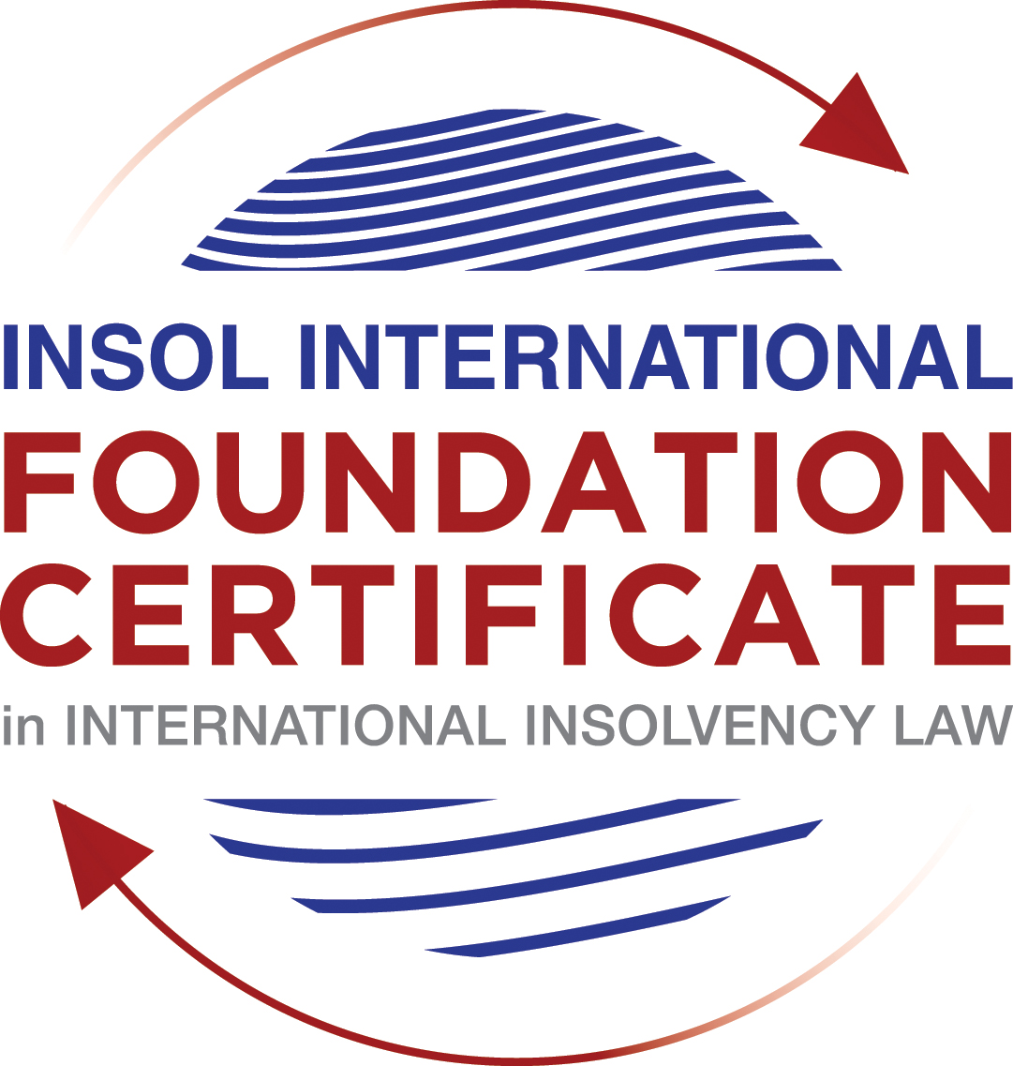

SUMMATIVE (FORMAL) ASSESSMENT: MODULE 2A

THE UNCITRAL MODEL LAWS RELATING TO INSOLVENCY

This is the summative (formal) assessment for Module 2A of this course and is compulsory for all candidates who selected this module as one of their compulsory modules from Module 2. Please read instruction 6.1 on the next page very carefully.

If you selected this module as one of your elective modules, please read instruction 6.2 on the next page very carefully.

The mark awarded for this assessment will determine your final mark for Module 2A. In order to pass this module, you need to obtain a mark of 50% or more for this assessment.

INSTRUCTIONS FOR COMPLETION AND SUBMISSION OF ASSESSMENT

Please read the following instructions very carefully before submitting / uploading your assessment on the Foundation Certificate web pages.

1. You must use this document for the answering of the assessment for this module. The answers to each question must be completed using this document with the answers populated under each question.

2. All assessments must be submitted electronically in MS Word format, using a standard A4 size page and a 11-point Arial font. This document has been set up with these parameters – please do not change the document settings in any way. DO NOT submit your assessment in PDF format as it will be returned to you unmarked.

3. No limit has been set for the length of your answers to the questions. However, please be guided by the mark allocation for each question. More often than not, one fact / statement will earn one mark (unless it is obvious from the question that this is not the case).

4. You must save this document using the following format: [student number.assessment2A]. An example would be something along the following lines: 202021IFU-314.assessment2A. Please also include the filename as a footer to each page of the assessment (this has been pre-populated for you, merely replace the words “studentnumber” with the student number allocated to you). Do not include your name or any other identifying words in your file name. Assessments that do not comply with this instruction will be returned to candidates unmarked.

5. Before you will be allowed to upload / submit your assessment via the portal on the Foundation Certificate web pages, you will be required to confirm / certify that you are the person who completed the assessment and that the work submitted is your own, original work. Please see the part of the Course Handbook that deals with plagiarism and dishonesty in the submission of assessments. Please note that copying and pasting from the Guidance Text into your answer is prohibited and constitutes plagiarism. You must write the answers to the questions in your own words.

6.1 If you selected Module 2A as one of your compulsory modules (see the e-mail that was sent to you when your place on the course was confirmed), the final time and date for the submission of this assessment is 23:00 (11 pm) GMT on 1 March 2021. The assessment submission portal will close at 23:00 (11 pm) GMT on 1 March 2021. No submissions can be made after the portal has closed and no further uploading of documents will be allowed, no matter the circumstances.

6.2 If you selected Module 2A as one of your elective modules (see the e-mail that was sent to you when your place on the course was confirmed), you have a choice as to when you may submit this assessment. You may either submit the assessment by 23:00 (11 pm) GMT on 1 March 2021 or by 23:00 (11 pm) BST on 31 July 2021. If you elect to submit by 1 March 2021, you may not submit the assessment again by 31 July 2021 (for example, in order to achieve a higher mark).

7. Prior to being populated with your answers, this assessment consists of 9 pages.

ANSWER ALL THE QUESTIONS

QUESTION 1 (multiple-choice questions) [10 marks in total]

Questions 1.1. – 1.10. are multiple-choice questions designed to assess your ability to think critically about the subject. Please read each question carefully before reading the answer options. Be aware that some questions may seem to have more than one right answer, but you are to look for the one that makes the most sense and is the most correct. When you have a clear idea of the question, find your answer and mark your selection on the answer sheet by highlighting the relevant paragraph in yellow. Select only ONE answer. Candidates who select more than one answer will receive no mark for that specific question.

Question 1.1

Which of the following statements incorrectly reflects the main purpose of the Model Law?

- The Model Law provides effective mechanisms for dealing with cases of cross-border insolvency so as to promote a number of objectives, including the protection and maximisation of trade and investment.

- The Model Law provides effective mechanisms for dealing with cases of cross-border insolvency so as to promote a number of objectives, including the fair and efficient administration of cross-border insolvencies that protects the interests of all creditors and other interested persons, not including the debtor.

- The Model Law is a substantive unification of insolvency law so as to promote co-operation between courts of the enacting State and foreign States and facilitation of the rescue of financially troubled businesses.

- All of the above.

Question 1.2

Which of the following statements is unlikely to be a reason for the development of the Model Law?

- The existence of a statutory basis in national (insolvency) laws for co-operation and co-ordination of domestic courts with foreign courts or foreign representatives.

- The difficulty of agreeing multilateral treaties dealing with insolvency law.

- The practical problems caused by the disharmony among national laws governing cross-border insolvencies, despite the success of protocols in practice.

- None of the above.

Question 1.3

Which of the following challenges to a recognition application under the Model Law is most likely to be successful?

- The registered office of the debtor is not in the jurisdiction where the foreign proceedings were opened, but the debtor has an establishment in the jurisdiction of the enacting State.
- The registered office of the debtor is in the jurisdiction of the enacting State, but the debtor has an establishment in the jurisdiction where the foreign proceedings were opened.

- The debtor has neither its COMI nor an establishment in the jurisdiction where the foreign proceedings were opened.

- The debtor has neither its COMI nor an establishment in the jurisdiction of the enacting State.

Question 1.4

“Cross-border insolvencies are inherently chaotic and value evaporates quickly with the passage of time”. Which of the following rules or concepts set forth in the Model Law best addresses this feature of cross-border insolvencies?

- The locus standi access rules.

- The public policy exception.

- The safe conduct rule.

- The “hotchpot” rule.

Question 1.5

For a debtor with its COMI in South Africa and an establishment in Brazil, foreign main proceedings are opened in South Africa and foreign non-main proceedings are opened in Brazil. Both the South African foreign representative and the Brazilian foreign representative have applied for recognition before the relevant court in the UK. Please note that South Africa has implemented the Model Law subject to the so-called principle of reciprocity (based on country designation), Brazil has not implemented the Model Law and the UK has implemented the Model Law without any so-called principle of reciprocity. In this scenario, which of the following statements is the most correct one?

- The foreign main proceedings in South Africa will not be recognised in the UK because the UK is not a designated country under South Africa’s principle of reciprocity, but the foreign non-main proceedings in Brazil will be recognised in the UK despite Brazil not having implemented the Model Law.

- Both the foreign main proceedings in South Africa and the foreign non-main proceedings in Brazil will not be recognised in the UK because the UK has no principle of reciprocity and Brazil has not implemented the Model Law.

- Both the foreign main proceedings in South Africa and the foreign non-main proceedings in Brazil will be recognised in the UK.

- None of the statements in (a), (b) or (c) are correct.

Question 1.6

Which of the following statements regarding concurrent proceedings under the Model Law is true?

- No interim relief based on Article 19 of the Model Law is available if concurrent domestic insolvency proceedings and foreign proceedings exist at the time of the application of the foreign proceedings in the enacting State.

- In the case of a foreign main proceeding, automatic relief under Article 20 of the Model Law applies if concurrent domestic insolvency proceedings and foreign proceedings exist at the time of the application of the foreign proceedings in the enacting State.

- The commencement of domestic insolvency proceedings prevents or terminates the recognition of a foreign proceeding.

- If only after recognition of the foreign proceedings concurrent domestic insolvency proceedings are opened, then any post-recognition relief granted based on Article 21 of the Model Law will not be either adjusted or terminated if consistent with the domestic insolvency proceedings.

Question 1.7

When using its discretionary power to grant post-recognition relief pursuant to Article 21 of the Model Law, what should the court in the enacting State primarily consider?

- The court must be satisfied that the interests of the creditors and other interested parties, excluding the debtor, are adequately protected.

- The court should consider whether the relief requested is necessary for the protection of the assets of the debtor or the interests of the creditors and strike an appropriate balance between the relief that may be granted and the persons that may be affected.

- The court should consider both (a) and (b).

- Neither (a) nor (b) must be considered by the court.

Question 1.8

Which of the statements below regarding the Centre of Main Interest (or COMI) and the Model Law is incorrect?

- COMI is a defined term in the Model Law.

- For a corporate debtor, the Model Law does contain a rebuttable presumption that the debtor’s registered office is its COMI.

- While (for purposes of the Model Law) the COMI of a debtor can move, the closer such COMI shift is to the commencement of foreign proceedings, the harder it will be to establish that the move was “ascertainable by third parties”.

- None of the above.

Question 1.9

Which of the following types of relief have, prior to the adoption of the Model Law on Recognition and Enforcement of Insolvency-Related Judgments, been declared beyond the limits of the Model Law?

- Enforcement of insolvency-related judgments.

- An indefinite moratorium continuation.

- Both (a) and (b).

- Neither (a) nor (b).

Question 1.10

When for the interpretation of the Model Law “its original origin” is to be considered in accordance with article 8 of the Model Law, which of the following texts is likely to be of relevance?

- The UNCITRAL Guide of Enactment and the Practice Guide.

- The UNCITRAL Guide of Enactment and the Legislative Guide – Parts One, Two, Three and Four.

- The UNCITRAL Guide of Enactment and the Judicial Perspective.

- All of the above.

QUESTION 2 (direct questions) [10 marks in total]

Question 2.1 [maximum 3 marks]

One of the elements of the definition of “foreign proceeding” as set out in article 2(a) of the MLCBI, is that the proceeding is “authorised or conducted under a law relating to insolvency”. Discuss whether a “foreign solvent winding-up proceeding of a debtor on just and equitable grounds” is likely to meet this element.

Answer 2.1
The element which requires a foreign proceeding to be authorised or conducted under a law relating to insolvency is an important element when it comes to recognition to ensure that there is consistency in the proceedings in two jurisdictions. Usually a law relating to insolvency would be one which satisfies the basic principles of any insolvency law and contain the features like collective proceeding, objective of maximisation of value for stakeholders either by rescue or liquidation and which allows a breathing space to the debtor.

A winding up proceeding of a solvent debtor does not fall under the term ‘law relating to insolvency’ bi virtue of the order passed by the English court in the case of Sturgeon
Central Asia Balanced Fund Ltd. The court took a view that winding up a solvent company would produce a return to its members and not the creditors.

Question 2.2 [maximum 3 marks]

The following three (3) statements relate to particular provisions / concepts to be found in the Model Law. Indicate the name of the provision / concept (as well as the relevant Model Law article), addressed in each statement.

Statement 1 “This Article provides the ultimate safeguard to the sovereignty of the enacting State”

Statement 2 “This Article provides guidance on a key concept in the MLCBI that is not otherwise defined in it”

Statement 3 “The Article contains a rebuttable presumption that results from a recognition of a foreign main proceeding”

Answer 2.2

Statement 1 – Public Policy Exception in Article 6.

Statement 2 – Centre of Main Interest (COMI) in Article 16.

Statement 3 – Presumption of Insolvency in Article 31.

Question 2.3 [2 marks]

While the concepts of COMI (Centre of Main Interest) in the European Insolvency Regulation and the MLCBI are similar, they serve different purposes. Please explain.

Answer 2.3

The statement in the question is true that the COMI in both the MLCBI and EIR serve a different purpose. MLCBI though does not define COMI requires its ascertainment to determine the proceedings as Main or Non-Main at the time of recognition based on which further the relief is determined.

Recital 27 of the EIR on the other hand requires determines the jurisdiction of insolvency law within the member states based on COMI. COMI will decide whether the EIR is applicable in the case or not. Further, unlike MLCBI, EIR (Recast) also defines COMI.

Question 2.4 [2 marks]

In terms of relief, what should the court in an enacting State do if, after recognition of a foreign non-main proceeding, another foreign non-main proceeding is recognised? You should mention the most relevant article of the MLCBI. What (ongoing) duty of information does the relevant foreign representative in each foreign non-main proceeding have towards the court in the enacting State? You are required to mention the most relevant article of the MLCBI.

Answer 2.4
As per Article 30 of MLCBI if another non-main proceeding is recognised in addition to an existing non-main proceeding, then the court must either grant, modify or terminate the relief for the purpose of facilitating a coordination among these non-main proceedings. One of the reasons could be because as per Article 30(c ) – where there are more than one non-main proceeding, then no such proceeding is treated preferentially.

As per Article 25, the foreign representatives of each foreign non-main proceedings have a duty to provide the information sought by another foreign representative through the Court.

QUESTION 3 (essay-type questions) [15 marks in total]

A foreign representative of a foreign proceeding opened in State B in respect of a corporate debtor (the Debtor) is considering whether or not to make a recognition application under the implemented Model Law of State A (which does not contain any reciprocity provision). In addition, the foreign representative is also considering what (if any) relief may be appropriate to request from the court in State A.

Write a brief essay in which you address the three questions below.

Question 3.1 [maximum 4 marks]

Prior to making a recognition application in State A, explain how access and co-ordination rights in State A can benefit the foreign representative?

Answer 4.1
In the given case the Foreign Representative of State A can apply to the Court in State B for recognition of proceedings in State A.

The access rights available under MLCBI will allow the Foreign Representative of State A to have a standing in the courts of State B without being discriminated. The access can either be either to observe the proceeding in State B without having any rights or powers, or an access to make an application for recognition of foreign proceedings in State A or access granted after recognition which will allow the foreign representative of state A to make various petitions, submissions and apply for relief.

Access is primarily a tool to allow a foreign representative to reach out for exploring various rights or privileges available in other jurisdiction. It saves Time, Expense and promotes transparency.

Principles of Coordination in the MLCBI allows the courts and foreign representatives to work in harmony with each other and achieve efficient and optimal results in the event there are two or more proceedings going on concurrently. Another objective is to achieve consistency in various acts of representatives of both the jurisdictions.

Communication is the most important tool available for coordination between the Courts or Courts and Foreign Representatives, or between two or more Foreign Representatives. This communication is the essence of coordination which can be done by various means.

Question 3.2 [maximum 6 marks]

For a recognition application in State A to be successful, briefly explain (with reference to relevant MLCBI articles) the minimum requirements for qualifying as a “foreign proceeding” and a “foreign representative” under the MLCBI. In addition, you are also required to list and briefly explain (with reference to relevant MLCBI articles) any other evidence, restrictions, exclusions and limitations that must be considered, as well as the judicial scrutiny that must be overcome for a recognition application to be successful.

Answer 3.2

As per Article 2 ,for recognition of proceeding of State A in State B the minimum requirements of being a foreign proceedings would be that the proceedings in State A which is a foreign state are either Judicial or Administrative under a law relating to insolvency. The proceedings should be collective for the purpose of either reorganisation or liquidation which assets are subject to control and supervision by the foreign court of State A.

Foreign Representative would be a person who would be authorised in proceedings of State A to administer the reorganisation or liquidation of debtors assets or affairs.

Points to consider while applying for a recognition application in State B:

- It needs to be ensured that the proceeding is not governed by a special insolvency regime.

- State B has either a COMI or at least an establishment for becoming eligible to make an application either as Foreign Main or Foreign Non-Main proceedings.

- Recognition should be for the foreign proceeding to which the Foreign Representative (as defined above) has been appointed.

- As per Article 15 the application shall be accompanied by necessary documents such as a certified copy of commencement of foreign proceeding or a similar certificate evidencing the commencement.

- As per Article 16 the Judiciary is entitled to presume that in the absence of any proof to the contrary the Registered Office is always presumed to be the COMI of the debtor. Judiciary will also presume that the documents submitted in support of application are authentic and the certificate produced in support of foreign proceedings is within the meaning of MLCBI.

- If the above conditions are satisfied, then as per Article 17 the Recognition would be granted.

- As per Article 18 the foreign representative has to ensure that post recognition it has an ongoing obligation to inform the court in State B of any major developments like change in status of recognised proceedings or any other proceeding it has become aware of.

Question 3.3 [maximum 5 marks]

As far as relief is concerned, briefly explain (with reference to relevant MLCBI articles) what pre- and post-recognition relief can be considered in the context of the MLCBI, as well as any restrictions, limitations or conditions that should be considered in this context. For purposes of this questions, it can be assumed that there is no concurrence of proceedings.

Answer 3.3

Reliefs available under MLCBI can be broadly categorized under 3 categories-
- Automatic Mandatory Relief:
  - It is available when the foreign proceedings are recognized as Foreign Main Proceedings. (Article 20).
  - It primarily contains reliefs with respect to application of a Moratorium which contains granting a stay on proceedings, stay on execution against assets and suspension of rights to transfer an asset of debtor.

- Non-Automatic and Post-recognition discretionary relief:
  - It is available when the foreign proceedings are recognized as Foreign Non-Main Proceedings. These may also be allowed in Main proceedings in addition to those available under Article 20. (Article 21).
  - This includes reliefs available under Article 20 to the extent not allowed earlier. In addition to this, it also includes reliefs such as examination of witness, taking evidence, allowing a foreign administrator to administer debtors assets.

- Urgent Interim Relief:
  - It can be granted prior to recognition of proceedings. (Article 19).
  - This mainly includes a stay on execution against debtors assets and allowing a foreign representative to administer debtors assets in order to preserve value along with some reliefs available under Article 21.

The reliefs granted would not be unlimited and can be very well witnessed by landmark judicial orders available in the matter of Rubin v Eurofinance SA, Fibria Celulose S/A v Pan Ocean Co Ltd. and The IBA Case which dealt with numerous issues such as indefinite moratorium, enforcement of judgements on avoidance provisions and application of foreign insolvency law to English contracts.

The reliefs granted under the above categories can be modified as per Article 22 if the court is satisfied that the interests of debtor’s creditors and other interested parties are not adequately protected.

QUESTION 4 (fact-based application-type question) [15 marks in total]

Global Shipping Company (“GSC”) is a shipping company incorporated under the laws of the Cayman Islands, but it was primarily operated from the UK. GSC filed for local insolvency proceedings in the Cayman Islands and local liquidators were appointed. Approximately one year after the opening of the Cayman Island insolvency proceedings, in which the liquidators of GSC worked primarily out of the Cayman Islands to deal with the various aspects of the GSC liquidation, it is decided by the GSC liquidators to make a recognition application in Texas (USA) due to the fact that some assets of GSC are located there as well as some creditors of GSC.

Question 4.1 [maximum 6 marks]

For this question, assume that you are the US judge dealing with the application by the GSC liquidators, as foreign representatives, for the recognition of the Cayman liquidation proceedings of GSC as either foreign main or foreign non-main proceedings. Focusing only on the assessment of whether the foreign proceedings qualify as “main” or “non-main” proceedings, how would you go about determining whether the COMI or an establishment of GSC existed in the Cayman Islands at the relevant time?

Answer 4.1

Though there is no definition of COMI in MLCBI, it does provide some guidance on this aspect. As the USA has adopted MLCBI, the guidance would be useful in determining whether Cayman Islands contain a COMI or merely an Establishment.

Though there is a presumption in Article 16 that in absence to the proof to the contrary, the registered office would be COMI. But the following factors are also important in determining whether the COMI is in Cayman Islands or not:
- Location of central administration of debtor and,
- Location readily ascertainable by creditors of the debtor.
These factors are in addition to other factors such as location of employees, principal assets, cash management etc.

However, COMI should in any case be readily ascertainable by its debtors.

In the given case, though the registered office is in Cayman Islands the complete administration is being done at UK and the parties dealing with GSC would assume that it is a company whose business is located in the UK while only government authorities would find Cayman Islands as the principal place of business for the purpose of legal compliances.

Also assuming that all the major creditors would be located locally in the UK, it is safe to presume that Cayman Islands is not a COMI and has only an Establishment.

Therefore, USA would recognise Cayman Islands as a Foreign Non-Main Proceedings.

Additional facts for question 4.2:

GSC has so-called “representative offices” in Brazil and Nigeria, but these offices are mainly “letter boxes” and there are no employees. GSC does have a “proper” UK office where 20 employees work. Everything in the representative offices is done remotely, primarily from either the Cayman Islands or the UK office. GSC has both operations and assets in the US and the UK. GSC further has bank accounts with local banks in the US, the UK, Brazil and Nigeria, but its global operations are primarily financed by a number of bilateral loans in US$ by a small number of local Cayman Islands banks, with whom GCS is very close. The total amount of GSC’s bank debt is US$50m. In addition, GSC recently managed – through the savvy assistance of a well-connected Swiss banker – to issue private placement notes (PPNs) for a total amount of US$10m to three sophisticated Swiss private investors. The Swiss investors insisted that the PPNs were governed by English law.

Question 4.2 [maximum 3 marks]

The GSC liquidators manage to opening local insolvency proceeding in Nigeria; would those local Nigerian insolvency proceedings be recognised in the US as foreign non-main proceedings? If a recognition application under Chapter 15 is made before the US court in Texas, how likely is it that the requested recognition will be granted?

Answer 4.2

Nigeria has only a representative office without any employee. It has an asset in the form of a bank account for minimal local operations. Nigeria has no assets other than a representative office and a bank account. Therefore it would qualify as a foreign non-main proceedings in the USA.

Additional facts for question 4.3:

To facilitate reaching a restructuring agreement, the GSC liquidators decide to open US Chapter 11 proceedings. There they manage to reach a restructuring agreement with all the creditors, apart from the three Swiss holders of the PPNs who decided to completely refrain from participating at all in the US Chapter 11 proceedings of GSC. Since the restructuring agreement met the required thresholds of creditor support it was – according to US law – binding on all creditors of GSC, including the non-participating Swiss PPN holders. The reason the Swiss PPN holders did not participate in the US Chapter 11proceedings of GSC, was that they would like to enforce their rights against GSC under English law and obtain full repayment of their claims under the PPNs instead of the compromise reached under the US restructuring agreement of GSC. They are hopeful that the so-called “Gibbs Rule” under English law will help them in this respect.

Question 4.3 [maximum 6 marks]

What can the Cayman Islands liquidators do to avoid that the assets of GSC in the UK are available to the Swiss PPN holders and what do you expect the considerations of an English court to be if the liquidators decided to request a recognition of the US Chapter 11 proceedings in the UK together with such appropriate relief under the Model Law as implemented in the UK which – in effect – prevents the Swiss PPN holders from enforcing their English law claims against GSC under the PPNs?

Answer 4.3

Considerations of court in UK while recognising foreign proceedings in the USA would be as following:
- The court in the UK will consider whether the Chapter 11 proceedings in the USA are a judicial or administrative proceeding under a law relating to insolvency.
- It will also ensure whether the proceedings are collective in nature under which the assets of debtor are under supervision by a foreign court.
- The proceedings are either for Reorganization or Liquidation.

Once the proceedings are recognized, the foreign representatives will apply for appropriate reliefs. If the Liquidators of Cayman Islands wish to prevent Swiss PPN holders from enforcing their English law claims under Gibb’s rule, it would have to request for staying the commencement of individual actions or individual proceedings concerning the debtor’s assets, rights, obligations or liabilities.

However the Appellate Courts observation in The IBC Case will also have to be ensured which requires that the stay would be necessarily to protect the interest of local creditors in UK and the stay would have to be an appropriate way of achieving such protection.

* End of Assessment *

Cayman Islands has not implemented the Model Law.
The UK has implemented the Model Law and for the purpose of this question it should be assumed that the UK has implemented the Model Law without any relevant changes to it.
The US have implemented the Model Law and for the purpose of this question it should be assumed that the US have implemented the Model Law without any relevant changes to it.
Brazil and Nigeria have not implemented the Model Law.
The Gibbs rule is derived from an English case of 1890 and stands for the proposition that a debt governed by English law cannot be discharged or compromised by a foreign insolvency proceeding. Discharge of a debt under the insolvency law of a foreign country is only treated as a discharge therefrom in England if it is a discharge under the law applicable to the contract.

