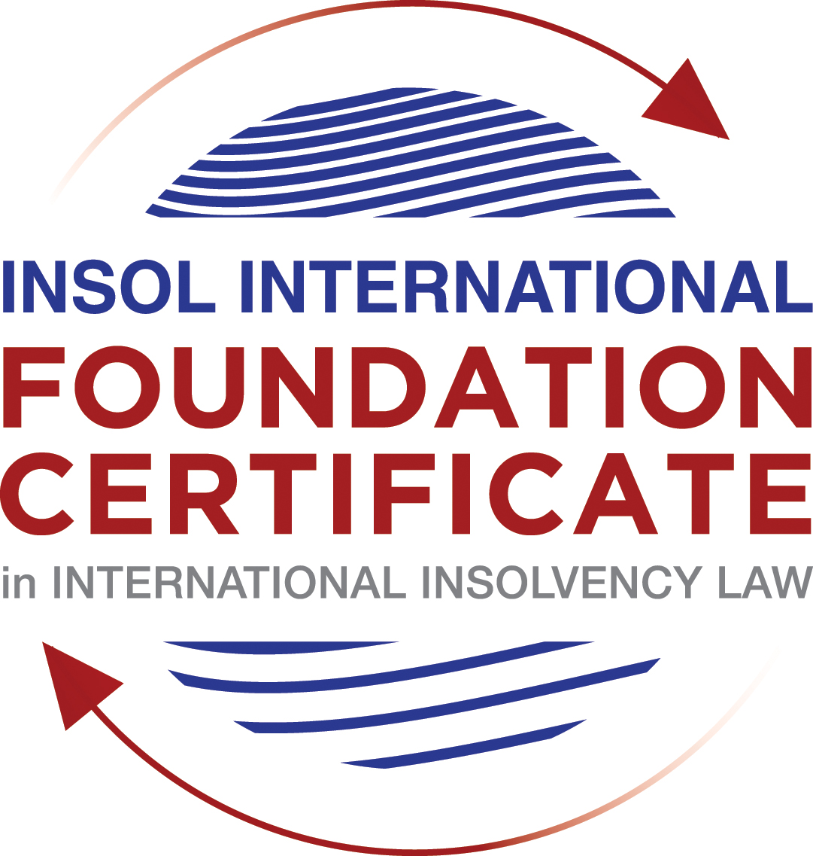

SUMMATIVE (FORMAL) ASSESSMENT: MODULE 3A

THE INSOLVENCY SYSTEM OF THE UNITED STATES

This is the summative (formal) assessment for Module 3A of this course and is compulsory for all candidates who selected this module as one of their compulsory modules from Module 3. Please read instruction 6.1 on the next page very carefully.

If you selected this module as one of your elective modules, please read instruction 6.2 on the next page very carefully.

The mark awarded for this assessment will determine your final mark for Module 3A. In order to pass this module, you need to obtain a mark of 50% or more for this assessment.

INSTRUCTIONS FOR COMPLETION AND SUBMISSION OF ASSESSMENT

Please read the following instructions very carefully before submitting / uploading your assessment on the Foundation Certificate web pages.

1. You must use this document for the answering of the assessment for this module. The answers to each question must be completed using this document with the answers populated under each question.

2. All assessments must be submitted electronically in MS Word format, using a standard A4 size page and a 11-point Arial font. This document has been set up with these parameters – please do not change the document settings in any way. DO NOT submit your assessment in PDF format as it will be returned to you unmarked.

3. No limit has been set for the length of your answers to the questions. However, please be guided by the mark allocation for each question. More often than not, one fact / statement will earn one mark (unless it is obvious from the question that this is not the case).

4. You must save this document using the following format: [student number.assessment3A]. An example would be something along the following lines: 202021IFU-314.assessment3A. Please also include the filename as a footer to each page of the assessment (this has been pre-populated for you, merely replace the words “studentnumber” with the student number allocated to you). Do not include your name or any other identifying words in your file name. Assessments that do not comply with this instruction will be returned to candidates unmarked.

5. Before you will be allowed to upload / submit your assessment via the portal on the Foundation Certificate web pages, you will be required to confirm / certify that you are the person who completed the assessment and that the work submitted is your own, original work. Please see the part of the Course Handbook that deals with plagiarism and dishonesty in the submission of assessments. Please note that copying and pasting from the Guidance Text into your answer is prohibited and constitutes plagiarism. You must write the answers to the questions in your own words.

6.1 If you selected Module 3A as one of your compulsory modules (see the e-mail that was sent to you when your place on the course was confirmed), the final time and date for the submission of this assessment is 23:00 (11 pm) GMT on 1 March 2021. The assessment submission portal will close at 23:00 (11 pm) GMT on 1 March 2021. No submissions can be made after the portal has closed and no further uploading of documents will be allowed, no matter the circumstances.

6.2 If you selected Module 3A as one of your elective modules (see the e-mail that was sent to you when your place on the course was confirmed), you have a choice as to when you may submit this assessment. You may either submit the assessment by 23:00 (11 pm) GMT on 1 March 2021 or by 23:00 (11 pm) BST on 31 July 2021. If you elect to submit by 1 March 2021, you may not submit the assessment again by 31 July 2021 (for example, in order to achieve a higher mark).

7. Prior to being populated with your answers, this assessment consists of 8 pages.

ANSWER ALL THE QUESTIONS

QUESTION 1 (multiple-choice questions) [10 marks in total]

Questions 1.1. – 1.10. are multiple-choice questions designed to assess your ability to think critically about the subject. Please read each question carefully before reading the answer options. Be aware that some questions may seem to have more than one right answer, but you are to look for the one that makes the most sense and is the most correct. When you have a clear idea of the question, find your answer and mark your selection on the answer sheet by highlighting the relevant paragraph in yellow. Select only ONE answer. Candidates who select more than one answer will receive no mark for that specific question.

Question 1.1

FabCo, based in Utah, owes SupplyCo, based in Mexico, US$10,000 on a past-due invoice. May SupplyCo file an involuntary petition to place FabCo into chapter 11 bankruptcy proceedings?

- Yes.

- Yes, if FabCo has fewer than 12 non-contingent, non-insider creditors.

- Yes, if other creditors owed at least US$5,775 join in the petition.

- No, because SupplyCo doesn’t know whether FabCo is insolvent.

- No, because SupplyCo is not a US company.

Question 1.2

Which of the following is a mandatory, rather than discretionary, basis to deny recognition of a foreign judgment under state law based on one of the Uniform Acts?

- The foreign judgment is subject to appeal in the foreign country.

- The foreign judgment is an injunction.

- The foreign judgment was issued by a court, contrary to the parties’ agreement to arbitrate.

- The defendant did not have sufficient notice of the foreign proceeding to put on a defense.

- The foreign judgment is inconsistent with another final judgment on the same subject matter.

Question 1.3

Which of the following is likely to be a party in interest in the bankruptcy of XYZ Corp?

- A shareholder in ABC Corp, to which XYZ Corp is substantially indebted.

- A journalist writing about XYZ Corp’s bankruptcy.

- A shareholder in MNO Corp, which owns all of XYZ Corp’s shares.

- A retired employee of XYZ Corp who receives payments from the company’s pension plan.

- A non-profit organization that advocates for companies like XYZ Corp to be held responsible for climate change.

Question 1.4

If a debtor rejects an executory trademark license agreement under which it licenses a trademark to its counterparty, which of the following is true:

- The counterparty must immediately stop using the trademark.

- The counterparty can continue using the trademark for the remaining period of the license.

- The counterparty has a claim for damages for breach of contract.

- Both (a) and (c).

- Both (b) and (c).

Question 1.5

In which of the following circumstances may a counterparty enforce a contractual ipso facto clause?

- The contract would obligate the counterparty to extend a loan to the debtor.

- The contract is a lease of real property.

- The clause is triggered by the bankruptcy filing of a third party, not the debtor.

- Both (a) and (c).

- Ipso facto clauses are never enforceable against a debtor.

Question 1.6

What does a chapter 11 debtor have exclusivity to propose for the first 120 days of proceedings?

- Avoidance actions.

- A plan of reorganization.

- DIP financing.

- Lifting the automatic stay.

- Formation of an equity committee.

Question 1.7

Which of the following is not a requirement to confirm a “cramdown” plan?

- Acceptance of the plan by all classes of secured creditors.

- Acceptance of the plan by at least one class of impaired, non-insider creditors.

- The plan is fair and equitable to dissenting classes of creditors.

- The plan does not discriminate unfairly against dissenting classes of creditors.

- The dissenting creditors receive no less than they would under a liquidation scenario.

Question 1.8

When may distributions to creditors diverge from the absolute priority rule?

- In a chapter 7 proceeding with consent of the affected senior creditor.

- In a chapter 7 proceeding with consent of the affected junior creditor.

- In a chapter 11 proceeding with consent of the affected senior creditor.

- In a chapter 11 proceeding with consent of the affected junior creditor.

- The absolute priority rule cannot be deviated from.

Question 1.9

Who may serve as a foreign representative to seek recognition of a foreign proceeding under chapter 15?

- An officer of the debtor if it is a debtor-in-possession in the foreign proceeding.

- The board of directors of the debtor if it is a debtor-in-possession in the foreign proceeding.

- An insolvency professional appointed by the court overseeing the foreign proceeding.

- An insolvency professional appointed by a creditor where the foreign proceeding is an involuntary receivership.

- All of the above.

Question 1.10

Which of the following is not available as relief in a chapter 15 proceeding?

- Sale of US property free and clear pursuant to section 363.

- Prosecution of avoidance actions pursuant to section 544 .

- Entrusting the management of US assets to the foreign representative.

- Application of the automatic stay under section 362 to the debtor’s interests in US property.

- Discovery about the debtor’s assets.

QUESTION 2 (direct questions) [10 marks]

Question 2.1 [maximum 1 mark]

What two alternative qualifications render a corporation eligible to be a debtor in a US chapter 7 or 11 proceeding?

[In order to qualify as debtor in either chapter 7 or 11 a corporation needs to have a place of business in the US or poses any assets in the US.]

Question 2.2 [maximum 2 marks]

What is an executory contract?

[An executory contract is one which upon commencement of insolvency proceedings, there are material unperformed obligations on the sides of both sides. For example if the debtor has entered a construction project with a company and upon commencement of insolvency proceedings, the roof is still to be fitted and the debtor still has an outstanding balance to pay for the construction works. ]

Question 2.3 [maximum 2 marks]

What is a “priming lien” and what requirements must be met for such a lien to be granted to secure DIP financing?

[Priming lien is a form of financing available to a DIP possession authorized by court when all other means of financing are impossible and it occupies a position equal to or at times senior to pre-petition liens.
Not only the other financing options must have been exhausted before turning to this option, the DIP must equally demonstrate that the interest of the secured creditor being primed is well protected.]

Question 2.4 [maximum 2 marks]

In voting on a plan of reorganization, which class(es) of creditors are (i) deemed to accept the plan, (ii) deemed to reject the plan and (iii) permitted to vote on the plan? What vote is necessary for a class of creditors to accept a plan?

[In voting a plan of reorganization, unimpaired creditors are deemed to accept the plan while the class that would receive nothing is deemed to reject the plan. The impaired class is permitted to vote on a reorganization plan and at least two-thirds of vote of creditors of a particular class is requisite.
]

Question 2.5 [maximum 3 marks]

How does the automatic stay available in chapter 15 proceedings differ from that available in chapter 11 proceedings?

[The difference lies in a number of factors:
First of all, the stay in chapter 11 is automatic and applies to creditor action the world over whereas the stay in chapter 15 applies only to creditor actions within the United States.
Secondly the petition for recognition of a foreign main proceeding needs to be recognized in the US before the stay can be granted.
The stay in chapter can equally be granted on an interim basis pending recognition or following recognition of a foreign non proceeding.]

QUESTION 3 (essay-type questions) [15 marks in total]

Question 3.1 [maximum 3 marks]

What fiduciary duties do directors of Delaware corporations owe and to whom are the duties owed in the ordinary course of business? To whom are duties owed when the corporation is potentially or actually insolvent?
[In ordinary course of business directors of Delaware corporations owe fiduciary duty of loyalty to the corporation’s best interest and the duty of educated decision making still to the corporation’s best interest. They are however protected by the business judgement rule meaning they are presumed to have acted in the corporation’s best interest unless it can be proven that they acted negligently.

Even in time of potential or actual bankruptcy, the directors owe duties the corporation and its shareholders and not to creditors. This uncertainty had been settled by the Supreme court in the case of Trenwick Am Litig Trust v Ernst & Young wherein it was stated that the law imposes no absolute obligation on the board of a company that is unable to pay its bills to cease operations and to liquidate.]

Question 3.2 [maximum 3 marks]

Describe the circumstances in which a bankruptcy court may enter a final order, who reviews appeals from bankruptcy court orders and how non-final orders are reviewed.

[Bankruptcy courts may enter final orders in core proceedings. This necessitates that at the outset of each motion, parties must decide if such is a core or non-core proceeding. There are however core proceedings wherein bankruptcy courts lack competence and for them to adjudicate on such proceedings, they must submit to this district courts for approval and recommendation. ]

Question 3.3 [maximum 4 marks]

Describe how claims for recovery of preferences, fraudulent conveyance and constructive fraudulent conveyance differ.

[A claim for recovery of preference is one made aimed at recovering debtor’s property that was transferred within the suspect period to a creditor in circumstances that warrant that creditor to benefit more than he would be entitled to in a normal chapter 7 proceeding. Usually, such claims aim at equalizing treatment of creditors within same pool and also to disincentivize the raise to acquire the distressed debtor’s property.
On the other hand, fraudulent conveyance and constructive fraudulent conveyance recoveries target transfers that were made two years before the insolvency petition if they were tagged with any irregularities.]

Question 3.4 [maximum 5 marks]

How does a US bankruptcy court determine whether a foreign proceeding is a main or non-main proceeding under chapter 15?

[Although COMI may be a concept foreign to US law, the elements used by US courts to determine jurisdiction, venue and relief are very much related to elements that constitute COMI. Basically, a debtor’s place of incorporation is his COMI even though this is a rebuttable presumption and the determination of COMI is very much based on objective evidence as to access by creditors and third parties to the supposed COMI. Normally any proceeding being carried out in the COMI is considered to be a main proceeding and that which is carried out where the creditor has only an establishment is a non-main proceeding. For an establishment to be considered, the debtor must be carrying out a non- transitory activity there and not just a destination spontaneously chosen on forum shopping basis. This explains why in the Bears Stearns case Cayman Island was held not to be the COMI of an Exempt company which was only registered there but carried out no business there.
]

QUESTION 4 (fact-based application-type question) [15 marks in total]

Question 4.1 [maximum 5 marks]

Rental Corporation is a publicly-traded company that leases office space from office building owners and sublets the space to small businesses. It has recently announced that it is being investigated by the US Department of Justice Fraud Division (DOJ) regarding allegedly fraudulent misstatements of revenues; shortly after the announcement, a securities class action litigation was filed against Rental Corporation in New York federal court. Due to the increase in the numbers of businesses operating remotely, Rental Corporation has suffered a decline in revenues. As a result, it has failed to pay rent on some of its office space leases and it has just defaulted on its quarterly payment on its credit facility. What would be the effect of a chapter 11 petition being filed by Rental Corporation on each of (i) the DOJ investigation, (ii) the securities class action litigation; (iii) the delinquent leases and (iv) the credit facility?

[The most attractive feature of the US insolvency proceeding is the automatic stay that ensues after petition. However, there are some exceptions to the application of this stay. Tax recovery proceedings may be stayed but not criminal actions in this case, the DOJ investigation would not be stayed since it is a criminal action against the debtor. The securities class action litigation will not be stayed since it falls under exceptions .Equally, eviction of debtor from non- residential property after expired leases is not protected by the stay. The credit facility would be available for priming liens.]

Question 4.2 [maximum 5 marks]

Considering the facts set forth in Question 4.1, what protections does the Bankruptcy Code provide to lessors of office space to Rental Corporation?

[The automatic stay can be lifted by the relief of stay motion that can be initiated by lessors of office space to Rental Corporation. This motion could be based on lack of adequate protection of the lessors’ interest in the estate of the debtor during insolvency proceedings as the rental premises may deteriorate in value during proceedings. The lessors can equally demonstrate that the debtor has no equity in its property and the property is not necessary in the reorganization process.]

Question 4.3 [maximum 5 marks]

Paint Corporation formulates house paint according to proprietary and patented recipes at its factory in the United States, which it sells to home improvement stores under a number of distribution contracts. The US Environmental Protection Agency is investigating whether Paint Corporation’s operations are causing harmful chemicals to contaminate a nearby river. Paint Corporation is concerned it cannot afford the clean-up that may be required and is seeking to sell its business. Home Corporation is interested in buying the business, but does not want the potentially contaminated property (it can manufacture paint at its own factory) and is concerned about obtaining consent from all the home improvement stores to assign the distribution contracts. How would a sale under section 363 of the Bankruptcy Code address these issues?

[The sale under section 363 would perfectly address the worries of Home Corporation. Being a sale under court supervision, it would be free and clear from any claims that may come up as a result of the contamination claim]

* End of Assessment *

