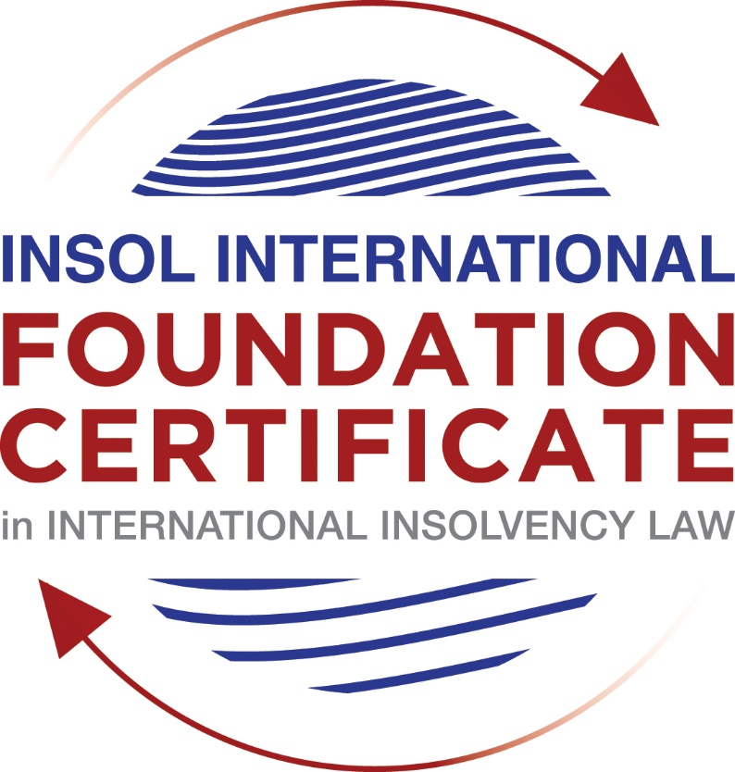

SUMMATIVE (FORMAL) ASSESSMENT: MODULE 1

(INTRODUCTION TO INTERNATIONAL INSOLVENCY LAW)

This is the summative (or formal) assessment for Module 1 of this course and is compulsory for all registered candidates on the Foundation Certificate. The mark awarded for this assessment will determine your final mark for Module 1. In order to pass this module you need to obtain a mark of 50% or more for this assessment.

INSTRUCTIONS FOR COMPLETION AND SUBMISSION OF ASSESSMENT

Please read the following instructions very carefully before submitting / uploading your assessment on the Foundation Certificate web pages.

1. You must use this document for the answering of the assessment for this module. The answers to each question must be completed using this document with the answers populated under each question.

2. All assessments must be submitted electronically in MS Word format, using a standard A4 size page and a 11-point Arial font. This document has been set up with these parameters – please do not change the document settings in any way. DO NOT submit your assessment in PDF format as it will be returned to you unmarked.

3. No limit has been set for the length of your answers to the questions. However, please be guided by the mark allocation for each question. More often than not, one fact / statement will earn one mark (unless it is obvious from the question that this is not the case).

4. You must save this document using the following format: [student number.assessment1summative]. An example would be something along the following lines: 202021IFU-314.assessment1summative. Please also include the filename as a footer to each page of the assessment (this has been pre-populated for you, merely replace the words “studentnumber” with the student number allocated to you). Do not include your name or any other identifying words in your file name. Assessments that do not comply with this instruction will be returned to candidates unmarked.

5. Before you will be allowed to upload / submit your assessment via the portal on the Foundation Certificate web pages, you will be required to confirm / certify that you are the person who completed the assessment and that the work submitted is your own, original work. Please see the part of the Course Handbook that deals with plagiarism and dishonesty in the submission of assessments. Please note that copying and pasting from the Guidance Text into your answer is prohibited and constitutes plagiarism. You must write the answers to the questions in your own words.

6. The final submission date for this assessment is 15 November 2020. The assessment submission portal will close at 23:00 (11 pm) GMT on 15 November 2020. No submissions can be made after the portal has closed and no further uploading of documents will be allowed, no matter the circumstances.

7. Prior to being populated with your answers, this assessment consists of 9 pages.

ANSWER ALL THE QUESTIONS

QUESTION 1 (multiple-choice questions) [10 marks in total]

Questions 1.1. – 1.10. are multiple-choice questions designed to assess your ability to think critically about the subject. Please read each question carefully before reading the answer options. Be aware that some questions may seem to have more than one right answer, but you are to look for the one that makes the most sense and is the most correct. When you have a clear idea of the question, find your answer and mark your selection on the answer sheet by highlighting the relevant paragraph in yellow. Select only ONE answer. Candidates who select more than one answer will receive no mark for that specific question.

Question 1.1

In early times insolvency law developed in England and was transplanted to continental Europe by means of the Lex Mercatoria.

- This statement is correct because continental Europe had no rules pertaining to debt collection and insolvency.

- The statement is correct because English Law played a significant role in the development of mercantile law in continental Europe.

- The statement is not correct because mercantile law, including insolvency law, developed in continental Europe based on principles of Roman and Germanic laws.

- The statement is not correct because the laws of the merchants in continental Europe were transplanted in England.

Question 1.2

The insolvency (bankruptcy) legislation of the USA and England are the same since they share the same layout and structures.

- The statement is not correct because although both systems have so called unified legislation, the US Bankruptcy Code of 1978 applies the same provisions to a large extent to both individual and corporate debtors, whereas the English Insolvency Act of 1986 contains quite separate provisions for individuals and companies.

- The statement is not correct because England has separate legislation for individual and corporate debtors.

- The statement is not correct because of the two systems, only the USA has unified or harmonised insolvency legislation.

- The statement is correct because the US legal system has adopted English law, including its insolvency legislation.

Question 1.3

The term “insolvency” differs from “bankruptcy” in that insolvency refers to cash flow (commercial insolvency) and bankruptcy to balance sheet insolvency (factual insolvency, that is, a situation where the debtor’s liabilities exceed its assets).

- The statement is correct because this is how these terms developed in both England as well as civil law countries.

- The statement is not correct because English law uses the term “bankruptcy” and the USA uses the term “insolvency” to describe the same factual situations concerning over-indebtedness.

- The statement is not correct because at some point in time “insolvency” used to describe the debt situation of the insolvent, either balance sheet or cash flow insolvency, whilst “bankruptcy” described the formal legal position of an insolvent debtor who is subject to a formal insolvency procedure; however, they are now used interchangeably.

- The statement is not correct because “bankruptcy” refers to the situation where a corporate debtor is liquidated or subject to a formal debt rehabilitation, whilst “insolvency” relates to individual debtors only.

Question 1.4

“International insolvency law” is a fixed and accepted term recognised by all the Member States of the United Nations (UN), since all such Member States have the same cross-border insolvency enforcement dispensations to deal with cross-border insolvency matters arising from other Member States.

- The statement is correct because all the UN Member States have adopted the UNCITRAL Model Law on Cross-Border Insolvency.

- The statement is correct because all the UN Member States follow English common law.

- The statement is correct because international insolvency law is applied private international law and all UN Member States have the same principles regulating private international law.

- The statement is incorrect because the term is largely used by commentators on cross-border insolvency law and it refers to a body of legal rules concerning certain insolvency procedures that cannot be fully enforced across borders because insolvency dispensations differ from Member State to Member State.

Question 1.5

Universalism and territorialism are two main approaches or theories followed by States in order to regulate their cross-border insolvency law dispensations. However, it is clear that universality is not yet fully embraced by all States and, at best, a kind of modified territorialism is followed by some States.

- The statement is correct because very few States allow insolvent estate representatives to deal with assets of a foreign debtor situated in their own jurisdiction without a prior local procedure to recognise the foreign insolvency proceeding.

- The statement is not correct because universality is the norm in the majority of States in cross-border insolvency matters.

- The statement is correct because there is no recognition of the universality approach in any State.

- The statement is not correct because important international policy-making bodies such as the International Monetary Fund (IMF), the World Bank Group and the United Nations have rejected the approach of territoriality.

Question 1.6

The domestic corporate insolvency laws of a country make no mention of the possibility of a foreign element in a liquidation that is commenced locally. There is also no locally applicable treaty or convention on insolvency proceedings.

In a local liquidation commenced in that country, to what other area of domestic law can the local court refer in order to resolve an international law issue that has arisen because of concurrent insolvency proceedings over the same debtor in a different country?

- UNCITRAL Legislative Guide on Insolvency Law.

- Private International Law.

- World Bank Principles for Effective Insolvency and Creditor Rights Systems.

- JIN Guidelines for Communication and Cooperation between Courts in Cross-Border Insolvency Matters.

Question 1.7

In international insolvency law, questions of jurisdiction are important (that is, whether a court can and will hear and determine a matter).

A company has been wound up in its place of incorporation, which is not in the United Kingdom. A creditor applies to an English court for a court order to wind up the foreign company in England.

Which of the following statements, concerning the facts surrounding such a winding-up application in England, is false?

- It is relevant whether the English court can exercise jurisdiction over one or more parties who have an interest in the distribution of the company’s assets.

- It is relevant whether the applicant creditor is reasonably likely to benefit if the English court makes the winding-up order.

- It is essential that the foreign company has assets in England.

- It is relevant whether the foreign company has a sufficient connection with England.

Question 1.8

Which of the following conventions or treaties may be described as adopting a comprehensive universalist approach to resolving international insolvency issues arising in concurrent insolvency proceedings in the member States?

- Montevideo Treaty on International Commercial Law (1889).

- Nordic Convention (1933).

- Montevideo Treaty on International Commercial Terrestrial Law (1940).

- Montevideo Treaty on International Procedural Law (1940).

Question 1.9

Which of the following does not address choice of law issues in its approach to addressing international insolvencies?

- UNCITRAL Model Law on Cross-Border Insolvency (1997).

- Section 426(5) Insolvency Act 1986 (UK).

- UNCITRAL Legislative Guide on Insolvency Law (2004).

- European Insolvency Regulation (EIR) Recast (2015).

Question 1.10

Which of the following statements best describes the international insolvency issues addressed by the UNCITRAL Model Law on Recognition and Enforcement of Insolvency-Related Judgments (2018)?

- “It permits recognition and enforcement of a detailed list of types of judgment that are defined as insolvency-related foreign judgments.”

- “It permits recognition and enforcement of a sui generis category of foreign insolvency orders or judgments that have otherwise only been recognised and enforced under the principle of comity.”

- “It permits recognition and enforcement of foreign judgments that arise as a consequence of or is materially associated with an insolvency proceeding, regardless of whether that insolvency proceeding has closed and that were issued on or after the commencement of that insolvency proceeding.”

- “It permits recognition and enforcement of all foreign insolvency judgments except those that commence a foreign insolvency proceeding.”

QUESTION 2 (direct questions) [10 marks]

Question 2.1 [maximum 3 marks]

Briefly discuss the various models that a State / jurisdiction may follow to base their cross-border insolvency laws on and / or to deal with cross-border issues in practice.

[Type your answer here]

Question 2.2 [maximum 3 marks]

A range of multilateral approaches have been developed in recent decades to address international insolvency issues. These initiatives have been undertaken by regional groupings of nation states or inter-governmental bodies and by multilateral commercial or professional bodies.

They have adopted a range of strategies including:

- uniform choice of law principles; and

- co-operation and co-ordination to promote recognition and enforcement.

Provide one example of each strategy listed in (a) and (b) above. In addition, briefly explain (in 1-2 sentences) why each initiative fits within its relevant category.

[Type your answer here]

Question 2.3 [maximum 4 marks]

In 1997, UNCITRAL adopted the Model Law on Cross-Border Insolvency (MLCBI) and encouraged its adoption by member States. In recent years, UNCITRAL has developed two more Model Laws relating to insolvency.

Describe the key issues that the latest two insolvency Model Laws address and how they complement the MLCBI.

[Type your answer here]

QUESTION 3 (essay-type questions) [15 marks in total]

Question 3.1 [maximum 5 marks]

It is said that it is currently difficult to develop a single cross-border insolvency dispensation and it seems that it will still take some time before a truly unified single cross-border insolvency dispensation will be introduced amongst the various jurisdictions of the world. You are required to write an essay on this aspect, explaining some of the difficulties involved in developing a single cross-border insolvency dispensation.

[Type your answer here]

Question 3.2 [maximum 5 marks]

UNCITRAL Working Group VI on Security Interests has developed a number of texts on secured transactions, such as the Legislative Guide on Secured Transactions (2007) and a Model Law on Secured Transactions (2016) applicable to movable assets. The Legislative Guide has a whole chapter (XII) on the impact of insolvency on a security right because insolvency law “is one field of law … where as a practical matter the regime of secured transactions deeply interacts with [insolvency law] and thus needs to be directly addressed in the Guide”.

When a collective insolvency proceeding has commenced, what is the significance of being a secured creditor with a secured claim (a security interest being a right in an asset to secure payment)?

What important issues can arise where the debtor has assets in a number of States and has granted security interests in those assets to creditors in those States?

[Type your answer here]

Question 3.3 [maximum 5 marks]

The UNCITRAL Model Law on Cross-Border Insolvency (1997) (MLCBI) contains provisions on co-operation and co-ordination in an international insolvency. Article 27 refers to the “[a]pproval or implementation by courts of agreements concerning the coordination of proceedings” as an example of co-operation under the MLCBI. One way in which this may occur is through the use of Protocols or Cross-Border Insolvency Agreements.

In the context of an international insolvency, how are Protocols or Cross-Border Insolvency Agreements developed and implemented? What guidelines have been developed by UNCITRAL and the Judicial Insolvency Network (JIN) for practitioners considering the use of such Protocols or Cross-Border Insolvency Agreements?

[Type your answer here]

QUESTION 4 (fact-based application-type question) [15 marks in total]

H Co Ltd (HCO) is a company incorporated with its head office and significant operations in Thule as well as being registered as a foreign company in Camelot, where it also carries on business. Lender Ltd (Lender) is incorporated and has its head office in Camelot. HCO has been expanding its business into Camelot more rapidly than its internal systems can handle at the same time as there is an unexpected downturn in this market. This has caused it to fall behind with payments to Lender. HCO’s CEO approaches Lender, which is actively considering its debt recovery options against HCO, to seek an informal workout arrangement. HCO is managing to meet its debts as they fall due in Thule; however, it is not trading well enough there to overcome the issues in Camelot.

If you require additional information to answer the questions that follow, briefly state what information it is you require and why it is relevant.

Question 4.1 [maximum 5 marks]

What key advantages and disadvantages should Lender consider regarding an informal out-of-court workout? What is the potential impact on these considerations that HCO is carrying on business in more than one State?

[Type your answer here]

Question 4.2 [maximum 5 marks]

In the scenario above, Thule has adopted the Model Law on Cross-Border Insolvency (MLCBI). In Camelot, where HCO has also been carrying on business as an unregistered foreign company, there are domestic insolvency laws; however, these laws do not address international aspects should they arise in an insolvency.

Lender obtains a liquidation order against HCO in Camelot. (Lender has only recently learned when initiating this litigation that HCO is in fact incorporated in Thule.) The Camelot liquidator learns that HCO has significant assets situated in Thule, as well as key directors residing there.

Advise the liquidator on the potential relevance that Thule has adopted the MLCBI for administering the Camelot insolvency proceeding. What key additional information is required to advise the liquidator on the relevance of the adoption of the MLCBI to any litigation in Thule and why?

[Type your answer here]

Question 4.3 [maximum 5 marks]

Assume that instead of the scenario above, HCO is the holding company of a group of companies (H group) operating a business enterprise. HCO and three group members are incorporated in one State; two group members are incorporated in second State; and two more group members are incorporated in a third State. HCO is subject to an insolvency proceeding in its State of incorporation; the group members in the second State are also insolvent; whereas the group members in the third State are solvent.

What difference does it make whether the domestic company laws of each State adopt an entity approach or enterprise approach to H group and the local members of H group?

What instrument and guidance texts have been developed by UNCITRAL to address the insolvency of an enterprise group?

[Type your answer here]

* End of Assessment *

