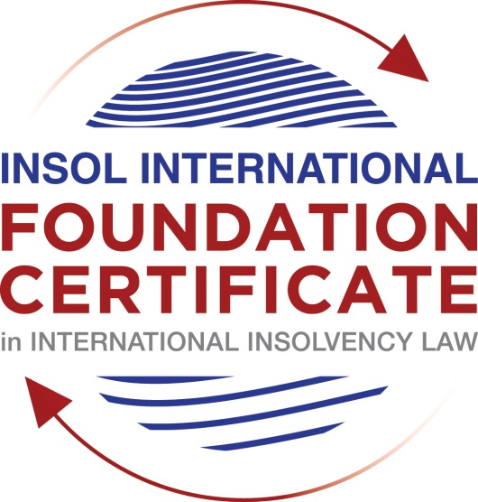

SUMMATIVE (FORMAL) ASSESSMENT: MODULE 7B

KENYA

This is the summative (formal) assessment for Module 7B of this course and must be submitted by all candidates who selected this module as one of their elective modules.

The mark awarded for this assessment will determine your final mark for Module 7B. In order to pass this module, you need to obtain a mark of 50% or more for this assessment.

INSTRUCTIONS FOR COMPLETION AND SUBMISSION OF ASSESSMENT

Please read the following instructions very carefully before submitting / uploading your assessment on the Foundation Certificate web pages.

1. You must use this document for the answering of the assessment for this module. The answers to each question must be completed using this document with the answers populated under each question.

2. All assessments must be submitted electronically in Microsoft Word format, using a standard A4 size page and an 11-point Arial font. This document has been set up with these parameters – please do not change the document settings in any way. DO NOT submit your assessment in PDF format as it will be returned to you unmarked.

3. No limit has been set for the length of your answers to the questions. However, please be guided by the mark allocation for each question. More often than not, one fact / statement will earn one mark (unless it is obvious from the question that this is not the case).

4. You must save this document using the following format: [studentnumber.assessment7B]. An example would be something along the following lines: 202021IFU-314.assessment7B. Please also include the filename as a footer to each page of the assessment (this has been pre-populated for you, merely replace the words “studentnumber” with the student number allocated to you). Do not include your name or any other identifying words in your file name. Assessments that do not comply with this instruction will be returned to candidates unmarked.

5. Before you will be allowed to upload / submit your assessment via the portal on the Foundation Certificate web pages, you will be required to confirm / certify that you are the person who completed the assessment and that the work submitted is your own, original work. Please see the part of the Course Handbook that deals with plagiarism and dishonesty in the submission of assessments. Please note that copying and pasting from the Guidance Text into your answer is prohibited and constitutes plagiarism. You must write the answers to the questions in your own words.

6. The final submission date for this assessment is 31 July 2021. The assessment submission portal will close at 23:00 (11 pm) BST (GMT +1) on 31 July 2021. No submissions can be made after the portal has closed and no further uploading of documents will be allowed, no matter the circumstances.

7. Prior to being populated with your answers, this assessment consists of 7 pages.

ANSWER ALL THE QUESTIONS

QUESTION 1 (multiple-choice questions) [10 marks in total]

Questions 1.1. – 1.10. are multiple-choice questions designed to assess your ability to think critically about the subject. Please read each question carefully before reading the answer options. Be aware that some questions may seem to have more than one right answer, but you are to look for the one that makes the most sense and is the most correct. When you have a clear idea of the question, find your answer and mark your selection on the answer sheet by highlighting the relevant paragraph in yellow. Select only ONE answer. Candidates who select more than one answer will receive no mark for that specific question.

Question 1.1

Which one of the following may not make an application for bankruptcy on an individual?

- A creditor.

- A combination of creditors.

- A supervisor of an individual voluntary arrangement.

- The debtor.

- The official receiver.

Question 1.2

Which of the following is not correct?

A bankruptcy trustee may not cancel a charge created by a bankrupt if:

- money was actually advanced or paid in good faith.

- the actual price or value of property sold or transferred was paid.

- there was any other valuable consideration given for the charge.

- the official receiver deems it fit to cancel the charge.

Question 1.3

When should the liquidator of a company convene a creditors’ meeting after appointment?

- Within 30 days.

- Within 28 days.

- Within 21 days.

- Within 14 days.

Question 1.4

Which of the following officeholders has no power to challenge a transaction at an undervalue under section 682 of the Insolvency Act?

- An administrator.

- A liquidator in a creditors’ voluntary liquidation.

- A liquidator in a compulsory liquidation.

- An administrative receiver.

Question 1.5

Which one of the following may not appoint or make an application for the appointment of an administrator?

- A creditor.

- The Official Receiver.

- Directors.

- A qualifying floating charge holder.

Question 1.6

Which one of the following powers / functions are not bestowed on an administrator?

- Power to sell charged assets.

- Power to borrow money.

- Power to hire or fire directors.

- Power to disclaim onerous contracts.

Question 1.7

Within how many days of the company entering into administration must the administrator hold an initial meeting of the company’s creditors?

- Within 14 days.

- Within 30 days.

- Within 60 days.

- Within 67 days.

Question 1.8

Within how many days is a supervisor of an individual voluntary arrangement (IVA) required to file his report on the IVA?

- Within 7 days.

- Within 14 days.

- Within 21 days.

- Within 28 days.

Question 1.9

Which of the following may not make a proposal for a company voluntary arrangement (CVA)?

- Creditors.

- Directors.

- Liquidator (where the company is in liquidation).

- Administrator (where the company is in administration).

Question 1.10

Which of the following oversees a company voluntary arrangement:

- A director.

- Official Receiver.

- Receiver.

- Liquidator.

- Supervisor.

QUESTION 2 (direct questions) [10 marks]

Question 2.1 [maximum 2 marks]

What are the options available to a secured creditor in the event of bankruptcy under the Insolvency Act?

[Type your answer here]

Question 2.2 [maximum 4 marks]

What are the grounds for the automatic discharge of a bankrupt? Does the automatic discharge have exceptions? If so, what are these exceptions?

[Type your answer here]

Question 2.3 [maximum 4 marks]

What are the objectives of the administration procedure under the Insolvency Act?

[Type your answer here]

QUESTION 3 (essay-type questions) [15 marks in total]

PLEASE SELECT ONLY ONE OF THE FOLLOWING QUESTIONS BELOW. PLEASE DELETE THE QUESTIONS YOU CHOOSE NOT TO ANSWER.

Question 3.1 [maximum 15 marks]

Discuss the process of voluntary and involuntary liquidation in a winding up.

[Type your answer here]

OR

Question 3.2 [maximum 15 marks]

Discuss the process of administration under section 534 of the Insolvency Act.

[Type your answer here]

OR

Question 3.3 [maximum 15 marks]

Fully discuss the priority of creditors under the Insolvency Act.

[Type your answer here]

QUESTION 4 (fact-based application-type question) [15 marks in total]

PLEASE SELECT ONLY ONE OF THE FOLLOWING QUESTIONS BELOW. PLEASE DELETE THE QUESTIONS YOU CHOOSE NOT TO ANSWER.

Question 4.1 [maximum 15 marks]

You have been approached by the directors of Eat it All Limited (EAL) to advise on their options in light of the company’s recent financial problems. The directors disclose the following to you:
- The company has not been doing well for the past three (3) years and the directors knew the company was insolvent;

- The company has outstanding loans owed to certain creditors. 20% of these loans are secured while 80% are unsecured;

- The company recently dismissed three of its directors for the misappropriation of funds;

- One of the company’s assets was sold to one of the main shareholder’s spouse at a value lower than market price;

- During the last nine months the company sold some assets to pay certain creditors who had threatened to sue them;

- As a result of its insolvency, the company was in the process of transferring (but this has not yet been completed) one of its most valuable assets to an SPV owned by its parent company;

- The directors have provided you with an independent business review report by a top audit firm that shows the company is viable and can return to profitability if certain structural changes are adopted. The directors inform you that they have shared this report with the company’s main creditors who are owed 80% of its total debts and who have shown their willingness to discuss any proposals from the company. The remaining creditors were unwilling to engage the directors.

The directors have asked you to advise them on the best course of action for the company and the various options available to them.

[Type your answer here]

OR

Question 4.2 [maximum 15 marks]

You have been approached by Mr X who claims to be a representative of UFO Limited, a foreign company registered in Kenya. Mr X claims that UFO Limited is being liquidated in its home jurisdiction and that an order directing that the company be wound up has been issued in its home jurisdiction. Mr X claims that UFO Limited has sufficient assets to pay its creditors in Kenya. Mr X requests that you advise him on how to proceed with the realisation of UFO Limited’s assets in Kenya.

[Type your answer here]

* End of Assessment *

