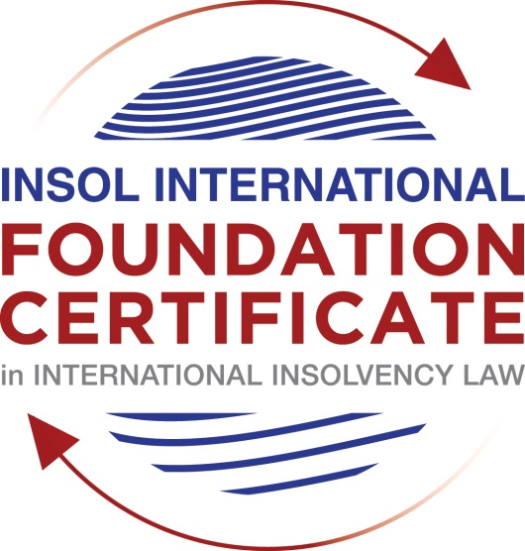

SUMMATIVE (FORMAL) ASSESSMENT: MODULE 6B

GERMANY

This is the summative (formal) assessment for Module 6B on this course and must be submitted by all candidates who selected this module as one of their elective modules.

The mark awarded for this assessment will determine your final mark for Module 6B. In order to pass this module, you need to obtain a mark of 50% or more for this assessment.

INSTRUCTIONS FOR COMPLETION AND SUBMISSION OF ASSESSMENT

Please read the following instructions very carefully before submitting / uploading your assessment on the Foundation Certificate web pages.

1. You must use this document for the answering of the assessment for this module. The answers to each question must be completed using this document with the answers populated under each question.

2. All assessments must be submitted electronically in Microsoft Word format, using a standard A4 size page and an 11-point Arial font. This document has been set up with these parameters – please do not change the document settings in any way. DO NOT submit your assessment in PDF format as it will be returned to you unmarked.

3. No limit has been set for the length of your answers to the questions. However, please be guided by the mark allocation for each question. More often than not, one fact / statement will earn one mark (unless it is obvious from the question that this is not the case).

4. You must save this document using the following format: [studentnumber.assessment5D]. An example would be something along the following lines: 202021IFU-314.assessment5D. Please also include the filename as a footer to each page of the assessment (this has been pre-populated for you, merely replace the words “studentnumber” with the student number allocated to you). Do not include your name or any other identifying words in your file name. Assessments that do not comply with this instruction will be returned to candidates unmarked.

5. Before you will be allowed to upload / submit your assessment via the portal on the Foundation Certificate web pages, you will be required to confirm / certify that you are the person who completed the assessment and that the work submitted is your own, original work. Please see the part of the Course Handbook that deals with plagiarism and dishonesty in the submission of assessments. Please note that copying and pasting from the Guidance Text into your answer is prohibited and constitutes plagiarism. You must write the answers to the questions in your own words.

6. The final submission date for this assessment is 31 July 2021. The assessment submission portal will close at 23:00 (11 pm) GMT on 31 July 2021. No submissions can be made after the portal has closed and no further uploading of documents will be allowed, no matter the circumstances.

7. Prior to being populated with your answers, this assessment consists of 6 pages.

ANSWER ALL THE QUESTIONS

QUESTION 1 (multiple-choice questions) [10 marks in total]

Questions 1.1. – 1.10. are multiple-choice questions designed to assess your ability to think critically about the subject. Please read each question carefully before reading the answer options. Be aware that some questions may seem to have more than one right answer, but you are to look for the one that makes the most sense and is the most correct. When you have a clear idea of the question, find your answer and mark your selection on the answer sheet by highlighting the relevant paragraph in yellow. Select only ONE answer. Candidates who select more than one answer will receive no mark for that specific question.

Question 1.1

How are the competences of a preliminary insolvency practitioner defined?

- By the debtor.

- By the creditors’ committee.

- By statute.

- By court decision.

Question 1.2

Which of the following securities has an accessory nature?

- Suretyship.

- Transfer of title by way of security.

- Mortgage (Grundschuld).

- Retention of tile.

Question 1.3

Creditors who wish to participate in the insolvency proceedings must file their claims with

- The creditors’ committee.

- The creditors’ meeting.

- The insolvency practitioner.

- The court.

Question 1.4

Who has the duty to file for insolvency proceedings?

- The directors of a Limited Liability Company (GmbH).

- All debtors.

- Legal persons only.

- Entrepreneurs only.

Question 1.5

Wage claims of employees stemming from the period prior to the opening of insolvency proceedings

- Enjoy super-priority even ahead of secured creditors.

- Qualify as expenses of the proceedings (liabilities of the estate).

- Rank as claims of ordinary creditors.

- Cannot be recognized in insolvency proceedings at all.

Question 1.6

Who of the following is entitled to submit an insolvency (restructuring) plan?

- Every creditor.

- The debtor.

- The court.

- The creditors’ committee.

Question 1.7

Which of the following circumstances is not relevant for the local jurisdiction of an insolvency court (Amtsgericht)?

- Registered office.

- Location of assets.

- Place of residence.

- Centre of economic activities.

Question 1.8

The rights of which group cannot be affected by an insolvency plan?

- Employees.

- Shareholders.

- Banks.

- Creditors with a right to separation.

Question 1.9

How long is the compliance period (time frame) for discharge of residual debt?

- Seven years.

- Six years.

- Three years.

- One year.

Question 1.10

How are foreign insolvency proceedings recognised in Germany?

- By decision of the court.

- By the insolvency practitioner.

- By statute (by force of law).

- By a decision of the creditors’ meeting.

QUESTION 2 (direct questions) [10 marks]

Question 2.1 [maximum 3 marks]

Which rules regulate cross-border insolvency law in Germany (only list the norms)?

[Type your answer here]

Question 2.2 [maximum 4 marks]

Explain the principle of publication in German law on security rights: which security rights are made public (and how) and which are not?

[Type your answer here]

Question 2.3 [maximum 3 marks]

What is and what happens at a “verification meeting” (Prüfungstermin)?

[Type your answer here]

QUESTION 3 (essay-type questions) [15 marks in total]

Explain the rules in German insolvency law relating to executory contracts.

[Type your answer here]

QUESTION 4 (fact-based application-type question) [15 marks in total]

In January 2018, Bank (B) has granted debtor (D) a loan of EUR 50,000. Since B asked for security, D has transferred legal title over a lorry by way of security and has assigned all current and future receivables against her customers by way of security. Sixteen (16) months later, in May 2019, D is unable to pay her debts when they fall due. On 3 July 2019, B, being aware of D’s substantive insolvency, terminates the loan contract and sells the lorry for EUR 20,000 to W. On 5 July 2019, B reveals the assignment to all customers of B and receives EUR 15,000 from X, who bought goods from D on 1 July 2019 and who pays B the money he owes to D. On 1 August 2019, D applies for insolvency proceedings. B receives another payment of EUR 10,000 from Y who bought goods from D on 10 September 2019. Five days later, the court opens insolvency proceedings and appoints I as insolvency administrator. I maintains B’s business and sells goods to Z for EUR 5,000. Z is a regular customer of B, knows about the assignment and pays EUR 5,000 upon delivery to B. I claims EUR 50,000 from B, arguing that the sale of the lorry and the payments of X, Y and Z are subject to transaction avoidance (§§129 et seq InsO).

What are the various legal positions? Test this based on the norms.

[Type your answer here]

* End of Assessment *

