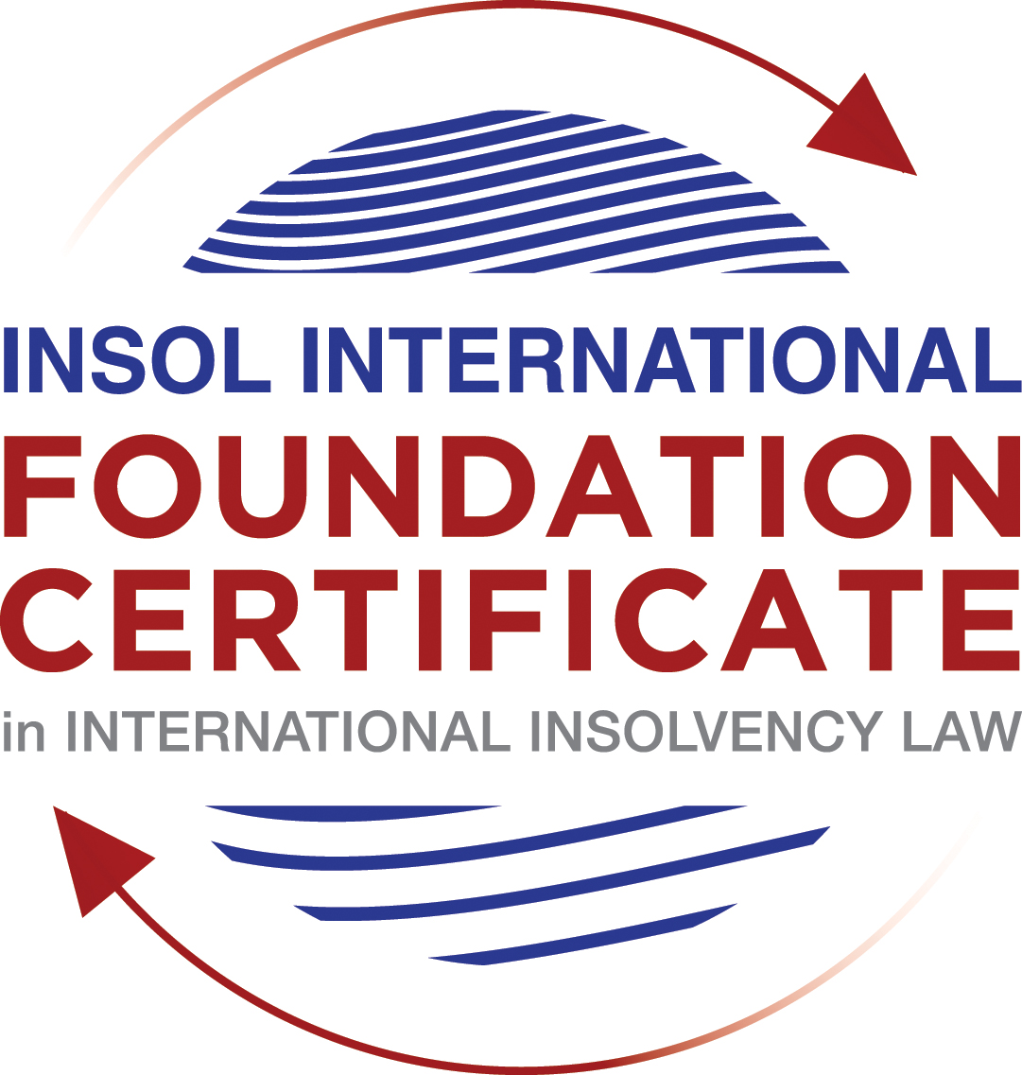

SUMMATIVE (FORMAL) ASSESSMENT: MODULE 5A

BERMUDA

This is the summative (formal) assessment for Module 5A of this course and is compulsory for all candidates who selected this module as one of their elective modules.

The mark awarded for this assessment will determine your final mark for Module 5A. In order to pass this module, you need to obtain a mark of 50% or more for this assessment.

INSTRUCTIONS FOR COMPLETION AND SUBMISSION OF ASSESSMENT

Please read the following instructions very carefully before submitting / uploading your assessment on the Foundation Certificate web pages.

1. You must use this document for the answering of the assessment for this module. The answers to each question must be completed using this document with the answers populated under each question.

2. All assessments must be submitted electronically in Microsoft Word format, using a standard A4 size page and an 11-point Arial font. This document has been set up with these parameters – please do not change the document settings in any way. DO NOT submit your assessment in PDF format as it will be returned to you unmarked.

3. No limit has been set for the length of your answers to the questions. However, please be guided by the mark allocation for each question. More often than not, one fact / statement will earn one mark (unless it is obvious from the question that this is not the case).

4. You must save this document using the following format: [studentnumber.assessment5A]. An example would be something along the following lines: 202021IFU-314.assessment5A. Please also include the filename as a footer to each page of the assessment (this has been pre-populated for you, merely replace the words “studentnumber” with the student number allocated to you). Do not include your name or any other identifying words in your file name. Assessments that do not comply with this instruction will be returned to candidates unmarked.

5. Before you will be allowed to upload / submit your assessment via the portal on the Foundation Certificate web pages, you will be required to confirm / certify that you are the person who completed the assessment and that the work submitted is your own, original work. Please see the part of the Course Handbook that deals with plagiarism and dishonesty in the submission of assessments. Please note that copying and pasting from the Guidance Text into your answer is prohibited and constitutes plagiarism. You must write the answers to the questions in your own words.

6. The final submission date for this assessment is 31 July 2021. The assessment submission portal will close at 23:00 (11 pm) GMT on 31 July 2021. No submissions can be made after the portal has closed and no further uploading of documents will be allowed, no matter the circumstances.

7. Prior to being populated with your answers, this assessment consists of 7 pages.

ANSWER ALL THE QUESTIONS

QUESTION 1 (multiple-choice questions) [10 marks in total]

Questions 1.1. – 1.10. are multiple-choice questions designed to assess your ability to think critically about the subject. Please read each question carefully before reading the answer options. Be aware that some questions may seem to have more than one right answer, but you are to look for the one that makes the most sense and is the most correct. When you have a clear idea of the question, find your answer and mark your selection on the answer sheet by highlighting the relevant paragraph in yellow. Select only ONE answer. Candidates who select more than one answer will receive no mark for that specific question.

Question 1.1

When is a Bermuda company deemed to be unable to pay its debts under section 161 and section 162 of the Companies Act 1981?

- Only when it is balance sheet insolvent.

- Only when it is cash flow insolvent.

- When it is balance sheet insolvent and cash flow insolvent.

- When it is either balance sheet insolvent, or cash flow insolvent, or a valid statutory demand has not been satisfied within a period of three weeks after service on the company’s registered office, or if a judgment in favour of a creditor remains unsatisfied.

Question 1.2

Who may appoint a Provisional Liquidator over a Bermuda company?

- A secured creditor.

- An unsecured creditor.

- The company itself (whether acting by its directors or its shareholders).

- The Supreme Court of Bermuda.

Question 1.3

In what order are the following paid in a compulsory liquidation under Bermuda law?

a) Preferential creditors; b) unsecured creditors; c) costs and expenses of the liquidation procedure; d) floating charge holders.

- a, b, c, d

- c, d, a, b

- c, a, d, b

- a, c, d, b

Question 1.4

What percentage of unsecured creditors must vote in favour of a creditors’ Scheme of Arrangement for it to be approved?

- Over 50% in value.

- 50% or more in value.

- Over 75% in value.

- A majority of each class of creditors present and voting, representing 75% or more in value.

Question 1.5

What is the clawback period for fraudulent preferences under section 237 of the Companies Act 1981?

- Two (2) years.

- One (1) month.

- Twelve (12) months.

- Six (6) months.

Question 1.6

What types of transactions are reviewable in the event of an insolvent liquidation?

- Only fraudulent conveyances.

- Only floating charges.

- Only post-petition dispositions.

- All of the above.

Question 1.7

How many insurance policyholders are required to present a petition for the winding up of an insolvent insurance company under section 34 of the Insurance Act 1978?

- At least five (5).

- One (1) is sufficient.

- At least 10 or more owning policies of an aggregate value of not less than BMD 50,000.

- At least 10.

Question 1.8

Where do secured creditors rank in a liquidation?

- Behind unsecured creditors.

- Behind preferential creditors.

- Behind the costs and expenses of liquidation.

- In priority to all other creditors, since they can enforce their security outside of the liquidation.

Question 1.9

Summary proceedings against a company’s directors for breach of duty (or misfeasance) may be brought by a liquidator under which provision of the Companies Act?

- Section 237 of the Companies Act 1981.

- Section 238 of the Companies Act 1981.

- Section 247 of the Companies Act 1981.

- Section 158 of the Companies Act 1981.

Question 1.10

What is a segregated account representative of an insolvent Segregated Accounts Company required to do under section 10 of the Segregated Accounts Companies Act 2000?

- Resign immediately.

- File a Suspicious Transaction Report forthwith.

- Make a written report to the Registrar of Companies within 30 days of reaching the view that there is a reasonable likelihood of a segregated account or the general account becoming insolvent.

- Notify the directors, creditors and account owners within 28 days.

QUESTION 2 (direct questions) [10 marks]

Question 2.1 [maximum 4 marks]

In what circumstances may be a Provisional Liquidator be appointed?

[Type your answer here]

Question 2.2 [maximum 2 marks]

When can rights of set-off be exercised after the commencement of a liquidation of a Bermuda company?

[Type your answer here]

Question 2.3 [maximum 4 marks]

Describe three possible ways of taking security over assets under Bermuda law?

[Type your answer here]

QUESTION 3 (essay-type questions) [15 marks in total]

Question 3.1 [maximum 8 marks]

Write a brief essay on the basis upon which foreign liquidators are granted recognition and assistance in Bermuda.

[Type your answer here]

Question 3.2 [maximum 7 marks]

Write a brief essay on the circumstances in which a foreign Court judgment will not be registered or enforced in Bermuda.

[Type your answer here]

QUESTION 4 (fact-based application-type question) [15 marks in total]

ELBOW LIMITED (“the Company”) was incorporated in 2019 as an exempt Bermuda company, with offices and a substantial business presence in Hong Kong. The Company was formed with the intention of investing in illiquid assets in the form of litigation funding loans and distressed debt in Asian markets.

Having funded a hopeless court case in Hong Kong against VICTORY LIMITED, a costs order was made by the Hong Kong Court against ELBOW LIMITED in favour of VICTORY LIMITED in the sum of USD 2 million, payable in full within 14 days.

At the due date for payment of the costs order to VICTORY LIMITED, ELBOW LIMITED’s assets were fully invested and its investments, although illiquid, were valued in the aggregate sum of USD 10 million.

The Company’s directors decided that it was in the best interests of ELBOW LIMITED and its shareholders not to satisfy the Hong Kong Court judgment and not to liquidate any of its assets to cash given the risk that an urgent “fire-sale” would completely destroy the value of those assets.

The Company’s directors subsequently borrowed an additional USD 5 million from its bank, LENDBANK, secured by way of a floating charge against all of its illiquid assets. Out of the USD 5 million received from LENDBANK, ELBOW LIMITED’s directors immediately paid themselves a bonus payment of USD 2 million and they also paid a dividend to the Company’s shareholders in the sum of USD 3 million.

VICTORY LIMITED only found out about these transactions two weeks later, through a report received from a disgruntled former employee of ELBOW LIMITED.

Using the facts above, answer the questions that follow.

Question 4.1 [maximum 7 marks]

What actions could VICTORY LIMITED take to try to recover its cost order against ELBOW LIMITED? Please consider (a) the jurisdictions in which it could take such action, bearing in mind the potential need for enforcement; (b) the defendants against whom it could take such action; (c) the pros and cons of litigation as opposed to insolvency proceedings; and (d) the causes of action that may be available against the various potential defendants.

[Type your answer here]

Question 4.2 [maximum 8 marks]

To what extent would it be open to ELBOW LIMITED to try to take steps to restructure its debt obligations? How and where would it do so? Please consider whether it would be more appropriate to take steps before the Hong Kong courts, the Bermuda courts, or both and, if so, why?

[Type your answer here]

* End of Assessment *

