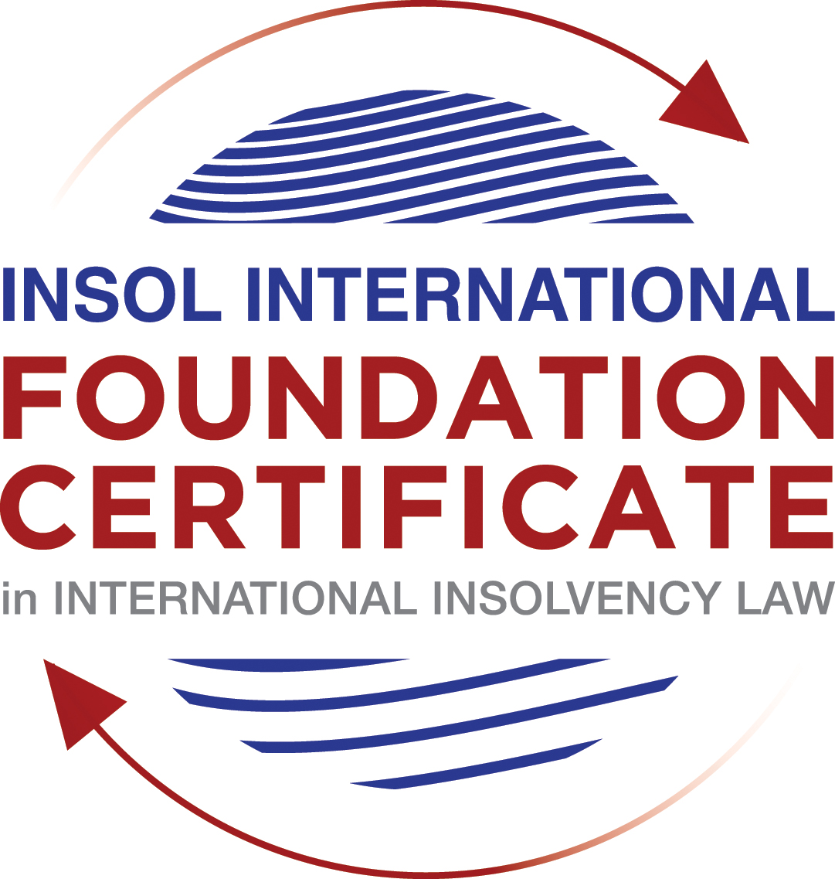

SUMMATIVE (FORMAL) ASSESSMENT: MODULE 2A

THE UNCITRAL MODEL LAW ON CROSS-BORDER INSOLVENCY

This is the summative (formal) assessment for Module 2A of this course and is compulsory for all candidates who selected this module as one of their compulsory modules from Module 2. Please read instruction 6.1 on the next page very carefully.

If you selected this module as one of your elective modules, please read instruction 6.2 on the next page very carefully.

The mark awarded for this assessment will determine your final mark for Module 2A. In order to pass this module, you need to obtain a mark of 50% or more for this assessment.

INSTRUCTIONS FOR COMPLETION AND SUBMISSION OF ASSESSMENT

Please read the following instructions very carefully before submitting / uploading your assessment on the Foundation Certificate web pages. Once you have submitted your assessment, you may not substitute your uploaded assessment for another. If you do, only the earliest submitted assessment will be marked.

1. You must use this document for the answering of the assessment for this module. The answers to each question must be completed using this document with the answers populated under each question (where this must be done is indicated under each question).

2. All assessments must be submitted electronically in MS Word format, using a standard A4 size page and a 11-point Arial font. This document has been set up with these parameters – please do not change the document settings in any way. DO NOT submit your assessment in PDF format as it will be returned to you unmarked.

3. No limit has been set for the length of your answers to each question. More often than not, one fact / statement will earn one mark, but it is also possible that half marks are awarded (this should be clear from the context of the question, or in the context of the answer).

4. You must save this document using the following format: [student number.assessment2A.docx]. An example would be as follows 201920IFU-0108.assessment2A.docx. Please also include the filename as a footer to each page of the assessment (this has been pre-populated for you, merely replace the words “student number” with the student number allocated to you). Do not include your name or any other identifying words in your file name. Assessments that do not comply with this instruction will be returned to candidates unmarked.

5. Before you will be allowed to upload / submit your assessment via the portal on the Foundation Certificate web pages, you will be required to confirm / certify that you are the person who completed the assessment and that the work submitted is your own, original work. Please see paragraph 7 of the Course Handbook, specifically the information on pages 15 and 16, which deals with plagiarism and dishonesty in the submission of assessments.

6.1 If you selected Module 2A as one of your compulsory modules (see the e-mail that was sent to you shortly after the commencement of the course), the final time and date for the submission of this assessment is 23:00 (11 pm) GMT on 1 March 2020. The assessment submission portal will close at 23:00 (11 pm) GMT on 1 March 2020. No submissions can be made after the portal has closed and no further uploading of documents will be allowed, no matter the circumstances.

6.2 If you selected Module 2A as one of your elective modules (see the e-mail that was sent to you shortly after the commencement of the course), you have a choice as to when you may submit this assessment. You may either submit the assessment by 23:00 (11 pm) GMT on 1 March 2020 or by 23:00 (11 pm) BST on 31 July 2020. If you elect to submit by 1 March 2020, you may not submit the assessment again by 31 July 2020 (for example, in order to achieve a higher mark).

7. Prior to being populated with your answers, this assessment consists of 9 pages.

ANSWER ALL THE QUESTIONS

QUESTION 1 (multiple-choice questions) [10 marks in total]

Questions 1.1. – 1.10. are multiple-choice questions designed to assess your ability to think critically about the subject. Please read each question carefully before reading the answer options. Be aware that some questions may seem to have more than one right answer, but you are to look for the one that makes the most sense and is the most correct. When you have a clear idea of the question, find your answer and mark your selection on the answer sheet by highlighting the relevant paragraph in yellow. Select only ONE answer. Candidates who select more than one answer will receive no mark for that specific question.

Question 1.1

Which of the following statements most accurately reflects the main purpose of the Model Law?

- The Model Law provides effective mechanisms for dealing with cases of cross-border insolvency so as to promote a number of objectives, including the protection and maximisation of trade and investment.
- The Model Law provides effective mechanisms for dealing with cases of cross-border insolvency – it promotes a uniform approach to cross-border insolvency and aims to provide a procedural framework for co-operation between jurisdictions.
- The Model Law is a substantive unification of insolvency law so as to promote co-operation between courts of the enacting State and foreign States and facilitation of the rescue of financially troubled businesses.
- The Model Law provides effective mechanisms for dealing with cases of cross-border insolvency so as to promote a number of objectives, including the fair and efficient administration of cross-border insolvencies that protect the interests of all creditors and other interested persons, but not including the debtor.

Question 1.2

Which of the following statements is unlikely to be a reason for the development of the Model Law?

- The “universal effect” of the insolvency laws and rules of State A in the jurisdiction of State B.
- The difficulty of agreeing multilateral treaties dealing with insolvency law.
- The practical problems caused by the disharmony among national laws governing cross-border insolvencies, despite the success of the use of protocols in practice.
- The existence of a statutory basis in national (insolvency) laws for co-operation and co-ordination of domestic courts with foreign courts or foreign representatives.

Question 1.3

Which of the following challenges to a recognition application under the Model Law is most likely to be successful?

- The registered office of the debtor is not in the jurisdiction where the foreign proceedings were opened.
- The foreign proceedings do not have a close equivalent in the jurisdiction of the enacting State where recognition is requested.
- There are already domestic insolvency proceedings opened in the enacting State in respect of the debtor of the foreign proceedings.
- The foreign representative is tasked with primarily looking after the interests of secured creditors.

Question 1.4

Which of the following statements best illustrates the so-called “safe conduct rule”?

- The foreign representative has standing in the courts of the enacting State without the need to meet any formal requirements such as a licence or consular action.
- Foreign creditors are entitled to individual notification of, inter alia, the commencement of local proceedings in respect of the debtor under the insolvency law of the enacting State, and of the time-limit to file claims in those proceedings.
- The enacting State does not assume jurisdiction over all the assets of the debtor on the sole ground that the foreign representative has made an application for the recognition of a foreign proceeding.
- Foreign creditors have the same rights as creditors domiciled in the enacting State in respect of the commencement of (and participation in) local proceedings regarding the debtor under the insolvency law of the enacting State.

Question 1.5

For a debtor with its COMI in the UK and an establishment in Brazil, foreign main proceedings are opened in the UK and foreign non-main proceedings are opened in Brazil. Both the UK foreign representative and the Brazilian foreign representative have applied for recognition before the relevant court in South Africa. Please note that the UK has implemented the Model Law, Brazil has not implemented the Model Law and South Africa has implemented the Model Law subject to the so-called principle of reciprocity (based on country designation). In this scenario, which of the following statements is the most correct one?

- The foreign main proceedings in the UK will be recognised in South Africa, but the foreign non-main proceedings in Brazil will not, because Brazil has not implemented the Model Law.
- Both the foreign main proceedings in the UK and the foreign non-main proceedings in Brazil will be recognised in South Africa because the debtor’s COMI is in the UK and the debtor has an establishment in Brazil, while the Model Law does not contain a principle of reciprocity.
- Neither the foreign main proceedings in the UK nor the foreign non-main proceedings in Brazil will be recognised as a result of the principle of reciprocity adopted in South Africa.
- None of the statements in a, b or c are correct.

Question 1.6

Which of the following statements regarding concurrent proceedings under the Model Law is false?

- No interim relief based on Article 19 of the Model Law is available if concurrent domestic insolvency proceedings and foreign proceedings exist at the time of the application of the foreign proceedings in the enacting State.
- In the case of a foreign main proceeding, no automatic relief under Article 20 of the Model Law applies if concurrent domestic insolvency proceedings and foreign proceedings exist at the time of the application of the foreign proceedings in the enacting State.
- The commencement of domestic insolvency proceedings does not prevent or terminate the recognition of a foreign proceeding.
- If only after recognition of the foreign proceedings concurrent domestic insolvency proceedings are opened, then any post-recognition relief granted and based on Article 21 of the Model Law, shall be either adjusted or terminated if inconsistent with the domestic insolvency proceedings.

Question 1.7

When using its discretionary power to grant post-recognition relief pursuant to Article 21 of the Model Law, what should the court in the enacting State primarily consider?

- The court must strike an appropriate balance between the relief that may be granted and the persons that may be affected thereby.
- The court should consider whether the relief requested is necessary for the protection of the assets of the debtor or the interests of the creditors.
- The court should consider both a) and b).
- Neither a) nor b) should be considered by the court.

Question 1.8

Which of the statements below regarding the Centre of Main Interest (COMI) and the Model Law is correct?

- COMI is not a defined term in the Model Law.
- For a corporate debtor, the Model Law does contain a rebuttable presumption that the debtor’s registered office is its COMI.
- While – for purposes of the Model Law - the COMI can move, the closer in time such COMI shift is to the commencement of foreign proceedings, the harder it will be to establish that the move was “ascertainable by third parties”.
- All of the above.

Question 1.9

Which of the following types of relief have been declared beyond the limits of the Model Law?

- Enforcement of insolvency-related judgments.
- The indefinite continuation of a moratorium.
- Both a) and b).
- Neither a) nor b).

Question 1.10

When for the interpretation of the Model Law “its original origin” is to be considered (in accordance with article 8 of the Model Law), which of the following texts is likely to be of the least relevance?

- The UNCITRAL Guide to Enactment.
- The UNCITRAL Legislative Guide on Insolvency Law – Parts One, Two, Three and Four.
- The Practice Guide.
- The Judicial Perspective.

QUESTION 2 (direct questions) [10 marks in total]

Question 2.1 [maximum 4 marks]

The chosen format of the Model Law is that of a model law that each State can decide on its own to adopt, in whole or in part, in its own legislation. Please provide two (2) advantages and two (2) disadvantages of this chosen format.

[Type your answer here]

Question 2.2 [maximum 2 marks]

The following two (2) statements relate to particular provisions / concepts to be found in the Model Law. Indicate the name of two of these provisions / concepts, as well as the relevant article(s) of the Model Law, addressed in each statement.

Statement 1: “This Article imposes a duty on the court when it applies certain other articles of the Model Law that [….] the interests of the creditors and other interested persons [….] are adequately protected.”

Statement 2: “This Article provides a non-exhaustive list […] of appropriate means by which one of the key four concepts of the Model Law can be implemented.”

[Type your answer here]

Question 2.3 [2 marks]

Explain what is meant by the so-called “hotchpot rule” and mention in which Article of the Model Law it is captured.

[Type your answer here]

Question 2.4 [2 marks]

Where more than one foreign insolvency proceeding has been opened against the same debtor, but not a domestic insolvency proceeding in the enacting State, there is an information duty on the foreign representative and a co-operation duty on the court in the enacting State. List the two (2) most relevant Articles in the Model Law that deal with these duties and briefly explain each duty.

[Type your answer here]

QUESTION 3 (essay-type questions) [15 marks in total]

The foreign representative of a foreign proceeding opened in respect of a corporate debtor in State B is considering whether or not to make a recognition application under the Model Law adopted and implemented in State A. The foreign representative is also considering what (if any) relief may be appropriate to request from the court in State A.

Write brief essays under each of the following three questions:
Question 3.1 [3 marks]

What access rights are immediately available to the foreign representative in State A before he makes a recognition application? Why might these rights be beneficial to the foreign representative?

[Type your answer here]

Question 3.2 [maximum 6 marks]

Summarise the three key considerations the foreign representative must weigh before he makes a decision to file for a recognition application and what are the three key considerations by the court in State A before it makes a decision on the recognition application?

[Type your answer here]

Question 3.3 [maximum 6 marks]

Summarise the three key considerations the foreign representative must weigh before he makes a decision to file for a relief application and what are the three key considerations by the court in State A before it makes a decision on the relief application?

[Type your answer here]

QUESTION 4 (fact-based application-type question) [15 marks in total]

Columbia Global Shipping (CGS) is a shipping company incorporated under the laws of Columbia. It has long-term English law governed shipping contracts with a company in Singapore (S) and a company in South Korea (SK). Each of these contracts contains a so-called ipso facto clause, allowing early termination of the contract upon one of the parties entering into insolvency proceedings. CGS has so-called “representative offices” in Argentina, Peru and Brazil, but these offices are mainly “letter boxes” and there are no employees stationed in these countries.

CGS does have a “proper” US office in Texas, where 20 employees work. Everything in the representative offices is done remotely from either the headquarters in Columbia or from the US office in Texas. While most of CGS’s assets are located in Columbia, CGS also has assets in the US and the UK. CGS further has bank accounts with local banks in the US, the UK, Argentina, Peru and Brazil, but its global operations are primarily financed by a number of bilateral loans in US dollars (USD) by a small number of local Columbian banks, with whom CGS has a very close relationship. The total amount of CGS’s bank debt is USD 50 million. In addition, CGS recently managed – through the savvy assistance of a well-connected Swiss banker – to issue private placement notes (PPNs) for a total amount of USD 10 million to three sophisticated Swiss private investors. The Swiss investors insisted that the PPNs be governed by English law.

Please Note:

For the purposes of this question it must be accepted that Columbia, Singapore, South Korea, the US and the UK have adopted and implemented the Model Law without any relevant modifications and that Argentina, Brazil and Peru HAVE NOT adopted the Model Law.

Question 4.1 [maximum 3 marks]

When CGS is informed that SK has filed for local insolvency proceedings in South Korea, CGS wishes to exercise its contractual right to terminate its shipping contract with SK early. However, the Korean liquidator explains that under Korean insolvency law ipso facto clauses are considered null and void. In addition, as the agreement is governed by English law, the Korean liquidator decides to apply before the relevant English court, under the Model Law as implemented in the UK, for recognition of the Korean insolvency proceedings as foreign main proceedings, and for appropriate relief so as to avoid an early termination by CGS of its shipping contract with SK.

How do you think the appropriate relief application by the Korean liquidator will be addressed by the English court, assuming that the Korean insolvency proceedings will be recognised as foreign main proceedings?

[Type your answer here]

Question 4.2

When the general financial distress in the shipping sector globally also starts to affect CGS, it decides to open domestic insolvency proceedings in Columbia in which it was able to reach a restructuring agreement with all its creditors, except for the three Swiss holders of the PPNs who decided to completely refrain from participating at all in the Columbian insolvency proceedings of CGS. Since the restructuring agreement in Columbia meets the required thresholds of creditor support it is – according to Columbian (insolvency) law – binding on all the creditors of CGS, including the non-participating Swiss PPN holders.

The reason the Swiss PPN holders have not participated in the Columbian insolvency proceedings of CGS is because they would like to enforce their rights against CGS under English law and obtain full repayment of their claims under the PPNs instead of any amounts they would receive in terms of the compromise reached under the Columbian restructuring agreement of CGS. They are hopeful that the so-called “Gibbs Rule” under English law will help them in this respect.

Please Note:

The “Gibbs rule” is derived from an English case of 1890 and stands for the proposition that a debt governed by English law cannot be discharged or compromised by a foreign insolvency proceeding. Discharge of a debt under the insolvency law of a foreign country is only treated as a discharge therefrom in England if it is a discharge under the law applicable to the contract.

In view of these additional facts, please address the following questions:

Question 4.2.1 [maximum 4 marks]

What (if anything) can the Columbian liquidator do to avoid a situation where the assets of CSG outside of Columbia are available to the Swiss PPN holders?

[Type your answer here]

Question 4.2.2 [maximum 4 marks]

What do you expect the considerations of an English court to be if the Columbian liquidator decides to request such appropriate relief under the Model Law as implemented in the UK which, in effect, prevents the Swiss PPN holders from enforcing their English law claims against CGS under the PPNs?

[Type your answer here]

Question 4.2.3 [maximum 4 marks]

Assuming CGS is able to open domestic insolvency proceedings in the US and Brazil, discuss whether it is likely that a Columbian court would recognise the US and Brazilian foreign proceedings respectively under the Model law as implemented in Columbia?

[Type your answer here]

* End of Assessment *

