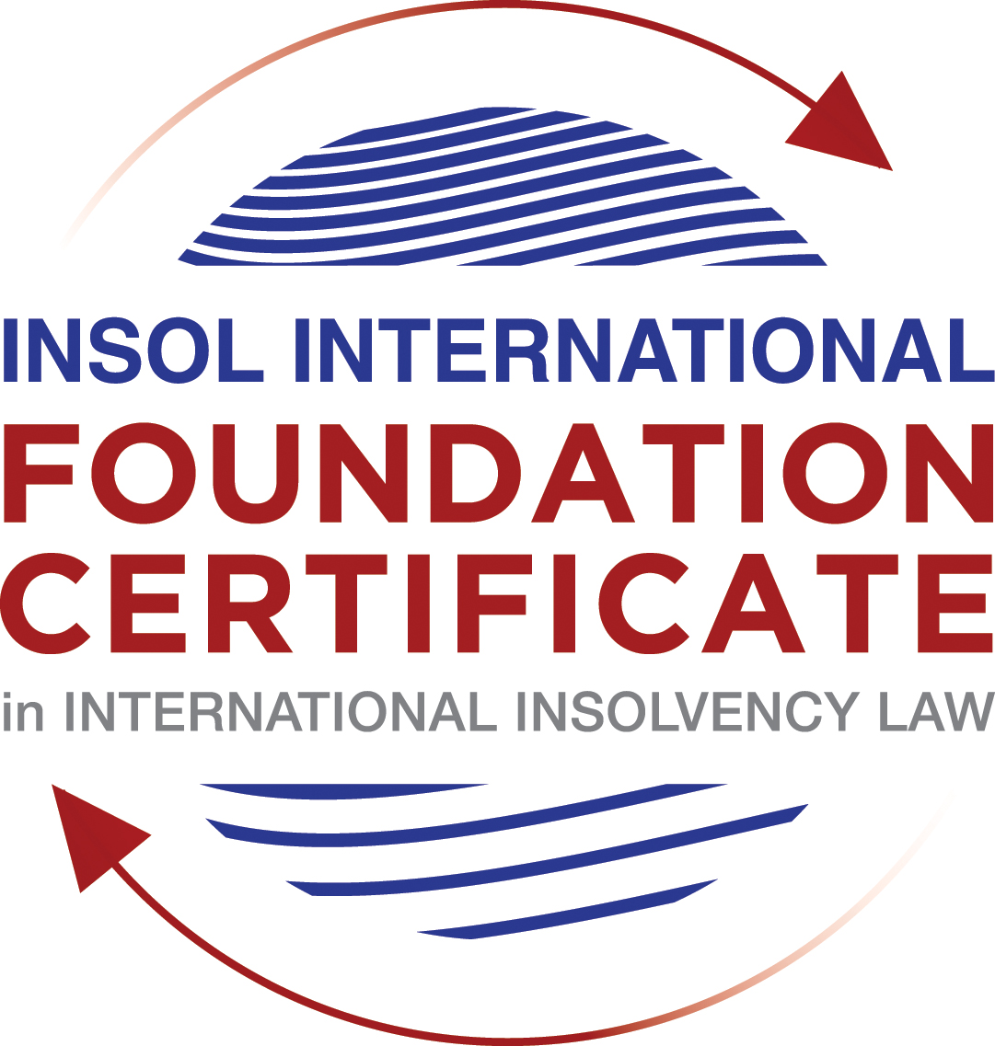

SUMMATIVE (FORMAL) ASSESSMENT: MODULE 1

(INTRODUCTION TO INTERNATIONAL INSOLVENCY LAW)

This is the summative (or formal) assessment for Module 1 of this course and is compulsory for all registered candidates on the Foundation Certificate. The mark awarded for this assessment will determine your final mark for Module 1. In order to pass this module you need to obtain a mark of 50% or more for this assessment.

INSTRUCTIONS FOR COMPLETION AND SUBMISSION OF ASSESSMENT

Please read the following instructions very carefully before submitting / uploading your assessment on the Foundation Certificate web pages. Once you have submitted your assessment, the system will not allow you to substitute your uploaded assessment for another.

1. You must use this document for the answering of the assessment for this module. The answers to each question must be completed using this document with the answers populated under each question.

2. All assessments must be submitted electronically in MS Word format, using a standard A4 size page and a 11-point Arial font. This document has been set up with these parameters – please do not change the document settings in any way. DO NOT submit your assessment in PDF format as it will be returned to you unmarked.

3. No limit has been set for the length of your answers to each question. However, please be guided by the mark allocation for each question. More often than not, one fact / statement will earn one mark (unless it is obvious from the question that this is not the case).

4. You must save this document using the following format: [student number.assessment1summative.docx]. An example would be something along the following lines: 201920IFU-0108.assessment1summative.docx. Please also include the filename as a footer to each page of the assessment (this has been pre-populated for you, merely replace the words “student number” with the student number allocated to you). Do not include your name or any other identifying words in your file name. Assessments that do not comply with this instruction will be returned to candidates unmarked.

5. Before you will be allowed to upload / submit your assessment via the portal on the Foundation Certificate web pages, you will be required to confirm / certify that you are the person who completed the assessment and that the work submitted is your own, original work. Please see paragraph 7 of the Course Handbook, specifically the information on pages 15 and 16, which deals with plagiarism and dishonesty in the submission of assessments.

6. The final submission date for this assessment is 15 November 2019. The assessment submission portal will close at 23:00 (11 pm) BST on 15 November 2019. No submissions can be made after the portal has closed and no further uploading of documents will be allowed, no matter the circumstances.

7. Prior to being populated with your answers, this assessment consists of 8 pages.

ANSWER ALL THE QUESTIONS

QUESTION 1 (multiple-choice questions) [10 marks in total]

Questions 1.1. – 1.10. are multiple-choice questions designed to assess your ability to think critically about the subject. Please read each question carefully before reading the answer options. Be aware that some questions may seem to have more than one right answer, but you are to look for the one that makes the most sense and is the most correct. When you have a clear idea of the question, find your answer and mark your selection on the answer sheet by highlighting the relevant paragraph in yellow. Select only ONE answer. Candidates who select more than one answer will receive no mark for that specific question.

Question 1.1

Civil Law and English (Common) Law countries have the same historical roots.

- This statement is untrue because English Insolvency Law developed from Roman law principles, and Civil Law Systems were based on the statute of Marlborough of 1267.
- This statement is untrue since Civil Law developed from early Roman law principles relating to debt recovery and English Insolvency Law developed via legislation, especially from the 16th century onwards.
- This statement is true since, on a principle basis, the developments of insolvency law as a system is the same in all systems.
- The statement is true since both systems developed from a pro-debtor approach towards the notion of over-indebtedness.

Question 1.2

Both Civil Law and English Law systems allowed for a generally liberal discharge of debt for over-indebted debtors right from the inception of these systems.

- This statement is untrue since in both systems the notion of a discharge only developed at a later stage.
- This statement is true since in both systems insolvency and rehabilitation procedures developed with a discharge as a way of departure.
- This statement is untrue since a discharge of debt never became part of any of these systems.
- This statement is true since creditors in both systems had an accommodating approach towards over-indebted debtors.

Question 1.3

England and the USA each have a single unified piece of insolvency legislation that applies to both personal and corporate insolvency.

- This statement is true - England has the unified 1986 Insolvency Act and the USA has the 1978 Bankruptcy Code. Both Acts cover personal and corporate insolvency.
- This statement is untrue - in England the Insolvency Act 1986 deals only with personal insolvency.
- This statement is untrue - the USA has separate Acts dealing with corporate liquidation and rescue.
- The statement is true - in England the companies’ legislation deals with corporate insolvency and rescue.
Question 1.4

All insolvency systems in the world are based on the pari passu distribution principle. This principle entails that all creditors are treated equally in insolvency matters.

- This statement is untrue - all systems draw a distinction between various classes of creditors and therefore treat them differently according to their status as creditors.
- This statement is untrue - some systems do not acknowledge this principle at all.
- This statement is true - this is the point of departure of insolvency systems.
- This statement is untrue - some systems do not even allow for equal treatment within the same categories of creditors.

Question 1.5

All countries have the same set of rules that apply for the recognition of a foreign insolvency order.

- The statement is untrue since all systems differ and some countries have no formal rules in place at all.
- This statement is true because all member states of the UN have adopted the UNCITRAL Model Law on Cross-Border Insolvency.
- This statement is true because the UNCITRAL Model Law on Cross-Border Insolvency applies directly to all UN member States.
- This statement is true since the International Court of Justice has a set of global cross-border insolvency principles that apply globally.

Question 1.6

The domestic corporate insolvency laws of a country make no mention of the possibility of a foreign element in a liquidation commenced locally. There is also no locally applicable treaty or convention on insolvency proceedings.

In a local liquidation commenced in that country, to what other area of domestic law can the local court refer in order to resolve an international law issue that has arisen because of concurrent insolvency proceedings over the same debtor in a different country?

- Public International Law.
- UNCITRAL Legislative Guide on Insolvency Law.
- World Bank Principles for Effective Insolvency and Creditor Rights Systems.
- Private International Law.

Question 1.7

Private international law raises questions of the conclusive effect of a foreign judgment and the enforcement of a foreign judgment. A foreign court has issued a judgment in a foreign insolvency which has a connection with England. The foreign insolvency officeholder seeks recognition and enforcement in an English court of a foreign order made in the foreign insolvency proceedings.

Which of the following statements, concerning the facts surrounding such a request for recognition and enforcement in England, is false?
- It is relevant whether the foreign order had commenced the foreign insolvency proceedings.
- It is relevant whether the foreign country has adopted the UNCITRAL Model Law on Cross-Border Insolvency 1997.
- It is relevant whether the foreign order was made during the course of the foreign insolvency proceedings.
- It is relevant whether the foreign country is a member of the EU that has adopted the European Insolvency Regulation (Recast) 2015.

Question 1.8

Which of the following Latin and Middle American conventions or treaties may be described as more “universalist” because it allows an insolvency proceeding over a debtor, which has a civil or commercial domicile in only one treaty State, to be given universal effect by the other treaty States?

- Havana Convention on Private International Law (1928).
- Montevideo Treaty on International Commercial Law (1889).
- Montevideo Treaty on International Commercial Terrestrial Law (1940).
- Montevideo Treaty on International Procedural Law (1940).

Question 1.9

Which of the following multilateral developments does not address choice of law issues in their approach to addressing international insolvencies?

- ALI / III Report on Transnational Insolvency: Global Principles for Cooperation in International Insolvency Cases (2012).
- UNCITRAL Model Law on Cross-Border Insolvency (1997).
- UNCITRAL Legislative Guide on Insolvency Law (2004).
- European Insolvency Regulation (EIR) Recast (2015).

Question 1.10

Which of the following statements best describes the international insolvency issues addressed by the UNCITRAL Model Law on Recognition and Enforcement of Insolvency-Related Judgments (2018)?

- “It permits recognition and enforcement of all foreign insolvency judgments except those that commence a foreign insolvency proceeding.”
- “It permits recognition and enforcement of foreign judgments that arise as a consequence of or is materially associated with an insolvency proceeding, regardless of whether that insolvency proceeding has closed and that were issued on or after the commencement of that insolvency proceeding.”
- “It permits recognition and enforcement of a detailed list of types of judgment that are defined as insolvency-related foreign judgments.”
- “It permits recognition and enforcement of a sui generis category of foreign insolvency orders or judgments that have otherwise only been recognised and enforced under the principle of comity.”

QUESTION 2 (direct questions) [10 marks]

Question 2.1 [maximum 3 marks]

Briefly discuss the main insolvency procedures available in Roman law.

[Type your answer here]

Question 2.2 [maximum 4 marks]

The range of multilateral approaches seeking to regulate international insolvencies are sometimes categorised into groups as either “hard law” that binds or “soft law” that influences.

Based on this, provide two examples of each category. In addition, explain briefly (in 1-3 sentences) why each fit within that category.

[Type your answer here]

Question 2.3 [maximum 3 marks]

When bodies develop approaches to regulate international insolvencies, they typically provide for a stay or moratorium, either as automatic or discretionary relief, upon recognition of a foreign insolvency proceeding.

Why is a stay or moratorium such a key provision for multi-State collective insolvency proceedings? Refer to the interests of debtors and creditors in your response.

[Type your answer here]

QUESTION 3 (essay-type questions) [15 marks in total]

Question 3.1 [maximum 5 marks]

Discuss the roots of the notion of voidable dispositions in Civil Law and English law jurisdictions and indicate the importance of this aspect for insolvency law.

[Type your answer here]

Question 3.2 [maximum 5 marks]

Describe the approach taken by the JIN Guidelines to resolving cross-border insolvency issues. If an insolvency court is considering adopting the JIN Guidelines, is there any advantage if the relevant jurisdiction has already enacted the UNCITRAL Model Law on Cross-border Insolvency?

[Type your answer here]

Question 3.3 [maximum 5 marks]

If a country has already adopted the UNCITRAL Model Law on Cross-Border Insolvency (1997), what are the advantages in also adopting the UNCITRAL Model Law on Recognition and Enforcement of Insolvency-Related Judgments (2018) and the UNCITRAL Model Law on Enterprise Group Insolvency (2019)?

[Type your answer here]

QUESTION 4 (fact-based application-type question) [15 marks in total]

Super Duper Pty Ltd (“Super”) is a company incorporated with its head office and significant operations in Atlantis as well as being registered as a foreign company in Dystopia, where it also carries on business. LargeCo Lender Ltd (“LargeCo”) is incorporated and has its head office in Dystopia. Super has been expanding its business into Dystopia more rapidly than its internal systems can handle at the same time as there is an unexpected downturn in this market. This has caused it to fall behind with payments to LargeCo. Super’s CEO approaches LargeCo, which is actively considering its debt recovery options against Super, to seek an informal workout arrangement. Super is managing to meet its debts as they fall due in Atlantis; however, it is not trading well enough there to overcome the issues in Dystopia.

If you require additional information to answer the questions that follow, briefly state what information it is you require and why it is relevant.

Question 4.1 [maximum 5 marks]

What key advantages and disadvantages should LargeCo consider regarding an informal out-of-court workout? What is the potential impact on these considerations that Super is carrying on business in more than one State?

[Type your answer here]

Question 4.2 [maximum 5 marks]

Assume that instead of the scenario above, LargeCo obtains an order against Super for a formal court-supervised insolvency proceeding in Dystopia. The Dystopian insolvency representative then learns of a concurrent insolvency proceeding commenced against Super in Atlantis a day earlier. Describe four international insolvency instruments that have been developed to assist liquidators who are appointed in concurrent plenary insolvency proceedings to maximise the returns for creditors.

[Type your answer here]

Question 4.3 [maximum 5 marks]

Assume that instead of the hypothetical States mentioned above, Super is registered in a member State of the European Union and carries on business in another Member State. The European Insolvency Regulation (Recast) applies in both States. Advise the liquidators appointed in Super’s place of incorporation on the potential relevance of the European Insolvency Regulation (Recast) for the realisation of Super’s assets and the effect on Super’s creditors because of Super’s connection with two member States.

[Type your answer here]

* End of Assessment *

