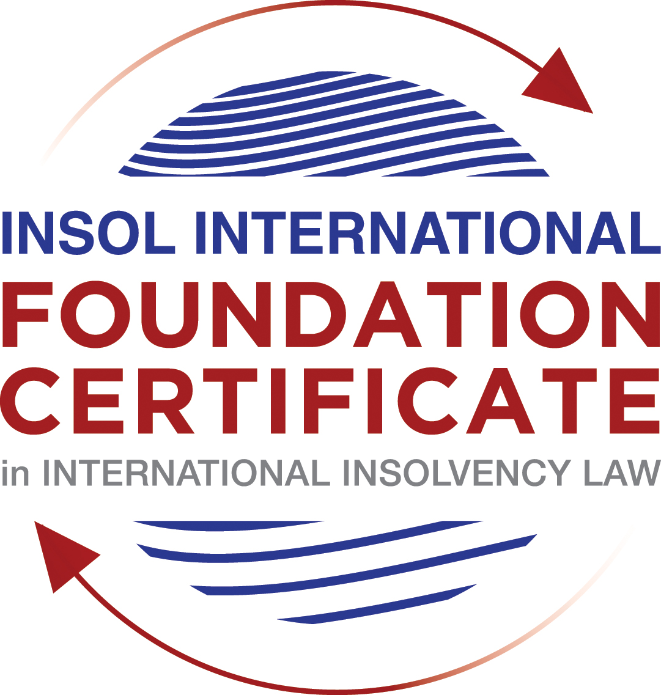

FORMATIVE ASSESSMENT: MODULE 1

(INTRODUCTION TO INTERNATIONAL INSOLVENCY LAW)

PROPOSED MODEL ANSWERS

The model answers for the formative assessment relating to Module 1 are provided in this document. Apart from the answers to the multiple choice questions, bear in mind that the answers provided below are indicative of how you should have answered the assessments and do not necessarily purport to be the only correct answers to the questions posed.

Question 1 (multiple-choice questions) [10 marks]

Question 1.1

It should be relatively easy to develop a single system to deal with cross-border insolvency since all jurisdictions have more or less the same local insolvency law rules.

- Incorrect: All countries have not implemented the UNCITRAL Model Law on Cross-Border Insolvency.

- Correct: This statement is indeed untrue since there are huge differences in both the approach and insolvency legislation of various jurisdictions.

- Incorrect: All systems do not have the same general insolvency concepts.

- Incorrect: The historical roots of all insolvency systems are not the same.

Question 1.2

The Statute of Ann, 1705 was a very important piece of legislation for the development of English insolvency law.

- Incorrect: This Act did not introduce imprisonment of debt.
- Incorrect: The Act did not deal with distributions of the proceeds derived from the proceeds of selling the assets of the estate.
- Correct: This Act did introduce the notion of discharge.
- Incorrect: This Act did not introduce fraudulent conveyances into English Law.

Question 1.3

The purpose of the UNCITRAL Legislative Guide (2004) has direct application in all the member States of the UN.

- Incorrect: UNCITRAL’s model legislative guidelines do not apply automatically to member States.
- Incorrect: All UN member States did not support its automatic implementation in their respective jurisdictions.
- Correct: The Legislative Guide does serve as soft law and contains best practice to be considered when countries revise their own insolvency legislation.
- Incorrect: The Legislative Guide is available for use by any countries as a reference point when reforming their own insolvency laws.

Question 1.4

Modern rescue proceedings have replaced liquidation as an insolvency procedure in most systems.

- Incorrect: Business rescue is important for socio-economic reasons but did not replace liquidation as an insolvency procedure in most systems.
- Incorrect: Liquidation is still used as an insolvency procedure and is essential to deal with businesses that cannot be rescued.
- Correct: There is still a need for both liquidation and rescue procedures in insolvency systems.
- Incorrect: All modern systems have at least a liquidation procedure.
Question 1.5

The principles and requirements for avoidable dispositions and executory contracts are the same in all jurisdictions – hence these do not pose problems in a cross-border insolvency matter.

- Correct: The requirements and principles do differ and pose problems in a cross-border case.
- Incorrect: The insolvency laws of the State where the original insolvency order is issued will not necessarily apply to all the other States involved in the matter.
- Incorrect: Avoidable dispositions and executory contracts do pose problems in a cross-border case since the requirements differ.
- Incorrect: Avoidable dispositions and executory contracts may not be disregarded in a cross-border case.

Question 1.6

To what law can the local court refer in order to resolve the specific international law issue?

- Correct: An insolvency treaty between the domestic state and foreign state has been ratified as part of the domestic law.
- Incorrect: Not a domestic law – it is a multilaterally developed instrument as a resource to influence domestic insolvency law reform.
- Incorrect: Not a law – it is a multilaterally developed instrument as a resource to influence domestic insolvency law reform.
- Incorrect: when an insolvency raises an issue connected with another legal system, it brings private international law (or conflicts of law) into play. In this case the ratified treaty will affect its relevance.

Question 1.7

Which one of the following documents mandates cooperation or communication between courts in concurrent insolvency proceedings on the same debtor, which are being conducted in different nation states?

- Incorrect: ALI / III Global Guideline 3: A court may communicate with another court in connection with matters relating to proceedings before it for the purposes of coordinating and harmonizing proceedings before it with those in another jurisdiction.
- Incorrect: EU Court-to-Court Communications Guideline 3: A court may communicate with another court in connection with matters relating to proceedings before it for the purposes of coordinating and harmonising proceedings before it with those in the other jurisdiction.
- Correct: UNCITRAL Model Law on CBI Article 25.1 “In matters referred to in article 1, the court shall cooperate to the maximum extent possible with foreign courts or foreign representatives
- Incorrect: JIN Guideline 1: … the courts should encourage administrators in Parallel Proceedings to cooperate in all aspects of the case, including the necessity of notifying the courts at the earliest practicable opportunity of issues present and potential that may (a) affect those proceedings; and (b) benefit from communication and coordination between the courts. Guideline 7: A court may receive communications from a foreign court and may respond directly to them.

Question 1.8

Which of the following conventions and treaties does not provide for judicial cooperation where there are surplus funds remaining in a proceeding in one treaty state and there are concurrent insolvency proceedings over the same debtor in another treaty state?

- Incorrect: Montevideo Treaty on International Commercial Law (1889) Title X On Bankruptcies Article 41 When there is a case for plurality of bankruptcies, in accordance with the provisions of this title, unclaimed funds after the payment of dividend will remain to the order of the court of the other bankruptcy. There will be judicial co-operation to this end.
- Incorrect: Montevideo Treaty on International Commercial Terrestrial Law (1940) Title VIII - On Bankruptcies Article 47 [similar to 1889 Article 41] .
- Incorrect: Montevideo Treaty on International Procedural Law (1940) Title IV – Creditors Meetings Article 21 also provides for a surplus in one estate where there are concurrent proceedings.
- Correct: INSOL Module 1 notes state where there are concurrent proceedings, the Havana Convention does not provide procedures for co-operation or co-ordination of any concurrent proceeding and footnotes the treaty texts. (Also footnotes Ian F Fletcher, Insolvency in Private International Law (2005, 2nd ed. Oxford University Press) at [5.23] and Appendix V.

Question 1.9

Which of the following aspects of international insolvency is not addressed in the EIR Recast?

- Incorrect: Addresses restructurings as well as liquidations
- Incorrect: defines “centre of the debtor’s main interests” - previously in the Recitals
- Correct: introduces a decentralised insolvency register connecting national registers (while not mentioned at this level of detail in the notes, the EIR Recast text website is footnoted.)
- Incorrect: corporate groups are acknowledged through enhanced cooperation and coordination provisions.

Question 1.10

What aspect is an international insolvency issue?

- Incorrect: it is registered as a local company
- Incorrect: this is a matter of the local court’s jurisdiction to hear proceedings for monies owed by a local debtor for services supplied locally. As there is no evidence that the foreign liquidator has already sought recognition and a stay locally, it is a civil and commercial proceeding in contract.
- Correct: this is a question on recognition and enforcement of foreign insolvency proceedings.
- Incorrect: it is not yet a claim in insolvency proceedings. (If the unsecured creditor is stayed from issuing local proceedings, it may be able to prove a claim in the foreign liquidation, in which case, there is no issue about proving in that foreign currency.)

QUESTION 2 (direct questions) [10 marks in total]

Question 2.1 [maximum 2 marks]

Wessels defines international insolvency as that body of law that “[i]s commonly described in international literature as a body of rules concerning certain insolvency proceedings or measures, which cannot be fully enforced, because the applicable law cannot be executed immediately and exclusively without consideration being given to the international aspect of a given case.”

Alternatively, Fletcher defines “international insolvency” or “cross-border insolvency” as a situation “…in which an insolvency occurs in circumstances which in some way transcend the confines of a single legal system, so that the a single set of domestic insolvency law provisions cannot be immediately and exclusively applied without regard to the issues raised by the foreign elements of the case.”

Question 2.2 [maximum 5 marks]

Universalism / universality is an approach that allows for more than one insolvency proceeding pending / originating in different jurisdictions to be dealt with under the provisions of one insolvency law, for example in the jurisdiction where the debtor has its centre of main interests (COMI). (This means that the law of the “main proceeding” will have worldwide effect, even outside the territorial jurisdiction of the State where the so-called main proceeding has been opened. It calls for so-called “unity of proceedings”, allowing the law of the State where the “main proceeding” is opened (the lex concursus) to regulate the matter.)

Territorialism is an approach that prescribes that the consequences of an insolvency proceeding will only apply to the State where the insolvency proceeding has been opened and can lead to a plurality or multiplicity of insolvency proceedings.

Question 2.3 [maximum 3 marks]

Three examples only are required:

- UAE: Dubai International Financial Centre: new Insolvency Law, Law No. 1 of 2019 commenced 13 June 2019 reforms domestic insolvency law and enacts the UNCITRAL Model Law.
- Bahrain: Bankruptcy Law No. 22 (2018) reforms domestic insolvency law and enacts the UNCITRAL Model Law.
- UAE Abu Dhabi: Federal Law by Decree No. (9) of 2016 on Bankruptcy.
- Saudi Arabia: Bankruptcy Law 2018 (Royal Decree No. M/05 dated 28/05/1439H which corresponds to 13/02/2018G).

QUESTION 3 (essay-type questions) [15 marks in total]

Question 3.1 [maximum 5 marks]

According to Sealy and Hooley the objectives of insolvency for individuals and corporations are the following:

- Individuals: to protect the debtor from harassment by creditors and to enable individuals to make a fresh start; to reduce indebtedness whilst taking personal circumstances into consideration.
- Corporations: where possible to preserve the business, or viable parts thereof and where personal liability has been abused, to impose personal liability on the responsible persons.
- Principles applicable to both: pari passu rules pertaining to distribution except where priorities / securities apply; reclaim voidable dispositions.
- Notion of exempt / excluded assets only applies to natural persons.

Question 3.2 [maximum 5 marks]

Difficulties may be encountered in various ways and firstly we may list the differences between domestic insolvency laws as a significant problem. Friman discusses the difference in terminology, for instance the various meanings of the term ”insolvency”, as well as the plethora of insolvency proceedings that may be encountered in different systems to deal with unpaid debt.

Omar states that “[a]part form the general situation in conflict of laws, differences in domestic norms have a particular impact on the position of creditors and the priorities they assert in insolvency. Where the debtor faces creditors pressing their claims in more than one jurisdiction, this will inevitably raise issues of conflict of laws. The conflict may itself be made more complex by the presence of qualifications, including the presence of security, set-off and netting arrangements, retention of title clauses and other means of protecting title available to creditors in national laws.”

Westbrook, a strong proponent of universalism, has identified nine key issues in cross-border cases:

- Standing (locus standi) for (recognition of) the foreign representative;
- moratorium on creditor actions;
- creditor participation;
- executory contracts;
- co-ordinated claims procedures;
- priorities and preferences;
- avoidance provision powers;
- discharges; and
- conflict-of-law issues.

Candidates may also refer to the lack of a uniform approach globally to deal with cross-border matters, apart from the differences in local laws and related issues as mentioned by the commentators.

Question 3.3 [maximum 5 marks]

Multilateral steps to promote harmonisation of nation states’ domestic insolvency laws: UNCITRAL Legislative Guide on Insolvency Law (2004); World Bank Principles for Effective Insolvency and Creditor Rights Systems (2011); European Parliament report on Harmonisation of Insolvency Law at EU Level (2010).
Factors that may substantiate your opinion on the likelihood of their impact include:
  - pressure from foreign investors seeking clarification for creditor protection;
  - the political implications of a low ranking on the World Bank Doing Business Report;
  - the IMF and World Bank may require some insolvency law reform as a condition of loan support.

Question 4 (fact-based application-type question) [15 marks in total]

Question 4.1 [maximum 5 marks]

The Cross-border Insolvency Act (CBIA) of Utopia has adopted the UNCITRAL Model Law on Cross-border Insolvency (MLCBI) as part of Utopia’s domestic laws. The MLCBI as drafted by UNCITRAL does not require reciprocity so it does not matter whether Erewhon has adopted the MLCBI or not. The Erewhon liquidator can apply to the Utopian court listed in the CBIA for recognition of the Erewhon liquidation order and of their appointment as the insolvency representative. If the requirements of the CBIA are met, then the Utopian court can recognise the foreign winding-up order and the appointment of the liquidator. The liquidator can also ask for relief by way of a local stay in Utopia of court proceedings by Apex to recover its debt.

Question 4.2 [maximum 2 marks]

- The applicable law on the stay of proceedings is that of the local insolvency law, so more information is required on Utopia’s insolvency laws on stays. It may be that the same principles would apply to a pending winding-up proceeding as to civil commercial litigation for debt recovery and so an order for a stay may be made.

- The MLCBI provisions on concurrent insolvency proceedings would come into effect.

Question 4.3 [maximum 8 marks]

A court has ordered the commencement of an insolvency proceeding against a corporate debtor in the State of its incorporation and head office. The company has operated business in a number of States and has assets (real property or interest in land, other tangible assets and intangible assets); creditors (including taxation or revenue authorities) and uncooperative directors in several States.

Without nominating a country here, four key international insolvency issues that would typically apply under insolvency laws in these circumstances are:

- Identifying; taking control over and realising assets that are in a foreign State. This can raise particular issues where there is foreign real estate. If the State has adopted the MLCBI or is subject to a comprehensive treaty, such as the Nordic Convention, or an instrument such as the EIR (Recast), then there are likely to be avenues to obtain recognition and support in the foreign States.
- Administering a claims process that includes foreign creditors, and whether foreign creditors are able to prove in a local insolvency proceeding and if so, what priority to accord them. Foreign taxation or revenue authorities are sometimes not allowed to prove in the insolvency proceeding.
- Obtaining information from uncooperative directors who are in another jurisdiction and whether it is possible to obtain a recognition order in those foreign States and relief by way of an order that the directors can be examined or otherwise required to assist the insolvency representative.
- As the company has operated businesses in several States, there is the possibility that other creditors may seek concurrent proceedings in other States. This raises issues of obtaining recognition in those States and relief by way of a stay on proceedings, execution against assets etc.

